Lesson 04 Demo 05
Debugging AI-Generated Code Using GitHub Copilot

Objective: To identify and fix errors in AI-generated code using GitHub Copilot

Tools required: VS Code with GitHub Copilot

Prerequisites: None

Steps to be followed:
- Launch VS Code and open a new file
- Review the erroneous function
- Identify errors and debug the function with GitHub Copilot
- Apply the fixes and test the function

Step 1: Launch VS Code and open a new file

  - Launch VS Code and click on File and then New File

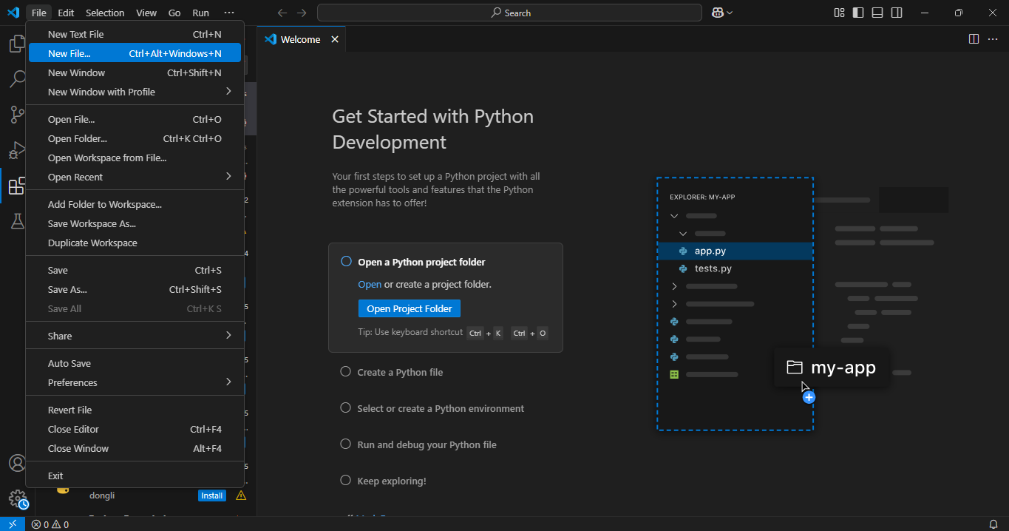

  - Select the Python File option from the name bar on top and a new Python file named Untitled-1 will open

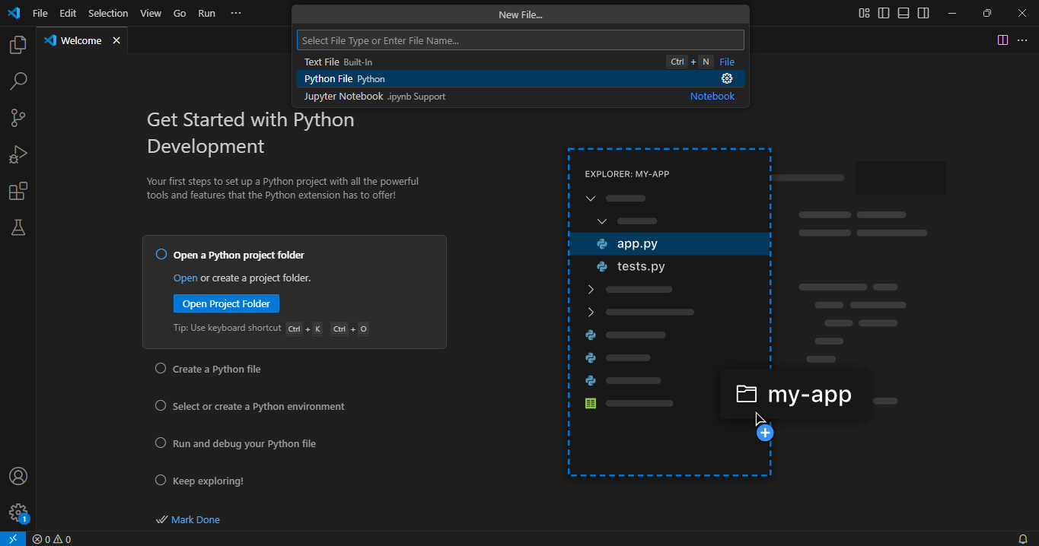

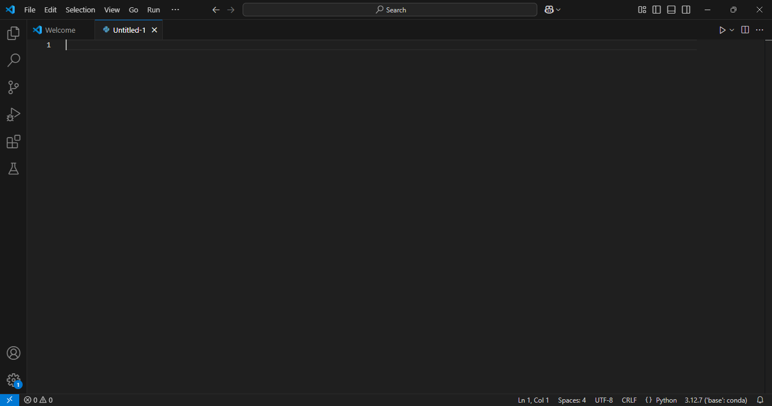

Step 2: Review the erroneous function

  - Copy and paste the following erroneous function, which is supposed to calculate the factorial of a number but contains logical and syntax errors:

def factorial(n):
if n = 0:
return 1
else:
return n * factorial(n - 1)

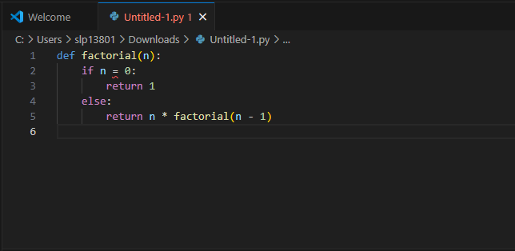

  - Click the play button to run the function and observe the error messages

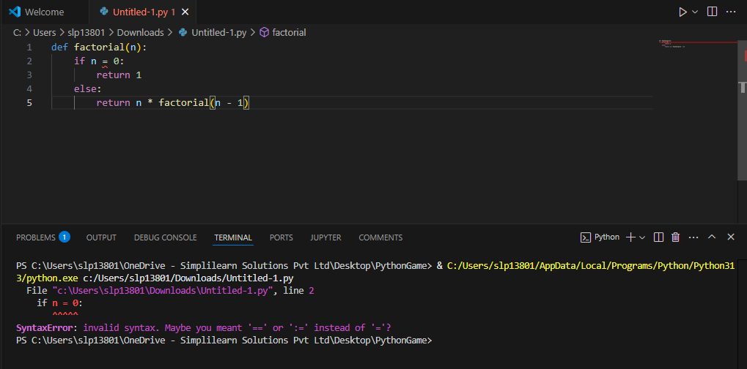

Step 3: Identify errors and debug the function with GitHub Copilot

  - Place your cursor on the erroneous code and add a comment like:

# Fix syntax errors and handle negative inputs

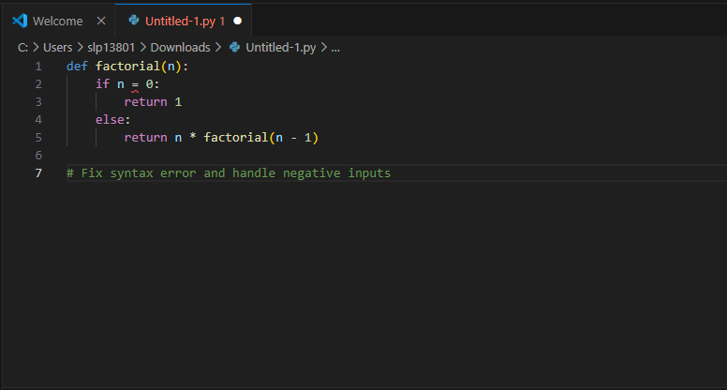

  - Press enter for GitHub Copilot to suggest an improved version of the function

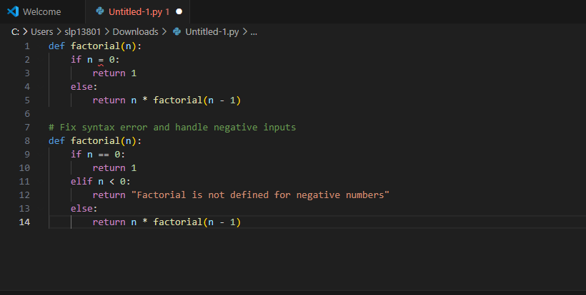

Step 4: Apply the fixes and test the function

  - Press tab to accept Copilot's suggestion, or you can manually rectify the function

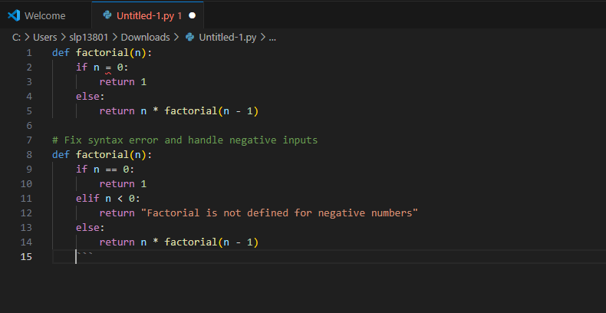

  - Remove the erroneous function that you created earlier

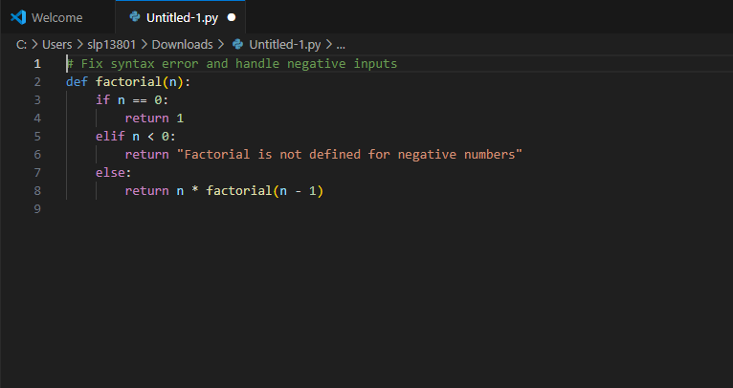

  - Add the following test cases to check different inputs:

print(factorial(5)) # Expected output: 120
print(factorial(0)) # Expected output: 1
print(factorial(-3)) # Expected output: "Factorial is not defined for negative numbers"

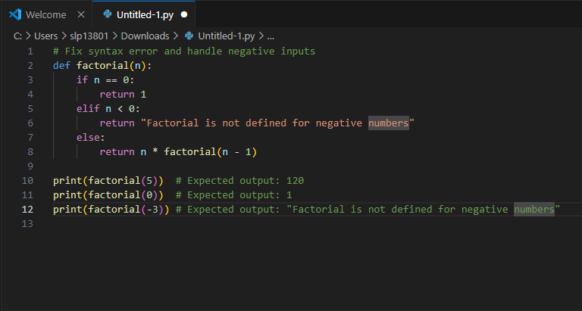

  - Click the play button to run the Python file in VS Code and observe the output

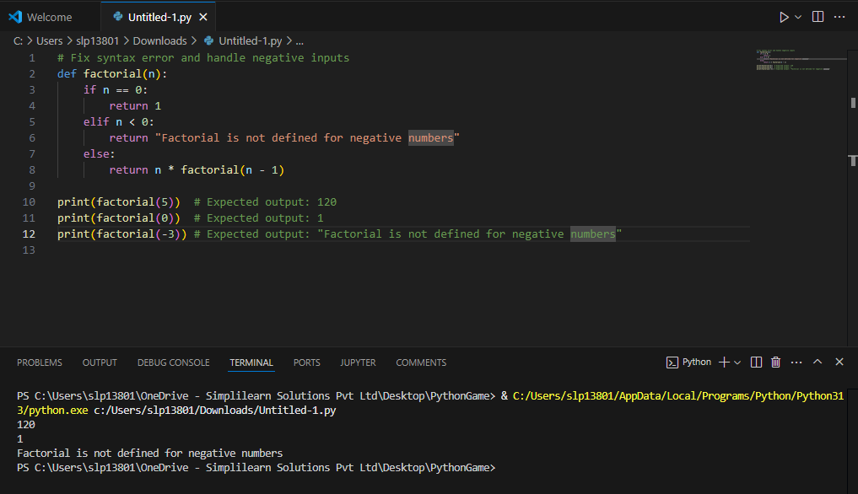

Note: The output in the terminal window should match the expected result.
By following these steps, you have successfully identified, debugged, and optimized an AI-generated function using GitHub Copilot. You have learned to analyze syntax and logical errors, leverage Copilot for automated fixes, and validate solutions with test cases. This structured debugging approach ensures that AI-assisted coding produces reliable and optimized results for real-world applications.

