Lesson 04 Demo 04
Creating a Function Using GitHub Copilot

Objective: To build a Python function that counts vowels in each string using GitHub Copilot in VS Code

Tools required: VS Code with GitHub Copilot

Prerequisites: None

Steps to be followed:
- Launch VS Code and open a new file
- Use Copilot to generate the function
- Test the function

Step 1: Launch VS Code and open a new file

  - Launch VS Code and click on File and then New File

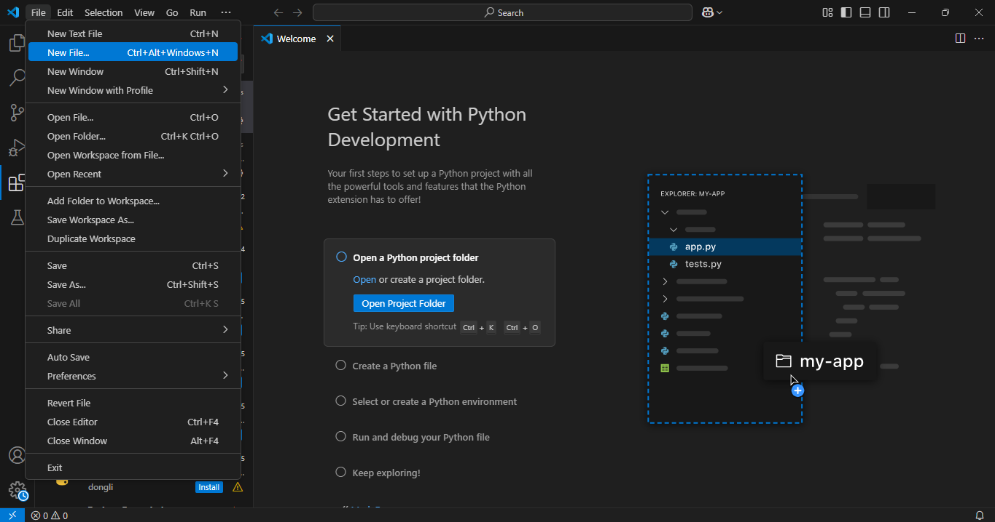

  - Select the Python File option from the name bar on top and a new Python file named Untitled-1 will open

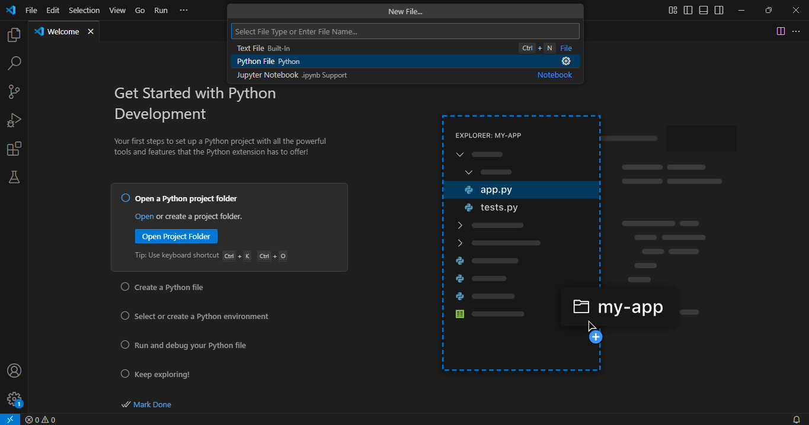

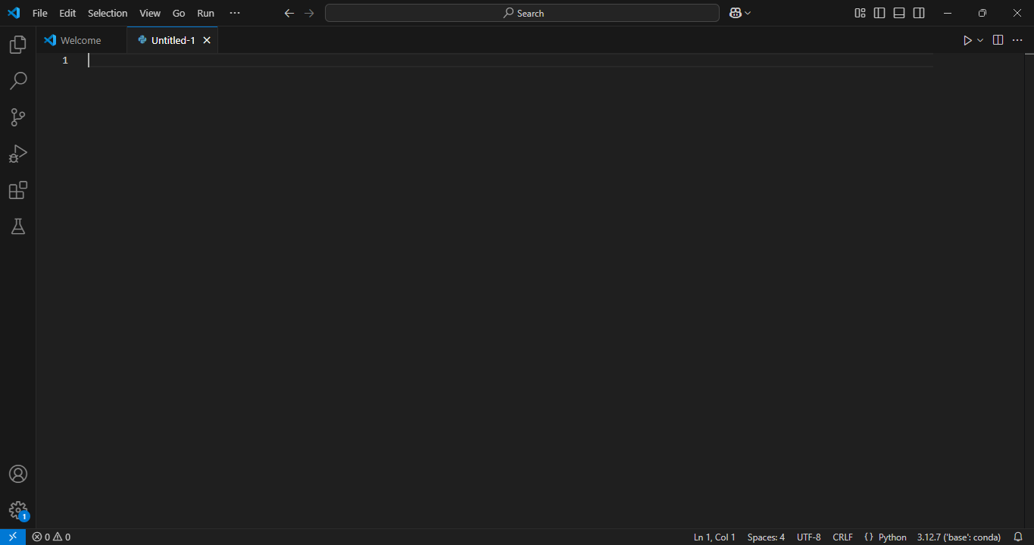

Step 2: Use Copilot to generate the function

  - Write a comment describing a function so that Copilot can generate the function for you

Example comment:
# Function to count the number of vowels in each string

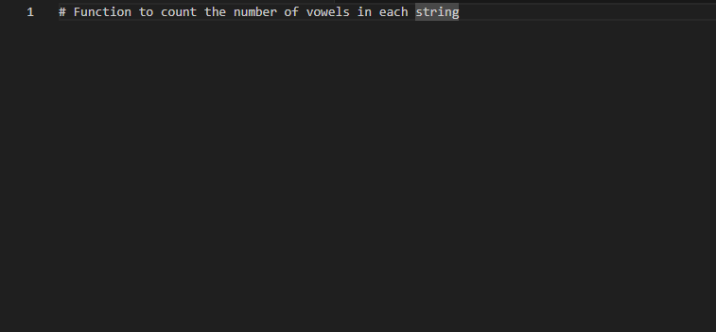

  - Press enter after writing the comment and wait for Copilot to suggest a function

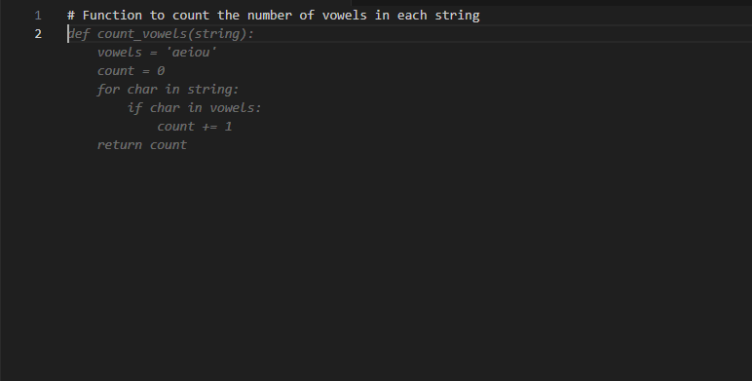

  - Press tab to accept the suggestion. Copilot will generate a function that loops through the string and counts the vowels.

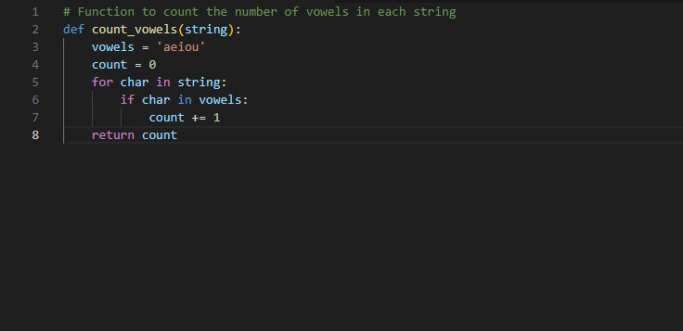

Step 3: Test the function

  - Add the following print statements to test the function with different inputs:

print(count_vowels("hello")) # Expected output: 2
print(count_vowels("Simplilearn")) # Expected output: 4
print(count_vowels("Python")) # Expected output: 1
print(count_vowels("AI-powered coding")) # Expected output: 5

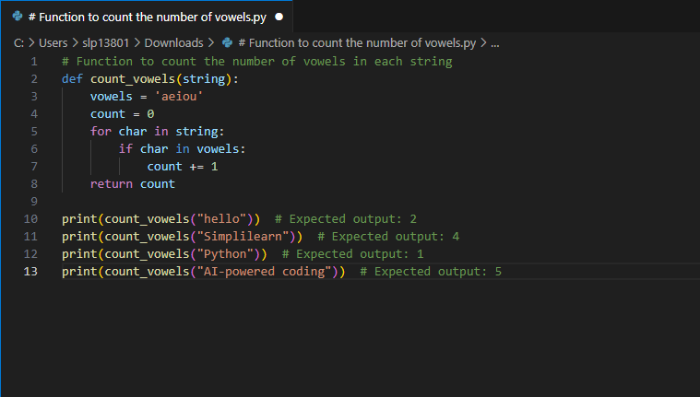

  - Click the play button on the top-right corner to run the Python file in VS Code
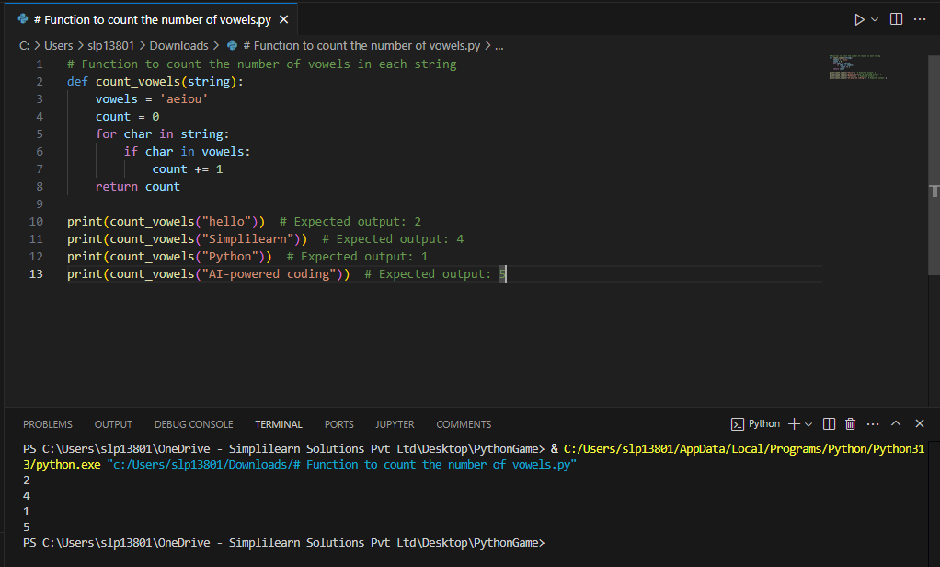

Note: The output in the terminal window should match the expected result.

By following these steps, you have successfully created a vowel-counting function using GitHub Copilot in VS Code. This demo showcased how Copilot can assist in auto-generating function logic, reducing coding time, and improving efficiency. You also learned how to test and validate AI-generated code to ensure accuracy. You can now experiment with Copilot by modifying the function to count consonants, detect special characters, or handle multilingual text, further enhancing your AI-assisted coding skills.

