PROJECT REPORT
Stock Analysis System
Rule-based screening and ranking of NSE equity stocks, with an ML experiment and news sentiment

Submitted by
Vyom Gupta (25MIS0494)
Y Pooja Reddy (25MIS0194)

Live site: https://amber-vyom.github.io/Stock_Analyser/
Source code: https://github.com/amber-vyom/Stock_Analyser

Contents
1. Abstract
2. Introduction and objectives
3. Scope and limitations of the problem
4. System architecture
5. Data source and pipeline
6. Methodology: checks, score and ranking
7. Data structures and algorithms
8. Machine learning experiment
9. News sentiment analysis
10. Web application
11. Testing and quality
12. Results and discussion
13. Limitations
14. Future work
15. Conclusion
16. References

1. Abstract
The Stock Analysis System is a rule-based screening and ranking tool for equities listed on the National Stock Exchange of India (NSE). It downloads the exchange's daily BhavCopy reports, keeps a rolling window of the latest seven trading days, evaluates every EQ-series stock against ten pass/fail checks, computes a weighted score out of 100 and ranks the stocks with a priority queue. The project was built to demonstrate real use of data structures and algorithms: hash tables for grouping, a sliding window for the rolling period, a binary heap for ranking, merge sort for full ordering and binary search for lookups.
Two experiments sit beside the ranking and never influence it: a machine-learning model that tries to predict whether a stock will close higher five trading days later, and a news-sentiment view built from recent headlines. The results are reported honestly. The ML model is only marginally better than guessing, and the score itself has not been backtested, so the system is a screening and learning tool, not a prediction system.
The results are presented in a React web application hosted as a static site, with a study guide to market terms, interactive algorithm demonstrations, a stock comparison view and a guided tour.

2. Introduction and objectives
Thousands of securities trade on the NSE every day. A beginner cannot read through all of them, so screening tools reduce the list to a manageable set by applying explicit rules. This project builds such a tool from official exchange data and uses it as a vehicle to apply core data structures and algorithms in a realistic setting.
The objectives were:
- Download and parse official NSE BhavCopy data reliably, skipping holidays and unavailable days.
- Store raw and processed data in SQL Server, refreshing processed metrics safely.
- Aggregate a rolling seven-trading-day window per stock.
- Apply ten transparent filters and compute a configurable weighted score.
- Rank stocks with a priority queue and demonstrate sorting and searching algorithms with tests.
- Expose the results through an API and a clear web interface.
- Evaluate a machine-learning model and a sentiment module honestly, without overstating results.

3. Scope and limitations of the problem
What the system is:
- A rule-based screener and ranker over the latest seven trading days of NSE equity data.
- An educational project with a web dashboard, a study guide and algorithm demonstrations.
What the system is not:
- Not real-time: it uses end-of-day reports, not tick-by-tick data.
- Not a validated prediction system: the score has not been tested against future prices.
- Not investment advice.

4. System architecture
Business logic lives in a reusable C# library (Stock_Analysis.Engine). The ASP.NET Core API and the tests both reuse it. The web front end is a React and TypeScript single-page application. The Python modules for the ML experiment and sentiment run separately and write JSON files that the front end displays.
Layer | Technology | Responsibility
Data source | NSE BhavCopy (UDiFF CM format) | Daily CSV reports inside ZIP archives
Engine | C# / .NET 10 | Download, parse, aggregate, filter, score, rank
Database | Microsoft SQL Server | RawData and ProcessedData tables
API | ASP.NET Core | Health, stocks, top stocks, snapshot and pipeline endpoints
Front end | React, TypeScript, Vite | Dashboard, Learn page, Algorithms page
Experiments | Python (NumPy, pandas, VADER) | ML experiment and news sentiment
Hosting | GitHub Pages / Netlify | Static site that reads a saved snapshot
Automation | GitHub Actions | Build, tests and Pages deployment

Data flow:
NSE reports → download and extract → CSV parser → RawData → seven-day aggregation → ProcessedData → ten filters → weighted score → priority queue → ranked list → API → web site.

5. Data source and pipeline

5.1 BhavCopy reports
The NSE publishes a BhavCopy file after every trading day. Each row gives a security's open, high, low and close prices, traded volume, traded value and number of trades. Only the EQ series (normal equity shares in regular rolling settlement) is analysed; bonds and other series are excluded.

5.2 Rolling seven-trading-day window
The downloader walks backwards from today, skipping weekends and treating HTTP 404 responses (holidays or unpublished days) as unavailable, until it has seven valid reports. The analysis step then selects the latest seven downloaded files by the date in their file names, so the window is correct even when a holiday falls inside it. Corrupt ZIP files are detected and discarded.

5.3 Aggregation
Records are grouped by symbol with a dictionary and sorted by date. For each stock the aggregator computes the total and average volume, average open and close, highest and lowest price, total trades, total traded value, the seven-day price change (first day's open to last day's close) and a volume-consistency figure from 0 to 100 (100 minus the mean absolute deviation of daily volume as a percentage of the mean).

5.4 Storage
Raw records are inserted only if the date and symbol are not already stored. Processed metrics use an update-or-insert inside one transaction, so existing stocks receive refreshed numbers every run. An earlier version only inserted new symbols, which left stale metrics; this was found and fixed during development.

6. Methodology: checks, score and ranking

6.1 The ten checks
Each stock is tested against ten pass/fail checks. The thresholds are starting assumptions, not proven optimal values.
# | Check | Rule
1 | Completeness | Traded on all 7 days of the window
2 | Positive return | 7-day price change greater than 0%
3 | Strong return | 7-day price change of at least 3%
4 | Close above open | Average close above average open
5 | Price stability | (High - Low) / Low of 15% or less
6 | Volume activity | Average daily volume of at least 1,000,000 shares
7 | Volume consistency | Volume consistency of at least 60 (out of 100)
8 | Strong momentum | 7-day price change of at least 5%
9 | High traded value | Total traded value of at least Rs 1 crore
10 | Overall quality | Change of 2% or more, consistency of 50 or more and volume of 500,000 or more

6.2 The weighted score
The original design gave ten points per passed check, so every stock passing all ten scored exactly 100. The final score is instead a weighted sum out of 100 that rewards how strongly a stock meets each measure. Every component is normalised to the range 0 to 1 and multiplied by its weight. Zero, negative and missing values are handled safely. The weights and scale limits are configurable (ScoringOptions).
Component | Max points | How it is normalised
Data completeness | 10 | Trading days divided by 7
Positive return | 8 | 7-day change, full marks at 2% or more
Strong return | 12 | 7-day change, full marks at 10% or more
Close versus open | 10 | Average close over average open, full marks at 5%
Price stability | 10 | 1 minus price range over 30%
Trading volume | 10 | Log scale from 100,000 to 10,000,000 shares per day
Volume consistency | 10 | Consistency divided by 100
Momentum with volume | 10 | Strong-return factor multiplied by consistency
Traded value | 10 | Log scale from Rs 10 lakh to Rs 100 crore
Overall quality | 10 | Checks passed divided by 10

The score is kept separate from the Boolean checks. Some overlap between components (for example the two return components) is deliberate and is a known simplification.

6.3 Ranking
Stocks are ranked by score first, then by the number of checks passed, then alphabetically by symbol so the order is deterministic. Stocks missing any of the seven days are excluded from the ranking by default, because incomplete windows are not comparable.

7. Data structures and algorithms
Each structure is used where it solves a real problem in the pipeline; none was added only for show.
Concept | Used for | Complexity | In the code
List traversal | Reading and parsing daily records | O(n) | NseParser, SevenDayAggregator
Dictionary (hash table) | Grouping records by symbol | O(1) per insert, O(n) total | SevenDayAggregator
Sliding window | Keeping the latest 7 trading days | O(f log f) for f files | NseReportFiles
Priority queue (binary heap) | Top-N ranking | O(n log n) overall; O(log n) per operation | StockRankingService
Merge sort | Full ranking and sort by symbol | O(n log n) time, O(n) space, stable | MergeSorter
Binary search | Symbol lookup | O(log n) on a sorted list | SymbolSearch

The heap-based Top-N and the merge-sort full ranking use the same comparison (score, then checks passed, then symbol). A unit test confirms that both give identical orderings. The web site includes an Algorithms page that lets a visitor step through the heap, merge sort and binary search using the real scores from the dashboard.
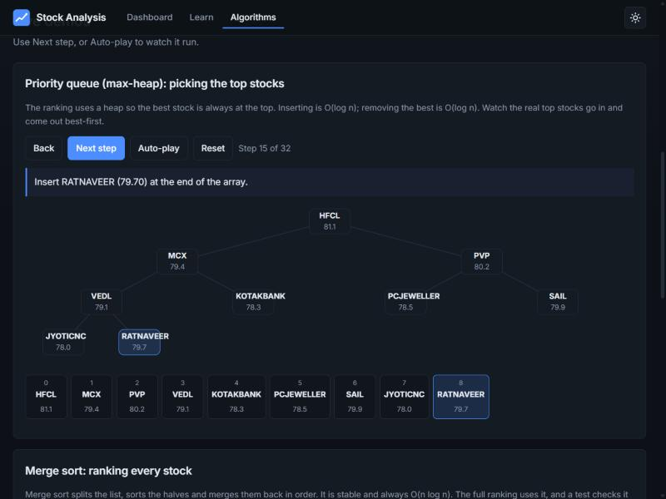
Figure 1: the heap demonstration on the Algorithms page.

8. Machine learning experiment
The ML module is a separate experiment. It asks one question: given a stock's seven-day features, will its closing price be higher five trading days later?

8.1 Data and features
About five months of NSE reports were used: 105 trading days from 2026-05-25 to 2026-10-23. The universe is EQ stocks with price >= 10 and average daily traded value >= 1,000,000; windows with a one-day price jump over 25% are dropped because prices are not adjusted for splits or bonuses.
Features, all computed only from information available on the prediction day: 7-day return, 3-day return, 1-day return, close versus open, 7-day price range, volume steadiness, log average volume and log traded value.

8.2 Preventing leakage
- Features use only past data; the target uses the future close.
- The data is split by time, not at random: training on 2026-06-03 to 2026-09-02 and testing on 2026-09-10 to 2026-10-15.
- A gap of 5 trading days separates the periods so overlapping targets cannot leak.
- Windows containing a one-day price jump over 25% are dropped, because prices are not adjusted for splits and bonus issues.

8.3 Model and results
A logistic regression fitted with Newton's method and L2 regularisation was implemented in NumPy. (The common scikit-learn library could not be loaded because a Windows application-control policy blocked one of its files, so it was not used.)
Model | Accuracy | ROC-AUC | Top-20 avg return | All stocks avg return
Logistic regression | 53.0% | 0.549 | -1.28% | -1.03%
Logistic regression (momentum only) | 56.5% | 0.575 | 1.37% | -1.03%
Baseline: always predict the majority class | 63.4% | 0.500 | - | -
Baseline: 7-day return above zero | 52.3% | 0.444 | - | -

Interpretation: ROC-AUC 0.549 is close to 0.5 (guessing), and the model's accuracy (53.0%) is below the majority-class baseline (63.4%). Its top-20 picks returned -1.28% versus -1.03% for all stocks over the test period. Treat this as an experiment with little or no predictive value.
ROC-AUC of 0.5 means no better than guessing. The test period was short, fell on average, and the model's highest-probability picks were mostly stocks that had just dropped sharply, a pattern that would need a much longer test to mean anything. The result is therefore presented as an experiment with a clear method, not as a working predictor.

9. News sentiment analysis
For the top-ranked stocks, recent headlines are fetched from Google News RSS (last 14 days). In this run 18 stocks and 112 headlines were analysed.
- Each headline is scored by VADER, a rule-based sentiment model, extended with a small list of finance words such as "upgrade", "surge", "plunge" and "probe".
- A headline is labelled positive, neutral or negative from its compound score; each stock gets an average and a label.
- A simple keyword count assigns one of four emotion tags: optimism, fear, anger or uncertainty.
- Each article is shown with its source, date, label and a short explanation of the words that drove the score.
Limitations: searching by ticker can match unrelated news, VADER is not trained on financial text, and the emotion tag is crude. The module is shown separately and does not affect the ranking or the ML model.

10. Web application
The site is a single-page React application with these parts:
- Overview: headline numbers, the three highest-ranked stocks and a scrolling price-change ticker.
- Rankings: sortable and filterable table, symbol search, CSV export, and a detail panel with the ten checks, a score breakdown and a plain-language summary.
- Compare: any two stocks side by side, with the stronger value highlighted in each row.
- Insights: a clickable score histogram, biggest gainers and most-traded stocks.
- Methodology and Learn: an explanation of the pipeline and a study guide with a searchable glossary of 57 market terms.
- Algorithms: interactive demonstrations of the heap, merge sort and binary search.
- Experiments: the ML and sentiment results, kept separate from the ranking.
- Guided tour for first-time visitors, light and dark themes, keyboard navigation, and a responsive layout.
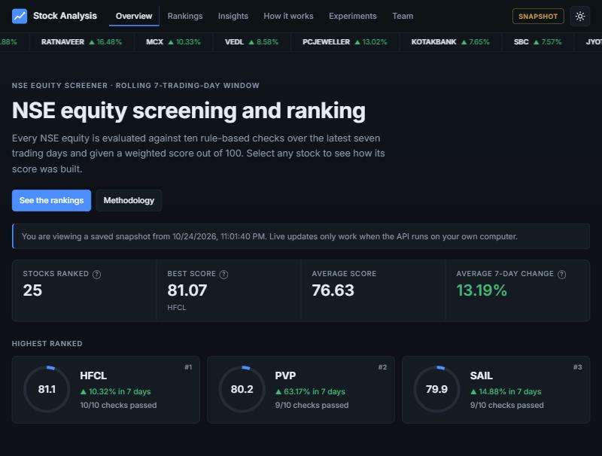
Figure 2: the dashboard overview.
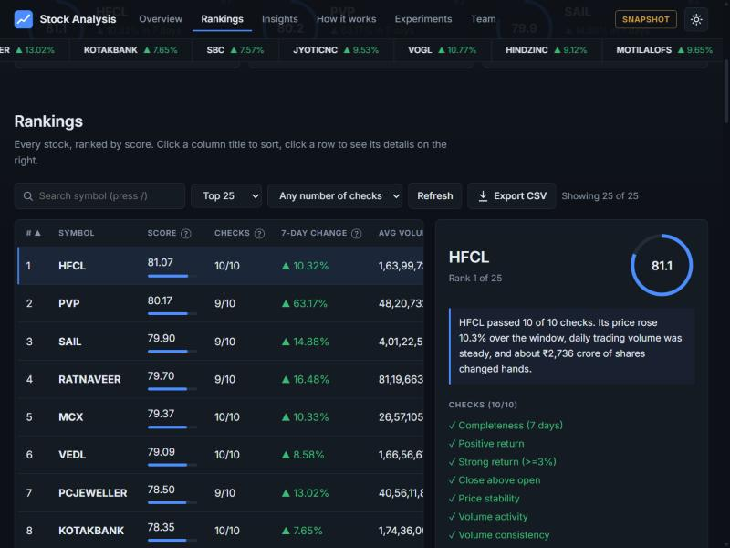
Figure 3: the rankings table with the stock detail panel.
Because free hosting cannot reach a local SQL Server, the published site reads a saved snapshot of the ranking. When the API runs locally the same front end uses live data and can refresh the data from the NSE with one button.

11. Testing and quality
- 27 C# unit tests (xUnit) cover scoring bounds and breakdown, ranking order and tie-breaks, exclusion of incomplete windows, aggregation (chronological price change, series filtering, volume consistency), report-file selection across holidays, merge sort (including stability and agreement with the built-in sort), binary search, and equality between the heap and merge-sort rankings.
- 6 Python tests cover the logistic model, the ROC-AUC calculation and the sentiment helpers.
- GitHub Actions builds the API, runs the C# tests and builds the front end on every push, and deploys the site to GitHub Pages.
- Not yet covered: automated tests of the database repositories, the downloader and the CSV parser.

12. Results and discussion
On the stored window (13 to 21 August 2026 (seven trading days)), the ten highest-ranked stocks were:
Rank | Symbol | Score | Checks | 7-day change | Avg daily volume
1 | HFCL | 81.07 | 10/10 | 10.32% | 16,399,730
2 | PVP | 80.17 | 9/10 | 63.17% | 4,820,732
3 | SAIL | 79.90 | 9/10 | 14.88% | 40,122,516
4 | RATNAVEER | 79.70 | 9/10 | 16.48% | 8,119,663
5 | MCX | 79.37 | 10/10 | 10.33% | 2,657,105
6 | VEDL | 79.09 | 10/10 | 8.58% | 16,656,671
7 | PCJEWELLER | 78.50 | 9/10 | 13.02% | 405,611,821
8 | KOTAKBANK | 78.35 | 10/10 | 7.65% | 17,436,001
9 | SBC | 78.34 | 10/10 | 7.57% | 7,114,795
10 | JYOTICNC | 78.00 | 10/10 | 9.53% | 1,046,115

Scores now differ between stocks that pass the same number of checks, which the original ten-points-per-check design could not do. The score breakdown shows exactly which components earned the points. The main limitation is that a high score has not been shown to precede higher future returns; verifying that requires a historical backtest that this project has not yet done.

13. Limitations
- Only seven trading days of data are used for the ranking, by design.
- Prices are not adjusted for splits and bonus issues, so such events can distort the seven-day change; the ML experiment drops affected windows.
- The score and its thresholds are assumptions and have not been backtested.
- The ML test period is short and covers a falling market, so its results cannot be generalised.
- News sentiment relies on ticker searches and a general-purpose lexicon.
- The hosted site shows a saved snapshot, not live data.
- Row uniqueness is enforced in the repository logic; database-level unique keys were not added or verified, and the repositories are not unit tested.

14. Future work
- Backtest the weighted score against later price moves over a longer history.
- Adjust historical prices for corporate actions and retrain the model on a longer period.
- Add database-level unique keys and batched inserts, with tests.
- Refresh the published snapshot automatically on a schedule.
- Add sector data for sector-level views.
- Evaluate finance-specific sentiment models.

15. Conclusion
The project delivers a working NSE screening and ranking pipeline from raw exchange files to a published web site, built around genuine uses of hash tables, a sliding window, a priority queue, merge sort and binary search, all verified by tests. The experiments were reported honestly: the machine-learning model showed almost no predictive power, which is a legitimate and expected outcome for a short dataset, and the score is presented as a screening aid rather than a forecast.

16. References
- National Stock Exchange of India. Daily BhavCopy reports (UDiFF CM format). https://www.nseindia.com
- Securities and Exchange Board of India. Investor education. https://investor.sebi.gov.in
- Cormen, T. H., Leiserson, C. E., Rivest, R. L. and Stein, C. Introduction to Algorithms. MIT Press.
- Hutto, C. J. and Gilbert, E. (2014). VADER: A Parsimonious Rule-based Model for Sentiment Analysis of Social Media Text. Proceedings of the International AAAI Conference on Web and Social Media.
- Project repository. https://github.com/amber-vyom/Stock_Analyser

Disclaimer: this report and the system it describes are for education only. Nothing in them is investment advice.

