|  |  |  |
| --- | --- | --- |
|  |  | *Algonquin College of Applied Arts & Technology* |

CST8276 - Assignment 01 (100 points, weight 10.0 %)

*The assignment must be uploaded to the Blackboard by Sunday February 12th at 11:59 pm. Late assignments are NOT accepted and they will not be graded.*

*Save all the answers in a word file with “****A01_YourName_LastName****” as a name.* ***Please use this document*** *to answer the questions and upload it to the blackboard.*

**ABC Company**

you are planning to be a database administrator in a big company (ABC company). You are still under training and by the end of the training program they might offer you a full-time job. However, it is all depending on your performance during the training period.

***The first task*** you have been ask to do is to create a *pfile* from the *spfile*. The name of the newly created *pfile* should be: “yourName.ora” and it should be placed in a new folder called “MyDbinit”. This folder is located in the same folder as the *spfile*.

1. Take snapshot of your work **Or** copy and paste your commands in the provided space. **The provided solution should contain all the details of your work in a way that I can reproduce it.** It is up to you if you want to add any extra explanations.

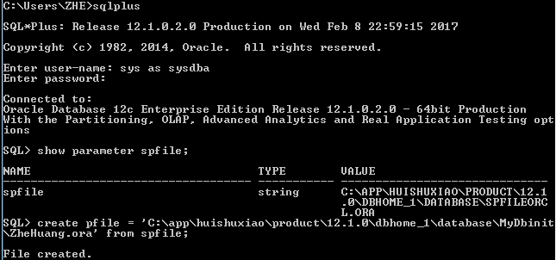

***In the second task***, you have been asked to check the default initialization file that the database is used to initialize its parameter. In order to achieve such goal follow the following steps:

1. Shutdown and then restart oracle instance

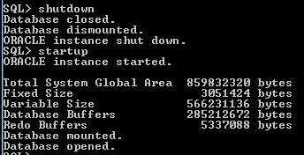

1. Check whether the database has been initialized by the *pfile* or the *spfile*.

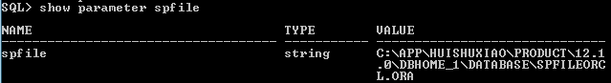There has value for parameter spfile which means database has been initialized by spfile, or else by pfile.

1. If it has been initialized by using the *spfile*, show the location of this *spfile*.



1. Inside the initialization file (whether it is *pfile* or *spfile*), there are a set of parameters. Check the maximum number of operating system processes that are allowed to connect to the oracle database simultaneously. Set it to 500.

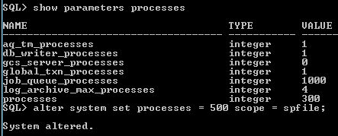

1. Display again the maximum number of processes. Has its value changed? Or it is still the same? Why.

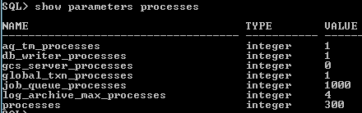

Its value did not change yet. Because these values cannot be modified in memory, we only can modify the spfile only and bounce the instance. When I restarted the database instance, the modified values would display

1. Shutdown your oracle instance and then restart it again. Check the value of the maximum number of processes. What can you say about this parameter? Is it a static or dynamic?

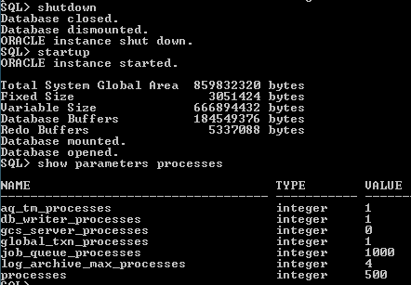

***In task three***, you have been asked to use the *pfile* that you have created in order to startup and initialize the database parameters.

First, shutdown your instance and then start it up using the pfile (yourName.ora). You need to do some research here. Check whether the instance has used the pfile or the spfile to initialize the parameter. Hint: you can use the SHOW PARAMETERS spfile, and check the value of the string. Moreover, check the maximum number of processes (It should be different from 500).

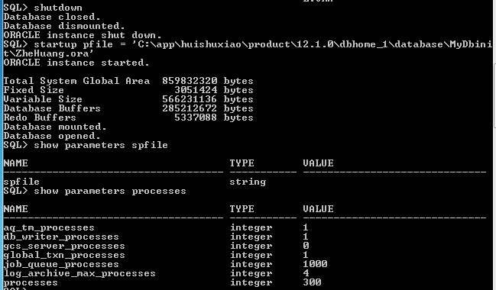

The instance has used the pfile (ZheHuang.ora) to initialize the parameter. Because when I ‘show parameter spfile’, there is no value for spfile, which means the instance is initialized by pfile. The maximum number of processes is 300.

Congratulation. You have completed your tasks as a trainee. You are now a full-time database administrator in the company. However, you have a three-month probation period. During this period, you have been asked to complete the following tasks related to creating and managing users’ access to the database.

**Task Four (Provide the necessary snapshots that show your work):**

1. Create a tablespace with a name ***Yourname_TS***, the name of the attached datafile is ***Yourname_TS.dat***. The size is 20M and it is autoextended.

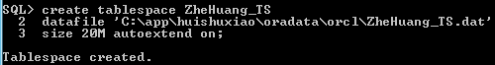

1. Create a temporary tablespace with a name ***Yourname_TS_Temp***, the name of the attached datafile is ***Yourname_TS_Temp.dat***. The size is 10M and it is also autoextended.

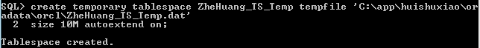

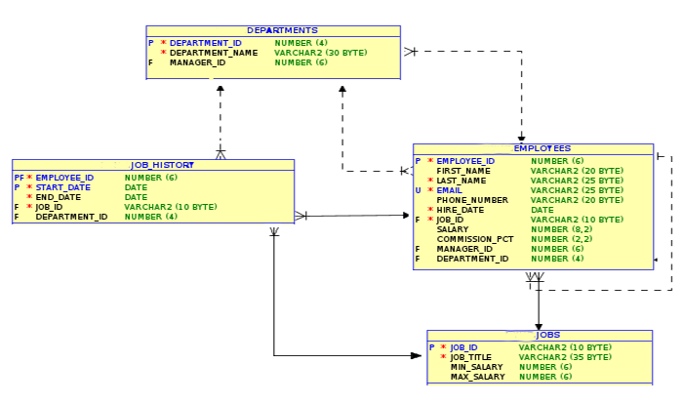

Figure 1: Schema Tables

1. Create a new user with ***YourFirstName_YourLasName*** as a user name. You may choose any password you want. ***Yourname_TS and Yourname_TS_Temp*** are the default and the temporary tablespaces of the new user. The new user should have a sysdba privilege.  
     
     
   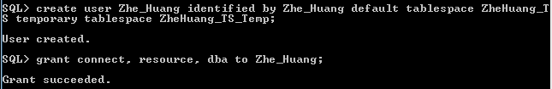
2. Log on using the new user username and password and use the ***HR_Schema.sql*** script provided for you to create the above schema.

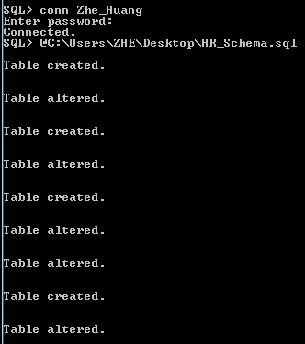

**Task Five: (Provide the necessary snapshots that show your work):**

Three new employees, ***Jenny***, ***David*** and ***Rachel*** have joined the company. Jenny is an HR manager who has the right to insert, delete, select or update an employee, and to create a new job. Moreover, Jenny can ***pass*** these privileges to other employees in the company. David and Rachel are HR clerks and they have the right to create a job, select and update employees (Figure 2).

Create two roles, ***HR_MGR*** role and ***HR_CLERK*** role. Grant them the required privileges.

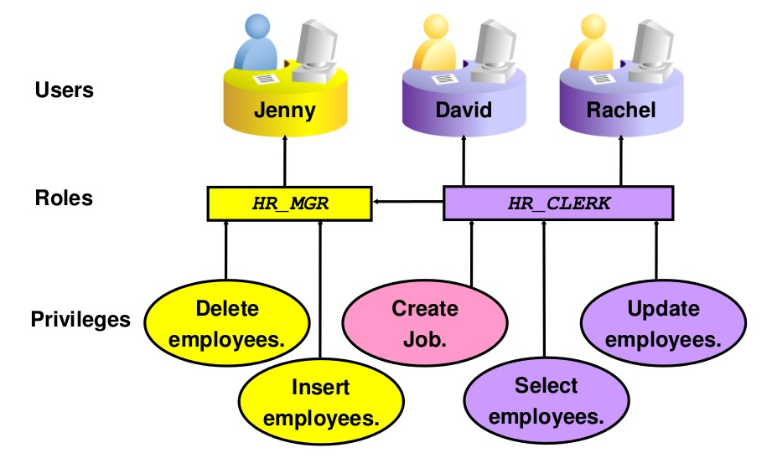

Figure 2: Privileges given to roles, and roles assigned to users.

It is the company policy that the maximum number of password login attempts is three. If the user fails to login after three attempts, the account will be locked for one minute. Two minutes is the maximum time that a user is allowed to be inactive. In addition, the password should expire after the first login.

1. Create a profile with a name ***User_Profile*** that implements the access policy of the company.  
     
   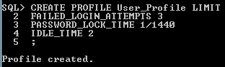
2. Create the above three users, Jenny, David, and Rachel. Assign the HR_MGR role to Jenny and the HR_CLERK role to David and Rachel. Moreover, assign the User_Profile to David and Rachel. The three users have the same tablespace and temporary tablespace (***Yourname_TS and Yourname_TS_Temp).***

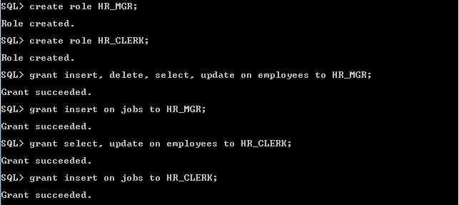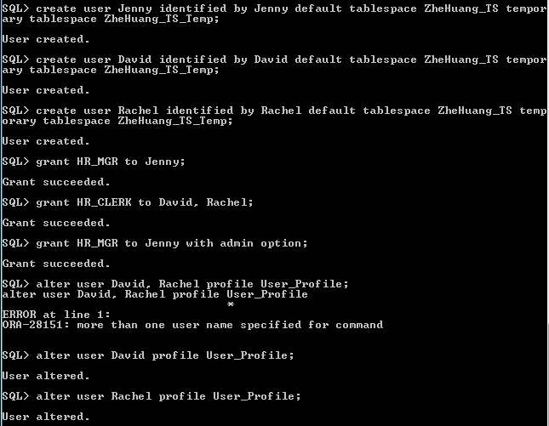

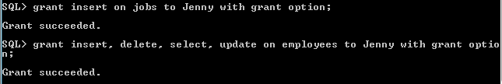

1. Grant all the necessary privileges to the new users so they can connect and perform the required operations.

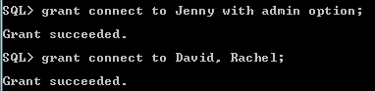

1. Login as Jenny and insert three employees to the employee table.

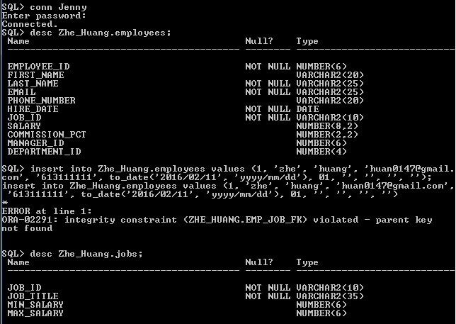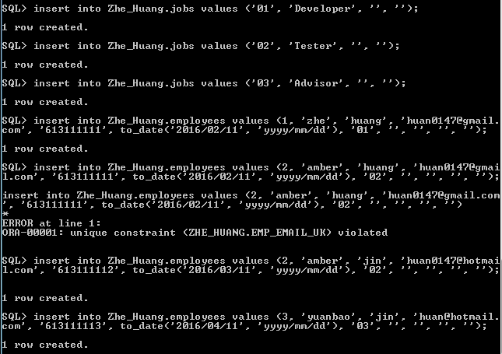

1. Use the select statement to list the employees.

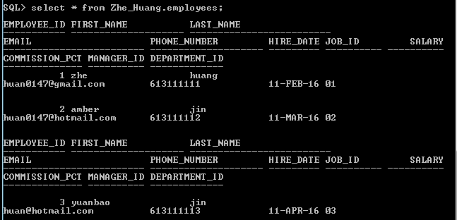

1. Delete the first employee of the list.

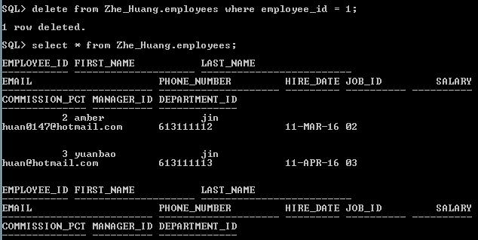

1. Now login as David, and try to insert a new employee to the employees table.

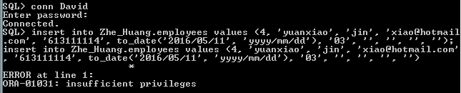

1. Delete an employee from the employees table.

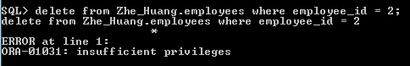

1. Create a job.

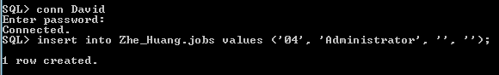

10- Jenny now is in a leave of absence. She has asked Mike to take over during her absence. Jenny asked you (DBA) to create a user for Mike. However, Jenny wants to grant her privileges to Mike by **herself**.

Now log on as a SYS DBA and create a new user. Do not grant any privileges to the new user at this stage.



11- Log on to the system now as Jenny and grant the privileges of Jenny to the new user.

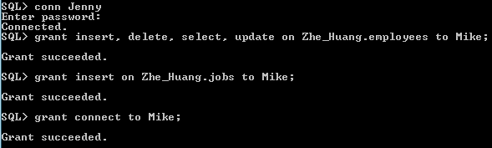

12- Log on now with the new user (Mike) and insert a new employee.

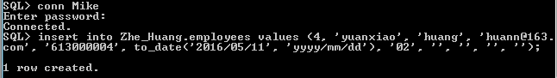

Great Job. You are DONE.

