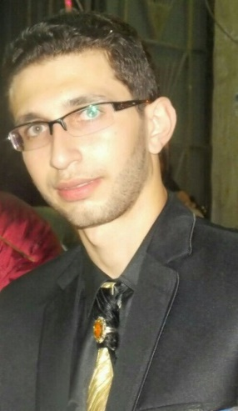

Abdelrahman Salah

Truedream120@gmail.com ,01201537818

21 Taher Beek Street, Alexandria Egypt

**PERSONAL STATEMENT**

**My name is Abdelrahman salah, I’m in a software engineering department in Faculty of computer and information at Helwan University**

**I’m a software developer and I interested in Mobile Application development**

**(Android), Java, Java EE, C#, C++ also I’m willing to learn new approaches and be up to date**

**Knowledge:**

I’m a software engineering Developer (Android and Web Developer, Desktop Developer)

I have about 1 year in developing android apps and 0-1 year for developing java EE Netbeans And 2-3 years desktop applications using java,C#.SQL DB ,Oracle

WORK EXPERIENCE

*-I Trained by Google in android intermediate course and I made a beauty Movie app submit it, I took a certificate in that field

*-I Trained by TIEC In innovation and how to think and to develop your Idea to make a product

##### Responsibilities && Achievements:

* Familiar with Object Oriented Programming and I love it
* I have good enough Knowledge in design patterns concept in java
* Familiar with Data Structure and I’m brilliant in using it
* Familiar with Networking and Socket Programming in java
* Familiar with how to work with Cloud Services
* Familiar with how to work with Version source control like Git and VSTS
* I’m Good enough in design UI/UX
* Hard worker, Self-Learning, Creative, Flexible, Communicator, Self Confidence and always ready to learn.
* Work ON Issues and support team in problem solving , always ready to work under pressure
* I always take responsibilities and be the leader and Never lose the purposefulness
* I Made in android Movie Application Which fetch data from url and display it in my app and there are Database that contains what you want to save ,videos and reviews and many other features
* I Made tic tac game (X/O) For Android and I add animation to it
* I Made Calendar APP For android and I Made a support layout for sending email for me and automatic response
* I Made app For sending Emails to other users in android
* I Made a small app for adding voices and how to stop it and start it and how to move the minutes of that record For android
* I Made baby care application in java servlets where I can add baby to system and update information and delete , retrieve using restful webservices techniques
* I Made a calculator app For android
* I Made an app for writing in tables and I print it in paper using java
* I Made a Search app using c# that I can search for a word in document and how many times that document repeats
* I Made an app using c# for managing every task in a project and calculate the time when it finish it was like a project management app
* I Can Work With APIs and RESTFUL webservices
* I Can Work on SQL DataBase and I Can Build webservices So I can use it in mobile app
* I Made in android a weather forecast I gain Jason array from API and display data in my application with other features
* I have a certificate in android development from google in training course of android intermediate (udacity course )
* I Made chat application using java and I can connect between devices using socket programming
* I Made college system where admin and student and teacher with fulfilling all features using java
* I Made application for searching and algorithm in search using c#
* I Finished application for data structure and other for comparing images , encrypting texts in image
* I Made a 2d game in game development and I released it on facebook.
* I have ability for self study and work hard whatever the situations and count on my self .
* I Can Work in any government and any time, I’m a hard worker.
* I’m Willing To learn New Approaches and be UP TO DATE

**Goals:**

**I’m willing to learn new approaches and to be UP TO DATE**

**I love science and I want to work hard and gather experiences and knowledge.**

**EDUCATION:**

**My GPA in my Field is 3.46 (Excellent) , i’m in a software engineering department in Helwan University,I’m a software developer**

**I know how to develop Mobile Application development (Android), Java ,Java EE,C# ,C++ ,and also I**

**know About designs in web ,a tour about javascript too ,2d game development, I have ability for self study**

* I have a certificate in android development from google in training course of android intermediate (udacity course )

Here is My Transcript for My Studies In College



Regards,