NHS Borders Analysis

Amber Lawther

19/12/2019

## Parsed with column specification:  
## cols(  
## .default = col_double(),  
## HBR2014 = col_character(),  
## CancerSiteICD10Code = col_character(),  
## CancerSite = col_character(),  
## Sex = col_character(),  
## SexQF = col_character(),  
## EASRLower95pcConfidenceIntervalQF = col_character(),  
## EASRUpper95pcConfidenceIntervalQF = col_character(),  
## WASRLower95pcConfidenceIntervalQF = col_character(),  
## WASRUpper95pcConfidenceIntervalQF = col_character()  
## )

## See spec(...) for full column specifications.

## Joining, by = c("cancer_site", "sex")

## Selecting by mf_incidence_change

# Incidence of Cancer in NHS Borders

### Initial look at overall incidences to determine if there is an apparent trend

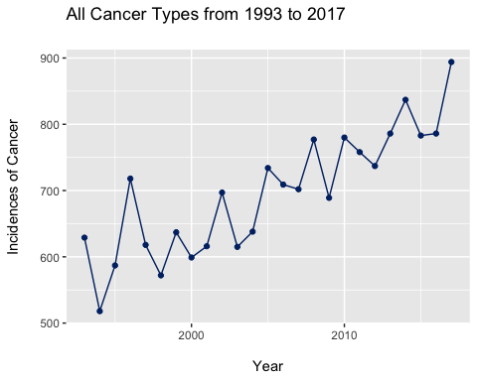

The graph displays an increasing trend in the overall incidence of cancer in NHS Borders.

#### The next step was to subtract 1993 incidences from 2017 incidences to portray the cancer sites with

#### the largest increase between the two years.

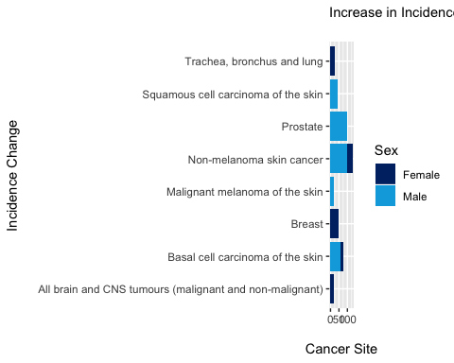

This graph shows that skin cancers make up some of the largest incidence changes between 1993 and 2017.

#### The information was corroborated by plotting line graphs, which illustrated an overall increase from

#### 1993 to 2017, and also by plotting graphs which showed the increase in incidences without the breakdown of sex.

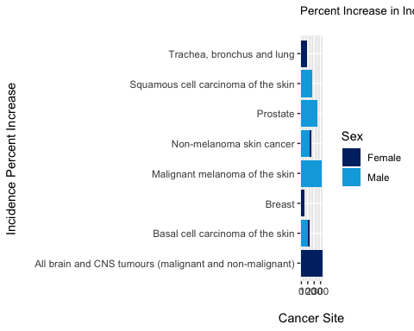

The percent increases were calculated to compare with the previous graph

#### The largest decreases between 1993 and 2017, along with the percent decreases, were also calculated #### and visualised, which can be seen in the following graphs.

