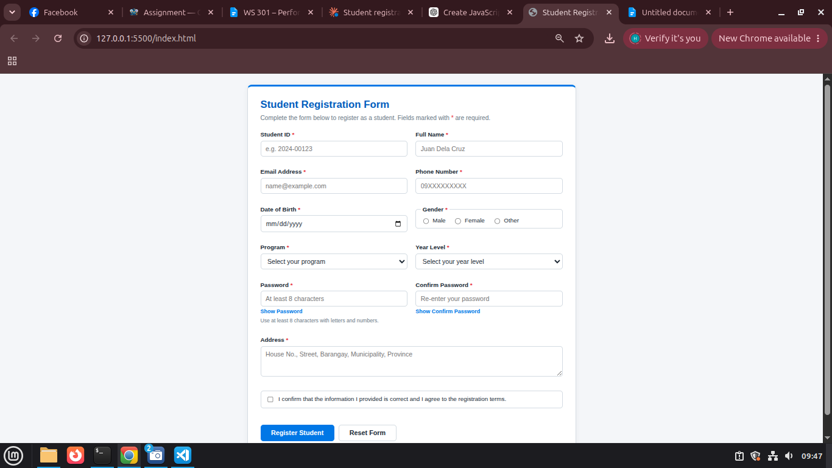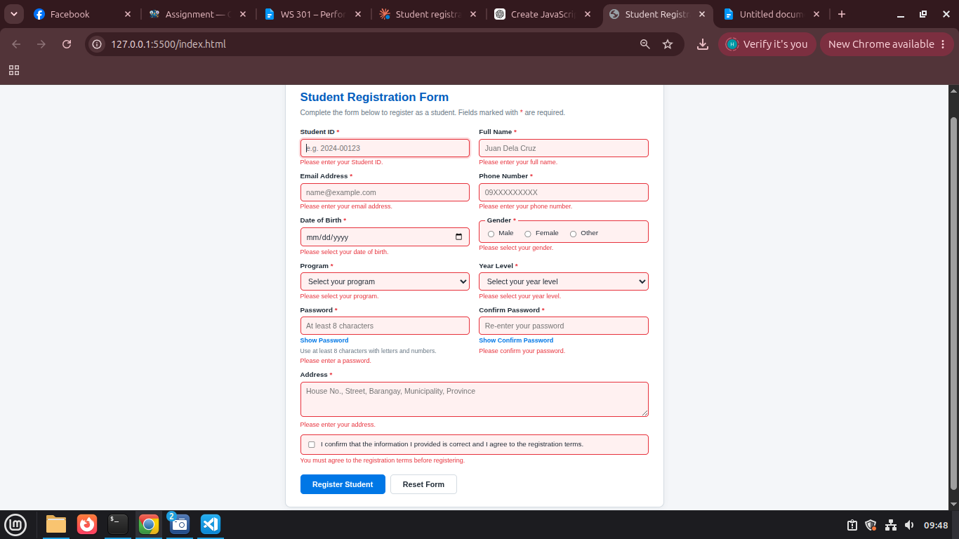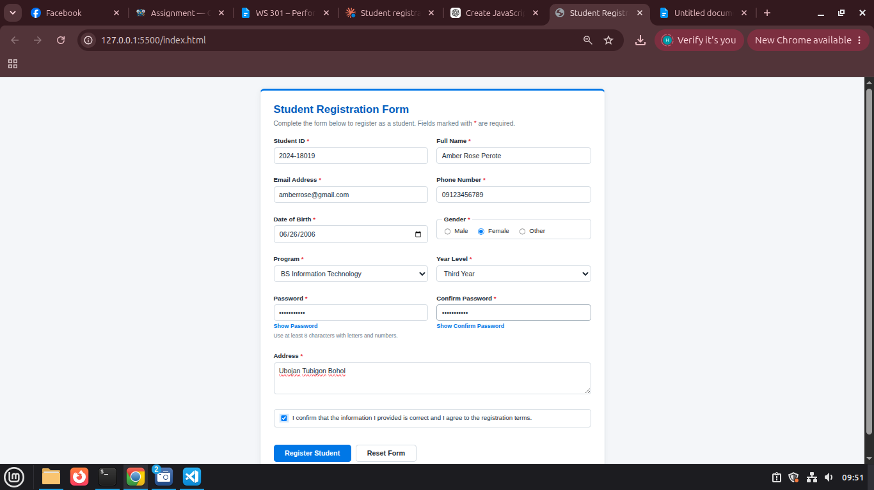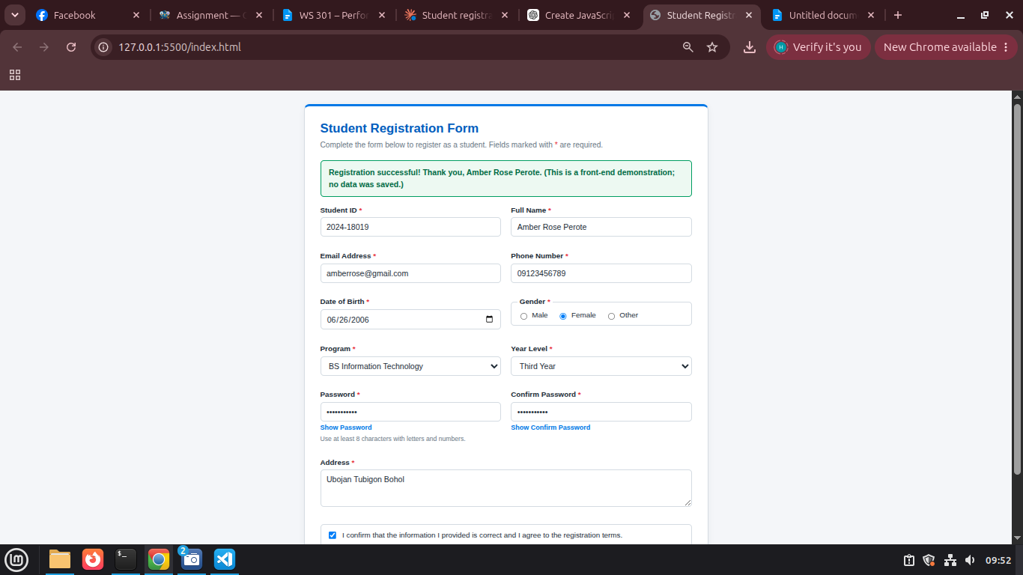
Short Explanation:

My Student Registration Form collects a student’s ID, full name, email, phone number, date of birth, gender, program, year level, password, address, and agreement, and it checks all of them before showing a success message. For validation, a validateField() function removes extra spaces from text inputs with trim() and then applies a rule to each field, such as regular expressions for the student ID, email, and 09XXXXXXXXX phone format, checks that gender, program, and year level are selected, a comparison of the password and confirm password, and a check that the agreement box is ticked. The form uses addEventListener("submit", function(event) { ... }) and calls event.preventDefault() first, so the page does not reload or submit while the data is being checked, and the success message appears only when every field is valid. Each invalid field shows its own specific error message below it, such as “Passwords do not match.” or “Phone number must use the format 09XXXXXXXXX (11 digits).” For CSS classes, I use classList.add("error") to give an invalid field a red border and a light red background, and classList.remove("error") removes that styling as soon as the user corrects the field. I also use classList.toggle("show-password") on the password container so the Show/Hide Password buttons switch the field’s visible state on and off. In the HTML, I added custom attributes such as data-validation, data-required, data-label, and data-min-length, and the JavaScript reads them through element.dataset to decide which rule to run, whether the field is required, how long it must be, and which field name to put in each error message. The main attribute I manipulate is the password input’s type, which setAttribute() changes between “password” and “text” so the password can be shown or hidden, and I also update aria-invalid on each field and set the date input’s max attribute to today so future birth dates cannot be chosen. Finally, the Reset Form button clears all entered information, error messages, error styling, and the success message, and it returns the password fields to their hidden state.

