Who We Are

With an interest in art and design but little guidance of where to take it, first-generation university freshman Amber Yams founded Creative Café in 2015. The goal was to create an online art community for introverts such as herself while providing resources, advice, and a space for artists in college to thrive in this new digital age, inspired by the aesthetics of quaint coffee shops.

Now graduated, Creative Café lives on through a new generation of college students, spearheaded by Amber Yams’ younger sister, Yamber Ams. As the Creative Café community continues to blossom, we hope to spread our influence to greater reaches while focusing on what matters most: keeping the artistic spirit alive.

Meet our current contributors!



Yamber Ams, Class of 2026

*Webmaster/Writer*

A sophomore majoring in Computer Science and minoring in art at Rutgers University, Yamber Ams has a passion for intersecting technology and art. Inspired by her older sister, Yamber Ams took over Creative Café in early 2022, when she began her college career. In her free time, she enjoys playing ukulele, reading, designing, writing, and judging the UIs of websites. After graduation, Yamber Ams seeks to pursue a career in video game development or UI/UX Design.

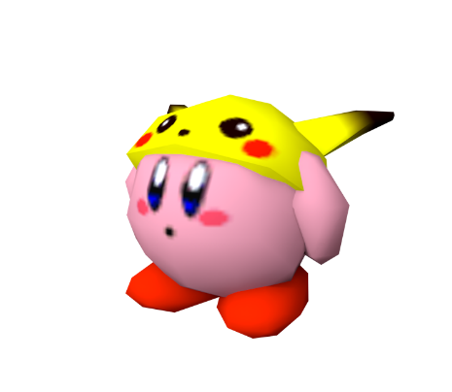

Peter Kachu, Class of 2027

*Designer/Photographer*

Peter Kachu, informally known as P. Kachu, is a freshman in the Mason Gross School of the Arts at Rutgers University. Although his major is currently undecided, Peter Kachu finds beauty in exploring the many facets of creativity and art – a main reason why he wanted to join the Creative Café team. In his spare time, he acquires lightbulbs and sparkplugs for his ever-growing electronics collection to be used… eventually (when? how? We may never find out).

Pauline Wag, Class of 2024

*Editor/Writer*

As a senior double majoring in Communications and Journalism at Princeton University, Pauline (Polly) Wag discovered Creative Café through some mutual friends of Amber Yams. With a keen interest in animation and art museums, Polly combines their love of writing with her knowledge of the arts to produce wonderfully entertaining and helpful guides, blogs, and more. In their free time, Polly enjoys swimming, as they earned three Youth Olympic gold medals for freestyle, freestyle relay, and medley relay in high school. With graduation rapidly approaching, Polly aims to have her own column in *The New Yorker* or *The New York Times*.

Piper Lup, Class of 2025

*Editor/Designer*

Piper Lup (nickname Pip) is an Information Systems and Graphic Design double major at Drexel University in Philadelphia. The furthest located of our team members, Pip discovered Creative Café while searching for online art communities for college students. As a dedicated site user for a few years, Pip officially joined our team in 2021, during the peak of quarantine (where online media was all anyone consumed!). When she is not designing, Pip enjoys long walks on the coast and taking cold mountain climbs.

Beatrice drill

Ivy saur

Polly Wag

Piper Lup