

Eugene Platform — Consolidated Programme Briefing
Overview, Scope, Current-State Architecture, Gaps and Technical Recommendations

Prepared for: CSL Behring — Business Development & R&D Stakeholders
Programme: Eugene Knowledge Graph & Agentic AI Platform
Date: May 2, 2026
Classification: Confidential — Internal Use Only
Version: 2.0 (Book Edition)

This document is a synthesised, book-format evaluation distilled from the Eugene Project Validation Document, the Stage 1 Assessment & Audit Report, the Developer Guide, and the canonical architecture diagram.

Table of Contents
Right-click and choose 'Update Field' to populate the table of contents.

Front Matter

About This Document
This briefing is the single, consolidated reference for the Eugene biomedical knowledge graph and agentic AI programme at CSL Behring. It is intended for client and stakeholder presentations and replaces the need to navigate between the Project Validation Document, the Stage 1 Assessment & Audit Report, the Developer Guide, and the next-generation architecture proposal. The five sections that follow tell a complete technical story: what Eugene is, what it does today, how it is built, where the gaps are, and what we recommend doing about them.
Every architectural claim in this document is grounded in source material in the docs/ folder. Where a measurement, a finding, or a remediation is cited, it traces to one of the four primary sources above. Diagrams are reproduced from the canonical Mermaid sources in the Developer Guide, augmented with the next-generation architecture preserved in CSL_Arch_nextGen.pdf.

Document Map
- Section 1 — Overview of Eugene: who it is for, what it does, and why it matters to CSL Behring.
- Section 2 — Scope and Capabilities: what the platform answers today, what data sources are integrated, and what use cases are in production.
- Section 3 — Detailed Current-State Architecture: the five running services, the data model, the request flow, the authentication design, and the AWS deployment topology.
- Section 4 — Gaps Identified: the twenty-one findings of the Stage 1 audit (CRITICAL, HIGH, MEDIUM) plus operational, data, and experience gaps observed in this assessment.
- Section 5 — Technical Recommendations: the next-generation target architecture, the four-phase remediation roadmap, the user-experience enhancement programme, and the non-functional commitments.
⚑ Confidential. Prepared for CSL Behring stakeholders. Reproduction or distribution outside CSL Behring requires programme-lead approval.

Section 1 — Overview of Eugene

1. What Eugene Is
Eugene is an enterprise-grade, AI-powered biomedical knowledge graph platform purpose-built for CSL Behring's competitive intelligence and research analytics operations. It allows non-technical users — Business Development analysts, R&D scientists, and Medical Affairs professionals — to pose complex, multi-hop biomedical questions in plain English and to receive synthesised, evidence-backed answers in seconds. The underlying graph integrates authoritative public data (USPTO patents, PubMed literature, ClinicalTrials.gov records) with internal CSL data assets, delivering a single conversational surface across what was previously a fragmented set of databases and tools.

1.1 Mission Statement
Eugene exists to compress the time required to answer biomedical competitive-intelligence and research questions from days of manual database navigation to seconds of conversational interaction. The Project Validation Document positions Eugene as a platform whose explicit objective is that a non-technical user should pose a multi-hop biomedical question in plain English and receive a synthesised, evidence-backed answer in real time.

1.2 Stakeholder Map
Role | Stakeholder Group | Responsibility
Executive Sponsor | CSL Behring Leadership | Strategic direction; budget approval
Product Owner | R&D / Competitive Intelligence | Requirements prioritisation; user acceptance
Platform Engineering | AI / Data Engineering Team | Architecture, development, deployment
End Users | Scientists, Analysts, Medical Affairs | Query, interpret, and act on insights
Security / Compliance | IT Security; Legal | Authentication, data governance review
Infrastructure | Cloud Platform Team | AWS environment management

1.3 Business Value
Eugene delivers five business outcomes today:
- Accelerated competitive intelligence — analysts query drug pipelines and patent landscapes in seconds rather than hours of manual database navigation.
- Reduced research latency — the agent eliminates the need for manual Cypher authorship, removing a hard skill barrier between scientists and the graph.
- Centralisation of biomedical knowledge — USPTO, PubMed, ClinicalTrials.gov, DrugBank, and internal CSL data are reachable through a single conversational surface.
- Scalable cloud-native infrastructure — AWS ECS Fargate, ALB-fronted, Terraform-managed in two environments (development and production).
- Auditability — every agent reasoning chain decomposes into structured MCP tool calls that are individually loggable and explainable.

Section 2 — Scope and Capabilities

2. What Eugene Can Answer

2.1 Representative Questions
The following questions, drawn from the validation document and demonstrated end-to-end on the platform today, illustrate the breadth of capability. Each is answerable by a non-technical user in under thirty seconds:
- Which organisations hold patents on drugs targeting the same indication as our lead compound, and what is their clinical trial status?
- Find all organisations in Germany with active Phase III trials in rare disease.
- Which drugs target EGFR and what trials are sponsored by which organisations?
- Trace the connection between AstraZeneca and the KRAS gene through patents and trials.
- What are the relationships of Hemophilia A in the graph?
- What are the drug aliases for Adderall?
- Generate a table of drugs, diseases and clinical trials researched by Biogen Inc.
- What recent PubMed studies mention ABL1?

3. Data Coverage

3.1 Data Sources Integrated
The Mermaid pipeline below — reproduced from the developer guide — shows how each source is downloaded, transformed into Entity / Relationship records, expanded with type nodes, and merged into Neo4j:
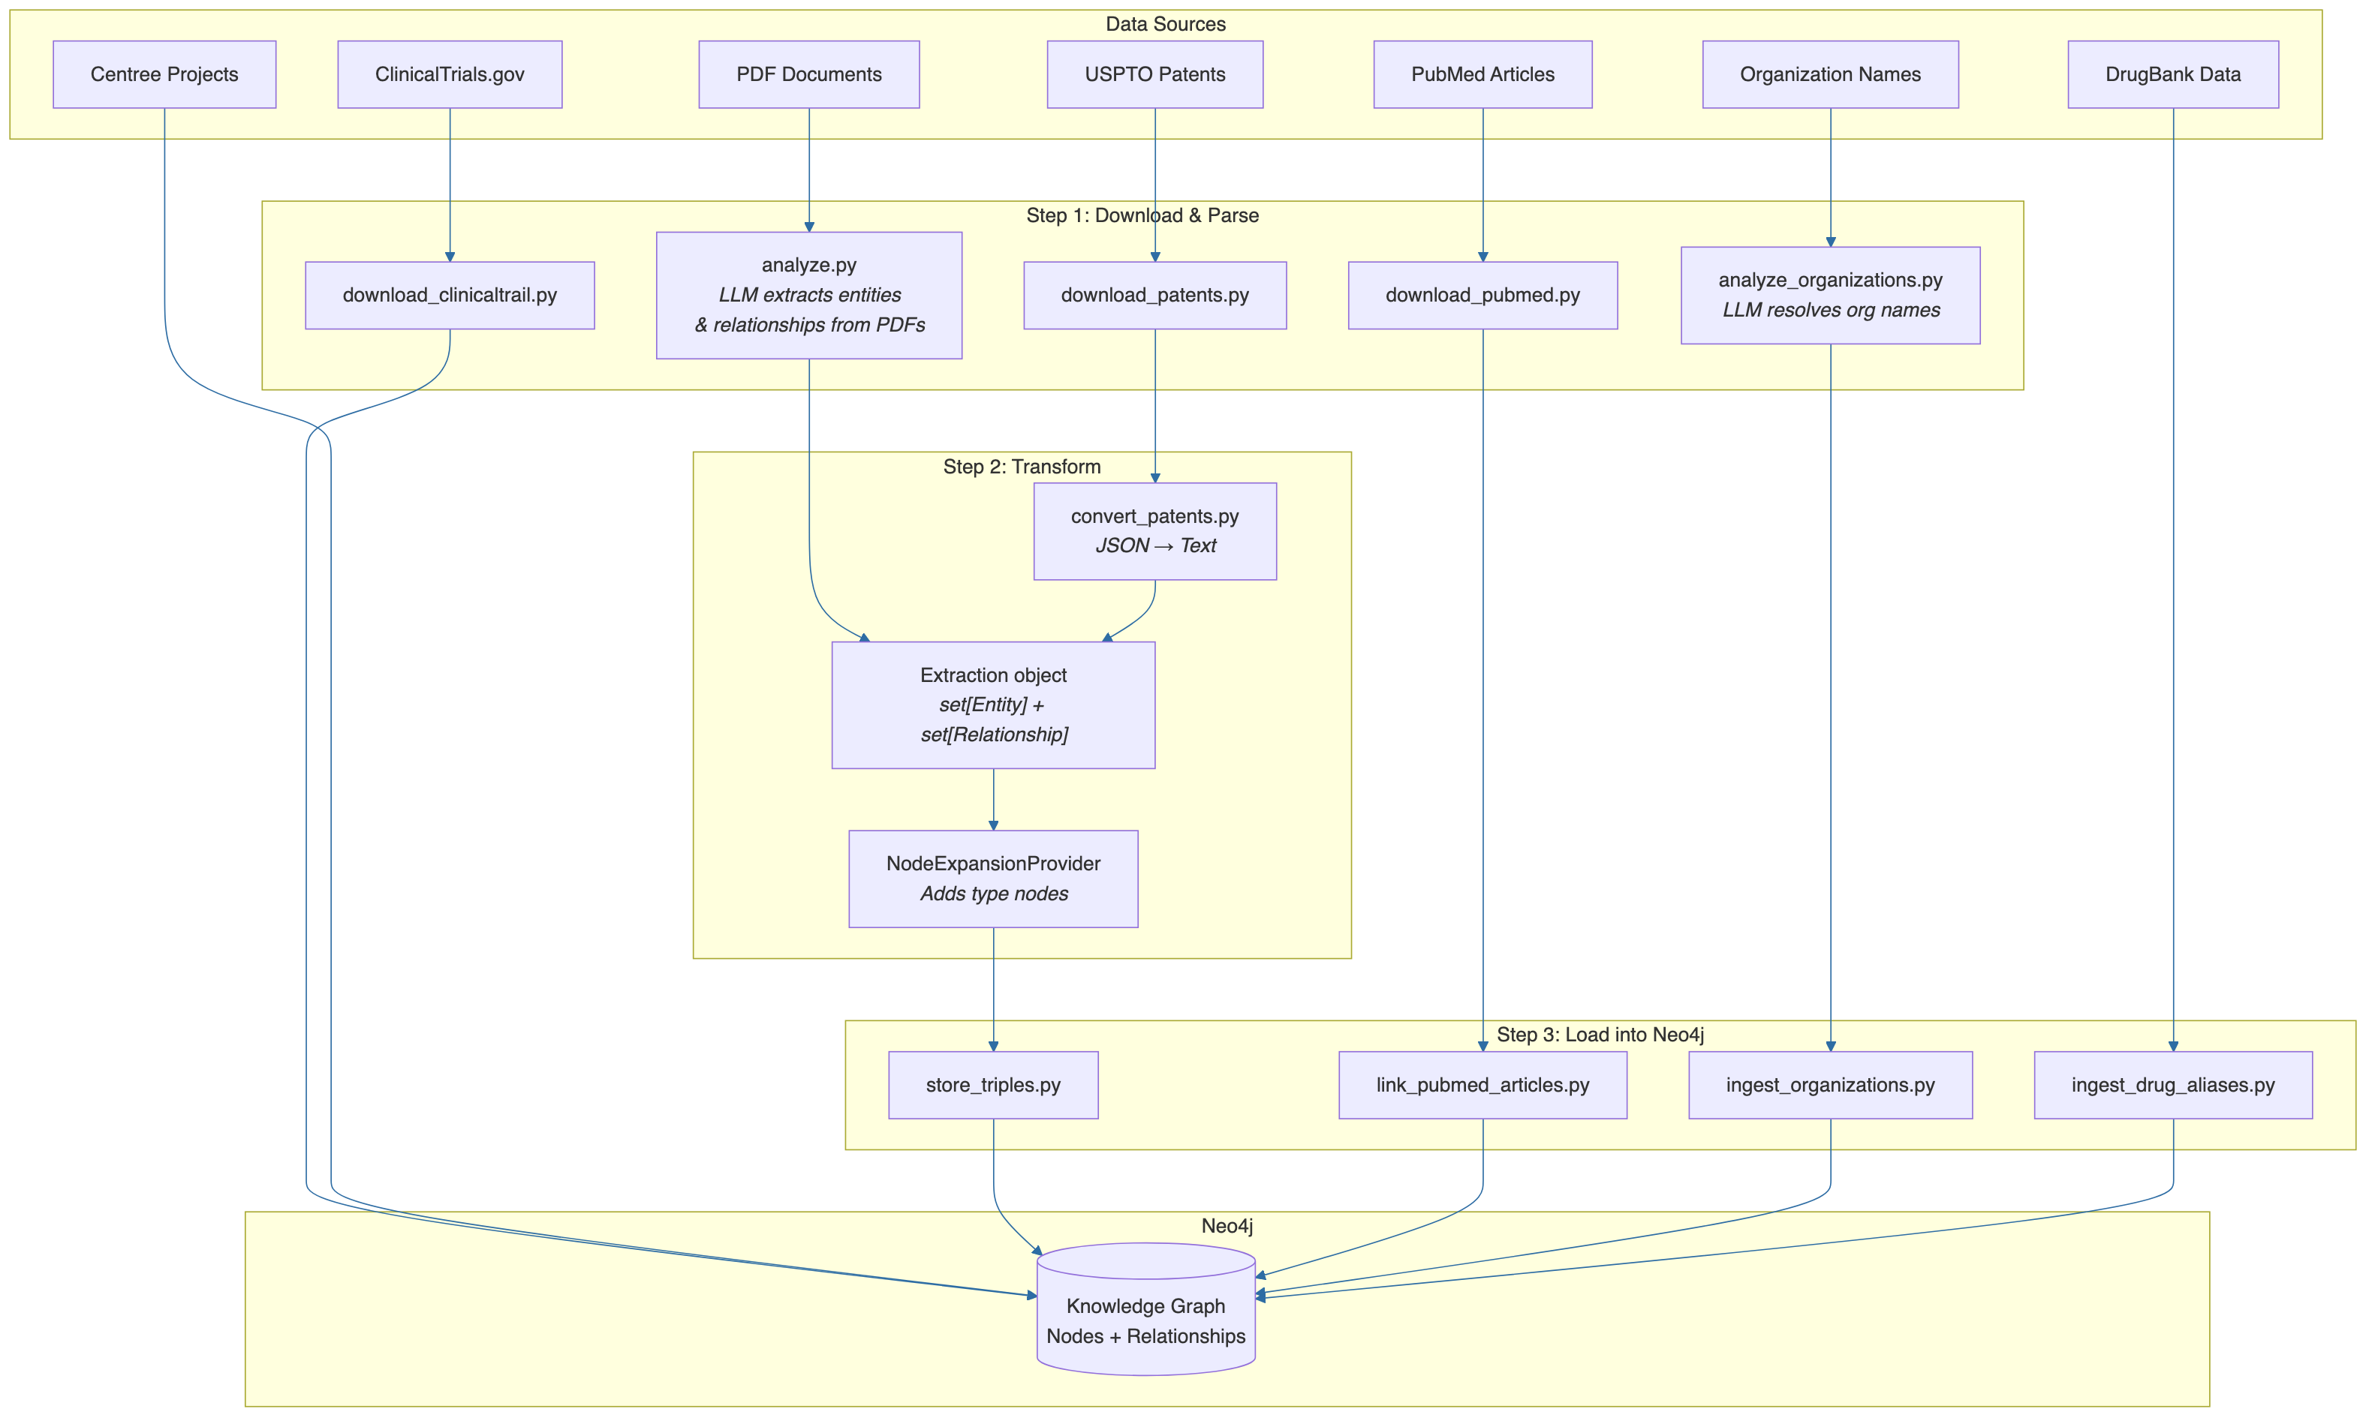
Figure (Mermaid). Data ingestion pipeline (download → transform → load), from DEVELOPER_GUIDE.md §5.
Source | Status | Description
USPTO Patents | Loaded | Patent records, filing dates, assignees
PubMed | Loaded | Journal articles, abstracts, citations
ClinicalTrials.gov | Loaded | Trial records, phases, sponsors
Internal CSL data | Loaded | Proprietary biomedical and deal data
DrugBank | Loaded | Drug mechanisms, indications, status
Organisation DB | Loaded | Pharma / biotech company records

3.2 Graph Scale
The Eugene knowledge graph contains approximately 484,000 nodes organised across nine principal labels and approximately 21 million typed, directed edges. Memory is tuned per environment, with production running 16 GB pagecache and 4–8 GB heap on dedicated EC2.
Node Label | Approx. Count | Key Properties
Drug | 4.6 k | node_id, name, mechanism_of_action, status, aliases
Disease | 17.1 k | node_id, name, icd_code, mesh_id, synonyms
GeneProtein | 27.7 k | node_id, name, hgnc_id, entrez_id, symbol
ClinicalTrial | 49.3 k | node_id, nct_id, title, phase, status, sponsor
Patent | 50 k + | patent_id, title, filing_date, grant_date, assignee
Organization | 26.1 k | node_id, name, hq_country, org_type, aliases
Publication | 100 k + | node_id, pmid, title, journal, publication_date
Annotation | — | source, text_span, confidence
Therapeutic Area | ~ 500 | node_id, name

3.3 Capability Inventory
- Twenty REST endpoints covering identity, foundation queries, drug/disease/patent/PubMed/organisation domains, similarity, and stats.
- Twelve MCP tools mediating the agent's access to the API: fetch_identity, fetch_by_label, fetch_similar, lookup_node_by_value, fetch_node_details, fetch_drug_aliases, fetch_facts, fetch_node_relationships, fetch_paths, has_reachable_path, find_organization_names, find_organization_assets.
- Two-hop graph traversal with hard-cap (MAX_SUPPORTED_HOPS=2) to prevent fan-out.
- Token-by-token streaming via Server-Sent Events for ChatGPT-class user experience.
- Dual-LLM provider auto-detect (OpenAI GPT-4.1 and Anthropic Claude Sonnet) with one-environment-variable swap.
- Microsoft Entra ID single sign-on plus Eugene-issued HS256 JWT for service-to-service propagation.

Section 3 — Detailed Current-State Architecture

4. High-Level Architecture

4.1 Five-Service Topology
Eugene is composed of five running services arranged in a five-tier microservice architecture, following Domain-Driven Design with hexagonal (ports-and-adapters) layering inside the Core API. The diagram below reproduces the canonical architecture from the Developer Guide.
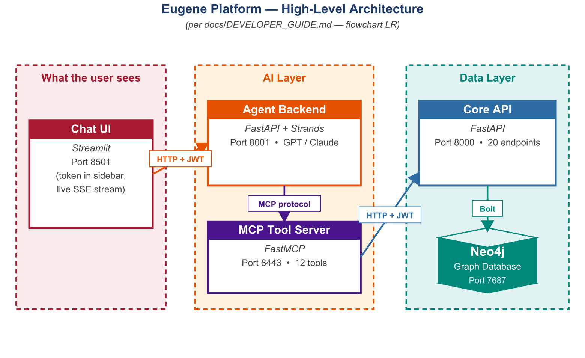
The same architecture is also captured in the developer guide as a Mermaid flowchart, reproduced below verbatim from <font name='Courier'>docs/DEVELOPER_GUIDE.md</font>:
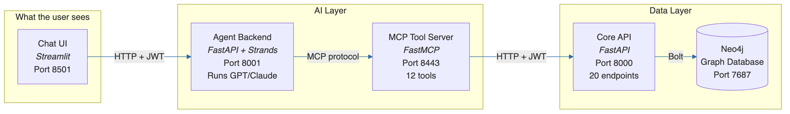
Figure (Mermaid). High-level architecture flowchart, from DEVELOPER_GUIDE.md §2.

4.2 Tier Responsibilities
Tier | Service | Responsibility
Presentation | eugene-agent-ui | User interaction; live token rendering
Agent | eugene-agent-ws | Reasoning loop; tool selection; LLM inference
Tool / Orchestration | eugene-mcp | Schema-validated tool surface; JWT enforcement
Data API | eugene_ws | Canonical graph API; 20 REST endpoints
Persistence | Neo4j 5.26 CE + Milvus | Graph + vector storage

4.3 Technology Stack
The Core API itself is organised by biomedical domain into the following router groups, faithful to the Mermaid graph in the developer guide:
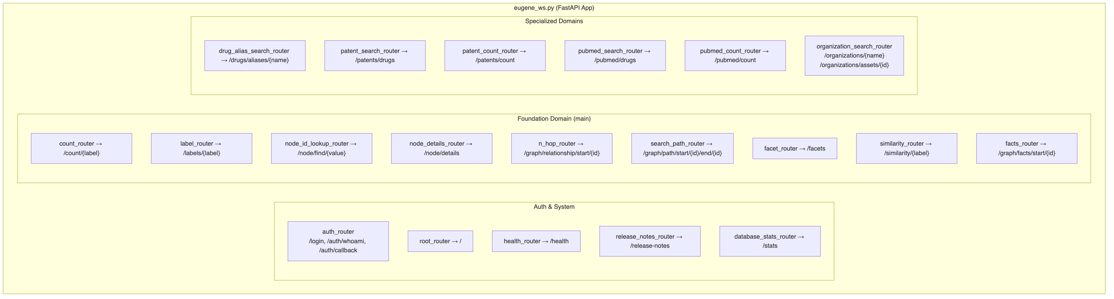
Figure (Mermaid). Core API router groups, from DEVELOPER_GUIDE.md §6.
The stack is intentionally Python-centric end-to-end (3.12 / 3.13), with FastAPI for HTTP services, Strands for the agent loop, FastMCP for the tool surface, Neo4j 5.26 Community Edition with APOC and GDS for the graph, and Milvus for vector similarity. Containerisation is Docker; orchestration is AWS ECS Fargate; infrastructure is Terraform-managed.

5. End-to-End Request Flow

5.1 Sequence Walk-through
When a user submits a question, control flows through every tier of the platform. The diagram below traces the canonical seventeen-step path for the example query "What are the relationships of Hemophilia A?":
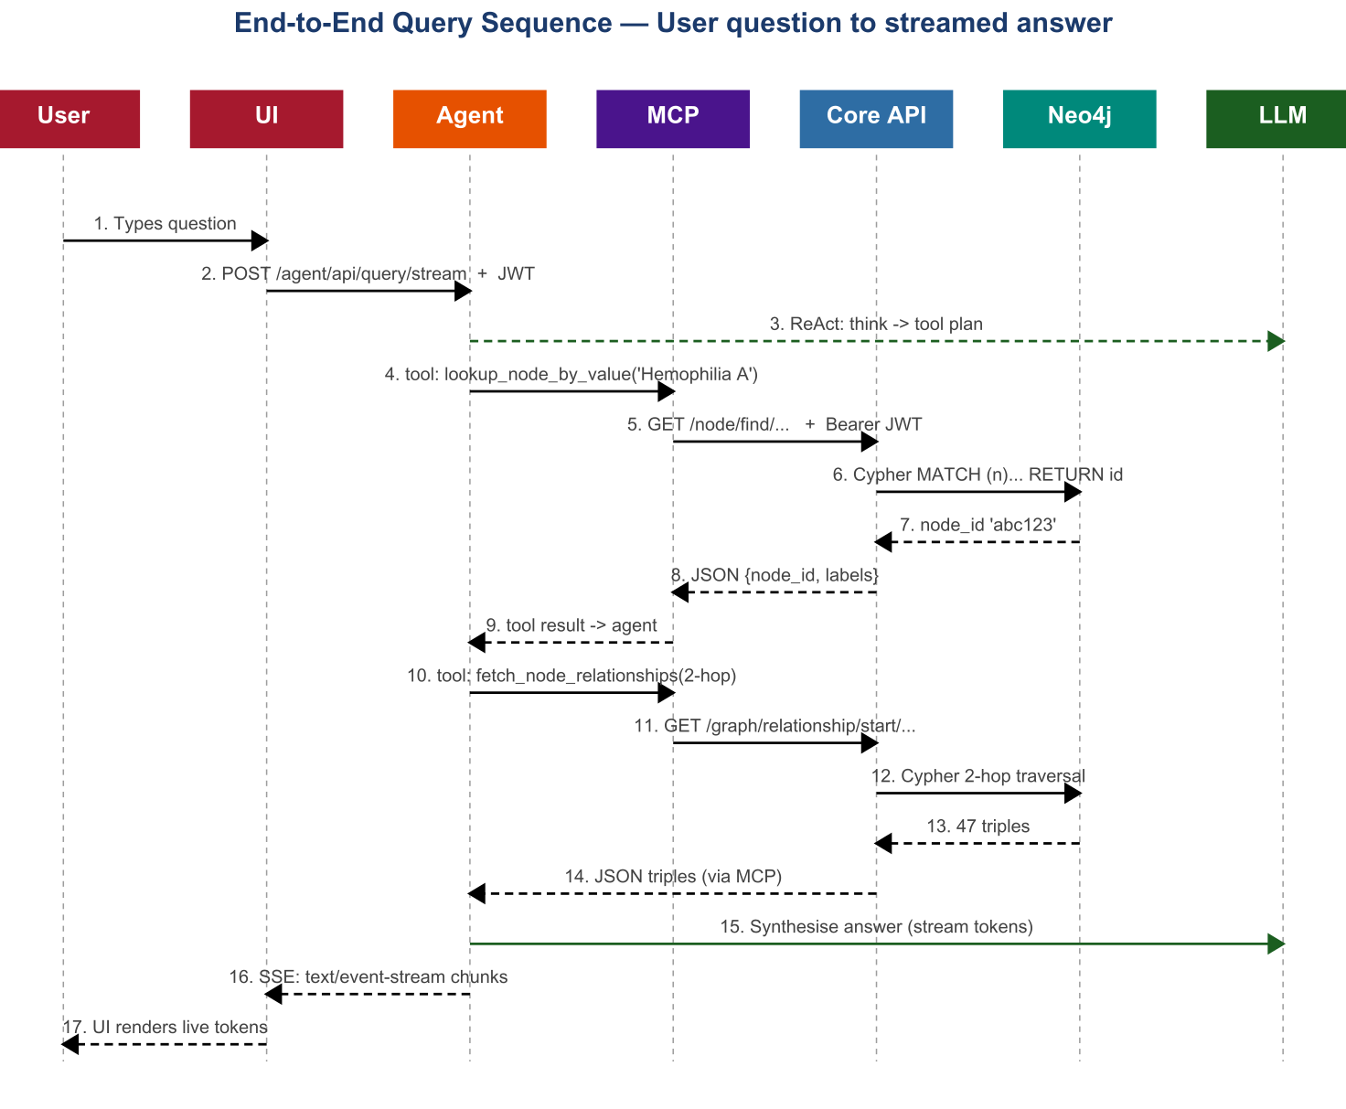
The developer guide records the same flow as a UML sequence diagram, showing the layered DDD pipeline inside the Core API (Router → Orchestrator → Provider → Adapter → Neo4j → mappers):
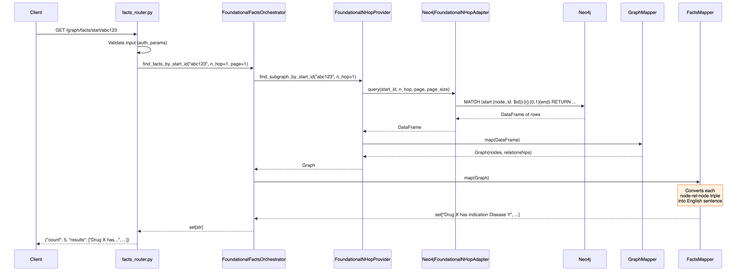
Figure (Mermaid). Request sequence for <i>GET /graph/facts/start/{id}</i>, from DEVELOPER_GUIDE.md §4.

5.2 ReAct Loop Inside the Agent
Inside the Agent Backend, the Strands framework drives a ReAct loop: the LLM reasons (Think), invokes an MCP tool (Act), receives a structured result (Observe), and repeats until it has sufficient evidence or its tool budget is exhausted, at which point it synthesises a streaming answer.
The developer guide expands the same loop into a per-tool flowchart showing how the agent reasons, calls an MCP tool, returns to reason, and ultimately streams the final answer back to the UI:
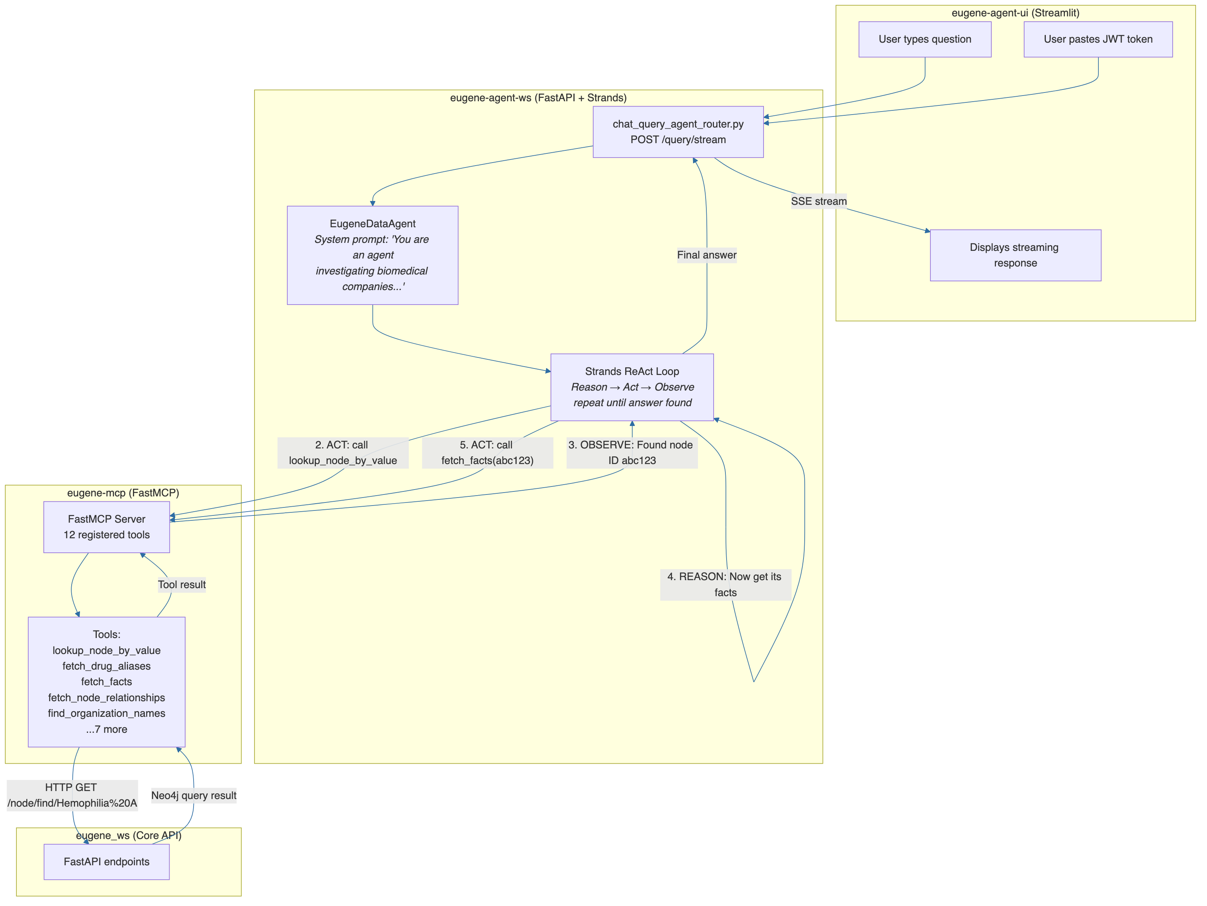
Figure (Mermaid). Agent layer with Strands ReAct loop, from DEVELOPER_GUIDE.md §7.

6. Data Model

6.1 Graph Schema
The graph carries nine principal node labels — Drug, Disease, GeneProtein, ClinicalTrial, Patent, Organization, Publication, Annotation, and Therapeutic Area. Principal relationship types are TARGETS, INDICATES, ASSOCIATED_WITH, OWNS_PATENT_ON, CONDUCTED_BY, STUDIES, PUBLISHED_IN, SYNONYM_OF, and PARENT_OF. All Cypher queries use parameterised binding; no string interpolation appears anywhere in the source.

7. Authentication & Authorisation

7.1 Two-Layer Identity Model
The developer guide describes the same identity flow as a sequence diagram, showing both the local-mode token issue path and the per-request validation path:
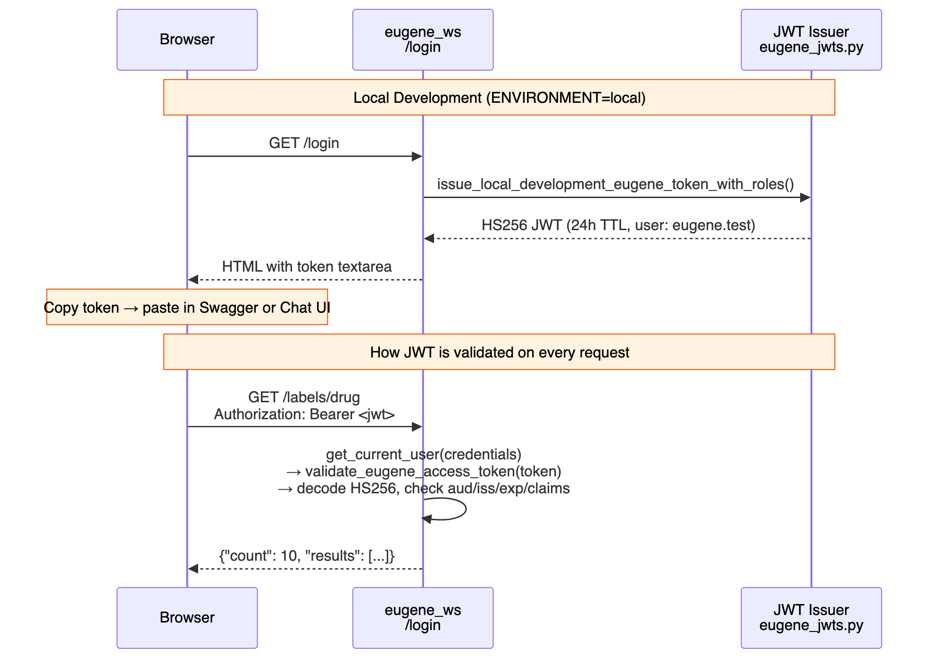
Figure (Mermaid). JWT login and per-request validation, from DEVELOPER_GUIDE.md §11.
Eugene operates a two-layer identity model. Layer 1 is enterprise SSO via Microsoft Entra ID using OAuth 2.0 Authorization Code flow. Layer 2 is an Eugene-issued HS256 JWT that propagates between services. After Entra ID returns an ID token, the Core API issues an Eugene JWT (24-hour TTL) with claims iss = https://eugene.ai.cslg1.cslg.net/{tenant_id}, aud = api://eugene/{client_id}, sub = user UPN, and roles. The same JWT travels with every request from browser to agent, MCP, and Core API; every tier validates signature, audience, issuer, and expiry.

7.2 RBAC Status
Row-level RBAC is not implemented today. The roles claim is present in the JWT but is not enforced inside Cypher. Until Q3 2026, the platform exposes only public data; introduction of patient-derived or commercially sensitive data is gated on RBAC implementation.

8. AWS Deployment Topology
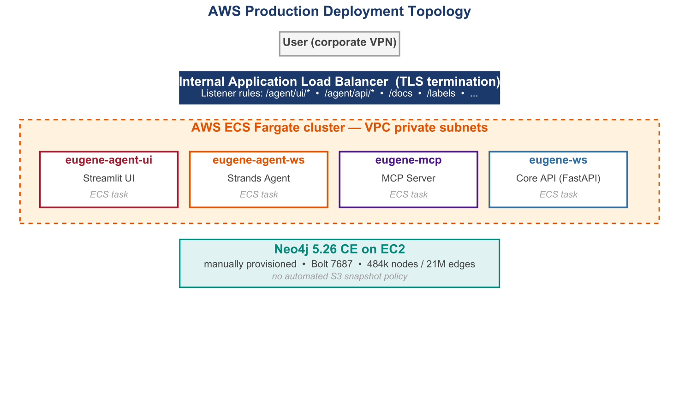

8.1 Environment Matrix
Attribute | Local | Difflabs (Dev) | AIA (Production)
Platform | Docker Compose | AWS ECS Fargate | AWS ECS Fargate
Region | — | us-east-1 | eu-central-1
Account | — | 087084717211 | 010928221940
Auth | Local JWT bypass | Entra ID | Entra ID
Neo4j | Container | ECS task | EC2 (manual)
Secrets | docker.env | Secrets Manager | Secrets Manager
TLS | Disabled | ALB-terminated | ALB-terminated
IaC root | — | difflabs/iac/ | infrastructure/

8.2 CI / CD
Code pushed to the repository triggers pre-commit hooks (Black, Ruff, isort), then GitHub Actions runs unit tests, integration tests against a Neo4j testcontainer, builds the Docker image, pushes to ECR, and runs Terraform plan. Production deployments require a manual approval gate before Terraform apply triggers a rolling ECS update. The developer guide records the same pipeline as a Mermaid flowchart:
Figure (Mermaid). CI / CD pipeline, from DEVELOPER_GUIDE.md §13.

Section 4 — Gaps Identified

9. Audit Outcome
The Stage 1 assessment identified twenty-one findings across security, agent framework, database, and observability domains. Two are CRITICAL, ten are HIGH, and nine are MEDIUM severity. Six positive findings recognise the platform's architectural strengths and are preserved through the recommended remediation programme. Estimated remediation effort to close every CRITICAL and HIGH item is approximately eight weeks of focused engineering work, parallelisable across two to three engineers.

10. Critical Findings
The two CRITICAL findings dominate the first week of the recommended Phase 1 hardening. Both are fixable in a day or less; both should land before any further functional work is committed.
ID | Title | Description | Remediation | Effort
SEC-01 | SSL verification disabled in MCP client | verify=False on httpx; service-to-service traffic vulnerable to MITM. | Set verify=True; pass cert path for self-signed dev certs. | 0.5 day
AGT-01 | Shared SlidingWindowConversationManager — race condition | Single manager shared across agent instances corrupts concurrent sessions. | Instantiate the manager per conversation, not per service. | 1 day

11. High-Severity Findings
Ten HIGH-severity findings span the agent, security, database, and observability domains. Eight are quick wins (half a day to one day each); two require multi-day effort (rate limiting, structured logging). Together they remove the platform's most acute production risks.
ID | Title | Description | Remediation | Effort
AGT-02 | Unbounded ReAct loop | No max_iterations on agent; can cycle indefinitely on tool calls. | Set max_iterations=25 in Agent constructor. | 0.5 day
AGT-03 | No agent execution timeout | Streaming connections held until client times out (~120s). | Wrap stream_async() in asyncio.wait_for(timeout=300). | 0.5 day
AGT-04 | Anthropic LLM client timeout not configured | OpenAI client has 60s timeout; Anthropic has none. | Pass timeout=60.0 to the Anthropic model configuration. | 0.5 day
AGT-05 | python_repl tool always loaded | LLM has access to arbitrary code execution by default. | Make python_repl opt-in; disable in production. | 0.5 day
SEC-02 | Allowlist raises generic Exception | Causes HTTP 500 instead of 403; leaks stack to clients. | Raise HTTPException(status_code=403, detail='Access denied'). | 0.5 day
SEC-03 | No rate limiting on any endpoint | Unlimited concurrent requests; DoS / cost exposure. | Add slowapi: 100 req/min per IP; 10 sessions per user. | 2 days
DB-01 | No Neo4j query timeout | Driver initialised without socket_keepalive or transaction timeout. | Set connection_timeout=30 and max_transaction_retry_time=30. | 1 day
OBS-01 | No structured JSON logging | Plain-text logging incompatible with CloudWatch Logs Insights. | Adopt python-json-logger across all services. | 2 days
OBS-02 | No metrics export | No Prometheus or CloudWatch metrics for application signals. | Add Prometheus client + scrape config; or CloudWatch EMF. | 3 days
OBS-03 | No distributed tracing | No correlation across services; cross-service debugging is forensic. | Integrate OpenTelemetry SDK + AWS X-Ray exporter. | 5 days
OBS-04 | Shallow /health endpoints | Returns OK without checking dependencies. | Add deep checks for Neo4j, MCP, LLM availability. | 1 day

12. Medium-Severity Findings
Nine MEDIUM-severity findings cover token revocation, PII / PHI filtering, connection-pool sizing, deep-pagination caps, file-session robustness, graph statistics, and graph-data freshness. They do not block limited rollout, but they are required for a 100-concurrent-user posture and for the regulatory expectations that follow any introduction of patient-derived or commercially sensitive data.
ID | Title | Description | Remediation | Effort
SEC-04 | No token revocation | No /logout; compromised JWT remains valid until exp. | Redis-backed denylist; expose /auth/logout endpoint. | 3 days
SEC-05 | PII / PHI not filtered | No redaction in prompts or responses; regulatory risk. | AWS Comprehend PII detection middleware on prompts and responses. | 5 days
DB-02 | No explicit Neo4j connection-pool sizing | Pool defaults limit concurrent throughput. | Tune pool_size against load tests. | 0.5 day
DB-03 | No deep-pagination offset cap | Unbounded OFFSET enables slow scans. | Reject OFFSET > 100,000 in pagination utility. | 0.5 day
AGT-06 | FileSessionManager — no recovery, no cleanup | Disk-based sessions; concurrent writes contend; no purge. | fcntl locking now; migrate to DynamoDB / Redis. | 2 days
GRAPH-01 | No graph statistics dashboard | Node / edge counts and growth rate not surfaced. | Add /stats/graph endpoint and a small dashboard. | 1 day
GRAPH-02 | Graph data freshness not tracked | No last_updated on nodes; staleness not detectable. | Add last_updated property; expose in /stats. | 2 days

13. Operational, Data, and Experience Gaps

13.1 Data Loading Gaps
⚑ USPTO patents count is currently zero in production (data deleted, never reloaded). PubMed count is currently zero (partial ingestion abandoned). Therapeutic-area subgroup counts are currently zero. These gaps are documented in the maintenance runbook and addressed in the data-readiness backlog.

13.2 Operational Gaps
- JWT signing-secret rotation is manual; no scheduled rotation.
- Neo4j SSL certificate rotation is manual; expires near year-end.
- Production Neo4j is provisioned manually on EC2; not yet Terraform-managed.
- No automated S3 snapshot policy for Neo4j data.
- No LLM cost instrumentation; per-query token consumption is not tracked.
- API canaries cover only five of twenty Core API endpoints.

13.3 Experience Gaps in the Streamlit UI
- No conversation export (JSON, Markdown, PDF).
- No citation panel or evidence drilldown.
- No graph visualisation; the agent's reasoning trail is opaque.
- No tool-call timeline or agent-decision lineage.
- Limited accessibility primitives; no keyboard shortcuts.
- Poor mobile responsiveness.
- No light / dark theme; no system-prompt templates.

14. Architectural Strengths to Preserve
The audit also surfaced six structural strengths. They are listed here so that the re-platforming work explicitly retains and amplifies them rather than refactoring them away.
Strength | Detail
Clean DDD + Hexagonal Architecture | Domain-driven layering with explicit ports and adapters; testable, swappable, well-named.
Comprehensive Knowledge Graph Ontology | Forty-four node types and thirty-one relationship types unify USPTO, PubMed, trials, drugs, deals.
Dual LLM Provider with Auto-Detect | Anthropic / OpenAI hot-swap on a single env switch; resilience and cost flexibility.
Stateless MCP Server | FastMCP with stateless_http=True; trivially horizontally scalable.
Streaming SSE Architecture | Token-by-token UX; first-token latency drives perceived speed.
Parameterised Cypher; Two-Hop Cap | No injection risk; bounded query cost prevents pathological queries.

Section 5 — Technical Recommendations

15. Next-Generation Target Architecture

15.1 Headline Picture
The next-generation architecture (CSL_Arch_nextGen.pdf) re-imagines Eugene as one specialist agent within a CSL-owned orchestration layer running on AWS Bedrock AgentCore. The diagram below summarises the target state.
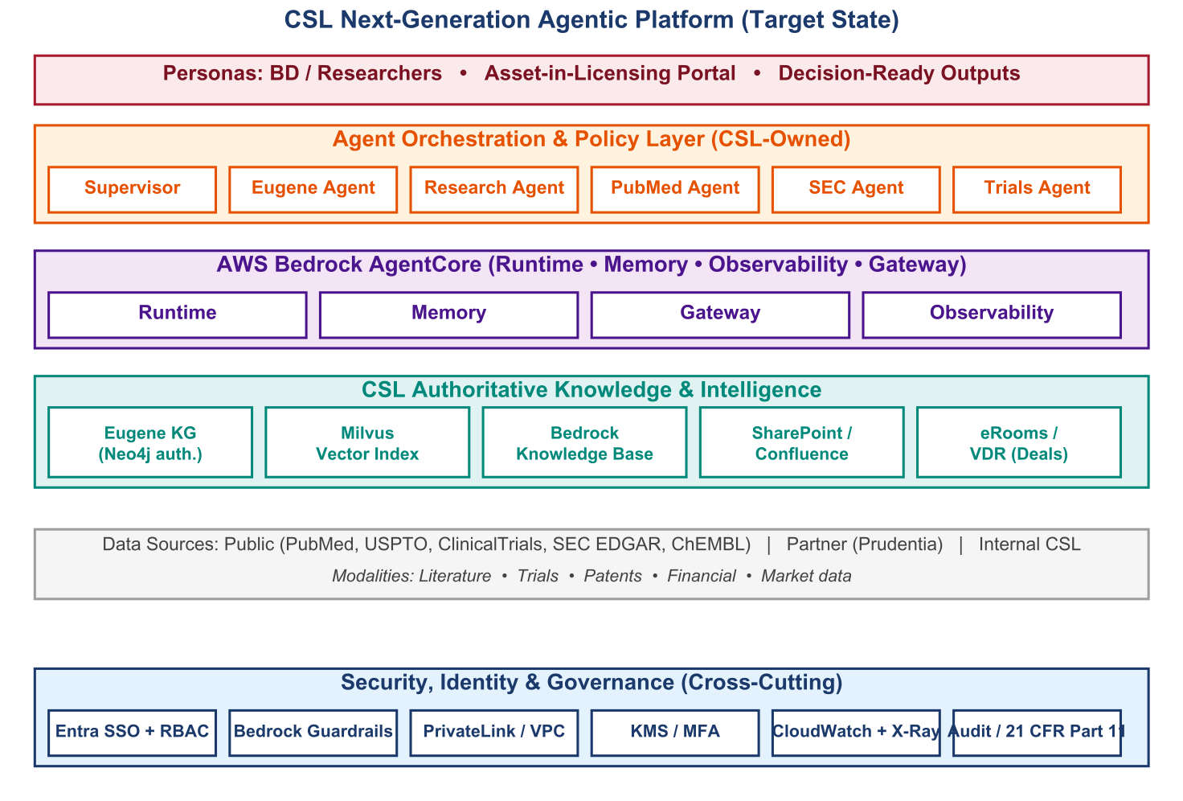

15.2 Research Agent — End-to-End Reference Architecture
The diagram below — sourced from <font name='Courier'>docs/CSL_Arch.drawio.svg</font> — renders the complete CSL-owned Research Agent reference architecture in a single view. It maps every layer of the next-generation platform from the BD / Researcher persona through the CSL-owned orchestration and specialist agents, into AWS Bedrock AgentCore (Runtime, Memory, Observability) and the AgentCore Gateway, across the authoritative knowledge tier (Eugene Knowledge Graph plus dual storage with Milvus indexes and Neo4j embeddings), the CSL data tier (internal tacit knowledge in SharePoint, Confluence, deal memos and IC decisions; controlled-access eRooms / VDRs; external and partner feeds including the Prudentia Sciences platform; and public / licensed sources covering literature, trials, patents, financial and market data), and the cross-cutting Security, Identity and Governance services (Entra SSO, RBAC, security and compliance controls, hybrid cloud / AI runtime, AWS PrivateLink, CloudWatch, X-Ray, KMS, MFA, and Bedrock Guardrails).

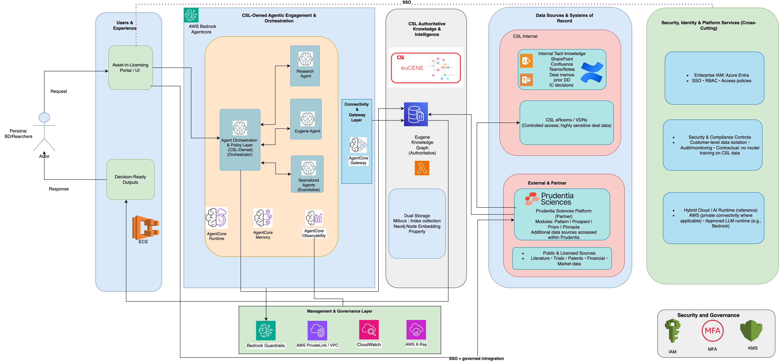
Figure. CSL Research Agent — next-generation reference architecture (rendered from docs/CSL_Arch.drawio.svg).

Three properties of this reference are worth highlighting for stakeholders. First, the Research Agent is one specialist within a CSL-owned orchestration layer — the Eugene Knowledge Graph remains the authoritative structured source, but the architecture admits additional specialists (PubMed, SEC, ClinicalTrials, ChEMBL, and future modalities) without re-platforming. Second, all service-to-service connectivity is mediated through the AgentCore Gateway — a single audit boundary for every agent action. Third, governance is unified: Bedrock Guardrails, customer-level data isolation, and contractual no-training commitments apply uniformly across every specialist, regardless of which underlying LLM is selected.

15.3 Key Shifts From the Current State
- Single agent → Supervisor + five specialists (Eugene, Research, PubMed, SEC, ClinicalTrials, Synthesis). Domain-optimised models and tool sets.
- External LLM APIs → AWS Bedrock as the primary LLM runtime, with Anthropic as fallback. Data residency stays inside the AWS partition.
- File-based sessions → AgentCore Memory (managed) or DynamoDB / ElastiCache. Durability and horizontal scale.
- Graph-only retrieval → Graph + Bedrock Knowledge Base + Milvus + SharePoint / Confluence / eRooms. Eugene becomes the authoritative structured source; unstructured CSL knowledge is retrieved via Bedrock KB; deal-room artefacts via controlled-access policies.
- Basic logging → AgentCore Observability + CloudWatch + X-Ray. Distributed tracing, structured logs, and metrics with unified alerting.
- 12 MCP tools → 16+ tools spanning PubMed, SEC EDGAR, ClinicalTrials, ChEMBL, plus the existing Eugene tool set.
- Implicit governance → Bedrock Guardrails, AWS PrivateLink, KMS, MFA, and 21 CFR Part 11-grade audit logging baked into every agent action.

15.4 Specialist Agent Topology
Agent | Responsibility | Tools | Model
Supervisor | Intent routing, response synthesis | classify_intent, route_to_agent | Claude Sonnet
Eugene Agent | KG queries, relationship traversal | 12 Eugene MCP tools | Claude Sonnet
Research Agent | Free-text research synthesis | search_kb, summarise | Claude Sonnet
PubMed Agent | Literature, citations | search_pubmed, get_article | GPT-4.1-mini
SEC Agent | Filings, M&A, financials | search_sec, get_filing | GPT-4.1-mini
Trials Agent | Trial discovery, protocol | search_trials, get_protocol | GPT-4.1-mini
Synthesis Agent | Cross-source aggregation | All read tools | Claude Sonnet

16. Four-Phase Roadmap

16.1 Phasing
Phase | Weeks | Outcomes
1. Foundation Fixes | 1 – 4 | All CRITICAL + HIGH findings resolved; structured logging; deep /health; rate limiting live.
2. Session & Observability | 5 – 8 | FileSessionManager replaced; OpenTelemetry + X-Ray; PII / PHI middleware; Neo4j S3 backups; first UI cohort delivered.
3. Multi-Agent & New Tools | 9 – 12 | Supervisor + specialist topology; PubMed / SEC / Trials agents; Bedrock as primary LLM; UI cohort 2 delivered.
4. Vector Search & Audit | 13 + | Bedrock Knowledge Base for unstructured KB; freshness tracking; explainability lineage API; UI cohort 3 + accessibility audit.

16.2 Quick Wins versus Strategic Items
Category | Findings | Effort
Quick Wins (0.5 – 1 day) | SEC-01, AGT-01, AGT-02, AGT-03, AGT-04, AGT-05, SEC-02, DB-01, DB-02, DB-03, OBS-04, GRAPH-01 | ≈ 8 days
Strategic (2 – 5 days) | SEC-03, SEC-04, SEC-05, OBS-01, OBS-02, OBS-03, AGT-06, GRAPH-02 | ≈ 23 days

17. User-Experience Enhancement Programme
Fifteen concrete enhancements are sized for delivery inside Phases 2 and 3. They retain the strengths of the current Streamlit chat surface and complete the Next.js v2 implementation that is already underway.
- Conversation snapshot export (JSON / Markdown / PDF).
- Citation and evidence drilldown panel with lineage API.
- Graph mini-map and zoom controls on the canvas.
- Tool-call timeline rendered as a per-turn Gantt.
- Role-based tool hints (read-only / admin-only / PII-risky).
- System-prompt templates: Default Biomedical, Patent Analyst, Clinical Trialist, Competitive Intelligence.
- Evidence drilldown with graph expansion to show cited paths.
- Share and collaborative export with read-only short links.
- Accessibility overhaul (WCAG 2.2 AA).
- Keyboard shortcuts (Cmd+K, Cmd+N, Cmd+E, Cmd+?).
- Light / dark theme toggle synchronised across canvas.
- Mobile-responsive layout (tablet and phone).
- Search history with autocomplete.
- Agent-decision lineage UI ("Why?" button per turn).
- Node-property hover tooltips on the graph canvas.

18. Non-Functional Targets
Dimension | Target
Latency P50 (simple query) | < 2 seconds
Latency P95 (multi-hop) | < 10 seconds
Concurrent agents | 100 sustained
Throughput per service | 1,000 req / minute
Availability | 99.9 % (multi-AZ)
Data residency | Within AWS partition end-to-end
Audit | Per-decision lineage; 21 CFR Part 11-ready
Security posture | Zero trust; gateway + service authn / authz
Accessibility | WCAG 2.2 AA
Mobile experience | Functional on tablet and phone

19. Programme Risks and Mitigations
Risk | Likelihood | Impact | Mitigation
LLM API rate limit under concurrent load | Medium | High | Queueing; exponential backoff; cache frequent queries
Bedrock service availability in eu-central-1 for Phase 3 | Low | High | Cross-region fallback or Anthropic
SEC EDGAR / ChEMBL licensing beyond fair-use | Medium | Medium | Procurement workstream in parallel with Phase 3
Change management on persona workflows | Medium | Medium | Internal champions; phased rollout
JWT secret compromise | Low | Critical | Rotation policy; future RS256
Neo4j data loss | Low | Critical | S3 snapshot policy in Phase 2
Dependency CVE in 175-package requirements | Medium | Medium | pip-audit in CI; Dependabot

20. Recommendation
We recommend proceeding to the four-phase remediation and next-generation roadmap, with the eight-week Phase 1 + Phase 2 security and operational backbone as the first commitment. The platform's architectural strengths — clean DDD layering, comprehensive ontology, dual-LLM resilience, stateless MCP, streaming SSE, and parameterised Cypher — mean that hardening work compounds rather than displaces what already works.
With the recommended investment, Eugene transitions from a credible first-generation internal tool to a strategic CSL asset that materially shortens BD diligence cycles by synthesising structured and unstructured intelligence in a single conversational, governed, auditable surface.

Appendices

Appendix A — Source Documents
- EUGENE_PROJECT_VALIDATION_DOCUMENT.md (v1.0, March 2026).
- EUGENE_STAGE1_ASSESSMENT_REPORT.pdf (April 2026).
- EUGENE_DEVELOPER_GUIDE.md (and the published PDF / DOCX).
- CSL_Arch_nextGen.pdf — next-generation architecture proposal.
- Supporting: oauth.md, entra_id.md, dns.md, csl_aws.md, maintenance.md, terraform.md, docker.md, local_dev_setup.md, ROUTE_DEEP_DIVE.md, EUGENE_PROJECT_EVALUATION.pdf, EUGENE_TECHNICAL_RECOMMENDATIONS.pdf.

Appendix B — Glossary
Term | Meaning
AgentCore | AWS Bedrock managed services for agent runtime, memory, gateway, observability
ALB | Application Load Balancer (AWS)
APOC | Awesome Procedures On Cypher (Neo4j plugin library)
DDD | Domain-Driven Design
ECR / ECS | Elastic Container Registry / Service (AWS)
GDS | Graph Data Science (Neo4j plugin)
HS256 / RS256 | Symmetric / asymmetric JWT signing algorithms
IaC | Infrastructure as Code
MCP | Model Context Protocol — agent tool surface protocol
NCT ID | ClinicalTrials.gov trial identifier
PMID | PubMed unique identifier
PrivateLink | AWS service exposing endpoints inside a VPC
RBAC | Role-Based Access Control
ReAct | Reason–Act–Observe agent pattern
SSE | Server-Sent Events
UPN | User Principal Name (Entra ID identifier)
VPC | Virtual Private Cloud (AWS)

