

Eugene Developer Guide
A Complete Walk-through of the Eugene Codebase — Architecture, Data Flow, Patterns, and Operational Practice

Prepared for: CSL Behring — Business Development & R&D Stakeholders
Programme: Eugene Knowledge Graph & Agentic AI Platform
Date: May 2, 2026
Classification: Confidential — Internal Use Only
Version: 2.0 (Book Edition)

This document is a synthesised, book-format evaluation distilled from the Eugene Project Validation Document, the Stage 1 Assessment & Audit Report, the Developer Guide, and the canonical architecture diagram.

Table of Contents
Right-click and choose 'Update Field' to populate the table of contents.

Eugene Developer Guide
⚑ <b>Start here if you're new to Eugene.</b> This guide walks you through the entire codebase — from the first file to read, through how data flows, to how to add your own features.

Table of Contents
- 1. What is Eugene?
- 2. The 5-Minute Architecture
- 3. Where to Start Reading Code
- 4. How a Request Flows Through the System
- 5. How Data Gets Into Neo4j
- 6. How the API is Built
- 7. How the AI Agent Works
- 8. The DDD Package Pattern
- 9. How to Add a New Feature
- 10. Configuration and Dependency Injection
- 11. Authentication Flow
- 12. Testing
- 13. Deployment
- 14. Complete File Reference

1. What is Eugene?
Eugene is a <b>biomedical knowledge graph</b> that connects drugs, diseases, genes, proteins, clinical trials, patents, and pharmaceutical organizations into a searchable graph database. An <b>AI chat agent</b> lets users ask natural-language questions like "What drugs treat Hemophilia A?" and gets answers by querying the graph.
<b>Tech stack</b>: Python 3.13, FastAPI, Neo4j 5.26, Milvus (vector DB), Strands (agent framework), FastMCP, Streamlit, Docker, Terraform, AWS.

2. The 5-Minute Architecture
Eugene has <b>5 running services</b> connected in a chain:
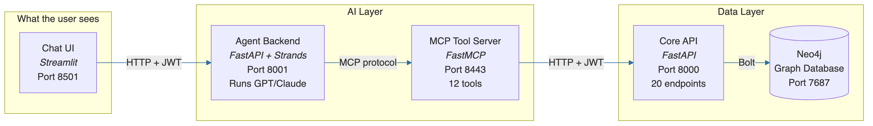
Figure 1. From DEVELOPER_GUIDE.md.
<b>In plain English:</b>
- User types a question in the <b>Chat UI</b> (Streamlit)
- The <b>Agent Backend</b> receives it and uses an LLM (GPT-4.1 or Claude) to reason about it
- The LLM decides to call <b>MCP tools</b> (like <font name='Courier' color='#1B3A6B'>lookup_node_by_value</font>, <font name='Courier' color='#1B3A6B'>fetch_facts</font>)
- Each tool makes an HTTP call to the <b>Core API</b> (<font name='Courier' color='#1B3A6B'>eugene_ws</font>)
- The Core API runs a <b>Cypher query</b> against <b>Neo4j</b> and returns data
- The LLM incorporates the data and generates a human-readable answer

3. Where to Start Reading Code

The Single Most Important File
<b><font name='Courier' color='#1B3A6B'>src/eugene_ws.py</font></b> — This is the spine of the system. Read lines 23-75:
def add_routers(app: FastAPI) -> None:
from router.auth import auth_router
from router import root_router, health_router, release_notes_router
from stats.router import database_stats_router
from foundation.router import label_router as foundation_label_router
from foundation.router import count_router as foundation_count_router
# ... 14 more router imports ...
from organization.router import organization_search_router
routers = [auth_router, root_router, health_router, ...]
for router in routers:
app.include_router(router.router)
Every import tells you a capability. Every router is a REST endpoint group.

Read These 6 Files In Order (30 minutes)
# | File | What you learn
1 | `src/eugene_ws.py` | The entire API surface — all 20 routers
2 | `src/foundation/router/label_router.py` | How an endpoint is defined (simplest example)
3 | `src/foundation/conf/conf.py` | How dependencies are wired (manual DI)
4 | `src/foundation/infra/db/adapter/neo4j_foundational_node_adapter.py` | How Cypher queries hit Neo4j
5 | `src/foundation/mapper/graph_mapper.py` | How Neo4j results become API responses
6 | `src/foundation/provider/foundational_n_hop_provider.py` | How business logic coordinates adapters + mappers

After reading these 6 files, you understand the <b>entire pattern</b>. Every other endpoint follows the same structure.

4. How a Request Flows Through the System

Example: "GET /graph/facts/start/abc123?page=1&page_size=50"
This is the flow when you ask "What are the facts about drug X?":
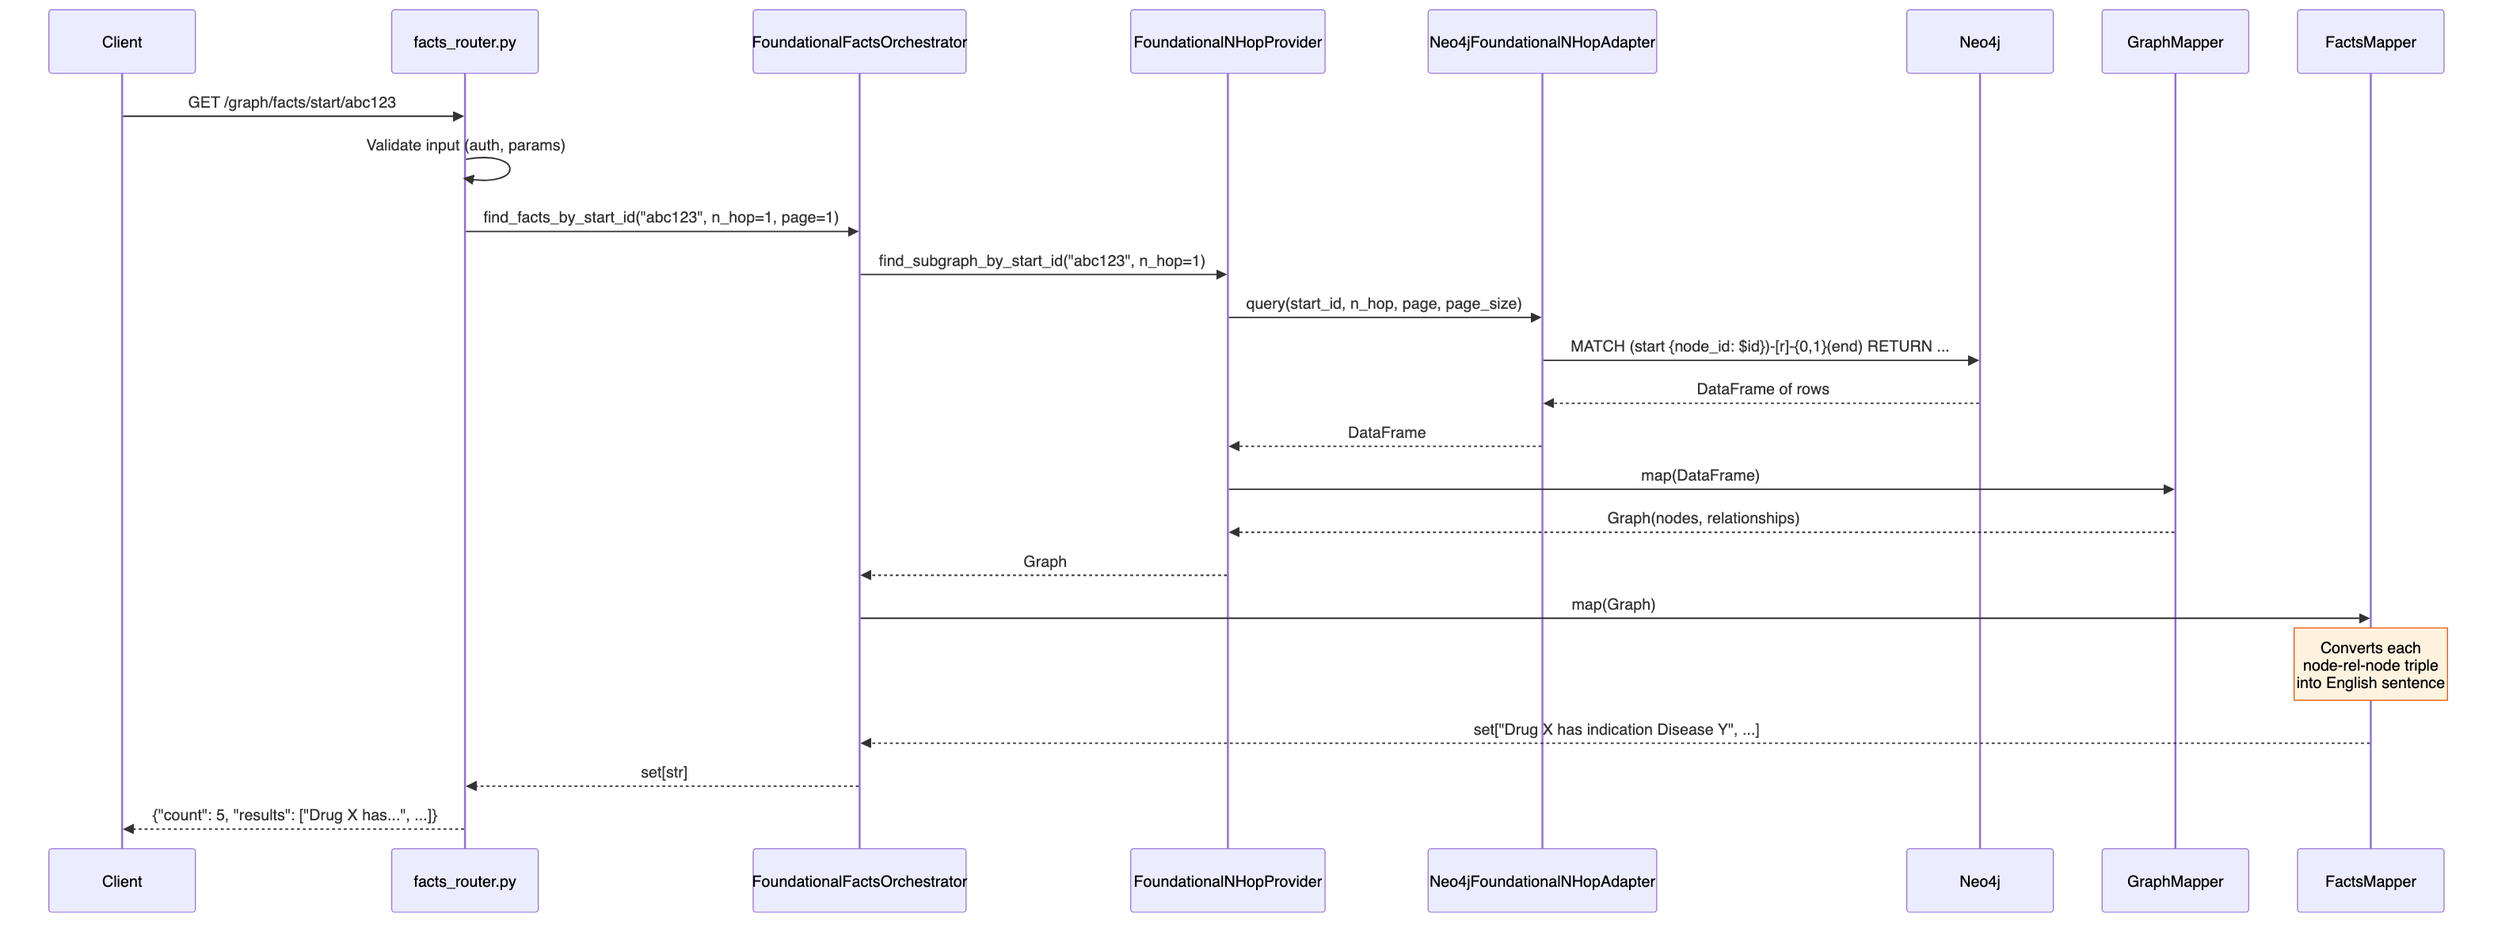
Figure 2. From DEVELOPER_GUIDE.md.

The Layer Cake
Every request goes through these layers, top to bottom:
┌─────────────────────────────────────────────────┐
│ ROUTER (FastAPI endpoint) │
│ File: foundation/router/facts_router.py │
│ Job: HTTP handling, input validation │
├─────────────────────────────────────────────────┤
│ ORCHESTRATOR (composes multiple providers) │
│ File: foundation/provider/*_orchestrator.py │
│ Job: coordinate multi-step workflows │
├─────────────────────────────────────────────────┤
│ PROVIDER (single business operation) │
│ File: foundation/provider/*_provider.py │
│ Job: call adapter, pass to mapper, validate │
├─────────────────────────────────────────────────┤
│ MAPPER (data transformation) │
│ File: foundation/mapper/*_mapper.py │
│ Job: DataFrame → Domain Model → Response │
├─────────────────────────────────────────────────┤
│ ADAPTER (database access) │
│ File: foundation/infra/db/adapter/*.py │
│ Job: build Cypher query, execute, return DF │
├─────────────────────────────────────────────────┤
│ NEO4J (graph database) │
│ Cypher queries against the knowledge graph │
└─────────────────────────────────────────────────┘

5. How Data Gets Into Neo4j

Data Ingestion Architecture
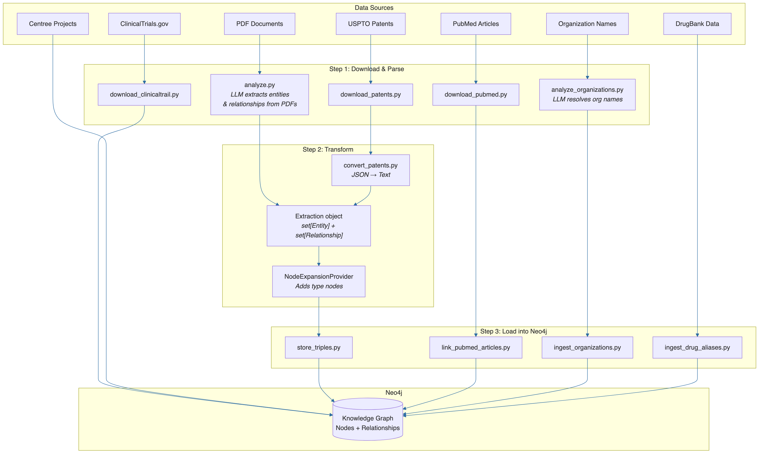
Figure 3. From DEVELOPER_GUIDE.md.

Tracing the Ingestion Code
<b>Start here:</b> <font name='Courier' color='#1B3A6B'>src/store_triples.py</font> — this is the main ingestion entry point:
def main():
driver = GraphDbConnectionFactory.remote_neo4j_instance_from_env()
neo4j_adapter = Neo4jGraphragAdapter(driver, "PubMedRAG")
stored_triples_loader = StoredTriplesLoader()
node_expansion_provider = NodeExpansionProvider()
# Step 1: Load CSV files into Entity + Relationship objects
extraction = stored_triples_loader.load(data_dirs=_data_dirs())
# Step 2: Add type nodes (e.g., a "Protein" type node linked to all proteins)
node_expansion_provider.expand_type_nodes(extraction=extraction)
# Step 3: Write to Neo4j using MERGE queries
neo4j_adapter.ingest(extraction=extraction)
<b>The data model</b> (what entities and relationships look like):
# src/graph/model/entity.py
@dataclass
class Entity:
id: str # unique hash
type: str # "Drug", "Disease", "Protein", etc.
value: str # "Hemophilia A", "Factor VIII", etc.
description: str # "A genetic bleeding disorder..."
# src/graph/model/relationship.py
@dataclass
class Relationship:
id: str # unique hash
source: Entity # from node
target: Entity # to node
relation: str # "indication", "drug_protein", etc.
description: str # "Afstyla treats Hemophilia A"
<b>How it hits Neo4j</b> (the actual Cypher in <font name='Courier' color='#1B3A6B'>neo4j_graphrag_adapter.py</font>):
-- For each relationship, this MERGE query runs:
MERGE (n1:`Drug` { value: "Afstyla", id: "abc", description: "...", type: "Drug" })
MERGE (n2:`Disease` { value: "Hemophilia A", id: "def", description: "...", type: "Disease" })
MERGE (n1)-[rel:`indication` { id: "ghi", type: "indication", description: "..." }]->(n2)
RETURN n1.value, n2.value, rel.type

Neo4j Property Conventions
The API adapters expect specific property names on nodes:
Property | What it is | Used by
`node_name` | Display name of the entity | All search/lookup queries
`node_id` | Unique identifier | All ID-based queries
`value` | Same as node_name (legacy) | GraphRAG ingestion
`name` | Same as node_name (legacy) | Some mappers
`organization_canonical_name` | Organization display name | Organization search
`org_id` | Organization ID | Organization asset queries

6. How the API is Built

The 20 Registered Routers
Each router is a FastAPI <font name='Courier' color='#1B3A6B'>APIRouter</font> registered in <font name='Courier' color='#1B3A6B'>src/eugene_ws.py</font>:
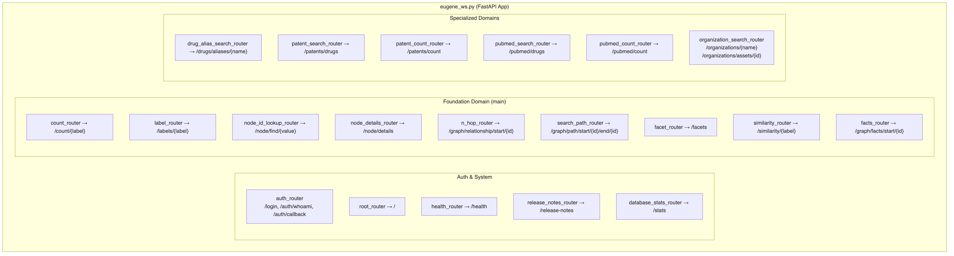
Figure 4. From DEVELOPER_GUIDE.md.

Anatomy of a Router
Every router follows this exact pattern. Here's <font name='Courier' color='#1B3A6B'>label_router.py</font> — the simplest:
# src/foundation/router/label_router.py
router = APIRouter(prefix="", tags=["foundation"])
# Dependency injection via conf.py factory functions
adapter = neo4j_foundational_node_adapter() # ← from foundation/conf/conf.py
@router.get("/labels/{label}")
def labels(
label: str,
page: int = Query(default=1, ge=1),
page_size: int = Query(default=25, ge=1, le=50),
user: dict = Depends(get_current_user), # ← JWT auth required
):
df = adapter.find_by_label(label, page, page_size) # ← Cypher query
return to_id_list_response(df) # ← Transform to JSON
<b>Key points:</b>
- <font name='Courier' color='#1B3A6B'>Depends(get_current_user)</font> enforces JWT authentication
- The adapter is created once at module load via <font name='Courier' color='#1B3A6B'>conf.py</font> factory
- The adapter returns a pandas DataFrame
- A utility function transforms it to the response JSON

7. How the AI Agent Works

Agent Architecture
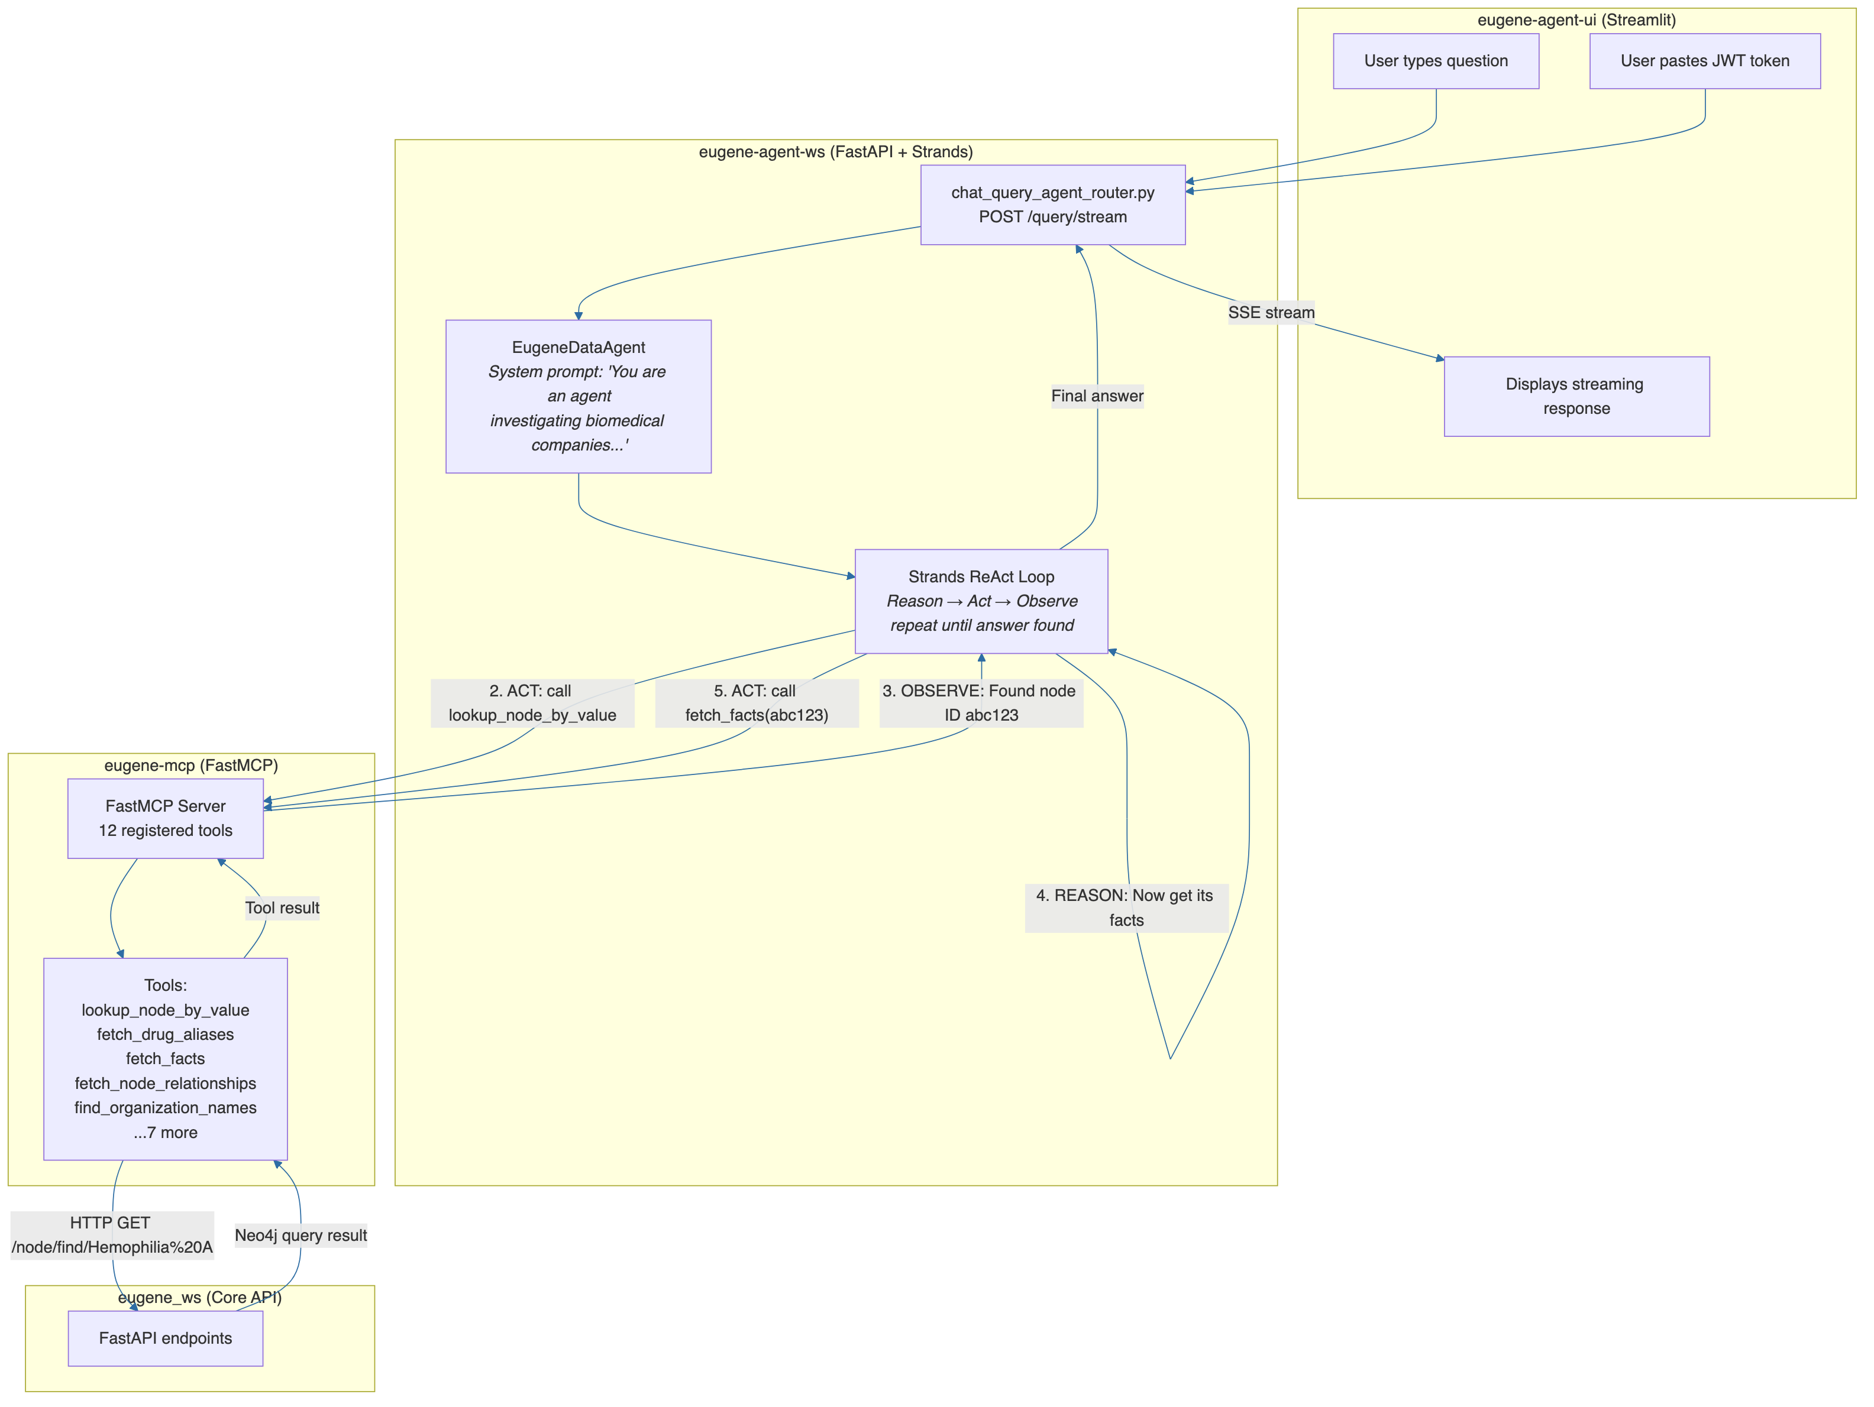
Figure 5. From DEVELOPER_GUIDE.md.

Key Agent Files (read in this order)
# | File | What it does
1 | `agents/eugene-mcp/src/eugene_mcp.py` | MCP server — registers 12 tools
2 | `agents/eugene-mcp/src/tools/eugene_node_tools.py` | Example tool: `lookup_node_by_value`
3 | `agents/eugene-mcp/src/util/request.py` | HTTP client that calls eugene_ws
4 | `agents/eugene-agent-ws/src/query/agent/eugene_data_agent.py` | **The agent** — Strands ReAct pattern
5 | `agents/eugene-agent-ws/src/query/router/chat_query_agent_router.py` | `/query/stream` endpoint
6 | `agents/eugene-agent-ws/src/query/conf/conf.py` | LLM provider selection (OpenAI/Anthropic)
7 | `agents/eugene-agent-ui/src/eugene_agent_ui.py` | Streamlit chat frontend

The 12 MCP Tools
These are the "hands" the AI agent can use:
Tool | What it does | Maps to API
`fetch_identity` | Who am I? (JWT claims) | `/auth/whoami`
`fetch_by_label` | List drugs, diseases, etc. | `/labels/{label}`
`fetch_similar` | Find similar nodes | `/similarity/{label}`
`lookup_node_by_value` | Find a node by name | `/node/find/{value}`
`fetch_node_details` | Get details for node IDs | `/node/details`
`fetch_drug_aliases` | Drug aliases, indications | `/drugs/aliases/{name}`
`fetch_facts` | Relationships as sentences | `/graph/facts/start/{id}`
`fetch_node_relationships` | N-hop graph traversal | `/graph/relationship/start/{id}`
`fetch_paths` | Shortest path between nodes | `/graph/path/start/{id}/end/{id}`
`has_reachable_path` | Can you reach B from A? | `/graph/reachability/start/{id}/end/{id}`
`find_organization_names` | Search org names by pattern | `/organizations/{pattern}`
`find_organization_assets` | Org's drugs, trials, IP | `/organizations/assets/{id}`

8. The DDD Package Pattern
Every domain in <font name='Courier' color='#1B3A6B'>src/</font> follows the same <b>6-folder structure</b>. Learn it once, navigate any domain:
src/foundation/ ← Domain name
├── model/ ← Data classes, enums, Pydantic models
│ ├── foundational_node_enum.py ← 36 node types (Drug, Disease, etc.)
│ ├── foundational_relationship_enum.py ← 27 relationship types
│ └── graph/graph.py ← Graph, Node, Relationship response models
│
├── provider/ ← Business logic
│ ├── foundational_n_hop_provider.py ← N-hop graph traversal
│ ├── foundational_path_provider.py ← Shortest path queries
│ ├── foundational_facts_orchestrator.py ← Composes n-hop + facts mapper
│ └── foundational_node_details_provider.py ← Node detail retrieval
│
├── conf/ ← Dependency injection (factory functions)
│ └── conf.py ← 40+ factory functions wiring everything
│
├── mapper/ ← Data transformation
│ ├── graph_mapper.py ← DataFrame → Graph model
│ ├── facts_mapper.py ← Graph → human-readable fact sentences
│ ├── node_details_mapper.py ← DataFrame → NodeDetails model
│ └── patent_search_result_mapper.py ← DataFrame → PatentSearchResult
│
├── infra/ ← Infrastructure adapters
│ ├── db/adapter/ ← 20 Neo4j adapter classes
│ │ ├── neo4j_foundational_node_adapter.py
│ │ ├── neo4j_foundational_n_hop_adapter.py
│ │ ├── neo4j_drug_aliases_adapter.py
│ │ └── ... (17 more)
│ └── embedding/ ← Embedding generation for vector search
│
├── router/ ← FastAPI endpoints
│ ├── label_router.py ← GET /labels/{label}
│ ├── n_hop_router.py ← GET /graph/relationship/start/{id}
│ ├── facts_router.py ← GET /graph/facts/start/{id}
│ └── ... (14 more)
│
├── load/ ← File loaders (CSV, checkpoints)
└── writer/ ← Output writers (TSV, CSV export)
<b>All 9 domains follow this pattern:</b>
Domain | Package | Key Responsibility
**Foundation** | `src/foundation/` | Core biomedical search (drugs, diseases, genes, paths, similarity)
**Organization** | `src/organization/` | Company name resolution + LLM disambiguation
**Graph** | `src/graph/` | Knowledge extraction, community detection
**Patent** | `src/patent/` | USPTO patent processing
**PubMed** | `src/pubmed/` | PubMed article processing
**TPP** | `src/tpp/` | Target Product Profiles
**Centree** | `src/centree/` | Therapeutic area projects
**ClinicalTrail** | `src/clinicaltrail/` | Clinical trial data
**Document** | `src/document/` | PDF parsing, LLM analysis

9. How to Add a New Feature

Example: Add a "Disease Search by Gene" endpoint

Step 1: Create the adapter (Cypher query)
# src/foundation/infra/db/adapter/neo4j_disease_gene_adapter.py
class Neo4jDiseaseGeneAdapter:
def __init__(self, driver: Driver):
self.driver = driver
def find_diseases_by_gene(self, gene_name: str) -> DataFrame:
query = """
MATCH (g:GENE_PROTEIN {node_name: $gene})-[:disease_protein]-(d:DISEASE)
RETURN d.node_id AS id, d.node_name AS name, g.node_name AS gene
ORDER BY d.node_name
"""
with self.driver.session() as session:
result = session.run(query, gene=gene_name)
return DataFrame(result.data())

Step 2: Wire it in conf.py
# src/foundation/conf/conf.py — add these functions:
def neo4j_disease_gene_adapter() -> Neo4jDiseaseGeneAdapter:
return Neo4jDiseaseGeneAdapter(driver=_neo4j_driver())

Step 3: Create the router
# src/foundation/router/disease_gene_router.py
from fastapi import APIRouter, Depends
from router.auth.auth import get_current_user
from foundation.conf.conf import neo4j_disease_gene_adapter
router = APIRouter(prefix="", tags=["foundation"])
adapter = neo4j_disease_gene_adapter()
@router.get("/diseases/by-gene/{gene_name}")
def diseases_by_gene(
gene_name: str,
user: dict = Depends(get_current_user),
):
df = adapter.find_diseases_by_gene(gene_name)
results = [{"id": r["id"], "name": r["name"]} for _, r in df.iterrows()]
return {"gene": gene_name, "count": len(results), "results": results}

Step 4: Register in eugene_ws.py
# src/eugene_ws.py — add to add_routers():
from foundation.router import disease_gene_router
# ... in the routers list:
routers = [
# ... existing routers ...
disease_gene_router,
]

Step 5 (optional): Add an MCP tool so the agent can use it
# agents/eugene-mcp/src/tools/eugene_disease_tools.py
class EugeneDiseaseTools:
@staticmethod
async def find_diseases_by_gene(gene_name: str) -> dict | str:
"""Find diseases associated with a gene or protein.
Args:
gene_name: gene or protein name, e.g. 'Factor VIII'
"""
token = extract_token()
url = f"{EUGENE_API_BASE}/diseases/by-gene/{gene_name}"
return await make_eugene_request(token=token, url=url)
Register it in <font name='Courier' color='#1B3A6B'>eugene_mcp.py</font>:
register_tools(mcp, [
# ... existing tools ...
EugeneDiseaseTools.find_diseases_by_gene,
])

10. Configuration and Dependency Injection
Eugene uses <b>manual DI</b> — no framework. Each domain has a <font name='Courier' color='#1B3A6B'>conf/conf.py</font> with factory functions.

How it works
# src/foundation/conf/conf.py
# Private: accepts explicit dependencies (for testing)
def _foundational_n_hop_provider(
neo4j_foundational_n_hop_adapter: Neo4jFoundationalNHopAdapter,
graph_mapper: GraphMapper,
) -> FoundationalNHopProvider:
return FoundationalNHopProvider(
neo4j_foundational_n_hop_adapter=neo4j_foundational_n_hop_adapter,
graph_mapper=graph_mapper,
)
# Public: resolves dependencies from environment (for production)
def foundational_n_hop_provider() -> FoundationalNHopProvider:
return _foundational_n_hop_provider(
neo4j_foundational_n_hop_adapter=neo4j_foundational_n_hop_adapter(),
graph_mapper=graph_mapper(),
)
<b>Why two functions?</b>
- <b>Public</b> (<font name='Courier' color='#1B3A6B'>foundational_n_hop_provider()</font>) — used by routers in production; auto-resolves dependencies
- <b>Private</b> (<font name='Courier' color='#1B3A6B'>_foundational_n_hop_provider(...)</font>) — used in tests; you pass mock dependencies directly

Key environment variables
Variable | Purpose
`NEO4J_URI` | Neo4j connection (e.g., `bolt://localhost:7687`)
`NEO4J_USERNAME` / `NEO4J_PASSWORD` | Neo4j credentials
`ENVIRONMENT` | Set to `local` to skip Entra ID OAuth
`EUGENE_CLIENT_SECRET` | JWT signing secret (shared by all services)
`OPENAI_API_KEY` | For GPT models in the agent
`ANTHROPIC_API_KEY` | For Claude models in the agent
`LLM_PROVIDER` | `openai` or `anthropic`
`EUGENE_MCP_SERVER_URL` | MCP server URL for the agent

11. Authentication Flow
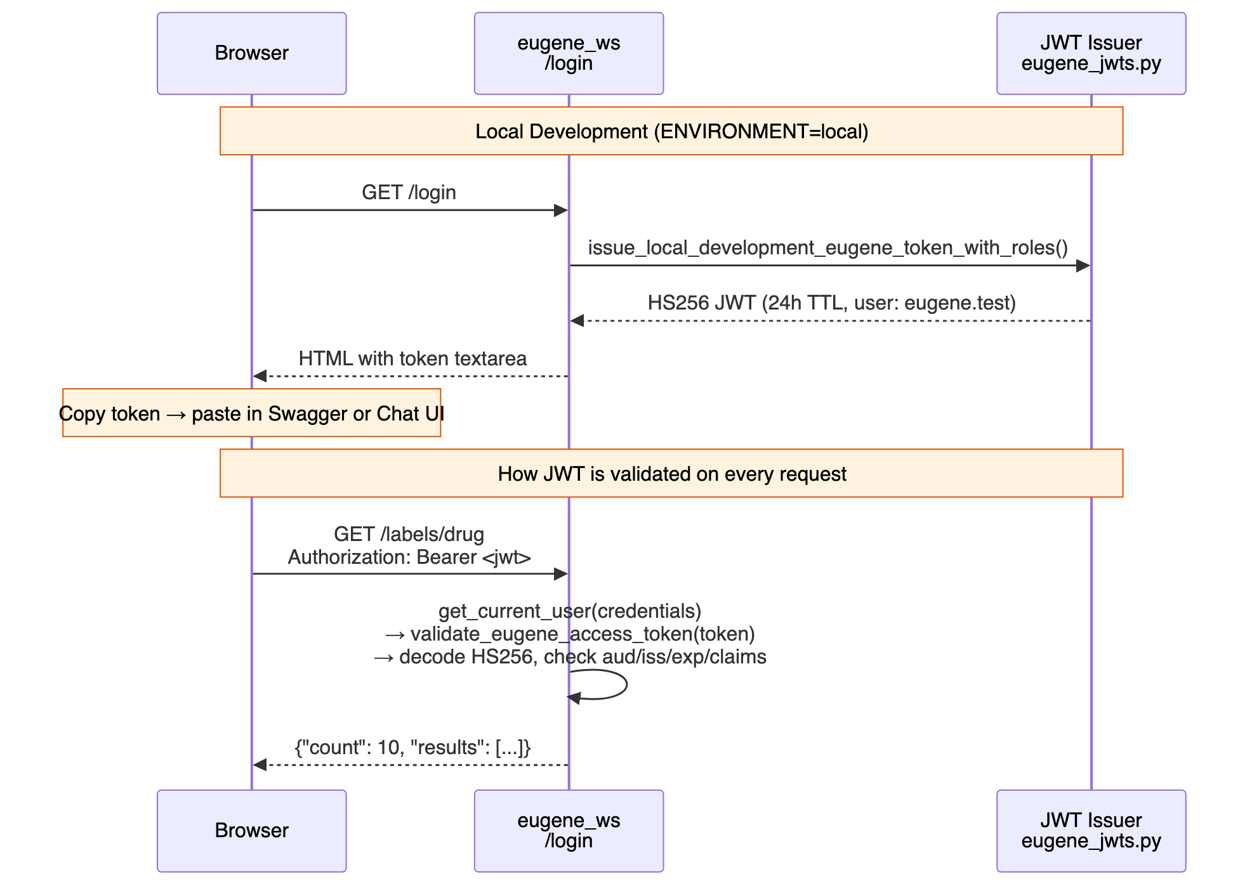
Figure 6. From DEVELOPER_GUIDE.md.
<b>Key files:</b>
- <font name='Courier' color='#1B3A6B'>src/router/auth/auth.py</font> — <font name='Courier' color='#1B3A6B'>get_current_user()</font> dependency (3 lines)
- <font name='Courier' color='#1B3A6B'>src/router/auth/eugene_jwts.py</font> — JWT encode/decode logic
- <font name='Courier' color='#1B3A6B'>src/router/auth/roles.py</font> — <font name='Courier' color='#1B3A6B'>USER_ROLE_MAP</font> (who gets what roles)
- <font name='Courier' color='#1B3A6B'>src/router/auth/const.py</font> — All auth constants from env
<b>Token claims:</b>
{
"iss": "https://eugene.ai.cslg1.cslg.net/{tenant_id}",
"aud": "api://eugene/{client_id}",
"sub": "eugene.test",
"upn": "eugene.test@cslhering.com",
"roles": ["user.public.read"],
"exp": 1711086400
}

12. Testing

Run tests
pytest # All tests, parallel, with coverage
pytest -v # Verbose
pytest src/foundation/mapper/ # One package
pytest -k "test_graph" # By name pattern

Test conventions
- Tests are <b>colocated</b>: <font name='Courier' color='#1B3A6B'>graph_mapper.py</font> → <font name='Courier' color='#1B3A6B'>graph_mapper_test.py</font> (same directory)
- Shared fixtures in <font name='Courier' color='#1B3A6B'>conftest.py</font> per package
- Test data in <font name='Courier' color='#1B3A6B'>tests/data/</font> (JSON fixtures)
- Parallel execution via <font name='Courier' color='#1B3A6B'>pytest-xdist</font> (<font name='Courier' color='#1B3A6B'>-n 2</font>)

Config (.pytest.ini)
[pytest]
minversion = 7.0
addopts = -n 2 --cov=src --cov-report=lcov:reports/coverage/lcov.info
log_cli = true
log_cli_level = INFO
markers =
serial: Run serially
integration: Integration tests

13. Deployment

Local (Docker Compose)
cp docker.env.template docker.env # Fill in credentials
docker compose up --build -d # Start all 5 services
Services at: Neo4j <font name='Courier' color='#1B3A6B'>:17474</font>, API <font name='Courier' color='#1B3A6B'>:18000</font>, MCP <font name='Courier' color='#1B3A6B'>:18443</font>, Agent <font name='Courier' color='#1B3A6B'>:18001</font>, UI <font name='Courier' color='#1B3A6B'>:18501</font>

Production (CI/CD)
Figure 7. From DEVELOPER_GUIDE.md.
Environment | Branch | AWS Account | Region
difflabs (dev) | Manual | 087084717211 | us-east-1
AIA (prod) | `qa`/`main` | 010928221940 | eu-central-1

14. Complete File Reference

Directory Map
src/
├── eugene_ws.py ★ START HERE — FastAPI app, registers all routers
├── fetch_secrets.py AWS Secrets Manager → .env
├── helper.py Env loading helpers
│
├── router/auth/ Authentication
│ ├── auth.py ★ get_current_user() — the auth dependency
│ ├── auth_router.py /login, /auth/whoami, /auth/callback
│ ├── eugene_jwts.py ★ JWT issue + validate (HS256)
│ ├── entra_id_jwts.py Entra ID token handling (RS256)
│ ├── roles.py USER_ROLE_MAP — who gets what access
│ ├── conf.py MSAL + env var loading
│ └── const.py All auth constants
│
├── foundation/ ★ MAIN DOMAIN — start reading here
│ ├── conf/conf.py ★ 40+ factory functions (DI wiring)
│ ├── model/ Domain models
│ │ ├── foundational_node_enum.py ★ All 36 node types
│ │ └── foundational_relationship_enum.py ★ All 27 relationship types
│ ├── router/ 17 FastAPI routers
│ │ ├── label_router.py ★ Simplest router — read first
│ │ ├── n_hop_router.py Graph traversal
│ │ ├── facts_router.py Facts as sentences
│ │ └── ...
│ ├── provider/ Business logic
│ │ ├── foundational_n_hop_provider.py ★ Core provider pattern
│ │ ├── foundational_facts_orchestrator.py ★ Orchestrator pattern
│ │ └── ...
│ ├── mapper/ Data transformation
│ │ ├── graph_mapper.py ★ DataFrame → Graph
│ │ ├── facts_mapper.py Graph → English sentences
│ │ └── ...
│ └── infra/db/adapter/ 20 Neo4j adapters
│ ├── neo4j_foundational_node_adapter.py ★ Node lookup queries
│ ├── neo4j_foundational_n_hop_adapter.py N-hop Cypher queries
│ └── ...
│
├── organization/ Org name resolution
│ ├── analyzer/ LLM-based analysis
│ ├── provider/ Multi-pass merge orchestrators
│ └── router/organization_search_router.py /organizations/* endpoints
│
├── graph/ Knowledge extraction
│ ├── model/entity.py ★ Entity dataclass
│ ├── model/relationship.py ★ Relationship dataclass
│ ├── model/extraction.py Container: set[Entity] + set[Relationship]
│ ├── infra/db/neo4j_graphrag_adapter.py ★ MERGE queries for ingestion
│ └── community/ Community detection
│
├── infra/ Cross-cutting infrastructure
│ ├── llm/llm_factory.py ★ LLM singletons (Ollama/Bedrock/OpenAI)
│ ├── embedding/ Embedding providers
│ └── db/graph_db_connection_factory.py ★ Neo4j connection factory
│
├── [25 CLI scripts] Data pipeline entry points
│ ├── store_triples.py ★ Main ingestion script
│ ├── ingest_organizations.py Load orgs into Neo4j
│ ├── analyze_organizations.py LLM org disambiguation
│ └── ...
│
agents/
├── eugene-mcp/src/ MCP Tool Server
│ ├── eugene_mcp.py ★ Server entry, registers 12 tools
│ ├── tools/ 7 tool classes
│ │ ├── eugene_node_tools.py ★ lookup_node_by_value, fetch_node_details
│ │ ├── eugene_drug_tools.py fetch_drug_aliases
│ │ ├── eugene_graph_tools.py fetch_relationships, fetch_paths
│ │ ├── eugene_organization_tools.py find_org_names, find_org_assets
│ │ └── ...
│ └── util/request.py ★ HTTP client for eugene_ws API
│
├── eugene-agent-ws/src/ Agent Backend
│ ├── eugene_chat_ws.py FastAPI entry point
│ ├── query/agent/eugene_data_agent.py ★ THE AGENT — Strands ReAct
│ ├── query/router/chat_query_agent_router.py /query, /query/stream
│ ├── query/conf/conf.py ★ LLM provider selection
│ ├── query/infra/llm/llm_factory.py OpenAI + Anthropic model factories
│ └── query/model/ Request/response/metrics models
│
├── eugene-agent-ui/src/ Streamlit Chat UI
│ └── eugene_agent_ui.py ★ Full Streamlit app
│
└── mlflow-0/src/ Agent evaluation framework
├── bedrock_eval.py Bedrock evaluation
├── openai_eval.py OpenAI evaluation
├── evaluate/scorers/ Custom MLflow scorers
└── prompt/ Prompt registry

Files marked with ★ are the essential ones to read first.

Quick Reference: "I want to..."
I want to... | Start here
Understand the API | `src/eugene_ws.py` → follow any router import
Add a new endpoint | Copy `src/foundation/router/label_router.py` as template
Add a new Neo4j query | Create adapter in `src/foundation/infra/db/adapter/`
Add a new MCP tool | Add method in `agents/eugene-mcp/src/tools/`, register in `eugene_mcp.py`
Change the LLM model | Edit `OPENAI_MODEL_ID` or `ANTHROPIC_MODEL_ID` in `docker.env`
Add a new data source | Create CLI script in `src/`, follow `store_triples.py` pattern
Understand auth | Read `src/router/auth/auth.py` (3 lines) → `eugene_jwts.py`
Add a new user role | Edit `USER_ROLE_MAP` in `src/router/auth/roles.py`
Run tests | `pytest` (parallel, with coverage)
Deploy locally | `docker compose up --build -d`
Deploy to AWS | Push to `qa` or `main` branch → GitLab CI/CD
Debug the agent | Check `docker logs eugene-agent-ws`
See what's in Neo4j | Open `http://localhost:17474`, run `MATCH (n) RETURN n LIMIT 25`

