Creepage distance is determined given the **working RMS voltage, the pollution degree, and the material group.**

The material group is defined by the CTI of the surface. The CTI can be thought of as a resistance that prevents current to flow between conductors. Thus, higher CTI means better protection against failure due to creepage.

I wonder how creepage applies to tracts inside the PCB.

It seems that pollution degree 1 can be assumed when there is no dust or moisture that can come on the PCB. Conformal coating solves this issue.

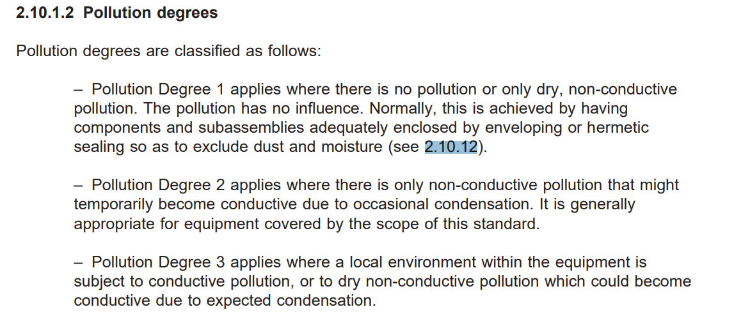

<https://composter.com.ua/documents/IEC60950-1.pdf>

<https://www.techspray.com/the-essential-guide-to-conformal-coating>