D = 0.18 , Vout = 16ishV

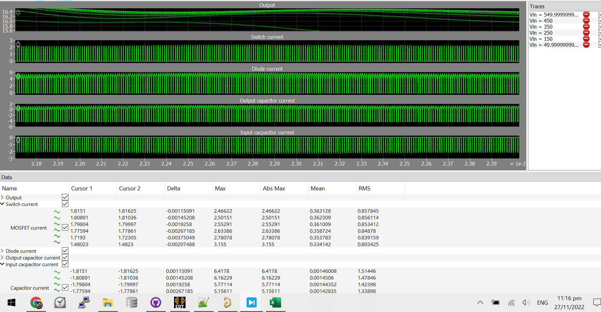

D = 0.25 , Vo = 25ish

