**Project Proposal Due Date:** November 01, 2015

**Name of Application:** Database for Malden Little League

**Author:** Andrew Bielecki

**Final Project Proposal**

**Statement of the problem and purpose of the Project:** The goal of this project is to create a database to help manage the operations of the Malden Little League. This database should provide reports to the board to help with enrollment, filling teams, and tracking players, coaches, equipment, and fields. I have been volunteered for the role of Information Officer on the league board, so this information would be of great value to me

**Scope of the study:** The application will include forms and reports to both enter information in the database and to allow reporting.

The following is a list of tentative forms:

1. Player (add and update).
2. Adult (add, update, and delete[we don't want to stay in touch with a parent removed from a child's life]).
3. Games (add, update).
4. Location(fields) (add, update).

The application will include the following reports:

1. Email lists for all adults, email lists for current players, email lists for eligible but non-enrolled players (players from last year that have not enrolled yet - important for keeping enrollment up).
2. Team rosters.
3. Schedule (sort by division, week, all year etc).
4. Coach CORI status (need to see who hasn't been approved yet).

Other reports include a main menu for the application, with all available options, and a search functionality. There should be more to come as well, still evaluating needs a little bit.

**Methodology:** The data structure required for this project is known to me as member of the Little League board. I will use the information to design the database. Actual names, phone numbers, and addresses will be generated through a random data generator

**Original Work:** I hereby certify that this project was prepared especially for this course. I will be submitting a related project for CSCI E-15 this semester. The CSCI E-15 project will be a redesign of the public facing webpage for the League. That project will use some similar tables to populate pages on the site (team rosters, schedule information) but will be rewritten in MySQL with a website written using Laravel. This project will be written for Oracle and ColdFusion and will contain backend information for use by the league and would not be public facing.

I have cleared this with both my CSCI E-15 instructor and the instructor for CSCI E-60. Please see attached emails.

**Prototype:** Enclosed to this report the reader will find the data model and the record diagrams.

## FULL DATA MODEL

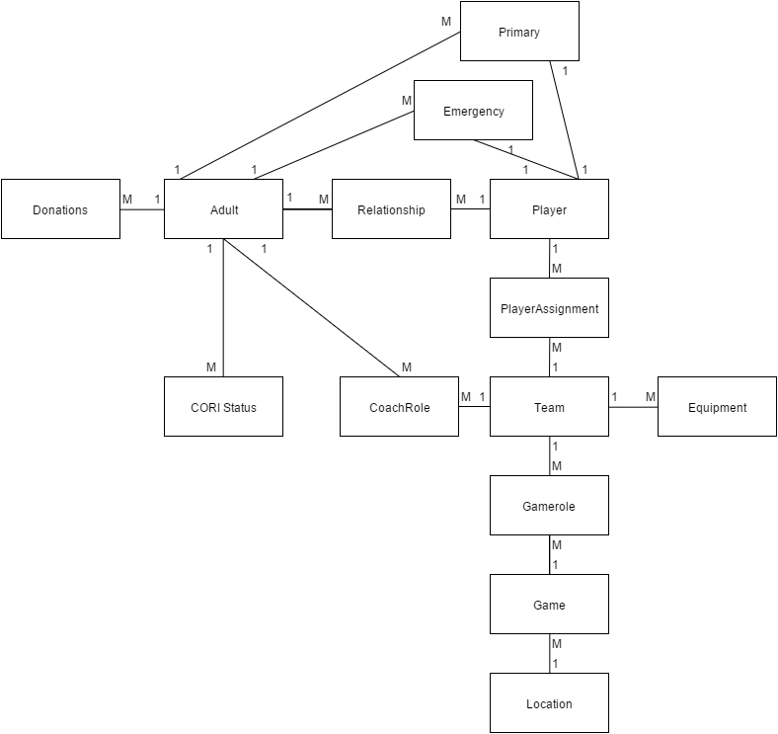

## RECORD DIAGRAMS

|  |  |  |  |  |  |  |
| --- | --- | --- | --- | --- | --- | --- |
|  | PK |  |  |  |  |  |
|  | PlayerID | LastName | FirstName | DOB | Sex |  |
| Player Entity | P00001 | Bielecki | Andrew | 2/16/2011 | M |  |
|  | P00002 | Santillo | Isaac | 11/7/2010 | M |  |
|  | P00003 | Smith | Carter | 10/31/2010 | M |  |
|  |  |  |  |  |  |  |
|  |  |  |  |  |  |  |
|  | PK |  |  |  |  |  |
|  | AdultID | LastName | FirstName | Address | PhoneNum | Email |
| Adult Entity | A00001 | Bielecki | Andrew | 5 Overhill, Malden MA 02148 | 5555555555 | [a@b.c](mailto:a@b.c) |
|  | A00002 | Bielecki | Gillian | 5 Underhill, Malden MA 02148 | 5555555556 | [b@b.c](mailto:b@b.c) |
|  | A00003 | Santillo | Chris | 5 Rainbow, Malden MA 02148 | 5555555557 | [c@b.c](mailto:c@b.c) |
|  | A00004 | Callahan | Colleen | 5 Waterman, Cumberland RI 02864 | 5555555558 | [d@b.c](mailto:d@b.c) |
|  |  |  |  |  |  |  |
|  | PK |  |  |  |  |  |
|  | TeamID | TeamName | Division | Status |  |  |
| Team Entity | TB01 | SeaDogs | Tball | Active |  |  |
|  | TB02 | MuckDogs | Tball | Active |  |  |
|  | TB03 | IronPigs | Tball | Active |  |  |
|  |  |  |  |  |  |  |
|  | PK |  |  |  |  |  |
|  | FieldID | Description | Address |  |  |  |
| Location Entity | Trafton | Trafton Field | Trafton Ave Malden, MA |  |  |  |
|  | Bruce | Bruce Field | Bruce Ave Maldenm MA |  |  |  |
|  | Linden | Linden Field | Linden Ave, Malden, MA |  |  |  |
|  |  |  |  |  |  |  |
|  | PK |  |  |  |  |  |
|  |  | FK |  |  |  |  |
|  | CORINum | AdultID | Year |  |  |  |
| CORI Entity | C00001 | A00001 | 2016 |  |  |  |
|  | C00002 | A00001 | 2015 |  |  |  |
|  | C00003 | A00002 | 2016 |  |  |  |

|  |  |  |  |  |  |  |
| --- | --- | --- | --- | --- | --- | --- |
|  |  |  |  |  |  |  |
|  | PK |  |  |  |  |  |
|  |  | FK |  |  |  |  |
|  | DonationNum | AdultID | Amount | Date |  |  |
| Donation Entity | D00001 | A00001 | 100 | 10/16/2015 |  |  |
|  | D00002 | A00002 | 25 | 10/15/2016 |  |  |
|  |  |  |  |  |  |  |
|  | PK | |  |  |  |  |
|  | FK | FK |  |  |  |  |
|  | AdultID | TeamID | Role | Year |  |  |
| CoachRole Entity | A00001 | TB01 | HeadCoach | 2016 |  |  |
|  | A00002 | TB01 | AssistantCoach | 2016 |  |  |
|  |  |  |  |  |  |  |
|  |  | FK |  |  |  |  |
|  | PK |  |  |  |  |  |
|  | GameID | FieldID | Date | Time | Winner |  |
| Game Entity | G00001 | Trafton | 10/10/2016 | 7PM |  |  |
|  | G00002 | Linden | 10/10/2016 | 7PM |  |  |
|  |  |  |  |  |  |  |
|  | FK |  | FK |  |  |  |
|  | PK | |  |  |  |  |
|  | GameID | Role | Team |  |  |  |
| GameRole Entity | G00001 | Home | TB01 |  |  |  |
|  | G00001 | Away | TB02 |  |  |  |
|  |  |  |  |  |  |  |
|  |  | FK | FK |  |  |  |
|  | PK |  |  |  |  |  |
|  | AssignNum | PlayerID | TeamID | Year |  |  |
| PlayerAssignment | 1 | P00001 | TB01 | 2016 |  |  |
|  | 2 | P00002 | TB01 | 2016 |  |  |
|  | 3 | P00003 | TB01 | 2016 |  |  |
|  |  |  |  |  |  |  |
|  | FK | FK |  |  |  |  |
|  | PK | |  |  |  |  |
|  | AdultID | PlayerID | Relationship |  |  |  |
| Relationship | A00001 | P00001 | Father |  |  |  |
|  | A00002 | P00001 | Mother |  |  |  |
|  | A00004 | P00001 | Grandmother |  |  |  |

|  |  |  |  |  |  |  |
| --- | --- | --- | --- | --- | --- | --- |
|  |  |  |  |  |  |  |
|  | FK | FK |  |  |  |  |
|  | PK | |  |  |  |  |
|  | PlayerID | AdultID |  |  |  |  |
| Emergency | P00001 | A00004 |  |  |  |  |
|  |  |  |  |  |  |  |
|  | FK | FK |  |  |  |  |
|  | PK | |  |  |  |  |
|  | PlayerID | AdultID |  |  |  |  |
| Primary | P00001 | A00002 |  |  |  |  |