BOOKCORPUSBUILDER Operator Manual
The accepted v1.0 workflow
BOOKCORPUSBUILDER Project
2026-08-04

BOOKCORPUSBUILDER Operator Manual
Application version: 0.2.1 (src/bookcorpusbuilder, pyproject.toml)
Architecture status: FROZEN at v1.0 (see docs/GOVERNANCE.md)
Manual status: Current — reflects the application exactly as installed
This manual documents the seven-workspace desktop application exactly as it exists today. Every screenshot in this manual was captured from the real application, driven through its real service layer against disposable practice books — no control described here is imagined, and no control that exists in the application has been omitted because it seemed unimportant.

Contents
- Introduction
- Safety and data integrity
- Starting the application
- Understanding the main window
- Settings
- Library workspace
- Structure Builder — choosing an outline source
- Structure Builder — pasting and parsing an outline
- Structure Builder — reviewing and approving the outline
- Page Alignment — conceptual explanation
- Page Alignment — buttonology
- Page Alignment — step-by-step worked example
- Extraction workspace
- Corpus Browser
- Run History
- Output folders and files
- Scanned PDFs
- Troubleshooting
- Daily operator checklist
- Quick-start guide
- Glossary
- Governance note

Ten-minute workflow
If you only read one page of this manual, read this one.
1. Add PDF (Library)
2. Paste or detect outline (Structure Builder → A. Create Structure)
3. Parse (Parse Preview)
4. Review (Structure Builder → B. Review Outline)
5. Approve (Approve Outline)
6. Map chapter pages (Page Alignment — add anchors)
7. Approve mapping (Verify and approve mapping)
8. Extract (Extract → Extract verified corpus)
9. Search (Corpus Browser)
10. Open source (Corpus Browser → Open source PDF / in-app preview)
Chapters 6 through 15 walk through this sequence in full detail, including every place it can legitimately stop and ask you for a decision. Read those chapters before processing your first real book — the “ten minutes” assumes a book with a clean table of contents and no page-mapping surprises, which is not every book.

1. Introduction

What BOOKCORPUSBUILDER does
BOOKCORPUSBUILDER turns a PDF of a scholarly book into a set of individually addressable, provenance-tracked text sections: one file per chapter or section, plus a machine-readable JSONL file and a manifest, all traceable back to the exact physical page of the exact source PDF they came from.

What it does not do
- It is not a PDF reader. Its built-in preview shows one page of extracted text at a time to support verification, not general reading.
- It is not an OCR tool. It can tell you a PDF is likely scanned; it does not read scanned pages for you (Chapter 17).
- It is not an AI chat application. One workspace (Structure Builder) can optionally call a local Ollama model to propose candidate outline rows, but every proposal is schema-validated and requires human approval before it can affect anything (Chapter 7).

Operator-governed philosophy
Every stage that could silently guess is instead required to stop and ask:
PDF
→ Deterministic parser (finds candidate headings and page numbers)
→ AI candidate (optional, never mandatory)
→ Schema validation
→ Human review and approval
→ Approved outline
→ Human-verified page mapping
→ Extraction
Human verification always overrides automation. Nothing you have not reviewed becomes part of the corpus.

Five things that are easy to confuse
Term | Meaning
PDF | The source file itself. Never modified by this application.
Outline | The list of section titles and printed page numbers you approve.
Page mapping | The verified rule that converts a printed page number into the physical PDF page that actually holds it.
Corpus | The extracted text output of one run: TXT files, one JSONL file, one manifest.
Extraction run | One specific, timestamped execution that produced one corpus. Old runs are never overwritten.

Workflow overview
Library → Structure Builder → Page Alignment → Extract → Corpus Browser → Run History
Settings is not a step in this sequence — it configures where all six other workspaces read and write, and can be opened at any time.

Architecture-freeze status
As of v1.0 the seven-workspace architecture, the outline schema, the page mapping model, and the extraction pipeline are a frozen contract (docs/GOVERNANCE.md). This manual documents that frozen contract. It will not describe features that do not exist yet, and it will be kept in sync as long as the contract does not change.

2. Safety and data integrity
Read this chapter before touching a real book.
- Source PDFs are never modified. Every stage reads the PDF; none of them write to it.
- Approved outlines are hash-bound. Once you approve an outline, its approval record stores the SHA-256 of both the outline file and the source PDF at that moment. If either changes afterward, the application detects the mismatch and blocks extraction rather than silently using stale data.
- Printed pages and physical pages are different things. The number printed at the bottom of a page ("21") and that page’s actual position in the PDF file (its 247th page, say) are frequently not the same number. Chapter 10 explains why and Chapter 11 shows you how to verify the difference for a specific book.
- Page mapping must be approved before extraction can run. The Extract workspace’s preflight check (Chapter 13) will not let you proceed on an unapproved or unresolved mapping.
- Cancelled runs are not promoted. If you cancel an extraction in progress, its temporary output is discarded — no partial run is ever left looking like a completed one.
- Previous completed runs remain intact. Extraction always writes to a new, timestamped run folder (Chapter 15). Nothing you did in a prior run is overwritten by a later one.
- Use a disposable profile for practice or testing. Set the BOOKCORPUSBUILDER_CONFIG environment variable to a throwaway JSON file path before launching (Chapter 3) so your real library, outlines, and corpus are never touched by practice work — this is exactly how every screenshot in this manual was produced.
- Analytical headings are not automatically trustworthy extraction boundaries. A heading detected inside a chapter (e.g. a sub-argument or a thematic aside) is metadata, not a verified section boundary, until its page location has actually been checked.
Never approve a mapping merely because the page numbers look plausible. Verify chapter openings visually, by reading the extracted text preview next to the anchor you are about to add (Chapter 12).

3. Starting the application
Purpose. Launch BOOKCORPUSBUILDER and confirm it started correctly.
Before you begin. You need a terminal and the retained GUI environment at ../BOOKCORPUSBUILDER-gui-venv (a Python virtual environment with PySide6 already installed, kept alongside the project checkout).
Steps.
- Open a terminal.
- Change to the project directory:
- cd /media/ambijat/SOPRANO2/GPT_workflow/BOOKCORPUSBUILDER
- Launch the application using the retained GUI environment:
- ../BOOKCORPUSBUILDER-gui-venv/bin/bookcorpus-gui
- For practice or documentation work only — launch against a disposable profile instead of your real one, so nothing you do here touches your real library or corpus:
- BOOKCORPUSBUILDER_CONFIG=/tmp/bookcorpusbuilder-practice-profile.json \
../BOOKCORPUSBUILDER-gui-venv/bin/bookcorpus-gui
- Close the application normally — from the window’s own close control, or Ctrl+Q/Alt+F4 depending on your desktop environment. Settings and window layout are saved automatically on close.
Expected result. A window titled BOOKCORPUSBUILDER opens, showing the seven-workspace navigation list on the left and the Library workspace selected by default (Figure 1).
Figure 1 — the application immediately after launch.
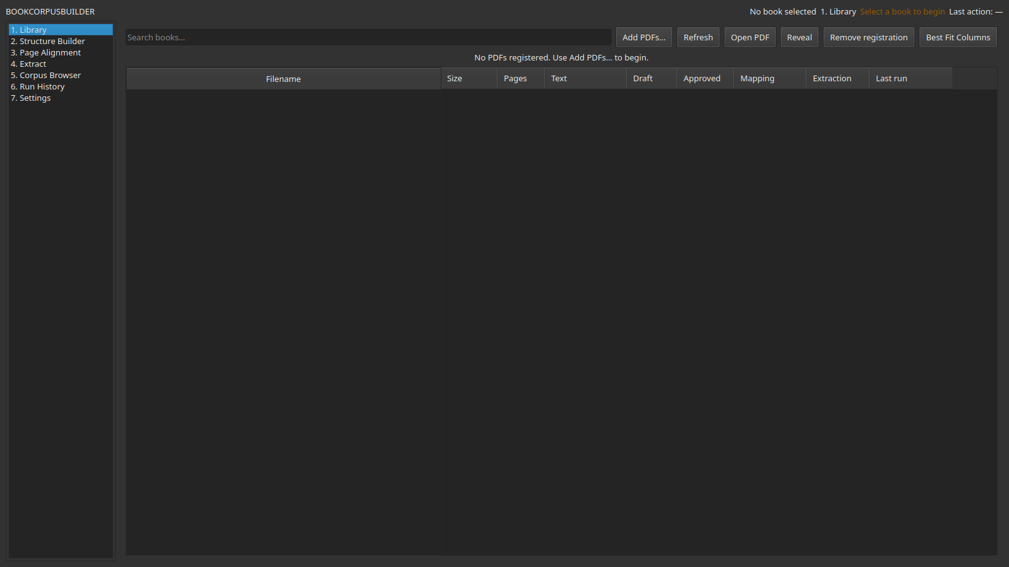
Figure 1: BOOKCORPUSBUILDER immediately after launch, Library workspace selected.
Alt text: BOOKCORPUSBUILDER main window on first launch, showing the seven-item workspace navigation list and an empty Library table.
If images are not available to you, the window layout is: a narrow list of seven workspace names on the left; the active workspace fills the rest of the window; a status line across the top shows which book is currently selected and whether it is ready for extraction.
Alternative launch (equivalent, useful for capturing logs or running under a debugger):
../BOOKCORPUSBUILDER-gui-venv/bin/python -m bookcorpusbuilder.gui.app
Common mistake. Running bookcorpus-gui with the project’s own .venv instead of ../BOOKCORPUSBUILDER-gui-venv. The project’s bundled .venv is a known-broken build environment (see docs/IMPROVEMENT_ROADMAP.md, Phase 1) and is not a supported way to run the GUI.
Recovery. If the command is not found or exits immediately with an ImportError mentioning PySide6, you are using the wrong Python environment — switch to ../BOOKCORPUSBUILDER-gui-venv/bin/bookcorpus-gui exactly as shown above.

4. Understanding the main window
The seven workspaces, in navigation order, are:
- Library — register PDFs and see their overall status at a glance.
- Structure Builder — create and approve a book’s outline.
- Page Alignment — verify printed-to-physical page mapping.
- Extract — run and monitor extraction.
- Corpus Browser — search and inspect extracted output.
- Run History — audit every extraction run, past and present.
- Settings — configure folders and defaults; supports all six workspaces above rather than being a step in the workflow itself.

Shared conventions across every workspace
- Selected-book context. Most workspaces act on “the selected book.” You choose it in Library; the header bar always shows which book (if any) is currently selected.
- Status messages. Actions report their result in the header’s status strip (temporary messages) or directly inside the workspace (validation panels, logs).
- Resizable splitters. Every workspace with a two- or three-pane layout (Page Alignment, Corpus Browser, Structure Builder’s outline review) has a draggable divider between panes. Its position is remembered between sessions.
- Table column resizing, movement, and “Best Fit Columns.” Every table in the application can have its columns dragged wider/narrower or reordered. A Best Fit Columns button is available near most tables to reset column widths to fit their current contents in one click.
- Header right-click menu and Shift-wheel horizontal scrolling. Right- clicking a table’s column header offers a menu to show or hide columns; holding Shift while scrolling the mouse wheel over a wide table scrolls it horizontally instead of vertically.
- Persistent window and column layout. Window size and position, splitter positions, and per-table column widths are all saved automatically and restored the next time you launch the application with the same configuration profile.
Figure 2 — a labelled overview of the main window.
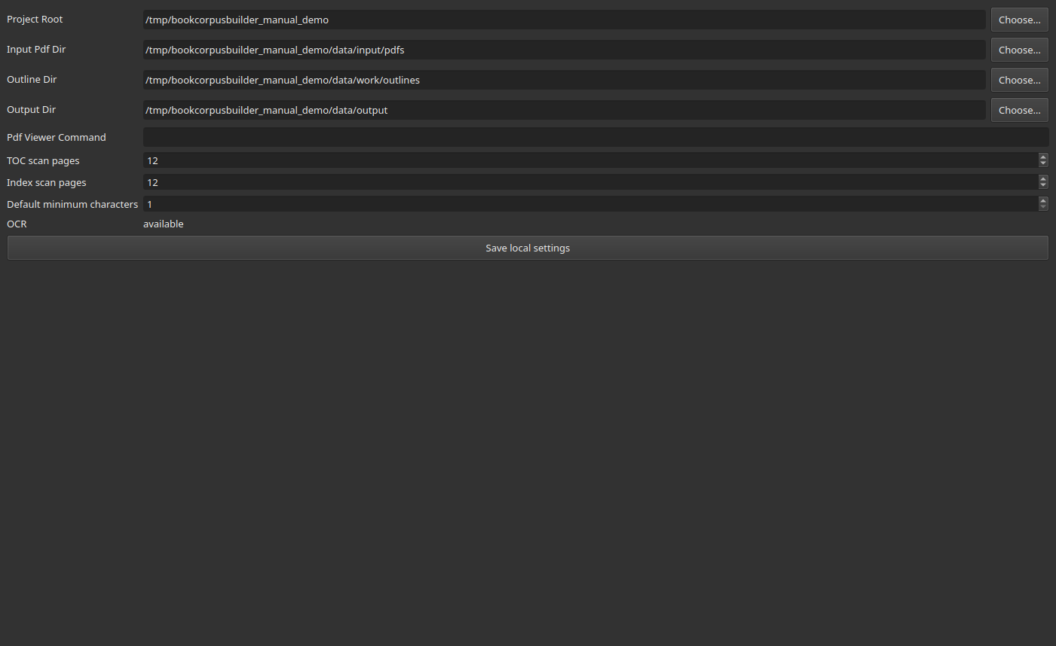
Figure 2: BOOKCORPUSBUILDER main window with the Settings workspace active, showing the navigation list and a populated form.
Alt text: Settings workspace showing folder fields, scan-page settings, and OCR availability.
Callouts for Figure 2:
- Navigation list (left) — the seven workspaces described above.
- Active workspace content (right) — changes completely depending on which workspace is selected; Settings is shown here as an example.
- Each folder field has an inline Choose… button that opens your operating system’s native folder picker.

5. Settings
Purpose. Confirm or change where BOOKCORPUSBUILDER reads PDFs from and writes outlines/corpus output to, and check whether OCR is available on this machine.
Steps.
- Open 7. Settings in the navigation list.
- Project Root — the base folder this configuration profile is anchored to. Changing it does not move any files; it only changes where the application looks next.
- Input Pdf Dir — where PDFs added via Library are copied to.
- Outline Dir — where outline drafts, approvals, and page-mapping records are stored, one JSON/CSV set per book.
- Output Dir — where extraction runs, corpus files, and run-history records are written.
- Use each field’s Choose… button to pick a folder with your operating system’s native dialog, or edit the path text directly.
- OCR shows available or unavailable depending on whether a tesseract binary is found on your system PATH at the moment Settings loads. This is a status indicator only — see Chapter 17 for what it does and does not mean.
- Profile isolation — which settings file is being edited is controlled by the BOOKCORPUSBUILDER_CONFIG environment variable set before launch (Chapter 3). Two terminals launched with two different values of that variable have entirely independent folders, histories, and libraries.
- Click Save local settings to persist your changes and immediately apply them to every workspace.
Figure 3 — the Settings workspace, shown in Figure 2 above.
What should not be changed casually: repointing Input Pdf Dir, Outline Dir, or Output Dir on a profile that already has real books registered effectively disconnects the application from all of that existing data (the paths recorded per book do not move with you). Only repoint these mid-project if you are deliberately migrating storage, and back up the old folders first.
Use a disposable profile for anything experimental. Point BOOKCORPUSBUILDER_CONFIG at a throwaway file, as shown in Chapter 3, before testing settings changes you are not sure about.

6. Library workspace
Purpose. Register PDFs, and see the processing status of every registered book without opening any of the other six workspaces.
Figure 4 — the empty Library workspace, before any book has been added.
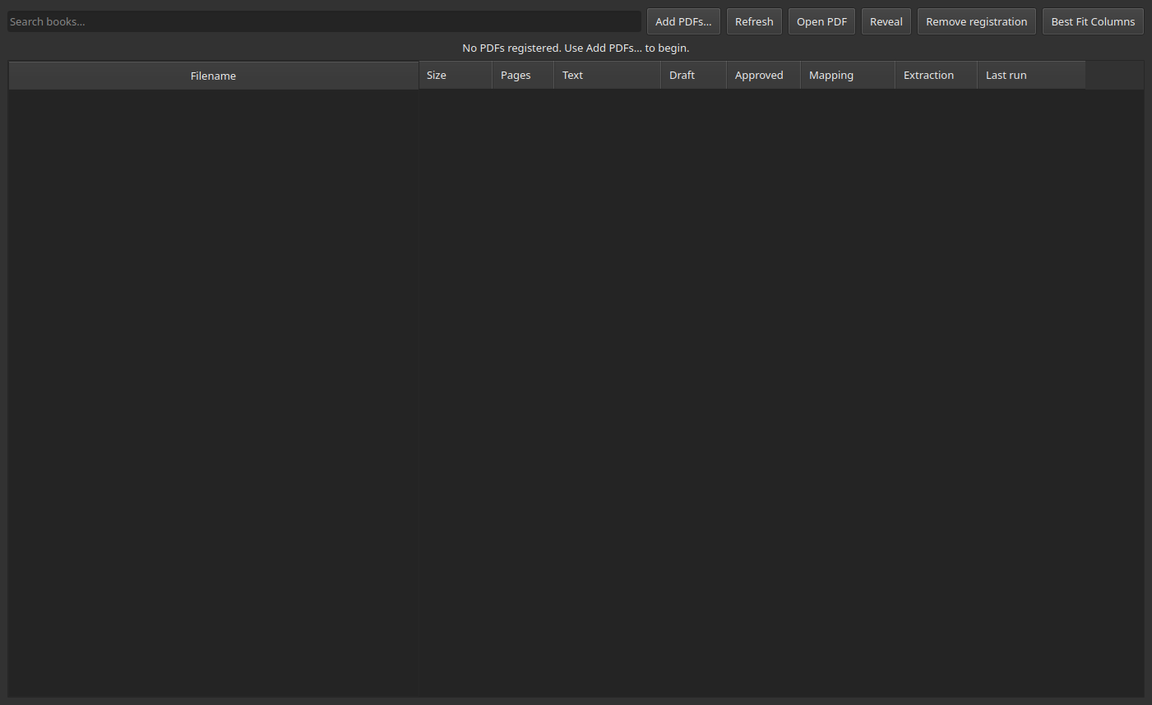
Figure 4: Library workspace, empty state, with the guidance message “No PDFs registered. Use Add PDFs… to begin.”
Alt text: Empty Library table with a centered prompt to add PDFs.
Steps: adding a book.
- Press Add PDFs…. Your operating system’s native file picker opens; select one or several PDF files.
- Each selected PDF is copied into the canonical input folder (Settings → Input Pdf Dir) and registered by its SHA-256 hash.
- Duplicate detection is automatic and by content, not filename. If a file with the same SHA-256 hash is already registered, the add is refused with a message naming the existing registration — the same PDF under a different filename will not create a second entry.
- The table refreshes to show every registered book.
Figure 5 — the Library after three practice books have been added.
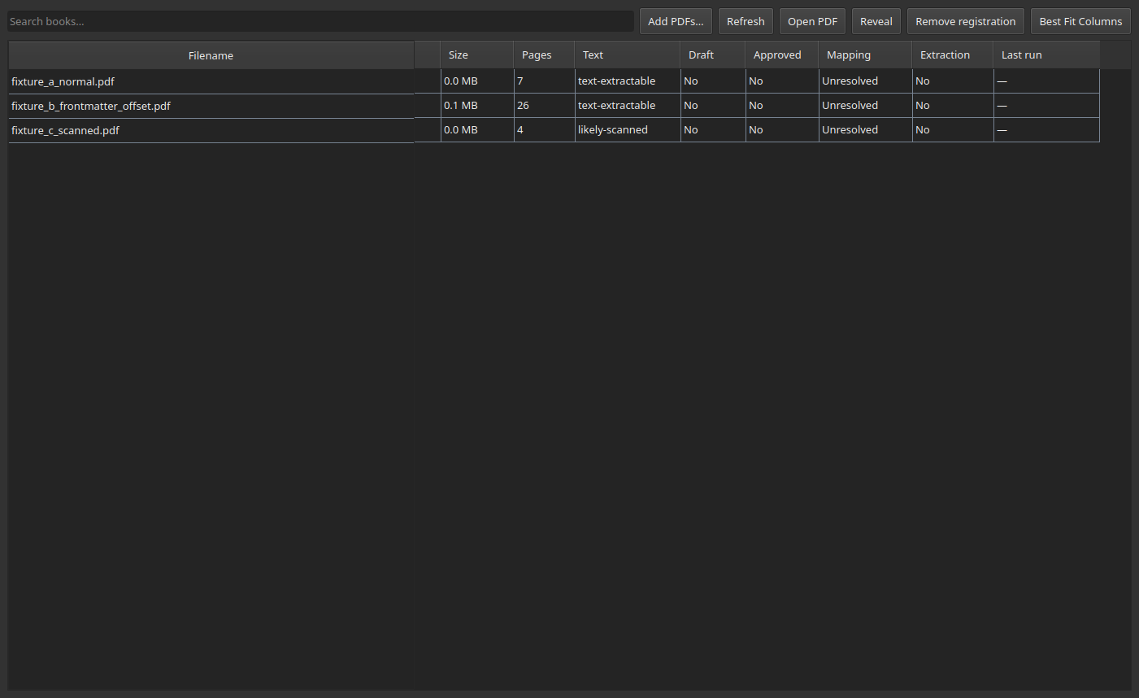
Figure 5: Library table showing three registered PDFs with columns for size, page count, text status, draft/approved/mapping/extraction status.
Alt text: Library table with three rows — a normal book, a book with a page-numbering offset, and a likely-scanned book — none yet processed.
Steps: selecting a book and reading its status.
- Click a row to select that book. The header bar updates to show it as the active book for every other workspace.
- Read the columns left to right:
Column | Meaning
Filename | The registered PDF’s filename.
Size | File size on disk.
Pages | Physical page count.
Text | text-extractable or likely-scanned (Chapter 17).
Draft | Whether an outline draft exists.
Approved | Whether the outline has been approved.
Mapping | Unresolved or Verified.
Extraction | Whether at least one completed extraction run exists.
Last run | The status of the most recent run, if any.
Figure 6 — a specific book selected, showing its row highlighted.
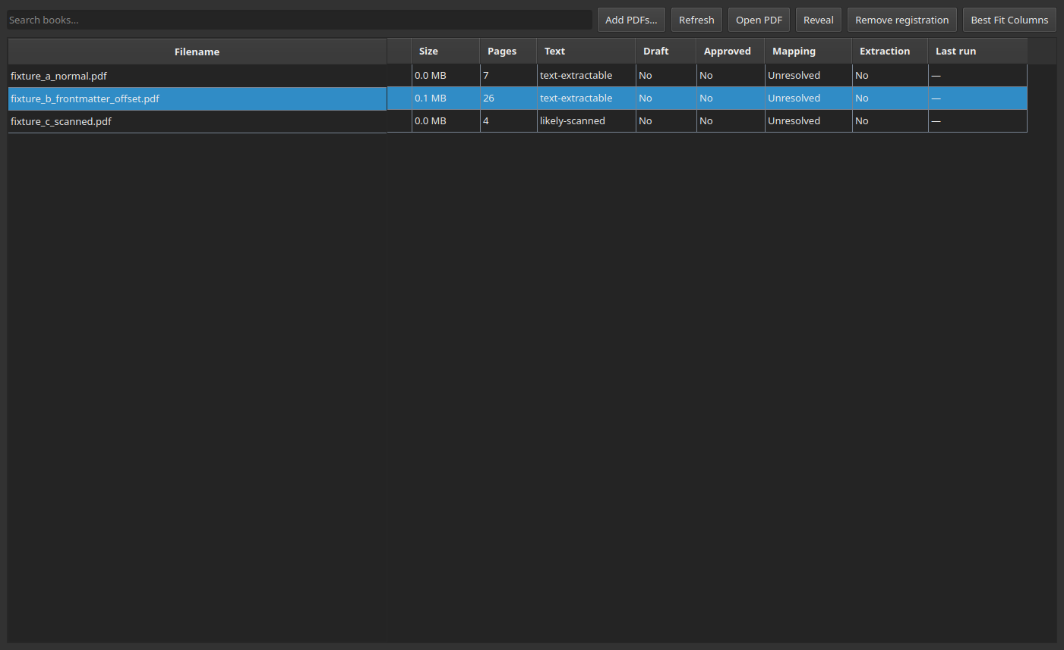
Figure 6: Library table with the front-matter-offset practice book selected and highlighted.
Alt text: Library table, second row (a book with a page-numbering offset) selected and highlighted blue.
Steps: other Library actions.
- Open PDF — opens the selected book’s PDF in your operating system’s default PDF viewer (external to BOOKCORPUSBUILDER).
- Reveal — opens your file manager at the PDF’s location on disk.
- Remove registration — asks for confirmation, then hides the book from the Library table. This does not delete the imported PDF or its original source file; it only stops the book from appearing in the list.
- Refresh — re-scans every registered PDF’s page count and text status (useful if a file changed on disk outside the application).
Common mistake. Assuming “Remove registration” deletes files. It does not — it only hides the entry. To free disk space, delete the file from the Input Pdf Dir yourself afterward.
Recovery. If you add the same PDF twice under different filenames, the second add is refused with a duplicate-hash message naming the first registration — select that existing entry instead of trying to re-add.

7. Structure Builder — choosing an outline source
Structure Builder has two tabs:
A. Create Structure — bring in candidate rows from any source, then review them
B. Review Outline — edit the canonical draft, then save/approve it
Supported sources, exactly as shown in the “1 · Choose a structure source” row of tab A:
- Paste outline — type or paste a table of contents (Chapter 8).
- Detect from PDF — run the deterministic layout/TOC parser (bookcorpusbuilder.outline.extract_outline_from_pdf) against the selected book’s native PDF text.
- Import CSV… — load a previously exported outline CSV.
- Import JSON… — load a BOOK_OUTLINE_CONTRACT_v1 structured JSON outline (a schema-validated format; malformed or mismatched-book JSON is rejected with a diagnostic, never silently accepted).
- Generate with Ollama… — optionally ask a local Ollama model to propose structured candidates from pasted source text. This is the one place the application can call an AI model, and only on your explicit action; its output is schema-validated and lands in the same review-before-approval candidate table as every other source. It requires a local Ollama server; it was not exercised for this manual.
- Build manually — add a single blank candidate row to fill in by hand.
Three states, not two:
candidate — a row currently in the "3 · Parsing preview" table on tab A.
Purely scratch space.
draft — the canonical outline for this book, saved but not yet approved.
approved — the draft, hash-bound and locked, ready for page mapping.
Parsing candidates does not modify the approved outline. You can parse, detect, import, and delete candidates freely on tab A without any risk to an already-approved outline — nothing on tab A is written anywhere until you explicitly press Merge into current draft or Create new outline.
Figure 7 — Structure Builder, tab A, before any source has been chosen.
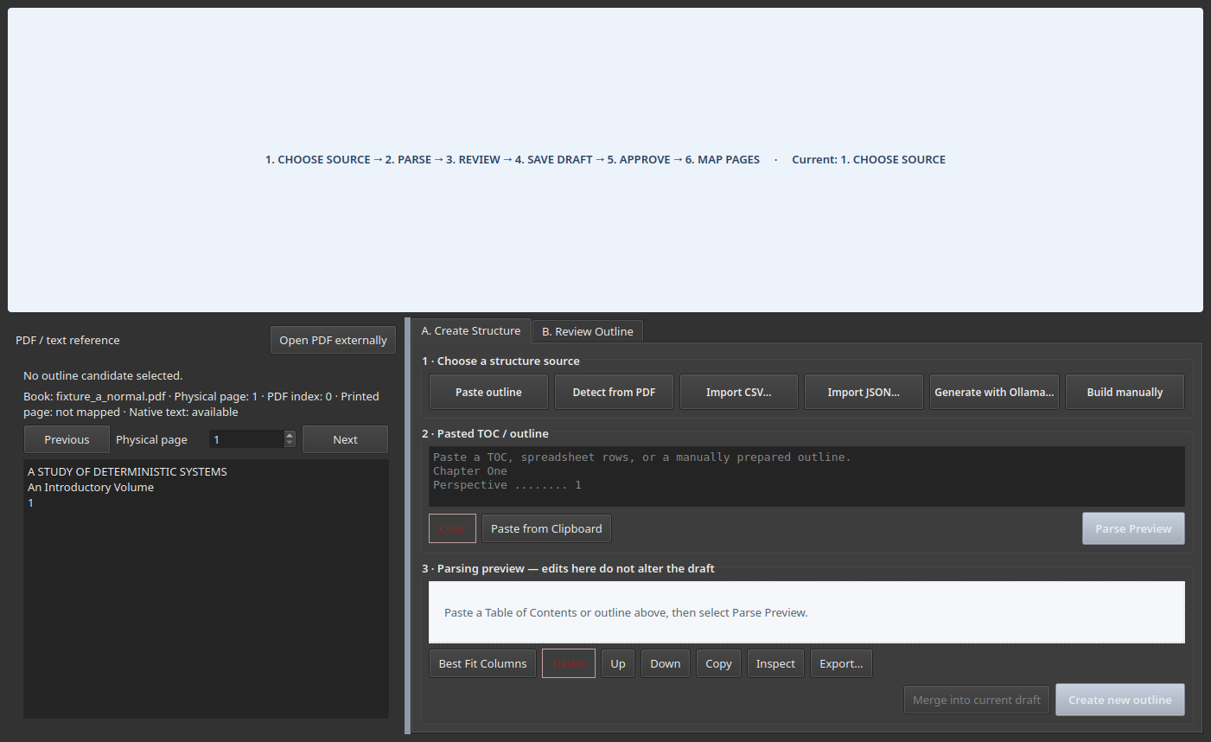
Figure 7: Structure Builder Create Structure tab, empty, showing the six source-choice buttons.
Alt text: Structure Builder with tabs “A. Create Structure” and “B. Review Outline”; tab A active, showing six source buttons and an empty paste box.

8. Structure Builder — pasting and parsing an outline
Purpose. Turn a pasted table of contents into reviewable candidate rows.
Before you begin. Select a book in Library first — every action in Structure Builder requires an active book.
Steps.
- In tab A, click into the 2 · Pasted TOC / outline box (or press the Paste outline button, which only moves focus there).
- Paste or type your outline, one entry per line, in either a dot-leader/spaced TOC style or a Sno,Title,Page style. For example, for a book whose real chapters open at printed pages 3, 5, and 7:
- Foundations .......... 3
Structures .......... 5
Continuity .......... 7
- Press Parse Preview.
Figure 8 — pasted text, not yet parsed.
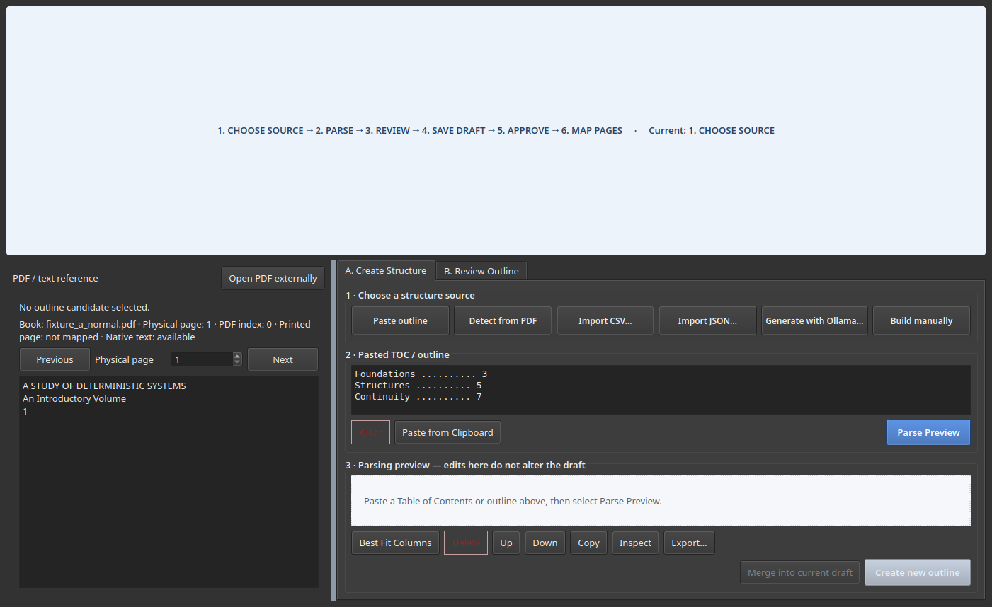
Figure 8: Structure Builder with three lines of pasted TOC text in the paste box, Parse Preview button highlighted.
Alt text: Paste box containing three TOC-style lines; parsing preview table still empty below it.
- Inspect the 3 · Parsing preview candidate table. Its columns are:
Column | Meaning
Include | Whether this candidate will be used if you accept the batch.
Sno | Section number, auto-assigned but editable.
Title | The parsed title text.
Kind | section, chapter, part, etc.
Printed page | The page number parsed from your text.
Level | Outline nesting depth.
Source | Which mechanism produced this row (pasted_text, pdf_toc, pdf_heading, csv_import, …).
Confidence | A deterministic confidence score for detected (not pasted/imported) candidates.
Warning | A short code if something needs attention (see below).
Figure 9 — after Parse Preview, showing three clean candidate rows.
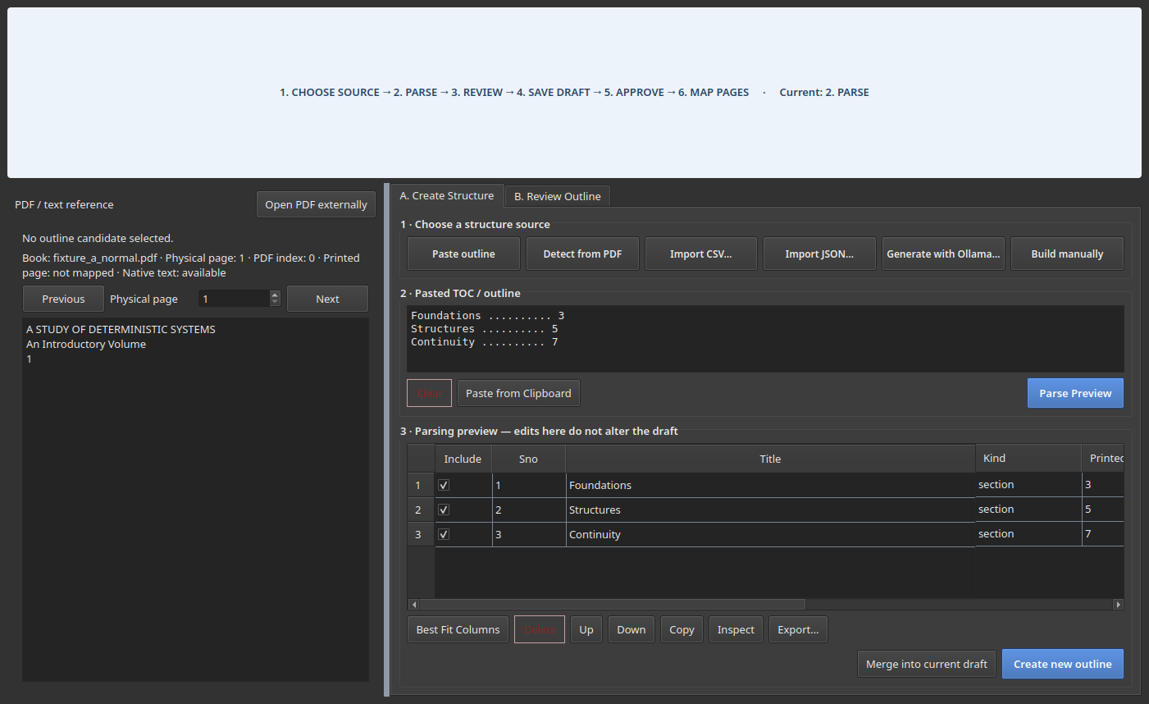
Figure 9: Structure Builder candidate table populated with three parsed rows: Foundations, Structures, Continuity, each with a printed page.
Alt text: Candidate table with three rows, all Include-checked, kind “section”, source “pasted_text”.
- Edit a title or page by double-clicking its cell.
- Exclude a candidate by unchecking its Include box — it stays visible for reference but will not be written into the draft.
- Inspect raw source by selecting a row and reading the detail panel beneath the table (shows the original text and the parser rule that matched it).
- Reorder rows with the Up/Down buttons.
- Export candidates with the Export… button, if you want a CSV copy of the current preview before deciding what to keep.
- Accept the reviewed candidates:
  - Create new outline replaces the book’s entire draft with the checked candidates (confirmation required if a draft or approval already exists).
  - Merge into current draft instead reconciles the checked candidates against the existing draft (Chapter 7’s “candidate vs. draft” distinction) and shows a merge preview before applying anything.
- Resolve conflicts conservatively: when the merge preview flags a conflicting page or a duplicate, prefer keeping the existing, already- reviewed draft value unless you have specifically re-verified the new one against the PDF.
Examples of warning codes you may see (from bookcorpusbuilder.gui.widgets.structure_builder):
Warning | Meaning
missing_page | The candidate has no printed page number at all.
ambiguous_page | The printed page could not be resolved to one confident value; Create new outline is blocked until this is fixed or the row is excluded.
Duplicate Sno and directly conflicting pages are surfaced the same way — as a row-level warning in this table, or as a named conflict in the merge preview when merging into an existing draft — never silently resolved for you.
Common mistake. Pressing Create new outline while a genuinely ambiguous-page candidate is still included. The application blocks this specific case with a message naming the problem; correct the page or exclude the row, then try again.
Recovery. Nothing here is destructive until you press Create new outline or Merge into current draft — if a parse goes wrong, just paste again and press Parse Preview to start over.

9. Structure Builder — reviewing and approving the outline
Purpose. Turn a draft outline into an approved, hash-bound outline ready for page mapping.
Steps.
- Switch to tab B. Review Outline (this happens automatically after Create new outline, or click the tab directly).
- Inspect the canonical outline table — the same book, now in its draft/approved form rather than scratch-candidate form. Columns: Include, Sno, Title, Kind, Printed start, Physical start, PDF index, Level, Source, Review status.
- Resize and move columns as needed (Chapter 4).
- Check, in order: every row you want is Included; Sno values are unique and in a sensible order; the hierarchy (Level) matches the book; Printed start matches what is actually printed on the page; Kind and Source are what you expect.
- Read the validation panel beside the table. It is grouped into three sections, always in this order:
- BLOCKING ERRORS — must be fixed before approval can succeed
WARNINGS — approval is still possible; review before proceeding
PASSED CHECKS — confirmation that a specific check succeeded
Figure 10 — the Review Outline tab, after creating a draft from three approved candidates.
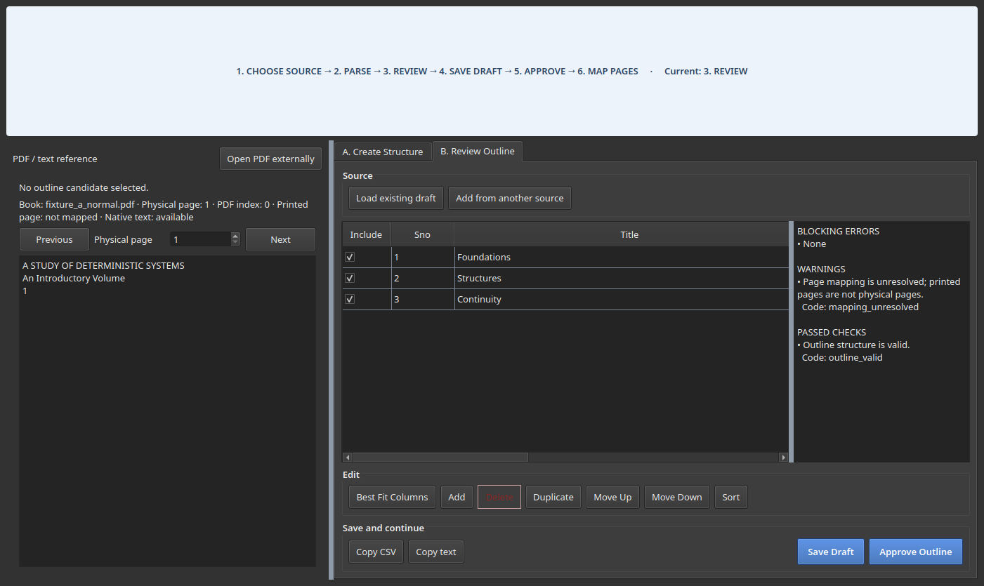
Figure 10: Structure Builder Review Outline tab showing the canonical outline table and a grouped validation panel.
Alt text: Canonical outline table with three rows and a validation panel reading BLOCKING ERRORS: None, WARNINGS: page mapping unresolved, PASSED CHECKS: outline valid.
- Use Add, Delete, Duplicate, Move Up, Move Down, and Sort to correct the table directly if needed.
- Press Save Draft at any point to persist changes without approving.
- Press Approve Outline when the table is correct. You will be asked for a short reviewer note; supply one (even a short one — it is stored with the approval record).
- Understand the approval hash. Approval computes and stores the SHA-256 of both the approved outline file and the source PDF at that exact moment (Chapter 2). This is what lets the application later detect “the book changed after I approved this” or “the outline changed after I approved this.”
- Editing after approval invalidates it in effect, not in place. The approved file is protected — editing rows and pressing Create new outline again creates a separate revised draft rather than silently overwriting the protected approval; you explicitly revoke the old approval (the application will ask) before a new one can replace it.
Do not approve analytical rows as extraction boundaries unless their page starts are verified. A row detected from an internal sub-heading or thematic aside is not automatically a real section break — read Chapter 2 again if this is not clear before approving your first real book.
Approving successfully navigates you directly to 3. Page Alignment — that is the next required step, not an optional one, since printed page numbers are not yet verified physical pages.

10. Page Alignment — conceptual explanation
This is the most important chapter in this manual. Read it fully before verifying your first book’s page mapping.

The coordinate chain
Printed page (the number printed on the page itself, e.g. "21")
↓
Physical page (that page's 1-based position in the actual PDF file, e.g. 24)
↓
PDF page index (the same position, 0-based, as pdfplumber/most PDF
libraries address it, e.g. 23)
Front matter (title pages, a table of contents, a preface, roman-numeral pages) sits before printed page 1 in the physical file. A book with three such pages has printed page 1 sitting at physical page 4 — an offset of +3 that is completely invisible if you only ever look at printed numbers.

Definitions
Term | Meaning
Printed page | The number printed on the page.
Physical page | The page’s real 1-based position in the PDF file.
PDF page index | Physical page minus one (0-based addressing).
Verification anchor | One specific printed-page-to-physical-page pair you have personally checked and recorded.
Offset | Physical page minus printed page, for one anchor.
Segment | A contiguous range of printed pages sharing one confirmed offset.
Confirmed segment | A segment backed by two or more agreeing anchors — never trusted on a single anchor alone.
Unconfirmed segment | A segment with only one anchor so far; its offset is not yet trusted for any page other than that anchor’s own.
Exception | A single printed page whose physical location you record directly, overriding whatever offset would otherwise apply (for genuinely irregular pages).
Extrapolated mapping | A page resolved by applying the one and only confirmed segment’s offset beyond that segment’s own anchor range — only ever done when there is no competing segment to make that guess ambiguous.
Unresolved entry | An outline entry whose printed page cannot currently be converted to a physical page at all.

Why one book can need multiple segments
- Roman-numeral front matter, as above: the body of the book has a different, later offset than the preface.
- Inserted plates or photo sections that are physically present in the PDF but are not part of the printed pagination — pages after the insert need a different offset than pages before it.
- Omitted or duplicate scans in the source PDF — a page repeated or missing changes the offset from that point forward.
- Genuinely different offsets in different volumes bound together as one PDF.
BOOKCORPUSBUILDER’s mapping model handles this by looking for maximal runs of anchors that agree on one offset and treating each run as its own segment, rather than assuming the whole book shares a single offset. A segment needs two agreeing anchors to be trusted for any page beyond the anchors themselves.

The idea in one picture
Printed: 1 10 21
|---------- +3 ------------|---------- +3 -------------|
Physical: 4 13 24
One confirmed segment, offset +3, covering printed pages 1 through 21.
A printed page far outside any anchor (say, printed page 500 in a much
longer book) is NOT safely covered by this segment and must either get
its own nearby anchor, or remain correctly reported as unresolved.

11. Page Alignment — buttonology
Every control described here is visible in Figure 11.
Figure 11 — the Page Alignment workspace, immediately after opening it for a freshly-approved outline.
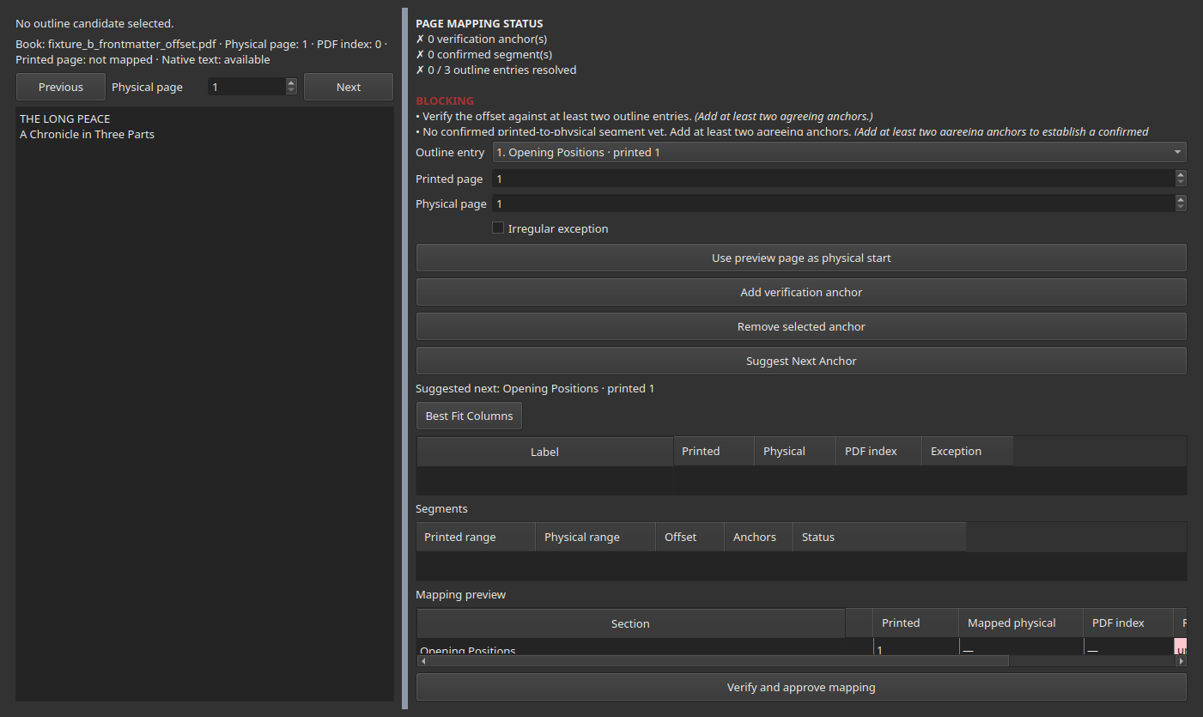
Figure 11: Page Alignment workspace, PDF preview on the left, status/anchors/segments/mapping preview on the right, no anchors added yet.
Alt text: Page Alignment workspace with a red “unresolved” status panel, an empty anchor table, and an outline entry dropdown populated with three chapters.
Callouts:
- PDF preview controls (left pane) — Previous / Physical page field / Next step through the PDF one physical page at a time; the pane below them shows that page’s extracted native text, for visual verification against the outline entry you are working on.
- Outline entry selector — choose which approved outline row you are currently aligning.
- Printed page / Physical page fields — the pair you are about to record as an anchor.
- Irregular exception checkbox — check this only for a genuinely irregular single page (Chapter 10’s “Exception”), not as a shortcut around verifying a normal chapter opening.
- Use preview page as physical start — copies whatever physical page the PDF preview is currently showing into the Physical page field, so you can navigate visually first and record second.
- Add verification anchor / Remove selected anchor — commit or retract one anchor.
- Suggest Next Anchor — deterministically points you at the next outline entry whose printed page does not yet resolve to a physical page, selecting it in the Outline entry dropdown for you. It performs no PDF text search and computes no confidence score — it is arithmetic over the mapping you have already verified, not a new detection engine. It is disabled with the message “No unresolved entries — nothing to suggest” once every included entry resolves.
- PAGE MAPPING STATUS panel — a running summary: anchor count, confirmed vs. unconfirmed segment count, and resolved / total outline entries, each with a ✓ or ✗. Below it, any BLOCKING or CONFLICT diagnostics are listed with a plain-language reason and a suggested corrective action.
- Verification Anchors table — every anchor you have added, its printed/physical/PDF-index values, and whether it is marked as an exception.
- Segments table — every segment implied by your current anchors: printed range, physical range, offset, anchor count, and status (confirmed or needs a second anchor).
- Mapping Preview table — every included outline entry, its printed page, its currently mapped physical page (if any), and a Resolution column.
- Verify and approve mapping — the final action; blocked while any BLOCKING diagnostic remains.
Resolution values, exactly as they appear in the Mapping Preview table:
Value | Meaning
anchor | This exact printed page was anchored directly — the most trustworthy resolution.
segment | This page falls inside a confirmed segment’s range.
extrapolated | Resolved by projecting the sole confirmed segment’s offset beyond its own anchor range (only when no other segment could disagree).
unresolved | No anchor, confirmed segment, or safe extrapolation currently covers this page.
Segment-table status values are confirmed (two or more agreeing anchors) or needs a second anchor (exactly one anchor so far).

12. Page Alignment — step-by-step worked example
This walkthrough uses a practice book built specifically to demonstrate an offset: fixture_b_frontmatter_offset.pdf, whose three unnumbered front-matter pages push printed page 1 to physical page 4.
Printed page 1 → Physical page 4 → PDF index 3
Printed page 10 → Physical page 13 → PDF index 12
Printed page 21 → Physical page 24 → PDF index 23
Steps.
- With the book’s outline already approved (Chapter 9), open 3. Page Alignment. The Outline entry dropdown lists all three chapters; nothing is anchored yet (Figure 11 above).
- Select the first chapter (“Opening Positions”, printed 1) in the Outline entry dropdown.
- Use the PDF preview’s Physical page field (or Next) to navigate to the book’s actual chapter opening — in this example, physical page 4 — and read the extracted text to confirm it really is “CHAPTER ONE / Opening Positions”, not a table-of-contents mention of it.
- Press Use preview page as physical start (or type 4 directly into the Physical page field).
- Press Add verification anchor.
Figure 12 — after the first anchor.
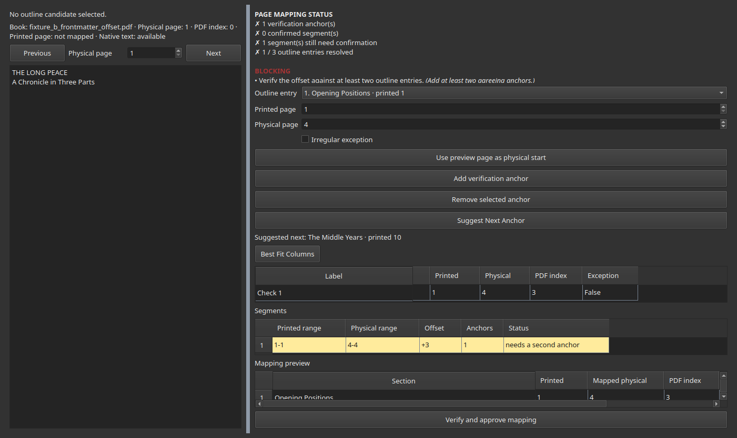
Figure 12: Page Alignment workspace with one anchor added, printed page 1 mapped to physical page 4, segment table showing one unconfirmed segment.
Alt text: One row in the Verification Anchors table; the Segments table shows one segment, “needs a second anchor”.
- Select a distant chapter (“The Middle Years”, printed 10). Repeat steps 3–5, confirming it opens at physical page 13.
Figure 13 — after the second anchor, now forming a confirmed segment.
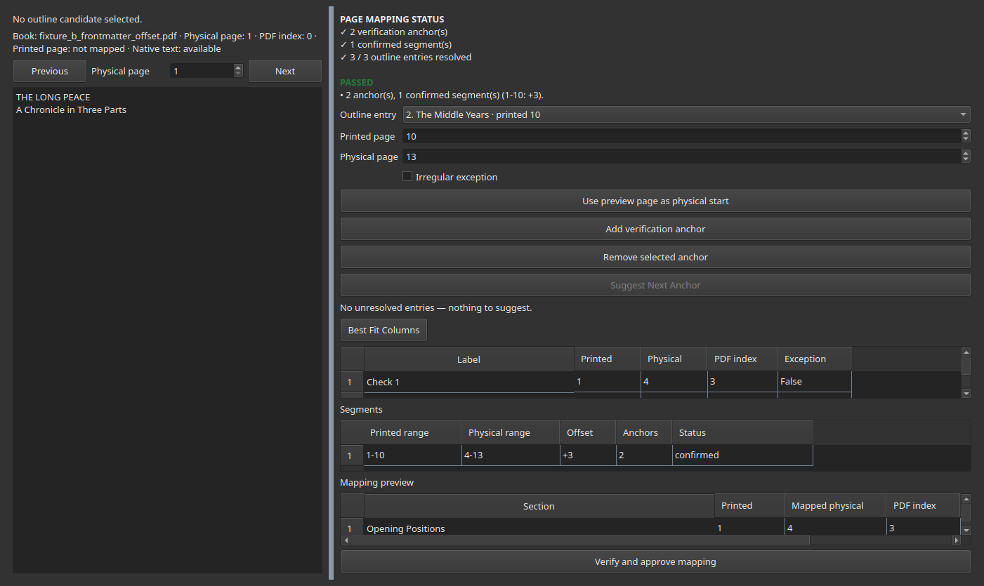
Figure 13: Page Alignment workspace with two anchors added and one confirmed segment spanning printed pages 1 to 10.
Alt text: Two rows in the Verification Anchors table; Segments table shows one confirmed segment, printed 1-10, offset +3.
- Repeat once more for the third chapter (“Settlement”, printed 21, physical
  - — because it agrees with the same +3 offset, it extends the same confirmed segment rather than creating a second one.
- Inspect Mapping Preview — every entry should now show anchor or segment in its Resolution column, and the status panel should read 3 / 3 outline entries resolved.
- If Suggest Next Anchor is still enabled at this point, it names the next entry that does not yet resolve — add an anchor for it and repeat.
- Press Verify and approve mapping.
Figure 14 — the approved mapping.
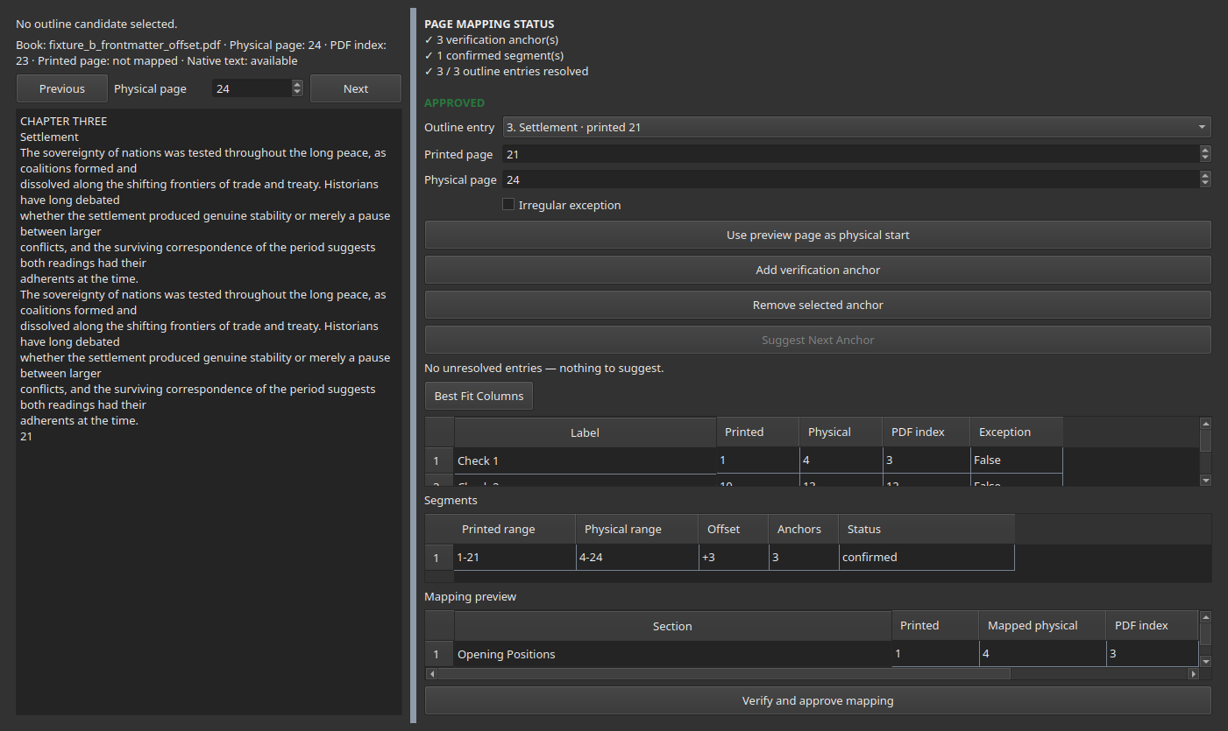
Figure 14: Page Alignment workspace after approval, status panel green “APPROVED”, all three entries resolved.
Alt text: Green APPROVED banner, three confirmed anchors, one confirmed segment covering printed 1-21, Suggest Next Anchor disabled.
Expected result. The status panel turns green and reads APPROVED; the Extract workspace’s preflight (Chapter 13) will now allow this book through.

Examples of blocked approval, and their corrective action
Situation | What you will see | Corrective action
One-anchor segment | segment_unconfirmed warning naming the anchor | Add a second, agreeing anchor near it.
Uncovered entry | uncovered_entry, blocking, naming the section and printed page | Add an anchor near that printed page.
Conflicting anchors | offset_conflict, blocking, naming both anchors and their disagreeing physical pages | Correct or remove one of the two anchors, or mark the irregular one as an exception.
Out-of-range physical page | anchor_out_of_range, blocking | Re-check the physical page number — it exceeds the PDF’s actual page count.

13. Extraction workspace
Purpose. Turn an approved outline plus an approved mapping into an extracted corpus.
Before you begin. The selected book must have both an approved outline (Chapter 9) and an approved page mapping (Chapter 12). Extraction is disabled until every blocking prerequisite passes — this is not a limitation to work around, it is the point.
Steps.
- Open 4. Extract with the prepared book selected.
- Set Minimum characters if you want very short (likely noise) sections silently skipped rather than written as near-empty files.
- Review Output root — where this run’s files will be written. Change it with Choose output… if needed.
- Press Validate / dry run. This runs the full preflight check without writing anything.
Figure 15 — a passing preflight.
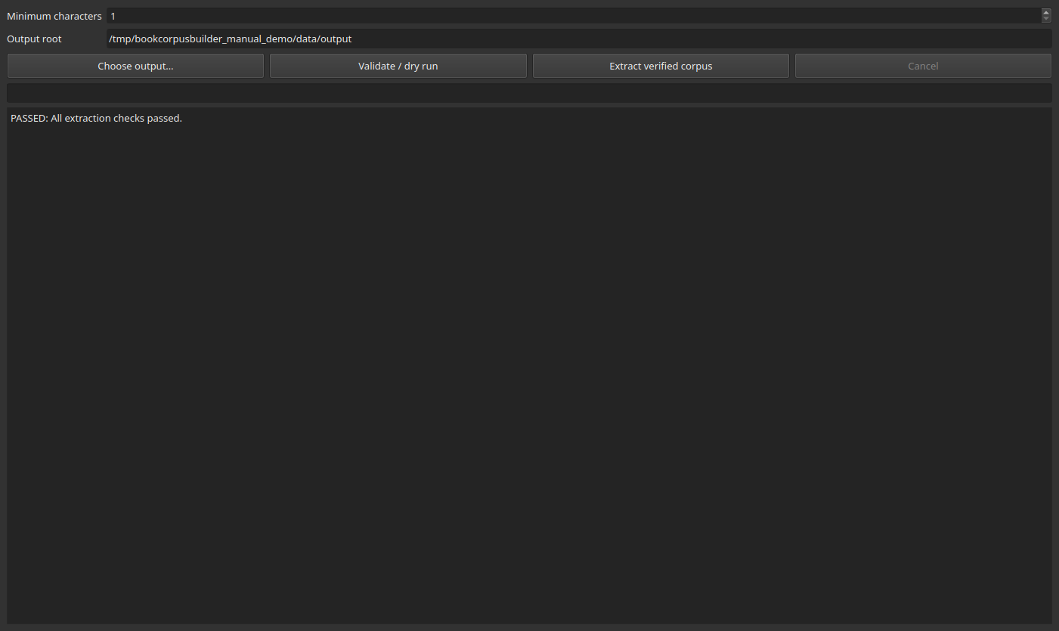
Figure 15: Extraction workspace after a dry run, log showing “PASSED: All extraction checks passed.”
Alt text: Extraction workspace log panel reading PASSED: All extraction checks passed, Extract button now enabled.
- Read the log. Each line is one diagnostic, prefixed PASSED, WARNING, or BLOCKING. The Extract verified corpus button only enables itself once there are zero BLOCKING lines.
- Press Extract verified corpus.
Figure 16 — extraction in progress.
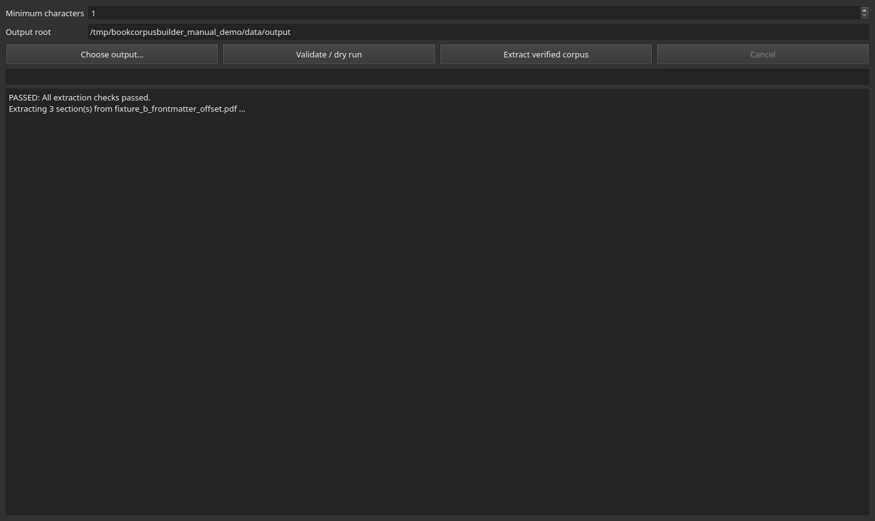
Figure 16: Extraction workspace mid-run, progress bar and a growing log of per-section completion messages.
Alt text: Progress bar and log lines “1/3: Opening Positions”, “2/3: The Middle Years”, building up.
- Monitor the progress bar and the log, which reports each section as it completes.
- On completion, the log reports expected, written, skipped, and failed counts, plus the exact output folder for this run.
Figure 17 — a completed run.
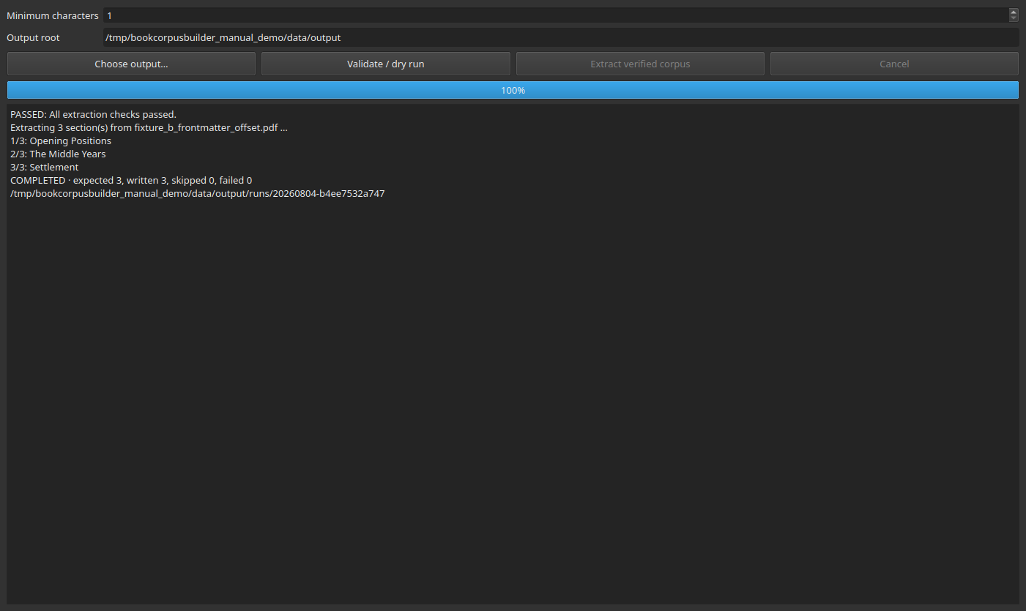
Figure 17: Extraction workspace after completion, log reading COMPLETED, expected 3, written 3, skipped 0, failed 0, with the output path.
Alt text: Log ending with COMPLETED, expected 3, written 3, skipped 0, failed 0, and the run’s output folder path.
- Cancel stops an in-progress run; its partial, temporary output is discarded rather than promoted to a real run folder (Chapter 2).
- Atomic promotion: a run’s output only becomes visible under its final run-ID folder once every file has been written successfully — a run that fails partway through does not leave a folder that looks complete.
Common mistake. Expecting Extract verified corpus to become available immediately after approving a mapping, without running Validate / dry run first. The button only enables after a dry run reports zero blocking issues — run the dry run explicitly, every time, even if you are confident.
Recovery. If the dry run reports a blocking issue, its message names the exact problem (an unapproved outline, an unapproved mapping, a source-PDF hash mismatch, and so on) — resolve that specific problem in the workspace it belongs to, then dry-run again.

14. Corpus Browser
Purpose. Search extracted text across one book or your whole corpus, inspect a result in context, and jump straight to its source page in the original PDF.
Steps.
- Open 5. Corpus Browser.
- Optionally choose a specific book (via Library selection) and/or a specific extraction run in the All runs dropdown — leave both at their “All” defaults to search everything.
- Type a phrase into the search box and press Search (or Enter).
- Filter further with All kinds (section kind), Printed from / to (a printed-page range), or the run filter above.
- Read the results list — each entry shows its title and a short snippet around the match.
Figure 18 — a search in progress.
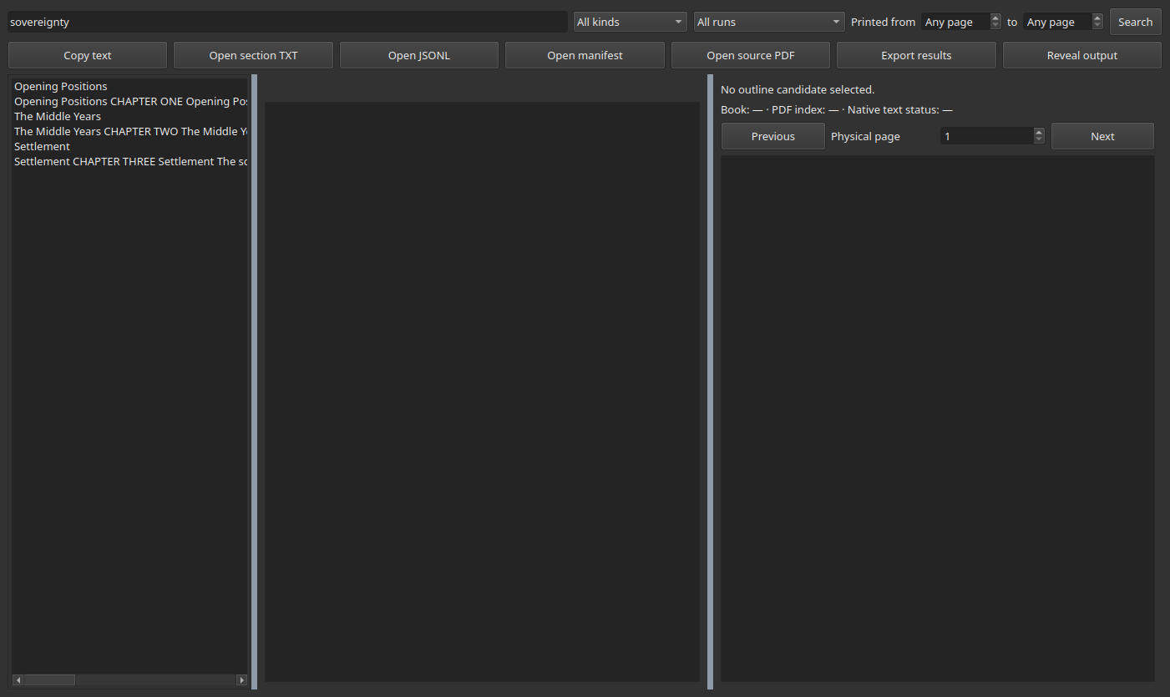
Figure 18: Corpus Browser with the query “sovereignty” entered and three matching results listed.
Alt text: Search box containing “sovereignty”, three results listed on the left, each with a snippet.
- Select a result to preview its full section text, metadata (book, kind, printed/physical page range, run ID, source PDF hash), and — in the third pane — the exact physical page of the original PDF it came from, jumped to automatically.
Figure 19 — a result selected, with its source page shown.
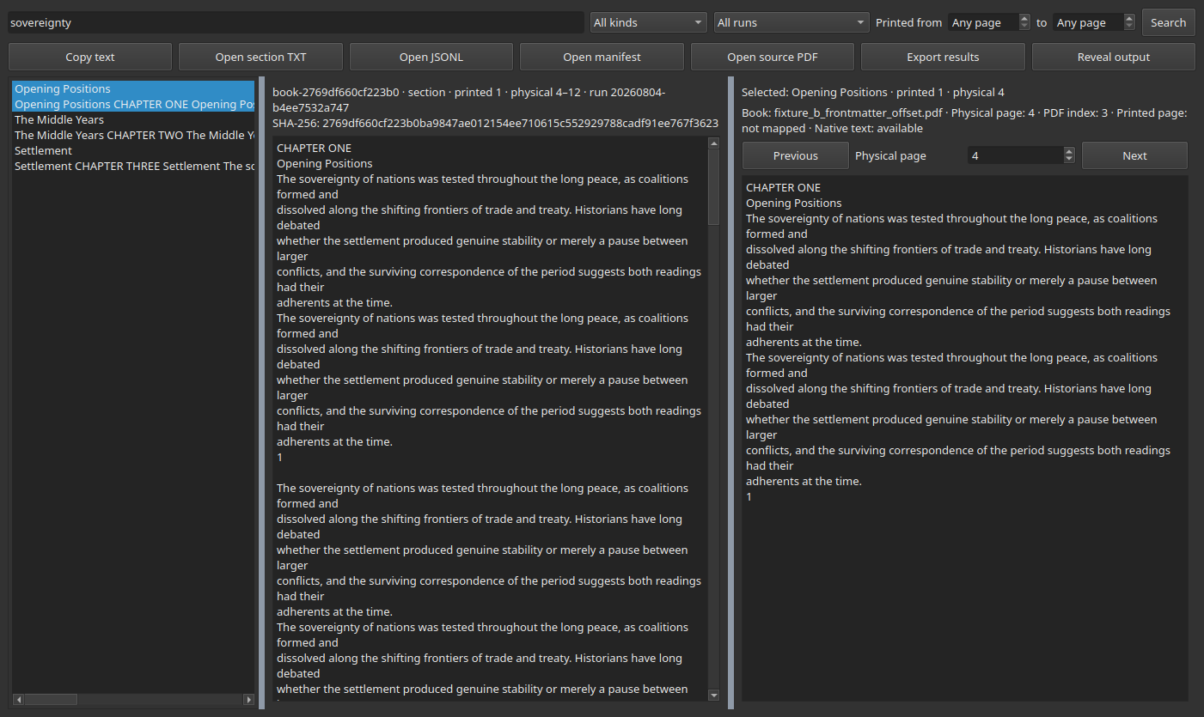
Figure 19: Corpus Browser with a result selected; center pane shows full section text, right pane shows the live PDF preview jumped to the matching physical page.
Alt text: Three-pane Corpus Browser — results list, full extracted text, and a PDF preview pane showing matching source text on the correct physical page.
- Copy text copies the currently previewed section’s full text to the clipboard.
- Open TXT / Open JSONL / Open manifest open the underlying export files for the selected result in their default application — these three files are the corpus’s authoritative, portable export; the in-app browser is a convenience layer on top of them, not a replacement for them.
- Open source PDF opens the original PDF externally; the in-app preview pane (callout 6 above) already shows the matching page without leaving the application.
- Reveal output opens your file manager at that run’s output folder.
- Export results saves the current result set as a JSON file you choose.
Common mistake. Searching with a run selected in the run filter and getting zero results because that particular run does not contain the term — check whether All runs is selected before concluding a phrase is not in the corpus at all.

15. Run History
Purpose. Audit every extraction run — not just the most recent one.
Steps.
- Open 6. Run History.
- Select a book in Library to filter to that book’s runs, or clear the selection to see every run across the whole profile.
- Read the table: Run ID, Started, Status (completed, failed, or cancelled), Book, Expected/Written/Skipped/ Failed counts, and Output location.
Figure 20 — run history after one completed run.
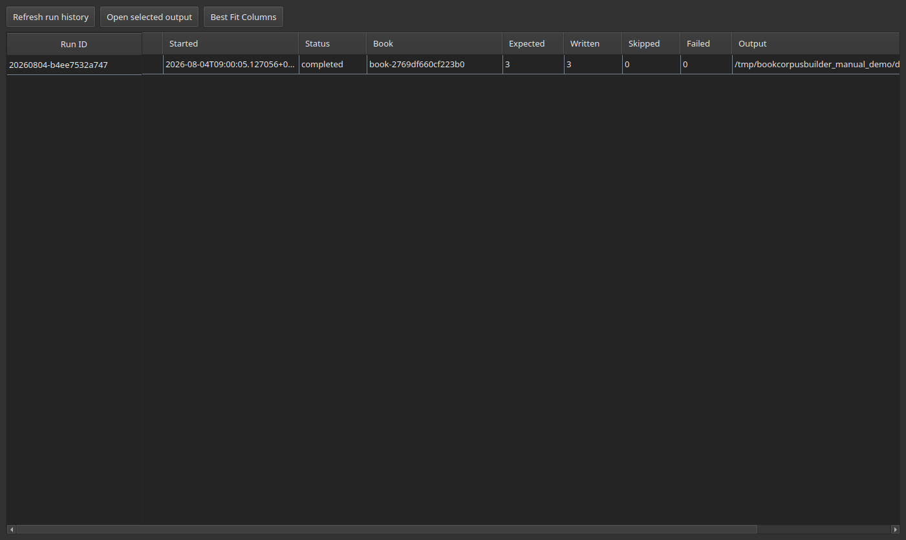
Figure 20: Run History table showing one completed run with its counts and output path.
Alt text: Run History table, one row, status “completed”, expected 3, written 3, skipped 0, failed 0.
- Select a row and press Open selected output to open that specific run’s output folder — including runs that are not the most recent one.
- Previous successful runs are never overwritten by a later run against the same book: each run gets its own timestamped folder (Chapter 2).
Failed or cancelled runs remain listed here too, with their status and whatever partial counts were recorded, so a failure is never silently lost — only its output is withheld from promotion (Chapter 13).

16. Output folders and files
Every extraction run produces the following, under the run’s own timestamped folder inside Output Dir:
data/output/
├── run_history/
│ └── <run-id>.json — one run record (Run History reads these)
└── runs/
└── <run-id>/
├── sections/<book-id>/ — one TXT file per extracted section
├── jsonl/ — one JSONL file, one line per section
└── manifests/ — one manifest CSV per book, one row per section
Outline and page-mapping sidecars live alongside each other under Outline Dir, one set per book (<book-id>_outline.csv, <book-id>_outline_clean.csv, <book-id>_approval.json, <book-id>_page_mapping.json).
Figure 21 — a real output folder tree, from the run captured for this manual.
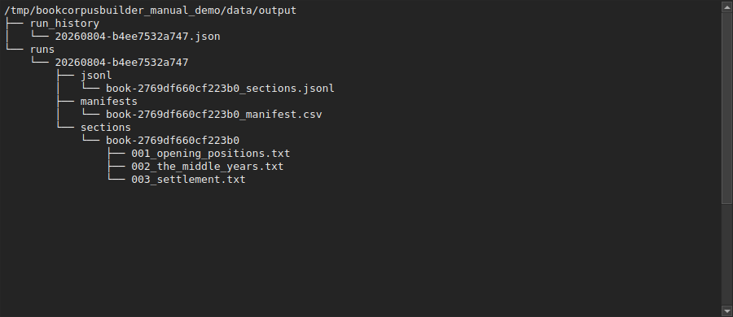
Figure 21: Folder tree showing run_history and runs directories, with one run folder containing jsonl, manifests, and sections subfolders.
Alt text: Text folder-tree listing of one extraction run’s output directory.
Folder/file | Purpose
sections/<book-id>/NNN_title.txt | The extracted text of one section, human-readable.
jsonl/<book-id>_sections.jsonl | The same sections as one machine-readable record per line, including full provenance fields (printed/physical/PDF-index, source hash, run ID).
manifests/<book-id>_manifest.csv | A spreadsheet-friendly index of every section written in this run.
run_history/<run-id>.json | The run record Run History reads (Chapter 15).
<book-id>_outline_clean.csv | The approved outline (Chapter 9).
<book-id>_approval.json | The approval’s hash-binding record (Chapter 2).
<book-id>_page_mapping.json | The approved page mapping (Chapters 10–12).
No other output file types are currently produced — if you find a file under these folders not described above, treat it as worth reporting rather than assuming it is expected.

17. Scanned PDFs
Purpose. Understand what BOOKCORPUSBUILDER can and cannot do with a scanned (image-only) PDF.
- Likely-scanned detection is automatic: on registration, Library reads the first three pages’ native text; if fewer than 80 characters of text are found across those three pages, the book is marked likely-scanned rather than text-extractable (visible in the Library table, Chapter 6).
- OCR availability (Settings, Chapter 5) only reports whether a tesseract binary is present on this machine’s PATH. It does not mean BOOKCORPUSBUILDER performs OCR — nothing in the current application invokes OCR at any stage, on any book, regardless of what this field shows. OCR execution is explicitly out of scope for v1 (docs/GOVERNANCE.md).
- Why no false outline should be accepted: a scanned page with no native text layer will not produce real TOC or heading candidates from the deterministic parser — any candidates that do appear from such a book should be treated with particular suspicion, since they cannot be confirmed against real extracted text the way a native-text book’s can.
- Extraction may remain effectively empty for a likely-scanned book: the extractor pulls native text per page, and a page with no text layer contributes nothing to its section’s output, even if the outline and mapping are both technically approved.
- Current scope: if you need a scanned book in the corpus, it needs to be OCR’d by an external tool first, producing a PDF with a real text layer, before BOOKCORPUSBUILDER can process it meaningfully.

18. Troubleshooting
Message | Meaning | Operator action
No book selected | No active library item | Select a book in Library.
No usable outline entries detected | Parsing produced nothing usable | Correct the pasted text and parse again.
Duplicate Sno | Two rows share a section number | Renumber one of the rows.
Empty title | A row has no heading text | Add a title before saving/approving.
Page mapping unresolved / offset_unresolved | No confirmed segment exists yet | Add at least two agreeing anchors.
segment_unconfirmed | Only one anchor exists for that offset | Add a second, agreeing anchor nearby.
uncovered_entry | An included entry’s printed page has no resolvable physical page | Add an anchor near that printed page.
offset_conflict | Two anchors on the same printed page disagree | Correct or remove one anchor, or mark it an exception.
anchor_out_of_range | A recorded physical page exceeds the PDF’s page count | Re-check and correct the physical page.
PDF changed after approval / approval_pdf_mismatch | The source PDF’s hash no longer matches the approval record | Re-review and re-approve; do not assume the old approval still applies.
OCR unavailable | No tesseract binary found on PATH | Install Tesseract if you need the status to read available — this does not enable OCR execution regardless (Chapter 17).
Extraction cancelled | You intentionally stopped a run | Restart extraction when ready; nothing was promoted from the cancelled attempt.
Duplicate PDF | Same SHA-256 hash already registered | Use the existing registration instead of re-adding.
Every one of these messages, in the real application, is paired with a plain- language explanation and (for Page Alignment specifically) a suggested corrective action — the technical code above is secondary, included here so you can look a specific message up quickly.

19. Daily operator checklist
□ Select correct book
□ Review outline source
□ Check chapter titles
□ Check printed pages
□ Save draft
□ Approve outline
□ Add at least two reliable anchors per required segment
□ Resolve all included entries
□ Approve page mapping
□ Pass extraction preflight (dry run)
□ Extract
□ Search corpus
□ Confirm outputs
□ Check Run History

20. Quick-start guide
See “Ten-minute workflow” at the top of this manual. It is repeated here for convenience:
1. Add PDF (Library)
2. Paste or detect outline (Structure Builder → A. Create Structure)
3. Parse (Parse Preview)
4. Review (Structure Builder → B. Review Outline)
5. Approve (Approve Outline)
6. Map chapter pages (Page Alignment — add anchors)
7. Approve mapping (Verify and approve mapping)
8. Extract (Extract → Extract verified corpus)
9. Search (Corpus Browser)
10. Open source (Corpus Browser → Open source PDF / in-app preview)
For a book with no usable table of contents, an unusual page-numbering scheme, or any blocked/unresolved state, stop and read the relevant detailed chapter (7–13) rather than guessing — every blocking state in this application exists because guessing at that point would risk silently mis-attributing text to the wrong page.

21. Glossary
Term | Meaning
Book ID | A stable identifier derived from a PDF’s SHA-256 hash; the same PDF always gets the same book ID, even re-added under a different filename.
Candidate | A scratch-space outline row on Structure Builder’s Create Structure tab, not yet part of any draft.
Draft | A book’s saved-but-unapproved outline.
Approved outline | A hash-bound, protected outline ready for page mapping.
Printed page | The page number printed on the page itself.
Physical page | The page’s true 1-based position in the PDF file.
PDF index | Physical page minus one.
Anchor | One verified printed-to-physical page pair.
Segment | A contiguous printed-page range sharing one confirmed offset.
Offset | Physical page minus printed page for a given anchor or segment.
Exception | A single printed page’s physical location recorded directly, overriding the segment offset for that one page.
Extrapolated mapping | A page resolved from the sole confirmed segment’s offset, beyond that segment’s own anchors.
Run ID | A unique identifier for one specific extraction run.
Manifest | A per-run, per-book CSV index of every section written.
JSONL | One JSON record per line; this project’s primary machine-readable corpus export.
Atomic output | A run’s output only appears under its final folder name once every file in it has been written successfully.
Likely scanned | A PDF whose first three pages together contain fewer than 80 characters of native text.
Provenance | The full chain from an extracted section back to its exact physical PDF page and source file hash.
Hash-bound approval | An approval record that stores the SHA-256 of both the outline and the source PDF at the moment of approval, to detect later drift.

22. Governance note
BOOKCORPUSBUILDER’s architecture is frozen as of v1.0. This manual documents that accepted v1 workflow exactly as it exists — no control, workspace, or behavior described here is planned, proposed, or aspirational.
Any conceptual addition to the application (new detection engines, AI assistants, knowledge graphs, new workspaces, and the like) belongs in docs/FUTURE_IDEAS_v2.md, not in this manual and not in the production application. If you believe you have found a genuine defect in the behavior described here, report it — the correct response to a limitation is a defect report against this documented behavior, not an improvised workaround that diverges from the accepted workflow.
See docs/GOVERNANCE.md for the full governance rule this note summarizes.

