BOOKCORPUSBUILDER

Complete Operator Manual
GUI v0.2.1 with resizable workbench and BOOK_OUTLINE_CONTRACT v1.0
Document revision: 2026-08-04
Purpose This manual explains how to import PDF books, create or paste outlines, verify printed-to-physical page mapping, extract section corpora, search outputs, and review run history. It is written for routine operators, not software developers.
Accepted operating state: August 2026
Contract-safety edition: Python defines the outline schema; deterministic services validate it; the operator approves it. Optional Ollama generation can produce candidates only. Proposed analytical headings remain metadata and cannot become extraction boundaries until their locations are verified.
Project location used in examples:
/media/ambijat/SOPRANO2/GPT_workflow/BOOKCORPUSBUILDER

Contents
1. Purpose and operating principles
2. Installation and launch
3. The seven workspaces
4. Standard end-to-end workflow
5. Library: adding and selecting books
6. Structure Builder: creating an outline
7. Review Outline: correcting and approving structure
8. Page Alignment: printed versus physical pages
9. Extract: validation and corpus generation
10. Corpus Browser: search and retrieval
11. Run History
12. Settings and configuration profiles
13. Handling scanned PDFs
14. Output files and folder structure
15. Common errors and remedies
16. Safe operating practices
17. Quick-reference checklists
Appendix A. Supported pasted-outline formats
Appendix B. Verified complete-run demo
Appendix C. Glossary

1. Purpose and operating principles
BOOKCORPUSBUILDER converts PDF books into a governed, section-based text corpus. It does not merely split a PDF by arbitrary page counts. The operator first establishes a trustworthy book structure, verifies how printed page numbers correspond to physical PDF pages, and only then authorises extraction.
Core rule Printed page numbers and physical PDF pages are different coordinate systems. Never approve extraction until page mapping has been verified.
- The source PDF is treated as read-only and is never edited by the application.
- Every book is registered by SHA-256 identity so duplicate imports can be detected.
- An outline remains a draft until the operator approves it.
- Editing an approved outline invalidates the approval and requires re-approval.
- Extraction is blocked until the outline and page mapping pass validation.
- Completed extraction runs are stored separately so earlier verified runs are not overwritten.
- TXT, JSONL and manifest files are the authoritative corpus exports.
- All retrieval is local and deterministic; no AI or online service is required.

2. Installation and launch

2.1 Recommended launch command
Open a terminal and run:
cd /media/ambijat/SOPRANO2/GPT_workflow/BOOKCORPUSBUILDER
../BOOKCORPUSBUILDER-gui-venv/bin/bookcorpus-gui
Environment Use the retained sibling GUI environment. Do not replace the project’s original .venv unless a separate maintenance task explicitly requires it.

2.2 Successful startup
- The main window title reads BOOKCORPUSBUILDER.
- The left navigation lists Library, Structure Builder, Page Alignment, Extract, Corpus Browser, Run History and Settings.
- The top status line shows the selected book, current workspace and last action.
- When no book is selected, actions that depend on a book remain disabled or show guidance.

2.3 Closing the program
Close the window normally. Do not terminate the process during extraction unless the application is unresponsive. Use the on-screen Cancel control during a running extraction.

3. The seven workspaces
Item | Meaning / operator action
1. Library | Import PDFs, select a book, inspect identity and status, open or reveal the source file.
2. Structure Builder | Create candidates by pasting an outline, detecting structure from the PDF, importing CSV/JSON or building manually; then load and review the canonical draft.
3. Page Alignment | Verify how printed pages map to physical PDF pages and zero-based PDF indices.
4. Extract | Run preflight validation and generate section TXT, JSONL and manifest outputs.
5. Corpus Browser | Search section titles and full text, preview matches and open source/output files.
6. Run History | Inspect completed, failed or cancelled runs and open their outputs.
7. Settings | Review project paths, scan windows, thresholds, viewer and OCR availability.
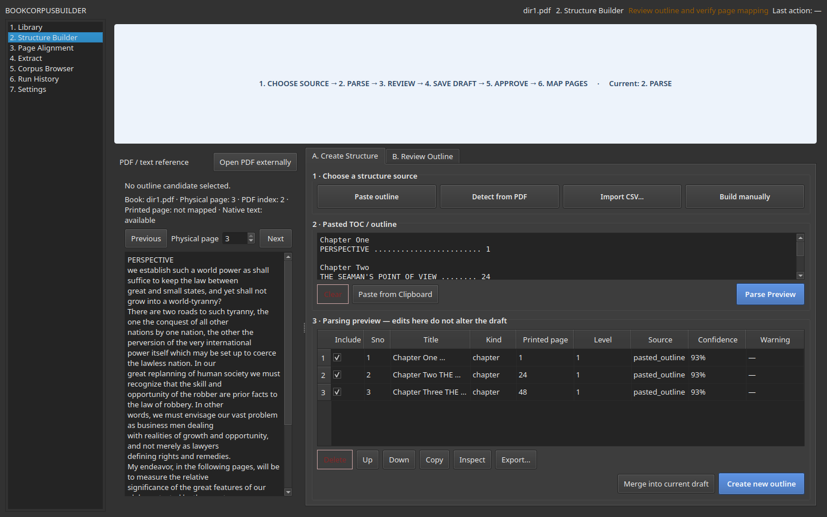
Figure 1. Create Structure mode with pasted text, candidate preview, explicit provenance and create/merge actions.

3.1 Resizable workbench controls
All tabular workspaces use spreadsheet-style headers. Column dividers are deliberately visible in light and dark palettes.
- Drag a header divider to resize a column.
- Double-click a divider to fit that column to its current contents.
- Drag a header label to change column order.
- Right-click a header to show or hide optional columns, fit all visible columns, or reset the layout.
- Choose Best Fit Columns in table toolbars to fit all visible columns.
- Hold Shift while using the mouse wheel to scroll horizontally.
- Identifier columns remain frozen: Filename in Library; Include/Sno/Title in Structure Builder; Label or Section in Page Alignment; and Run ID in History.
- Drag the wider divider between PDF/reference and work areas to allocate space to either pane.
Column width, order, visibility, splitter position and main-window geometry are stored in the local settings profile. They survive restart and remain isolated when BOOKCORPUSBUILDER_CONFIG selects a disposable profile. Frozen identifier columns cannot be hidden from the header menu.
Corpus Browser uses a resizable result-list/detail splitter rather than a multi-column result table; drag its centre divider to favour the hit list or the extracted-text reader.

4. Standard end-to-end workflow
1. Open Library and add or select a PDF book.
2. Open Structure Builder and choose the most convenient creation source: Paste outline, Detect from PDF, Import CSV, Import JSON or Build manually. To resume prior work, use Load existing draft in Review Outline.
3. Parse or load candidate entries and review them before acceptance.
4. Accept candidates into the canonical draft outline.
5. Open Review Outline, correct rows, save the draft and approve the clean outline.
6. Open Page Alignment and verify at least two mapping anchors.
7. Open Extract, resolve all blocking validation errors and start extraction.
8. Open Corpus Browser, search the resulting corpus and inspect source provenance.
9. Use Run History to reopen or verify the completed run.
Routine recommendation For most books, use Paste Outline when a TOC can be copied or prepared quickly. Use Detect from PDF as assistance, not as an unquestioned authority.

5. Library: adding and selecting books

5.1 Add a PDF
1. Open Library.
2. Select Add PDFs.
3. Choose one or more PDF files in the native file dialog.
4. Confirm that each imported book appears in the Library list.
5. Review page count and text status before proceeding.

5.2 What the Library records
Item | Meaning / operator action
Book ID | Stable identifier derived from SHA-256. It prevents output collisions and duplicate registrations.
Filename | The stored source PDF filename.
Page count | Number of physical PDF pages.
Text status | Native text available or likely scanned.
Outline status | No draft, draft present, or approved.
Mapping status | Unresolved, draft, or approved.
Extraction status | No run, completed run, failed run or cancelled run.

5.3 Duplicate PDF
If the same PDF is imported again, the application rejects the second registration using SHA-256 comparison and preserves the existing record.

5.4 Opening or revealing a book
- Open source PDF uses the system PDF viewer.
- Reveal source opens the containing folder in the file manager.
- Removing a registration must not delete the original external file.

6. Structure Builder: creating an outline
Structure Builder separates structure creation from canonical outline review. This prevents raw pasted text or detector output from silently becoming an approved outline.

6.1 Choose a structure source
Item | Meaning / operator action
Paste Outline | Best when the TOC can be copied from the PDF, OCR, a website, a note, spreadsheet or another tool.
Detect from PDF | Runs the local outline detector. It first looks for a TOC in the early pages; when no usable TOC is found, it falls back to document headings and captions. Review all results.
Import CSV | Loads an existing structured outline file.
Import JSON | Loads and validates a flat or nested structured JSON outline without using the free-form parser.
Generate with Ollama | Optional local generation of an unapproved book_outline_contract candidate from text already pasted by the operator. Requires the Ollama extra and a local model.
Build manually | Creates and edits rows one at a time.
Load existing draft | Available in Review Outline; restores the current draft, or the approved clean outline when no draft exists.

6.2 Paste Outline workflow
1. Select Paste Outline in Create Structure mode.
2. Paste the TOC or prepared outline into the multiline text box.
3. Choose Parse Preview or press Ctrl+Enter.
4. Review every candidate in the preview table.
5. Correct title, serial number, kind, printed page or hierarchy where necessary.
6. Exclude noise such as running headers or duplicate lines.
7. Inspect warning codes and the original raw source line for ambiguous entries.
8. Choose Create New Outline or Merge into Current Draft.
Important Parsing produces candidates only. Candidates do not become canonical outline rows until you explicitly accept or merge them.

6.3 Native JSON outline import
Choose Import JSON… for structured JSON files. The import always opens the normal candidate preview; it never creates, replaces or approves an outline by itself. If text beginning with { or [ is pasted into Paste Outline, the application asks: This appears to be JSON. Import it as structured JSON? A declined prompt leaves the text untouched and does not send it through the free-form parser.
Accepted forms are a flat array of row objects, or a document object containing optional book.title/book.author metadata and an outline array. Rows may contain nested children; these are flattened recursively while retaining their sno, parent_sno and hierarchy level.
Each row supports sno, title, kind, printed_start, level, parent_sno, source, include and children. Serial numbers must be non-empty and unique; titles must be non-empty; kinds must use the application vocabulary; printed starts must be integers, Roman labels or null; levels must be positive integers; parents must refer to another imported serial number or be null; and include must be Boolean. Missing source values default to imported_json.
The preferred authoritative interchange format is book_outline_contract version 1.0.0. Its required top-level fields are schema_name, schema_version, document, generation, pagination, entries, validation and approval. Python models define this contract, and the generated machine-readable schema is stored at schemas/book_outline_contract_v1.schema.json. Contract objects reject unknown fields instead of silently accepting schema drift.
Contract entries keep printed-page coordinates, physical/PDF coordinates, boundary status, provenance, quality, parent references and inclusion as separate fields. The importer checks unique entry IDs and source serials, existing and mutually consistent parents, hierarchy levels, coordinate consistency and extraction-boundary safety before candidate preview.
Unknown keys are listed in the import diagnostics panel and ignored. They are never converted into titles or rows. Malformed JSON is rejected. A null printed_start is marked missing_printed_page and left unchecked: the row may remain useful as analytical metadata, but cannot become an extraction boundary until the operator supplies a page. The raw JSON SHA-256, source provenance, parent relationship and subsequent user-edit marker survive acceptance into a draft and its provenance record.
For legacy flat/nested JSON, unknown keys remain non-blocking diagnostics. For the versioned contract, unknown fields are schema errors because additionalProperties is false throughout the generated schema.

Printed versus analytical structure
A verbatim printed chapter may be included when it has an accepted printed boundary. An analytical subdivision is useful metadata but defaults to kind: analytical_section, boundary.status: proposed, boundary.allow_extraction: false and include: false. It remains in a contract-derived draft and provenance, but validation blocks it if someone checks it as an extraction boundary before verification.

Optional Ollama candidate generation
Install the optional dependency with pip install -e '.[gui,ollama]', ensure the chosen model is available in the local Ollama service, paste the relevant source text, and choose Generate with Ollama…. The application supplies the same generated JSON Schema to Ollama with temperature zero, validates the response again in Python, and opens candidate preview. Ollama cannot save, approve, map or extract an outline. Its output must declare generation.method: ollama_structured, validation.status: not_validated and approval.status: draft.
The governing authority chain is: Python schema → deterministic validation → human review → verified page mapping → hash-bound approval. No generated candidate may jump directly to extraction.
Five gates are applied in order: valid JSON syntax; strict generated-schema validation; relational and coordinate validation; source-evidence validation; and human approval. Source evidence includes PDF identity and page range, verbatim raw text, provenance page labels, and in-range PDF indices. Lifecycle labels progress through generated_candidate, schema_valid, source_checked, human_reviewed, page_mapped, approved and extraction_ready; these are states, not buttons that an AI generator can select for itself.

6.4 Candidate preview columns
Item | Meaning / operator action
Include | Whether the candidate will be accepted or merged.
Sno | Serial or hierarchical section number.
Title | Proposed part, chapter or section title.
Kind | Part, chapter, section, appendix, notes, bibliography, index or other.
Printed page | Page label printed in the book or TOC.
Level | Hierarchy depth.
Source | pasted_outline, imported_json (or its supplied source), pdf_toc, pdf_heading, csv_import or manual.
Confidence | Parser confidence; not an approval decision.
Warning | Potential ambiguity requiring operator review.

6.5 Merge conflicts
When candidates are merged into an existing draft, the application distinguishes new rows, matching rows, conflicting rows and ignored rows. A conflict such as the same title with a different printed page must be resolved explicitly.
Item | Meaning / operator action
Keep draft | Preserve the existing canonical row.
Use candidate | Replace the conflicting field values with the reviewed candidate.
Keep both | Retain both rows where they genuinely represent separate entries.
Exclude candidate | Do not merge the candidate.

6.6 Clipboard and keyboard
Item | Meaning / operator action
Ctrl+V | Paste into the text editor.
Ctrl+Enter | Parse preview.
Ctrl+S | Save draft.
Delete | Remove the selected candidate when the candidate table has focus. Standard text-editor deletion remains unchanged.
Alt+Up / Alt+Down | Move selected row.

6.7 Candidate export and provenance
- Copy places selected candidate fields on the local clipboard as tab-separated text.
- Export writes the full candidate preview as CSV, JSON or plain text.
- When candidates create or merge into a draft, their original text, parser rule, confidence, warnings, inclusion state and user-edit marker are appended to <book_id>_outline_sources.json.
- The canonical CSV remains compact and downstream-compatible; large raw source text belongs in the provenance sidecar.

7. Review Outline: correcting and approving structure
After candidates are accepted, switch to Review Outline. This mode contains the canonical outline used by page mapping and extraction.
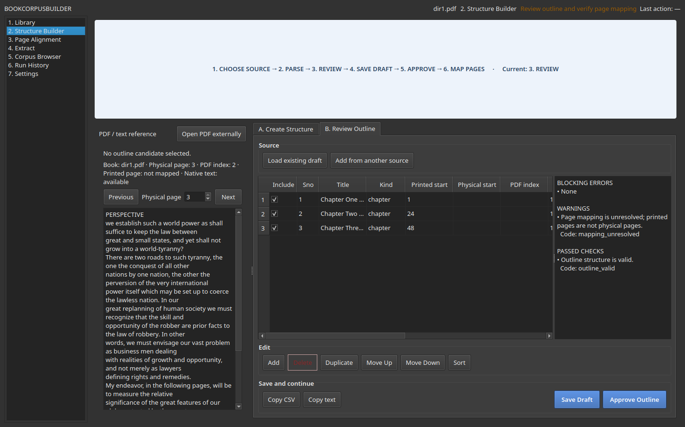
Figure 2. Review workspace with source-page text at left, canonical outline table in the centre and validation/candidate information at right.

7.1 Canonical outline fields
Item | Meaning / operator action
Include | Whether the row will be extracted.
Sno | Unique section identifier.
Title | Canonical title.
Kind | Structural type.
Printed start | Page number or page label as printed in the book.
Physical start | One-based physical PDF page, established during alignment.
PDF index | Zero-based PDF page index.
Level | Hierarchy level.
Source | Where the row originated.
Review status | Draft or approved state.
Roman front-matter labels can appear in candidate preview and in an unapproved draft. An included row without a positive Arabic printed_start produces invalid_printed_start and cannot be approved in v0.2.1. Exclude such a row from extraction or establish a verified Arabic coordinate before approval; never assume a Roman label is a physical page.

7.2 Review procedure
1. Select each outline row and compare its title with the previewed source page.
2. Correct titles, kinds, numbering and printed page values.
3. Remove duplicates and exclude structural rows that should not create text chunks.
4. Check the Validation panel for blocking errors, warnings and passed checks.
5. Save Draft.
6. When satisfied, choose Approve Outline.
7. Confirm that approval metadata is written and the outline status changes to approved.
Approval safety If you edit the canonical outline after approval, the approval is invalidated. Save and approve again before extraction.

8. Page Alignment: printed versus physical pages
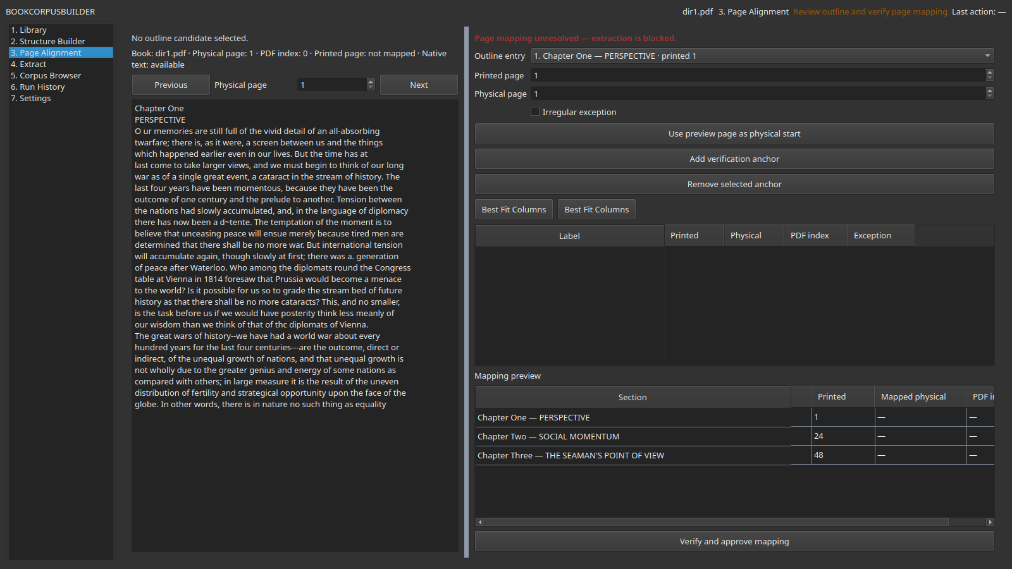
Figure 3. Page Alignment workspace. The left pane previews a physical page; the right pane records printed and physical coordinates and verification anchors.

8.1 Coordinate definitions
Item | Meaning / operator action
Printed page | Positive Arabic page number used by the current mapping and extraction services. Roman labels can be retained during candidate review but cannot be mapped as included rows in v0.2.1.
Physical page | One-based page number in the PDF viewer. The first physical page is 1.
PDF index | Zero-based internal page index. The first physical page is index 0.
Offset | Physical page minus printed page for regular Arabic pagination.
Anchor | A verified printed/physical page pair.
Irregular exception | A local mapping used when one offset cannot describe the whole book.

8.2 Standard two-anchor verification
1. Select an outline entry from the Outline entry list.
2. Use Previous and Next to navigate the preview to the true chapter-opening page.
3. Confirm the printed page shown in the TOC or book.
4. Choose Use preview page as physical start.
5. Add the first verification anchor.
6. Repeat with a second chapter or section well separated from the first.
7. Confirm that both anchors produce the same offset.
8. Review Mapping Preview.
9. Choose Verify and Approve Mapping.
Example If printed page 1 is physical page 4, the offset is +3 and the PDF index is 3. A second anchor such as printed page 2 -> physical page 5 confirms the same offset.

8.3 Irregular books
Use Irregular Exception only when the book contains inserted plates, missing pages, duplicated scans, multiple pagination regimes or another genuine discontinuity. Record exceptions narrowly rather than forcing a misleading global offset.

8.4 Mapping remains unresolved
Extraction stays blocked until the mapping is approved. Typical blocking messages include offset_unresolved, two_anchors_required, mapping_not_approved and mapped_page_invalid.

9. Extract: validation and corpus generation

9.1 Preflight gate
Before extraction, the application verifies the source PDF, approved outline, approved page mapping and output safety. Blocking errors must be resolved; warnings may require operator judgement.
- Source PDF exists and its hash still matches.
- Approved outline exists and its approval hash is current.
- Page mapping is approved.
- Serial numbers are unique.
- Included titles are non-empty.
- Physical starts are valid and within PDF bounds.
- Physical starts are monotonic unless an exception is recorded.
- At least one included extractable section exists.
- Output filenames will not collide.

9.2 Run extraction
1. Open Extract and confirm the correct book, approved outline and mapping are selected.
2. Review the minimum-character threshold and output location.
3. Run preflight.
4. Resolve every blocking item.
5. Select Extract.
6. Watch the progress bar, current-section label and structured log.
7. Wait for completed status before opening outputs.

9.3 Cancel safely
Use Cancel. The worker stops, temporary output is removed and the cancelled run is recorded without promoting partial data. Existing completed runs remain unchanged.

9.4 Successful outputs
- One text file per extracted section.
- One JSONL file containing section records and text.
- One manifest CSV containing paths, page ranges, counts and provenance.
- One run-history JSON record. Treat it as immutable operator evidence; the service writes it atomically under the run ID.

10. Corpus Browser: search and retrieval

10.1 Search modes
- Search by phrase in extracted full text.
- Search by section title.
- Filter by book.
- Filter by section kind.
- Filter by printed-page range.
- Filter by extraction run.

10.2 Reading a result
Item | Meaning / operator action
Snippet | Short context around the matched phrase.
Preview | Full extracted text for the selected section.
Book and section | Identity of the source and canonical outline row.
Printed pages | Book-facing page coordinates.
Physical pages / PDF index | Source-file coordinates.
Run ID | Extraction run that produced the record.
Source hash | Provenance link to the exact registered PDF.

10.3 Available actions
- Copy selected text.
- Open section TXT.
- Open JSONL.
- Open manifest.
- Reveal output folder.
- Open the source PDF in the system viewer. Exact-page navigation is not guaranteed in v0.2.1.
- Export selected results.
Retrieval principle Search results are derived from completed extraction outputs. If the source PDF or approved outline changes, create a new run rather than editing old outputs manually.

11. Run History
Run History provides the audit trail for extraction activity.
Item | Meaning / operator action
Completed | Output was validated and promoted to its run-scoped location.
Cancelled | Operator cancelled the worker; no live output was promoted.
Failed | An error prevented successful promotion.
Run ID | Stable identifier for reopening outputs and tracing provenance.
Counts | Expected, written, skipped and failed sections.
Hashes | Source PDF, outline and page-mapping identities used by the run.
1. Select a run.
2. Review its status and counts.
3. Open the output location, then open its manifest when needed.
4. Compare with later runs when troubleshooting changed results.

12. Settings and configuration profiles
Settings control machine-local paths and operational defaults. They must not hard-code another machine’s paths into the repository.
Item | Meaning / operator action
Project root | Base BOOKCORPUSBUILDER location.
Input PDF folder | Canonical registered-book folder.
Outline work folder | Draft, approval, provenance and mapping sidecars.
Output folder | Run-scoped section, JSONL, manifest and analysis outputs.
TOC scan pages | Retained early-page window for the auxiliary TOC/index scan service. The current Structure Builder detector uses the core outline detector instead.
Index scan pages | Retained late-page window for the auxiliary TOC/index scan service. It does not change the core detector’s fallback scan.
Minimum characters | Threshold below which an extracted section may be skipped.
PDF viewer | Stored local preference. In v0.2.1, Open PDF externally delegates to the system default viewer.
OCR availability | Reports whether OCR tooling is present; current GUI does not execute OCR.

12.1 Disposable configuration profile
For testing, create a separate configuration file whose paths all point to a disposable area. Merely naming a nonexistent configuration file is not sufficient: absent values fall back to the normal project paths.
Example /tmp/bookcorpusbuilder-test.json:
{
"project_root": "/tmp/bookcorpusbuilder-test",
"input_pdf_dir": "/tmp/bookcorpusbuilder-test/input",
"outline_dir": "/tmp/bookcorpusbuilder-test/outlines",
"output_dir": "/tmp/bookcorpusbuilder-test/output",
"toc_scan_pages": 12,
"index_scan_pages": 12,
"minimum_chars": 1,
"pdf_viewer_command": ""
}
Launch it with:
BOOKCORPUSBUILDER_CONFIG=/tmp/bookcorpusbuilder-test.json \
../BOOKCORPUSBUILDER-gui-venv/bin/bookcorpus-gui

13. Handling scanned PDFs
The application detects books with little or no native text and marks them as likely scanned. OCR availability may be reported, but OCR execution is intentionally absent in the accepted version.
1. Import the PDF in Library.
2. Check the text status.
3. If marked likely scanned, do not rely on automatic outline generation.
4. Obtain a TOC through an external OCR process or manual transcription.
5. Paste the resulting outline into Structure Builder.
6. Do not extract until usable text exists in the source PDF or an OCR-enabled derivative has been separately created and registered.
Do not misread success A blank native-text preview is not proof that the page is blank. It may be an image-only scan.

14. Output files and folder structure
The GUI extraction service writes each successful run to its own directory:
data/
├── input/pdfs/
├── work/outlines/
│ ├── <book_id>_outline.csv
│ ├── <book_id>_outline_clean.csv
│ ├── <book_id>_approval.json
│ ├── <book_id>_outline_sources.json
│ ├── <book_id>_page_mapping.json
│ └── <book_id>/
│ ├── outline_candidate.json
│ ├── outline_reviewed.json
│ └── outline_approved.json
└── output/
├── runs/<run_id>/
│ ├── sections/<book_id>/*.txt
│ ├── jsonl/<book_id>_sections.jsonl
│ └── manifests/<book_id>_manifest.csv
└── run_history/<run_id>.json
The per-book JSON folder is the versioned contract repository. Candidate files may be written only after explicit draft creation. Reviewed storage requires a reviewed lifecycle state; approved storage additionally requires valid schema and semantic checks, verified pagination, and a matching contract payload hash. The flat CSV files remain compatibility tables for the current GUI and extraction implementation.
Other output subdirectories may exist for retained legacy or optional analysis features. The paths above are authoritative for GUI extraction runs.
Item | Meaning / operator action
Sections | Individual UTF-8 TXT files.
JSONL | One JSON object per section, suitable for programmatic use.
Manifest | CSV index of titles, pages, paths, counts and provenance.
Outline sidecars | Approval, source provenance and mapping metadata.
Run record | Status, hashes, counts, timestamps and output location.

14.1 Do not edit generated output in place
If an outline or mapping is wrong, correct the canonical draft, approve again and create a new extraction run. Editing a completed run manually breaks provenance.

15. Common errors and remedies
Item | Meaning / operator action
No book selected | Return to Library and select a registered PDF.
Nothing pasted | Place TOC or outline text in the Paste Outline editor.
No usable outline entries detected | Inspect formatting, use a supported delimiter, split ambiguous lines or build manually.
duplicate_sno | Assign unique serial numbers.
empty_title | Enter a non-empty title or exclude the row.
invalid_printed_start | Enter a positive Arabic printed page or exclude the row. Roman labels remain review metadata but are not directly mappable in v0.2.1.
non_monotonic_physical | Correct page starts or record a genuine irregular exception.
physical_out_of_range | Use a physical page within the PDF page count.
mapping_not_approved | Complete and approve Page Alignment.
two_anchors_required | Add a second independent verification anchor.
offset_unresolved | Check anchor coordinates and reconcile conflicting offsets.
PDF changed after approval | Rebuild or reapprove outline/mapping against the current source hash.
Already registered | Use the existing Library record; the PDF hash is already known.
Likely scanned / zero native text | Use OCR externally or a text-enabled source; do not approve a false empty outline.
Cannot open PDF | Check system viewer configuration and file permissions.
Cancelled run | Expected: temporary output was removed. Restart extraction when ready.

16. Safe operating practices
- Keep source PDFs read-only where practical.
- Use a disposable configuration profile for experiments and acceptance testing.
- Approve only after reviewing the complete canonical outline.
- Use at least two page-mapping anchors.
- Prefer anchors far apart in the book.
- Review the first and last extracted section after every new book.
- Keep completed runs; do not overwrite or manually alter them.
- Back up the input, work and output directories together.
- Do not use the legacy extraction CLI for production work until its page-coordinate issue is migrated or deprecated.
- Do not assume OCR is occurring merely because Tesseract is installed.

17. Quick-reference checklists

17.1 New book checklist
- PDF registered once in Library.
- Correct book selected.
- Text status checked.
- Outline source chosen.
- Candidates reviewed and accepted.
- Canonical draft saved.
- Clean outline approved.
- Two page anchors verified.
- Mapping approved.
- Preflight passes.
- Extraction completes.
- First and last sections inspected in Corpus Browser.

17.2 Before approving an outline
- No duplicate serial numbers.
- No blank included titles.
- Parts and chapters have sensible hierarchy.
- Printed page labels match the source TOC.
- Noise and running headers are excluded.
- Back matter is included or excluded intentionally.
- Provenance source is visible.

17.3 Before approving mapping
- Anchor 1 is on the true section-opening physical page.
- Anchor 2 independently confirms the offset.
- PDF indices are one less than physical pages.
- Mapping preview is monotonic.
- Irregular exceptions are documented only where necessary.

17.4 After extraction
- Run status is completed.
- Written count is plausible.
- Manifest opens.
- Search returns a known phrase.
- Source provenance is displayed.
- No run-scoped temporary folder remains after completion, cancellation or handled failure.

Appendix A. Supported pasted-outline formats

Dotted leader
Chapter One
Perspective …………………… 1
Chapter Two
The Seaman’s Point of View …….. 24

Numbered
1. Perspective 1
2. The Seaman’s Point of View 24

Hierarchical
Part I The Old World
Chapter 1 Perspective 1
Chapter 2 Social Momentum 17
Part II The New World
Chapter 3 The Heartland 45

Pipe-delimited
1|Perspective|1
2|The Seaman’s Point of View|24
Hierarchical identifiers are also accepted and preserved as source provenance while the canonical outline receives unique integer serial numbers:
1 | Perspective | 1
1.1 | The Great War as a turning point in world history | 1
1.2 | Unequal national growth and geographical opportunity | 1
2 | Social Momentum | 5
2.1 | Liberty, equality and fraternity in the French Revolution | 5

Comma-delimited
1,Perspective,1
2,The Seaman’s Point of View,24

Tab-delimited
1 Perspective 1
2 The Seaman’s Point of View 24

Multiline
Chapter One
Perspective
1

Roman front matter
Preface vii
Acknowledgements ix
Introduction 1
Roman pages: Roman labels are preserved in candidate review and are never silently converted into physical page numbers. The v0.2.1 mapping service accepts positive Arabic page numbers only. Before approval, exclude a Roman-front-matter candidate from extraction or replace its printed start with a verified Arabic coordinate supported by the book’s mapping plan.

Appendix B. Verified complete-run demo
This acceptance example uses the supplied 196-row pipe-delimited TOC for Halford J. Mackinder’s Democratic Ideals and Reality and the registered completebook_DIR.pdf. It demonstrates the complete path from pasted text to searchable corpus without modifying the source PDF or any production outline. The run was executed in a disposable outline, mapping and output profile.

B.1 Demo identity
Item | Verified value
Source PDF | completebook_DIR.pdf
Physical PDF pages | 141
PDF SHA-256 | dacc47c9cdf0cabeb44ef68b09fc1a4c0e45a8a8872465b2b6024b74fb8446e0
TOC rows | 196 non-blank outline rows
TOC SHA-256 | f317fc7dc40b385d769c54c5bcbd1e6957e18834bf304dd5b3a5c3a95b40a862
Top-level rows | 8 chapters
Child rows | 188 analytical sections
Printed-page span | 1–145
The sample begins:
1 | Perspective | 1
1.1 | The Great War as a turning point in world history | 1
1.2 | Unequal national growth and geographical opportunity | 1
1.3 | Empire, world power and geographical reality | 2
It ends:
8.11 | Friends, neighbours and the fragmentation of modern society | 144
8.12 | Neighbourliness as the foundation of citizenship | 145
8.13 | Local community, nation and the League of Nations | 145

B.2 Structure Builder result
1. Select completebook_DIR.pdf in Library.
2. Open Structure Builder, paste the complete sample, and choose Parse Preview.
3. Confirm the following preview result before accepting it:
Check | Expected result
Candidate rows | 196
Included/usable rows | 196
Parser rule | delimited for all 196 rows
Hierarchy | 8 level-1 rows and 188 level-2 rows
Source serials | 196 unique values from 1 through 8.13
Parser warnings | None
Metadata in titles | None; prefixes such as 1.1 | are removed from titles
4. In candidate review, classify the eight level-1 printed rows as chapters. Classify the 188 interpretive child rows as analytical_section, with proposed boundaries and extraction disabled. The analytical rows remain useful contract metadata and retain their parents, but they are not corpus boundaries until an operator verifies them.
5. Create the draft, inspect the first and last rows, save it, and approve the clean outline.

B.3 Verified irregular page alignment
This PDF does not contain a simple constant offset over the entire printed-page span. Printed pages 4, 52, 82 and 128 are absent from the PDF sequence. The verified coordinate regimes are:
Printed pages represented by the TOC | Physical-page calculation
1–3 | physical = printed
5–51 | physical = printed − 1
53–81 | physical = printed − 2
83–127 | physical = printed − 3
129–145 | physical = printed − 4
The final regular regime was verified with two normal anchors:
Outline location | Printed | Physical | PDF index
Chapter Seven | 129 | 125 | 124
Postscript | 143 | 139 | 138
These anchors establish the base offset −4. The contract-safe demo enables only the eight printed chapter boundaries, so its disposable mapping contains six explicit exceptions for the earlier chapter starts: 1→1, 5→4, 21→20, 53→51, 83→80 and 105→102. This is a genuine irregular-pagination case, not a reason to force one inaccurate offset. If analytical boundaries are later verified and enabled, add the corresponding explicit mappings before approval.

B.4 Preflight and extraction result
The approved disposable outline and mapping produced:
Check | Verified result
Preflight | PASSED · preflight_passed
Run status | Completed
Contract entries | 196
Extraction-enabled verbatim chapters | 8
Disabled analytical metadata rows | 188
Expected extraction sections | 8
TXT files written | 8
JSONL records | 8
Manifest rows | 8
Skipped | 0
Failed | 0
First TXT | 001_perspective.txt
Last TXT | 183_postscript.txt
Search for Heartland | 4 chapter-level results
Run-history records | 1 completed disposable record
The contract-safety acceptance run ID was 20260804-2ba12058dc1c. Its run directory was temporary and was removed automatically after verification; the counts above are retained here as reproducible acceptance expectations, not as a production corpus claim.

B.5 What the demo proves
- Hierarchical pipe-delimited serials are not retained inside titles.
- Candidate order, source serials and parent relationships survive review.
- Analytical subdivisions remain visible without silently becoming extraction boundaries.
- An irregular book can pass preflight when its real pagination discontinuities are represented explicitly.
- Candidate preview does not silently approve or extract anything.
- Outline approval, mapping approval, extraction, search and Run History all complete in the governed order.

Appendix C. Glossary
Operator completion standard: A book is ready for routine research use only when its outline is approved, page mapping is approved, extraction has completed, and at least one known phrase can be retrieved with correct source provenance.
- Anchor: Verified printed-to-physical page pair.
- Approved outline: Hash-bound canonical outline authorised for mapping and extraction.
- Candidate: Parsed or detected potential outline row awaiting review.
- Canonical outline: Authoritative reviewed structure for a book.
- Clean outline: Approved canonical outline.
- Draft outline: Editable, unapproved structure.
- Extraction run: Auditable attempt to generate corpus outputs from a specific PDF, outline and mapping.
- Manifest: CSV inventory of extracted sections and provenance.
- Physical page: One-based page position in the PDF.
- PDF index: Zero-based internal page position.
- Printed page: Positive Arabic page number used for mapping; candidate review may separately preserve a Roman label.
- Provenance: Information linking a row or output to its source and transformation history.
- Structure Builder: Workspace for pasted, detected, imported or manually constructed book structure.

