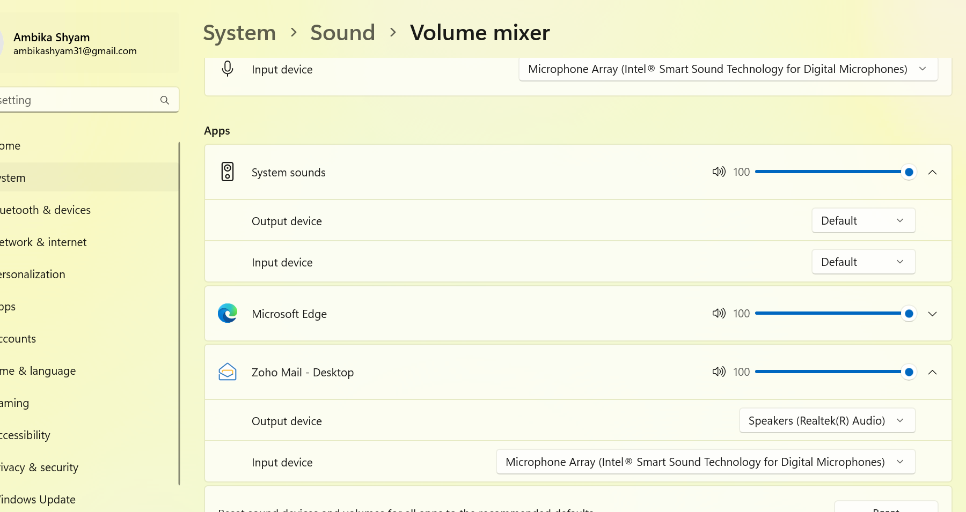

C:\ProgramData\Microsoft\Diagnosis\FeedbackArchive