HYPERION_BUDGET_F

VALIDATION SNAPSHOTS:

FOR CUSTOMER :

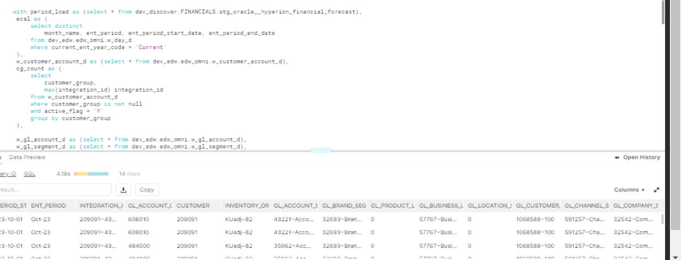

CUSTOMER_GROUP:

