BREAK THE COST OF

MARKETING, FRIGHT_COST, AND OTHERS NOT DIRECTLY RELATED TO CUSTOMER

WE HAVE TO ALLOCATE THESE COST PARTIALLY TO CUSTOMER

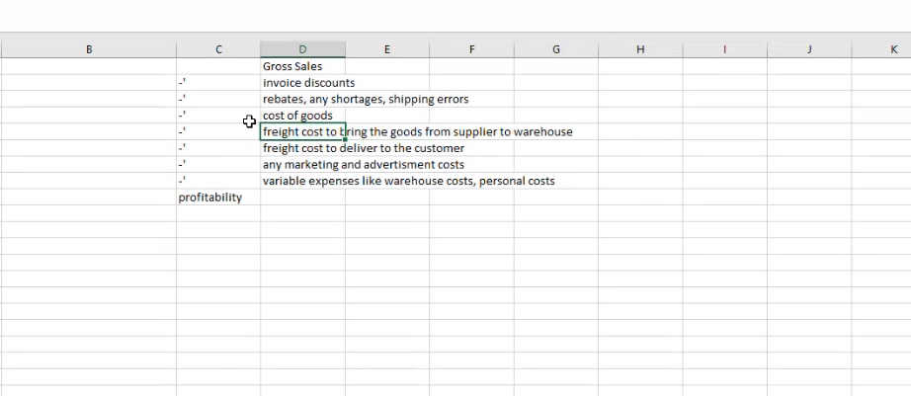

In this screen shot, I need to derive from freight to variable expenses using the logic given in the code given in the code and we have to use exceptions here to derive this.

For all the customers,

Take the cost directly and allocate to sales percentage

All the costs divided by percentage of sale

To calculate profiltability

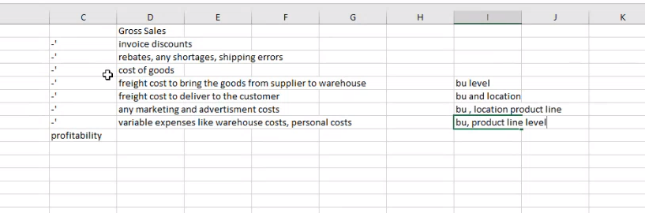

We will get the cost at the all these levels

Search for all the customers in the combination of bu,location,product_line and divide this cost by sales percentage

If I don’t get the customer sales for the 3rd level ..then I have to search for the customer sales for the 5th level and divide the cost by sales percentage

Percentage of sales varies in different levels(BU, etc..)

Percentage of the sales for the customers will be at higher level (that can be checked at the level BU and location)

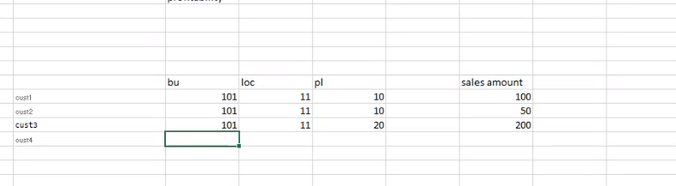

Cust 3 for different product line

Calculate percentage of sales at BU,LOC and PL (first step)

Calculate percentage of sales at BU,LOC (all the customers having same combinations) – 101,11

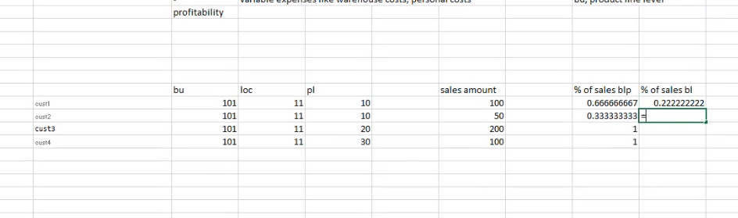

Sales percentage for cust 1 will be 100/net sales amount (450)

Similarly for all the other customers

Percentage of sales at BUL will be lesser than the BULPl

Example: freight cost for the customers for BU and L level (amout to be allocated will be selected from the percentage) of sales of BL

Allocations for each customer (we will add forecast)

Exception cases (which customers will get these costs example : advertising and media)

Most of the cost will be allocated by percentage of sales

Remove the three peiods

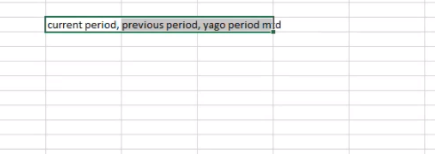

**And re insert these three periods**

**Aggregating at the month level we cannot see whats the change in yesterday date**

**In snapshot**

**Dbt queries breaking to parts with proper naming conventions**

**We did aggregate on sales history (for today)**

**Drop current period,**

**Go for previous year, year ago data**

**Calculate mtb year ago data**

**Reaggregate previous year and current year and insert data**

**Drop these three periods aggregrate and re insert those aggregates**

**IN code :**

**Deleting current period, previous period and year ago current period**

**These three we delete and we do reaggregate and insert this data**

**From current period I will be getting current period an dyago dat’s and**

**From forecast scenaros d I will be getting 3 scenarios**

**Customer scenarios d (it’s a one time dimension table used)**

**So need to set flag = “Y” to take corresponding scenario**

**Calculate percent of month that is completed :**

**Forecast for the month of April possible but not till the month of June 29th not possible**

**But for sales it is possible to find out till the month of June 29th**

**Tahe the mtd of the completed month * forecast to get the forcast of the expected month**

**To caculate that we are finding the percentage of how many ship dates already done**

**Line no 85 to 93 (calculate the ship date completed ) and to get forcast for expected month**

**Percentage of month complete to pro rate the forcast**

**Mtd for precent**

**Ship cal for pro rate of forrcast**

**Getting all the sales details columns such as**

1. **Item,products, gl_Accounts (transactions done at the gl_Accounts level)**
2. **Lien number 166 very important**
3. **This for full history and not the next line with jan date (as it is incremental)**

**First caculation**

**Trascational details required for the period (with sales details attribites)**

**Now I have all the sales (in the outer part)**

**Now I should go for the inner part (with alloc)**

**First calcution gets all the transacions**

**Second calculation to find all the cost (that we need to allocate by percent of sales)**

We are indetifying those costs (which do not have customers or item associated with it)

Which are entered manullay in to GL (important)

Line no : 425 to 435 that says important quoted above

Gl.event_clas_code is null (is manual entry)

Account type code not equaol to R (not revenue generating customer)

Source code not in (accountpayable, cogs and fa)

The above calculation for customrs that’s in the excel (from line o 5 to 8)

And allocate these costs to customwrs based on the percent of sales

Line no .430 is the exception for the customers having royality income

Another exception line no.454 (manual input sales) wc_dily_sales_m

(their operations not merged with our business process)

We are not supposed to include them in allocations

They provide temp reporting service and consolidated sales to us

But not merged with our business

Allocation we do at GL_ACCOUBT_LEVEL)

Not at custome or inventory level

418 (hierarchy product line ) where as 419 details product line

All the segments we are grouping by.

Irrespective of the product cost let us find out the percentage of sales for each customer

Next is the calculation of precent of sales

( need to tak up this video from 34.01) mins

* I nee to submi the code to satify to this level
* Allocation for the customers with exceptions
* In union all , yago…mtd calculation is separate calculation and before that it is for current year
* Third union all consolidating external sales details (wc_sales_m)
* Till 1181 we are doing salas part
* After that allocation
* Line no 1232 and 1233 (invoice amount) which …
* They are selling an item for the price above the mentioned item price
* They have to find out whats the variance price for that item
* I am going to take the price from wc_list_price (* quantity) will give the exact price
* Subtract from the previous line and get the variance price
* Variancr pricr in (line 1214) gives the price whats they have quoted for that item (above or below) the original pricr
* Line no 1304 to 1310 (exceptions ) I may handlt it later
* Alloc_segment_value_Descr in amazon will be chcked as IN (amazon consitons)
* 305 to 349 ignore
* Replace the forecast amout with the actual of the past period
* 289 to 301 (calculation of using actuals amount for the past three months (1.e less then current year) and dotn go for forecast and condition = current month or year then comes
* Forecast amount or budget amount
* From 204 (calculation for reports)
* W_gl_Segment_tl not avail so..we need to pick cols from w_segment_dh
* Pre_hooks to inert data into table or form akey forall the id fields to combine it and get it .