**Unit Test Cases**

1. Validate DAG for proper lineage
2. Successful clean execution on models.
3. Successful Entry in EL_BATCH_REFRESH_TRACKER
4. Unique test for integration id
5. Insert Record Test
6. Update Record Test
7. Audit Logs
8. **Validate for proper lineage**

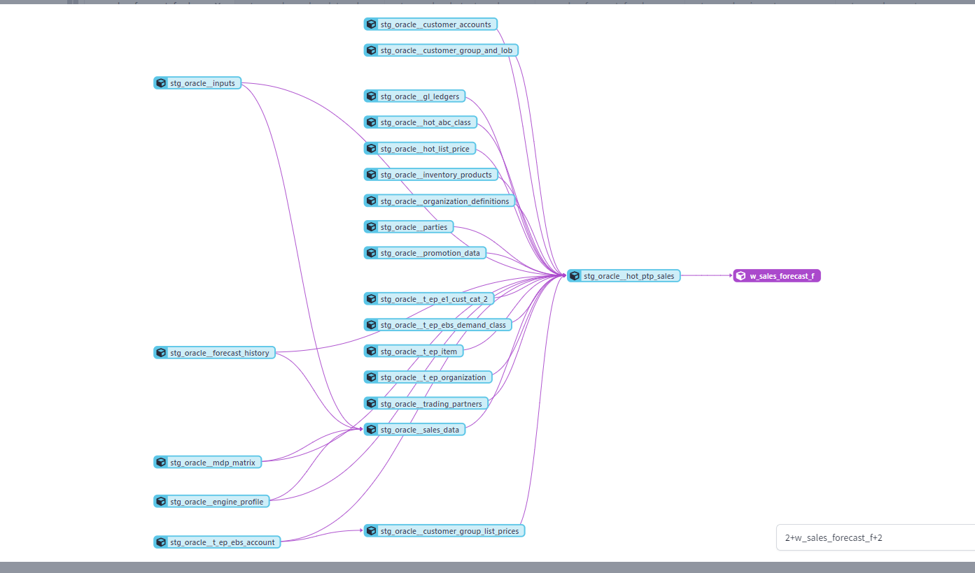

1. **Successful clean execution on models**

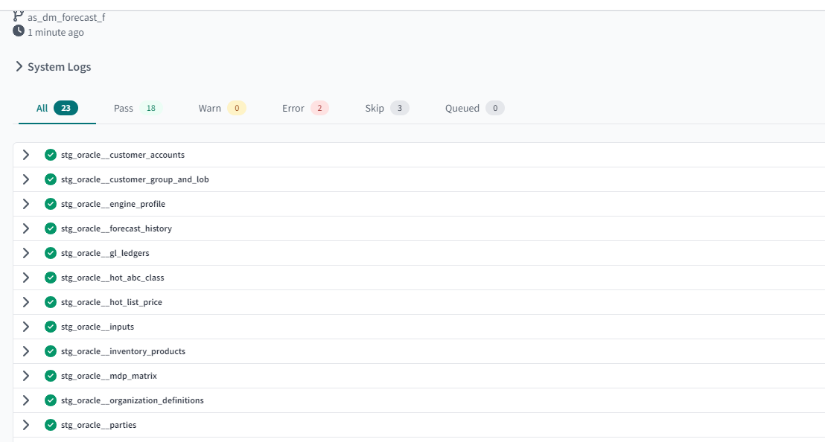

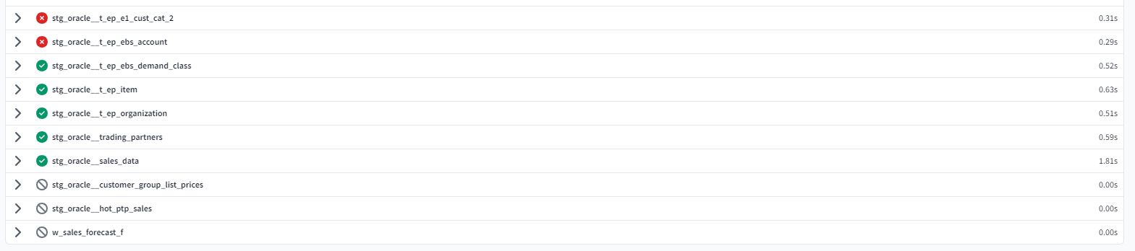

1. **Successful Entry in EL_BATCH_REFRESH_TRACKER**

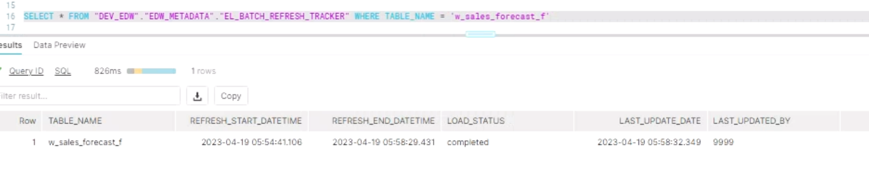

**DBT full refresh successful**

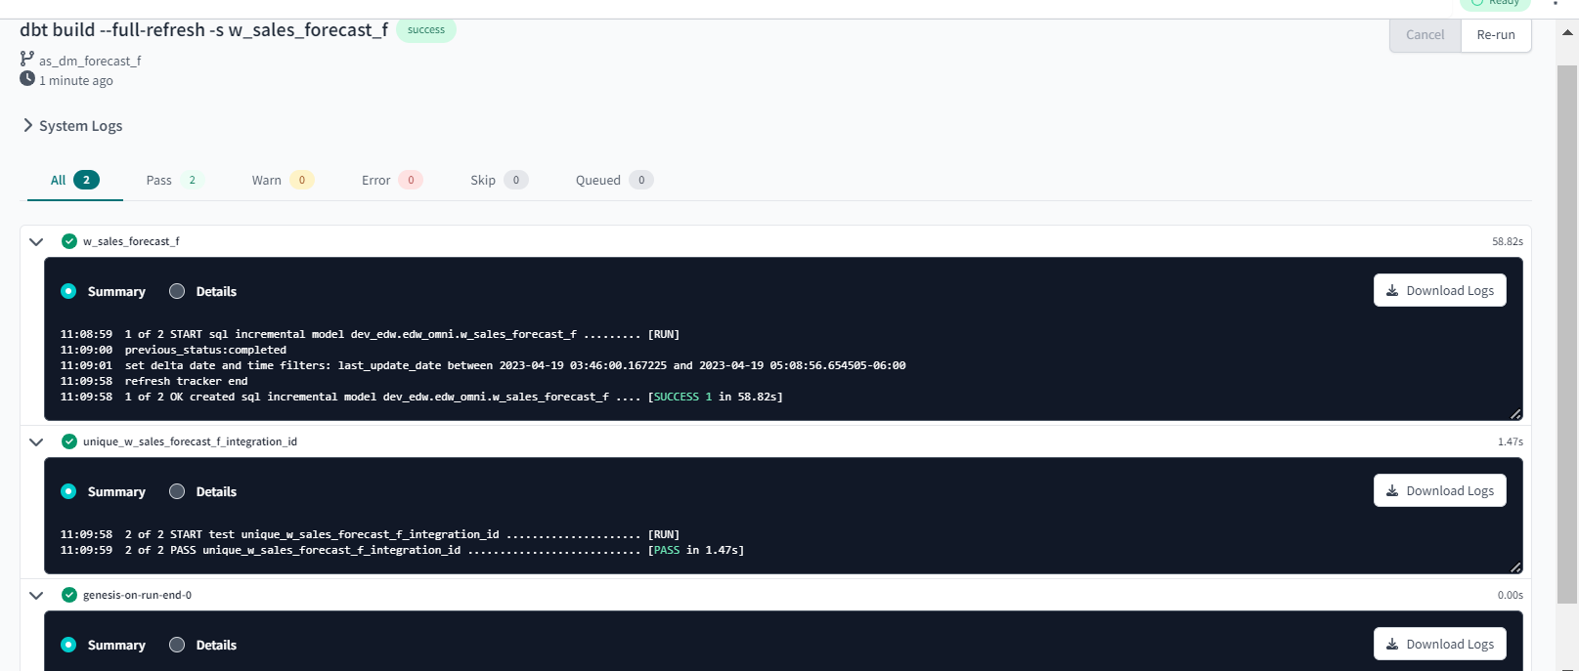

1. **Unique test**

**Unique test passes when finds integration id values are unique**

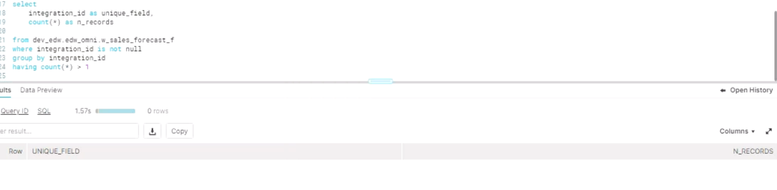

**Fails when finds integration id is not unique**

**DBT OUTPUT:**

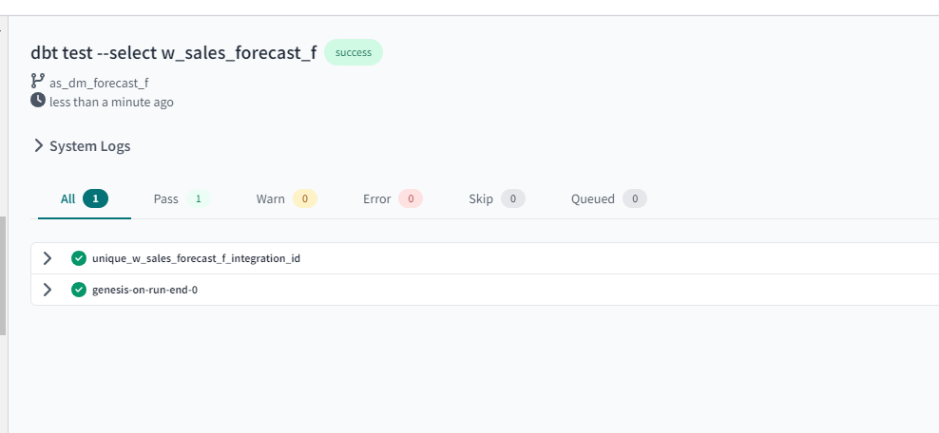

**DBT Output: Incremental Run**

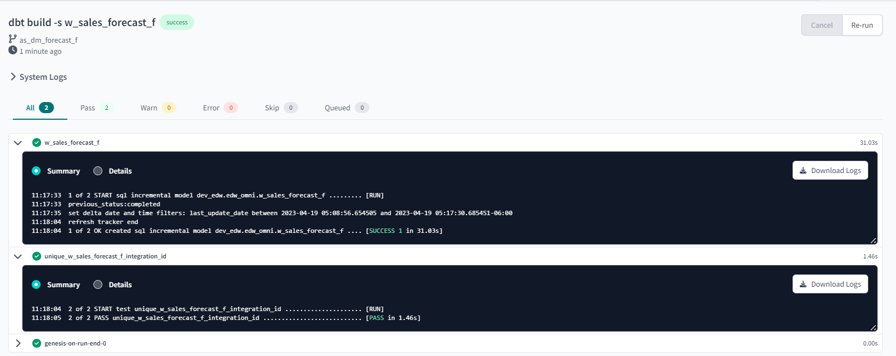

1. **Insert record test**

Inserted record in source table that got reflected in the stage table:

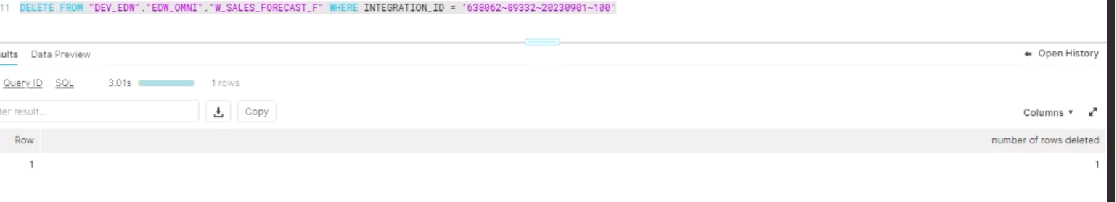

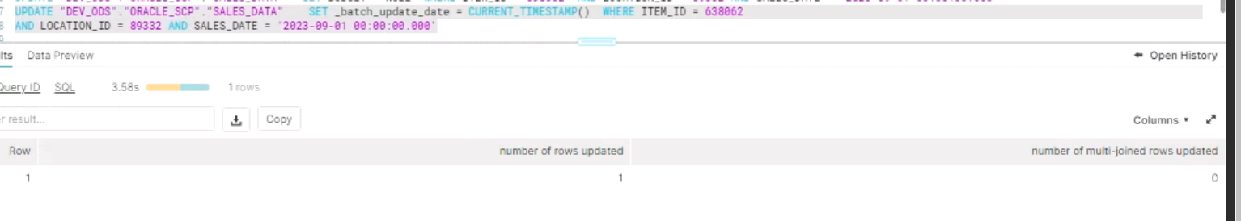

After DBT Incremental Run:

Final table output:

AFTER DBT INCREMENTAL RUN RECORD GOT INSERTED FROM STAGE MODEL:

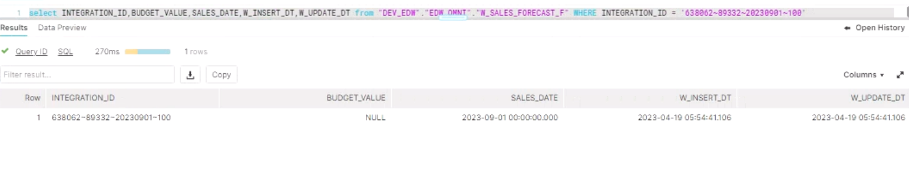

1. **Update Test**

Before updating:

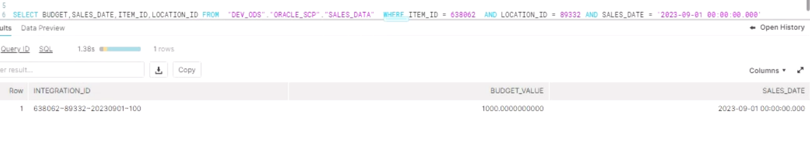

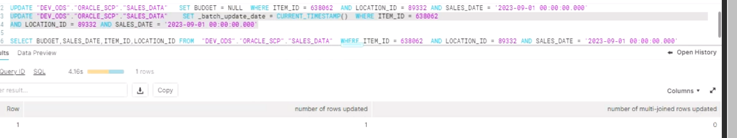

After Incremental Run:

After updating record:

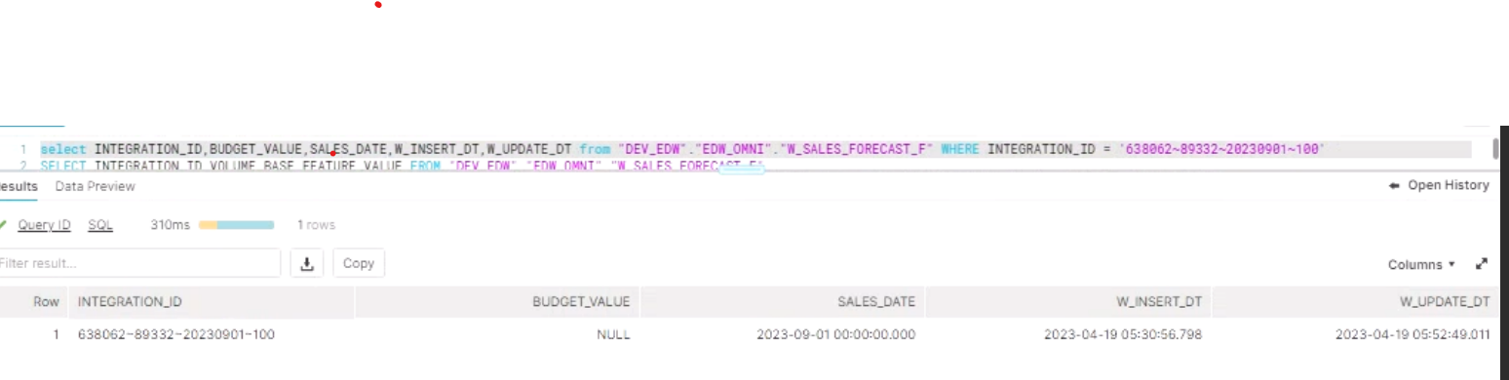

1. **Audit Logs**

