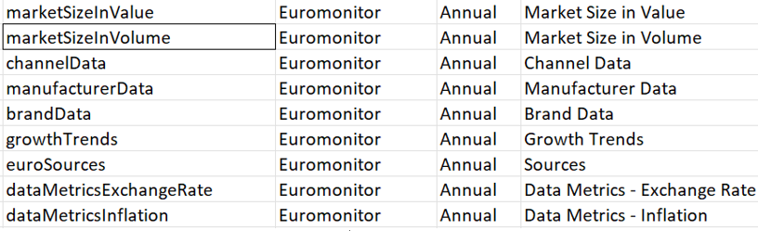

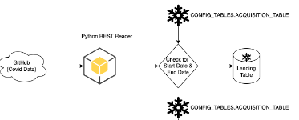

|  |  |  |  |
| --- | --- | --- | --- |
| Database Name | PROD_RAW | Schema Name | IHSMARKIT |
| Warehouse | PROD_INGEST_WH | Talend Repository Name | CASPIAN_DATA_PROD |
| Role | PROD_RAWBUILD_RW | Talend Plan Name | IHSMARKIT_ Phase-2 |
| Landing Table | IHS_CHINA_REGIONAL_SERIES_LANDING | Talend Job Name | PYTHON_RUNNERS |
| Task Name | PYTHON_RUNNER-IHSMARKIT__IHS_ECONOMIC_US_ECONOMY_HISTORICAL_SERIES | **Schedule** | **At 06:00, on the third Monday of the month, January through December** |
| DBT Plan Name | IHSMARKIT_ Phase-2 | DBT Task Name | DBT_RUNNER-REHYDRATE-IHSMARKIT-ALL_DATASETS(V7) |
| Python Program | ihsProcess.py | Arguments | IhsChinaRegionalConnection |

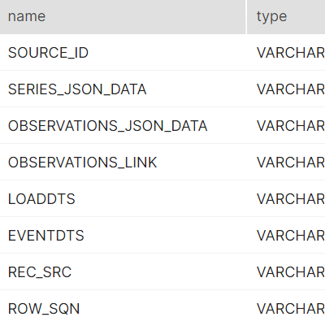

[11:45 AM] Ambika Shyam

Config diagram for 1. NOAA, 2. MS-POS, 3. similar web 4. SI_market-place (not yet updated @ run book)

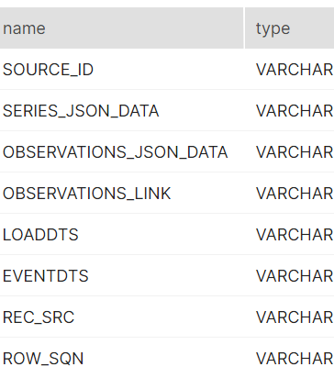

|  |  |  |  |  |
| --- | --- | --- | --- | --- |
| Database Name | PROD_RAW | Schema Name | IHSMARKIT | |
| Warehouse | PROD_INGEST_WH | Talend Repository Name | CASPIAN_DATA_PROD | |
| Role | PROD_RAWBUILD_RW | Talend Plan Name | IHSMARKIT_ Phase-2 | |
| Landing Table | IHS_ECONOMIC_CONSTRUCTION_CANADA_SERIES_LANDING | Talend Job Name | PYTHON_RUNNERS | |
| Task Name | PYTHON_RUNNER-IHSMARKIT_ihsEconomicConstructionCanadaSeriesConnection | **Schedule** | **At 06:00, on the third Monday of the month, January through December** | |
| DBT Plan Name | IHSMARKIT_ Phase-2 | DBT Task Name | DBT_RUNNER-REHYDRATE-IHSMARKIT-ALL_DATASETS(V7) | |
| Python Program | ihsProcess.py | Arguments | | ihsEconomicConstructionCanadaSeriesConnection |

|  |  |  |  |
| --- | --- | --- | --- |
|  |  |  |  |

1. China Regional Historical
2. Financial Markets Historical
3. Global Economy Historical
4. Global Economy
5. **Global Economy new**
6. Pricing and Purchasing Forecast
7. US Economy
8. World Market Monitor
9. Construction_Global – **data browser only**

