**ERORS IN EUROMONITOR:**

**1.MARKET SIZE IN VALUE:**

NEW_FILE:

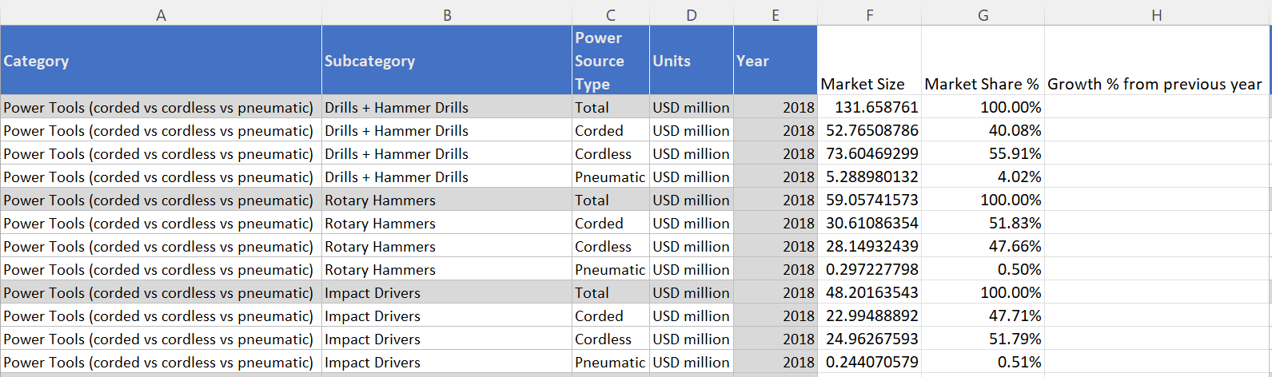

OLD FILE:

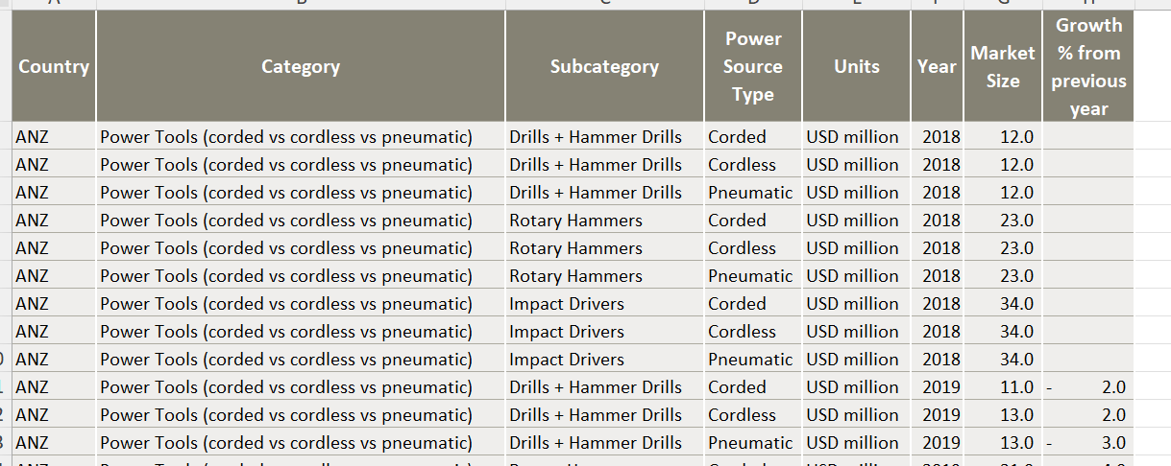

REMARKS: MARKET_SHARE_% included and COUNTRY excluded (in new file)

**2. CHANNEL_DATA:**

**NEW_FILE**

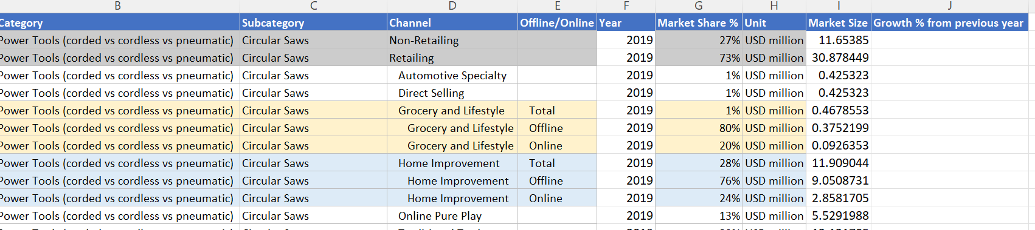

**OLD_FILE:**

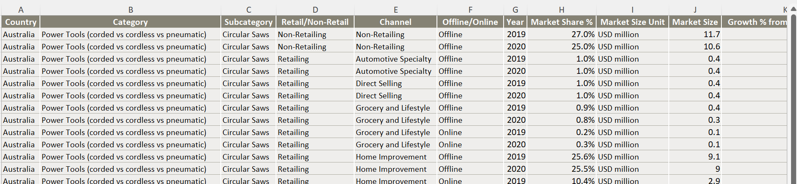

REMARKS: Column (Retail/Non-Retail) not included in new_file

**3. BRAND_DATA:**

NEW_FILE:

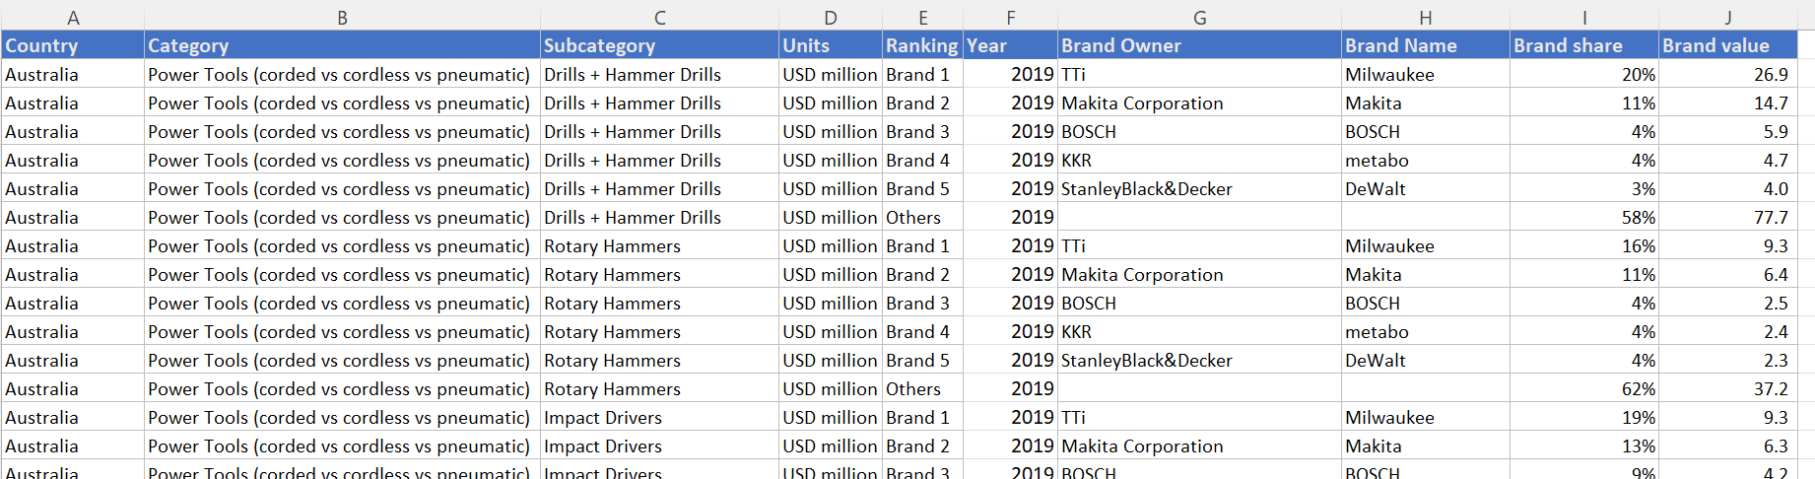

OLD_FILE:

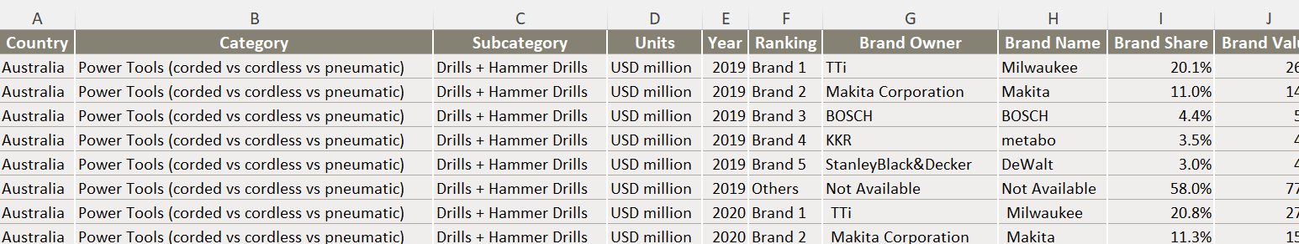

REMARKS: RANKING AND YEAR POSITION INTERCHANGED