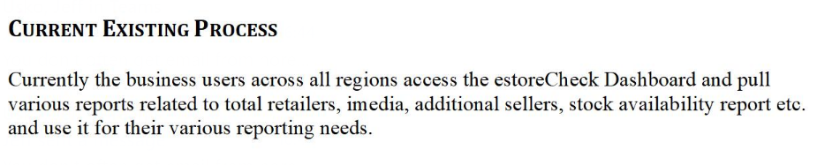

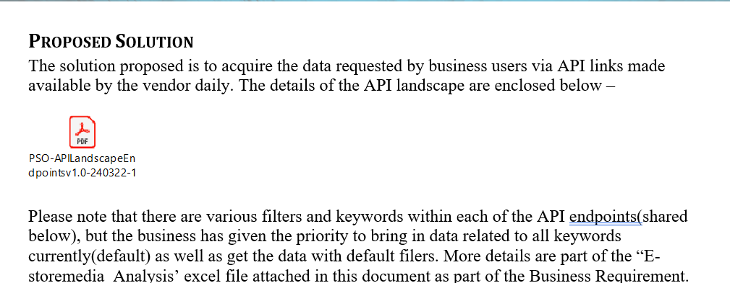

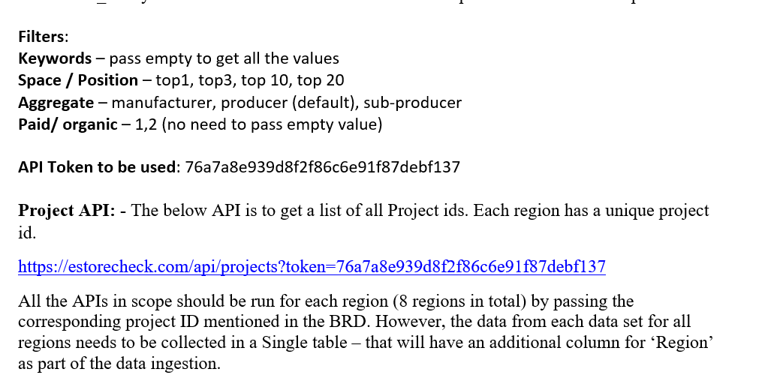

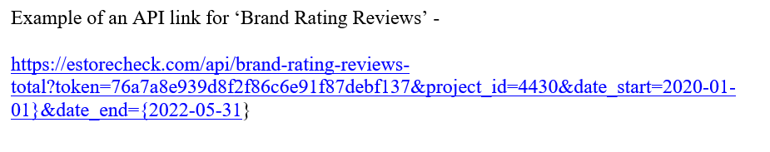

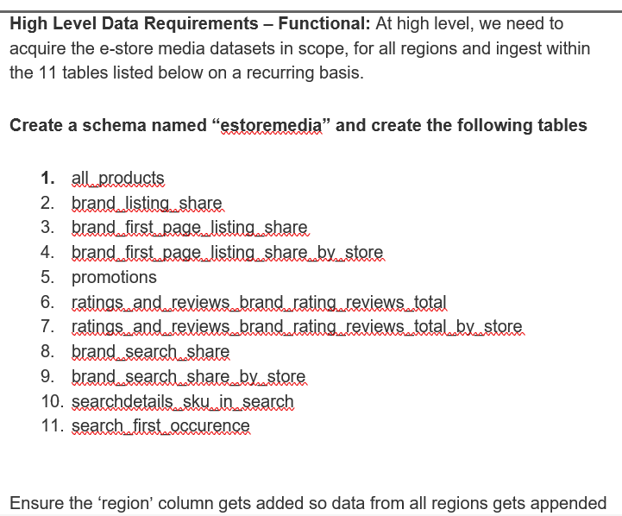

Doubt: ( data populated for each region) one by one for these 11 tables

Relation to this statement :

All the APIs in scope should be run for each region (8 regions in total) by passing the corresponding project ID mentioned in the BRD. However, the data from each data set for all regions needs to be collected in a Single table – that will have an additional column for ‘Region’ as part of the data ingestion.

High level requirements – popultating data for 11 tables (using all api’s for region one by one)

Using project_ID as the input (id for each region)

For example: if it is of region : INDIA (4430) as project id

I need to retrieve the all the apis specified for this region for the corresponding the 11 tables

Populate it and then go on to other region (is it like that?)

( need clarification)