SQL

MANDATORY CASE STUDY 1

**Submitted by: Ambika B**

Tasks To Be Performed:

**1. Display the number of states present in the LocationTable.**

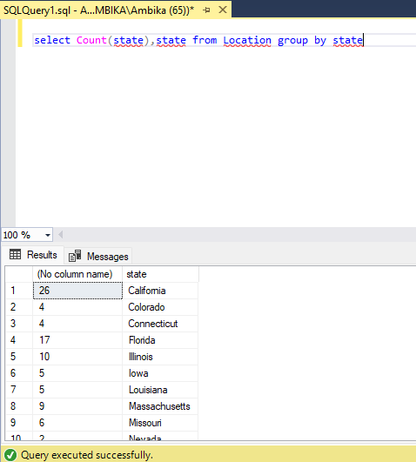

**2. How many products are of regular type?**

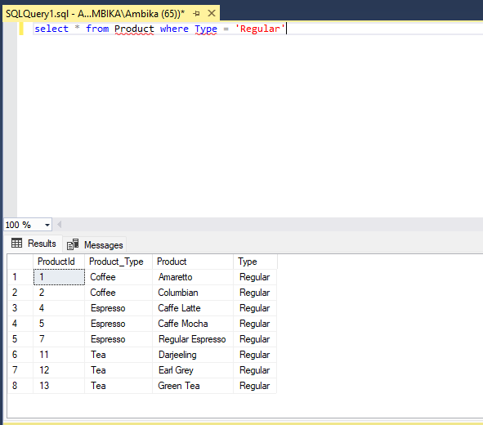

**3. How much spending has been done on marketing of product ID 1?**

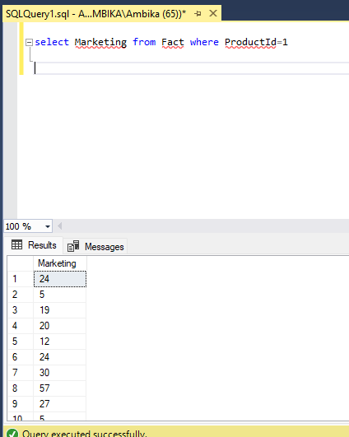

**4. What is the minimum sales of a product?**

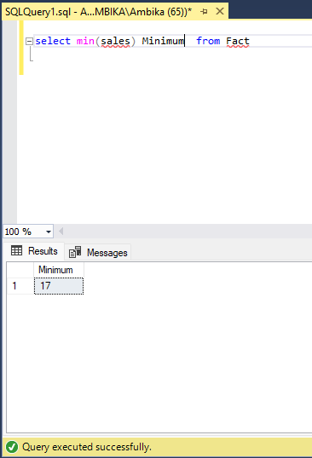

**5. Display the max Cost of Good Sold (COGS).**

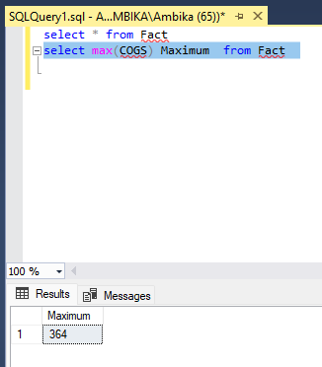

**6. Display the details of the product where product type is coffee.**

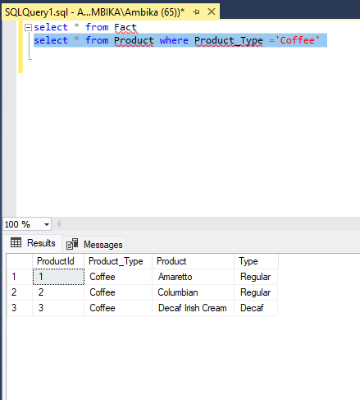

**7. Display the details where total expenses are greater than 40.**

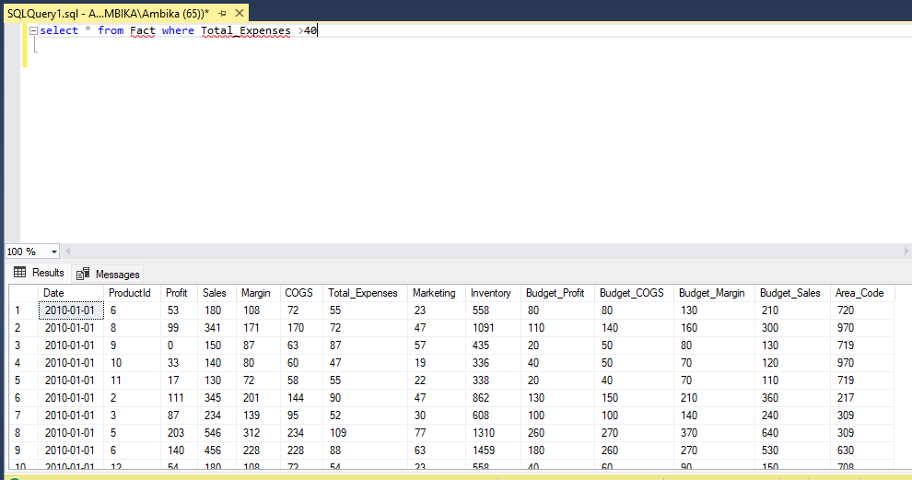

**8. What is the average sales in area code 719?**

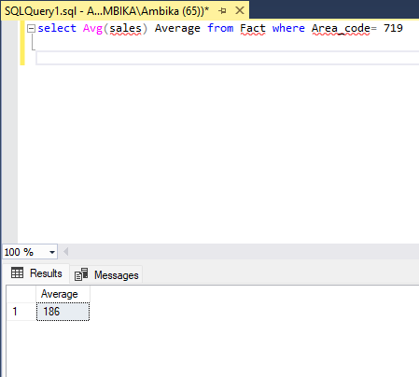

**9. Find out the total profit generated by Colorado state.**

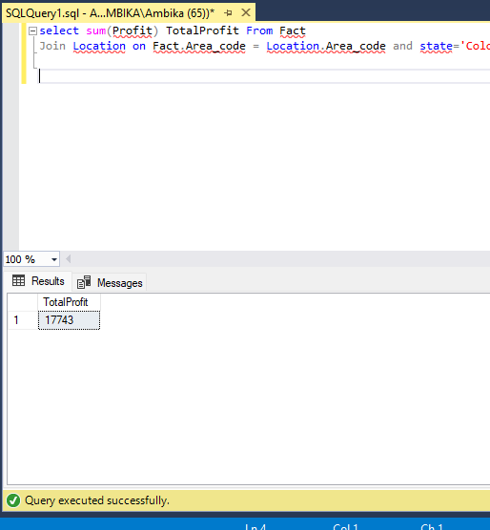

**10. Display the average inventory for each product ID.**

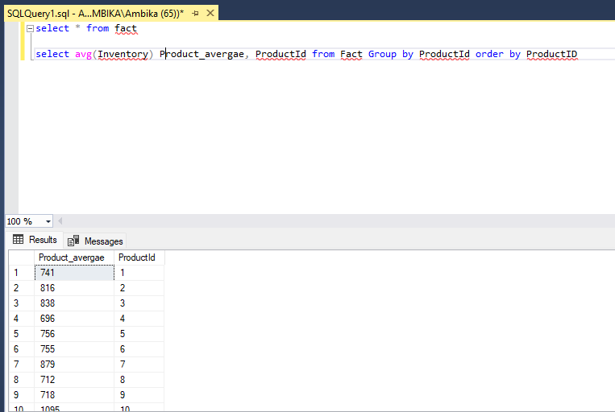

**11. Display state in a sequential order in a Location Table.**

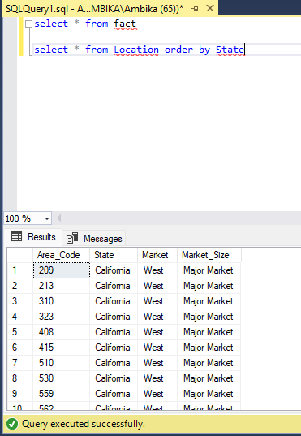

**12. Display the average budget of the Product where the average budget**

**margin should be greater than 100.**

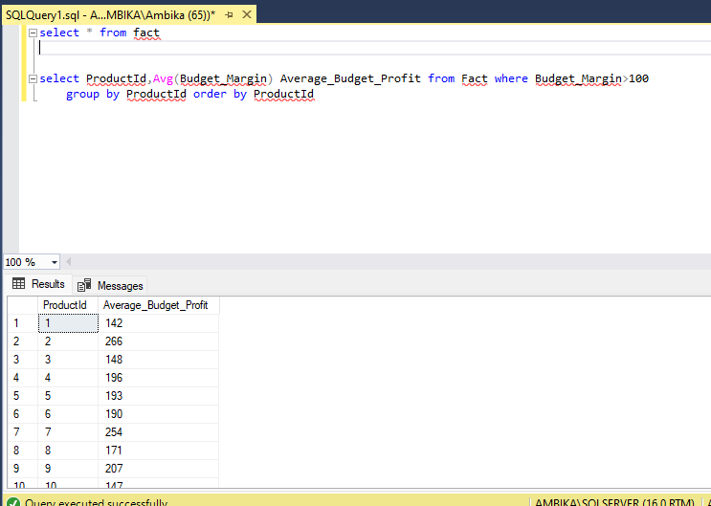

**13. What is the total sales done on date 2010-01-01?**

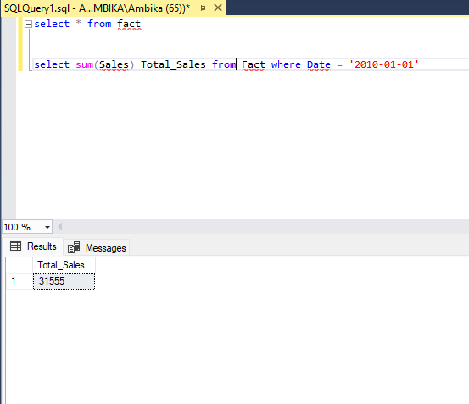

**14. Display the average total expense of each product ID on an individual date.**

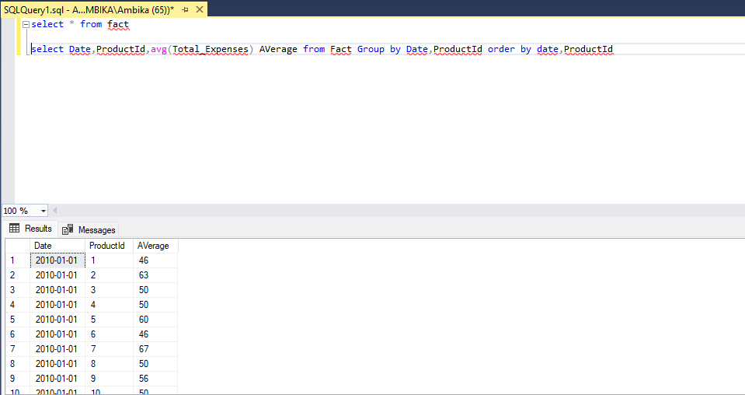

**15. Display the table with the following attributes such as date, productID, product_type, product, sales, profit, state, area_code.**

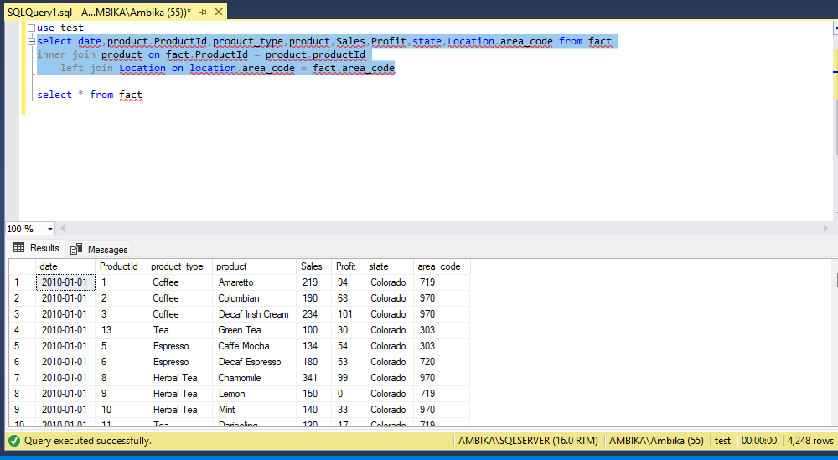

**16. Display the rank without any gap to show the sales wise rank.**

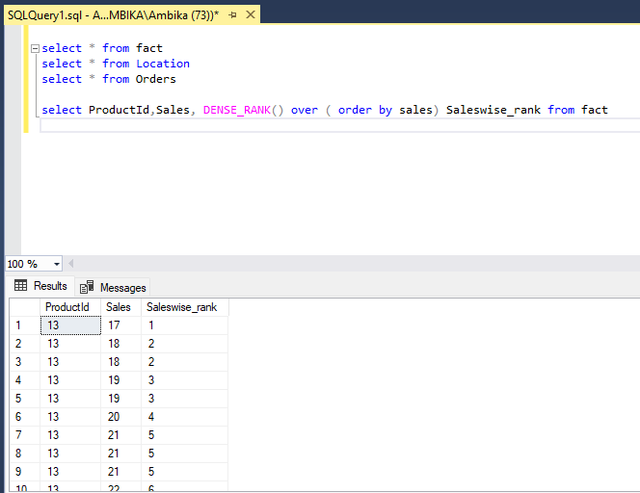

**17. Find the state wise profit and sales.**

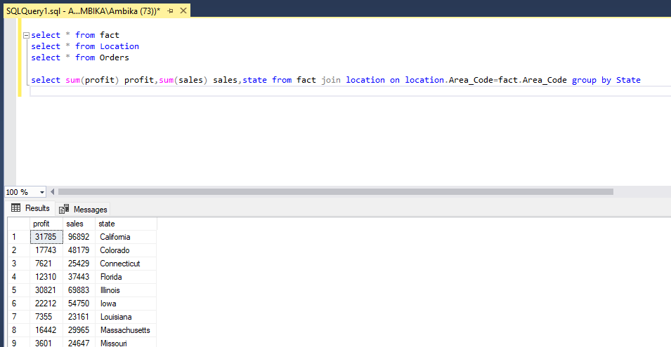

**18. Find the state wise profit and sales along with the productname.**

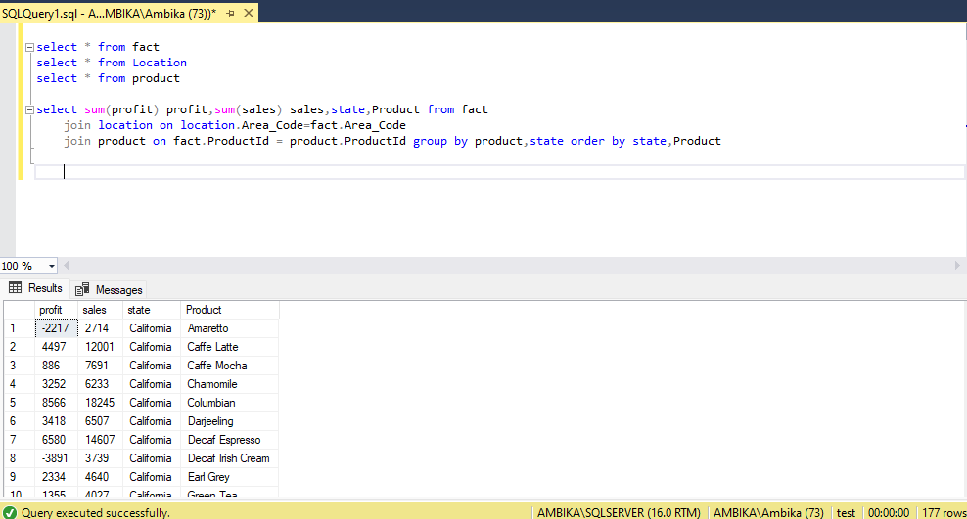

**19. If there is an increase in sales of 5%, calculate the increasedsales.**

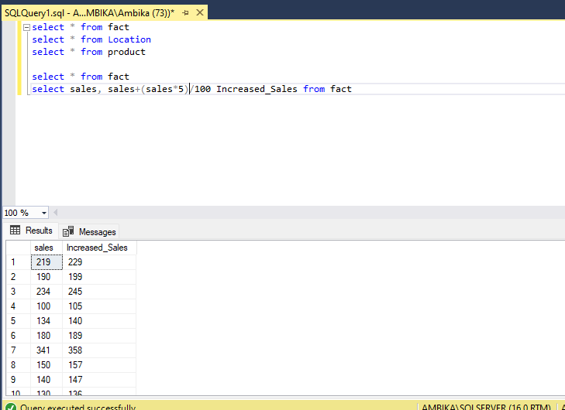

**20. Find the maximum profit along with the product ID and producttype.**

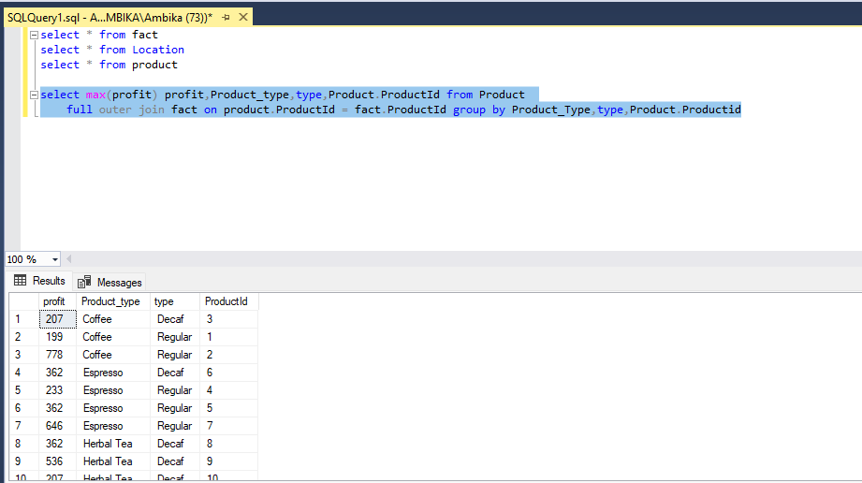

**21. Create a stored procedure to fetch the result according to the product type from Product Table.**

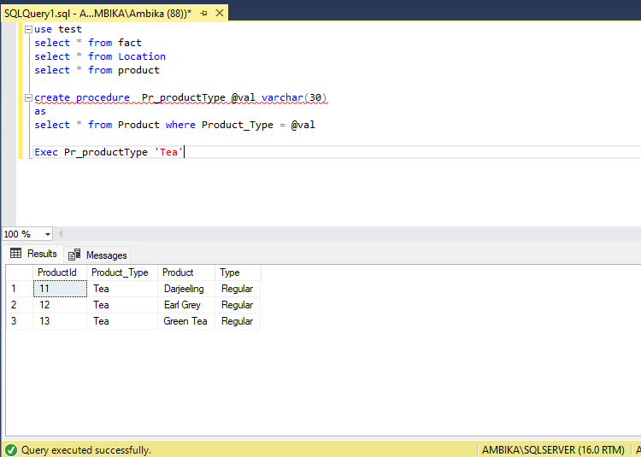

**22. Write a query by creating a condition in which if the total expenses is lessthan60 then it is a profit or else loss.**

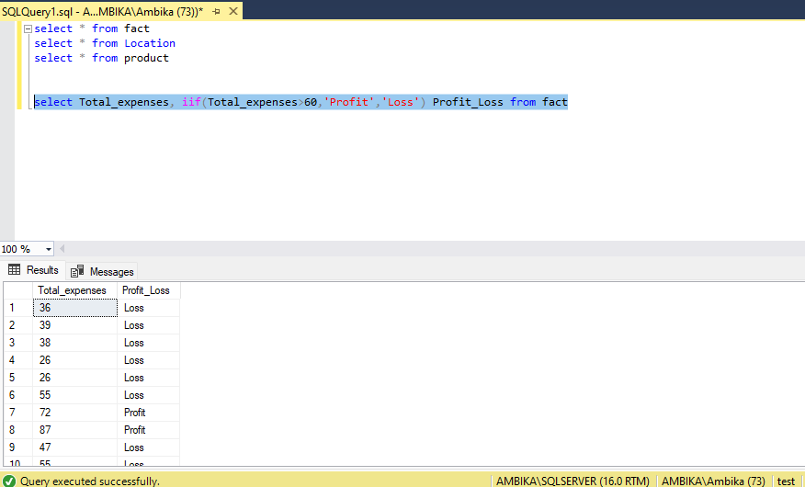

**23. Give the total weekly sales value with the date and product ID details. Use roll-up to pull the data in hierarchical order.**

**\*Sending 2 answers as not sure which one is correct**

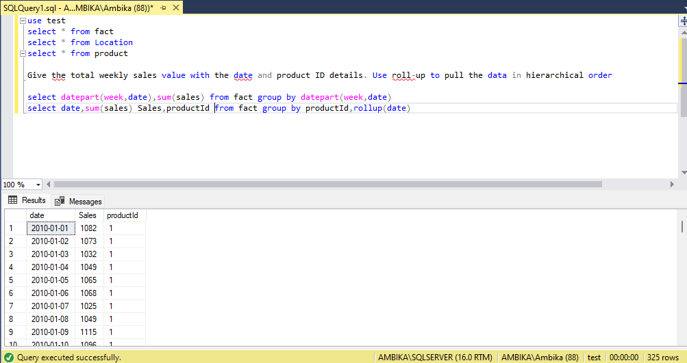

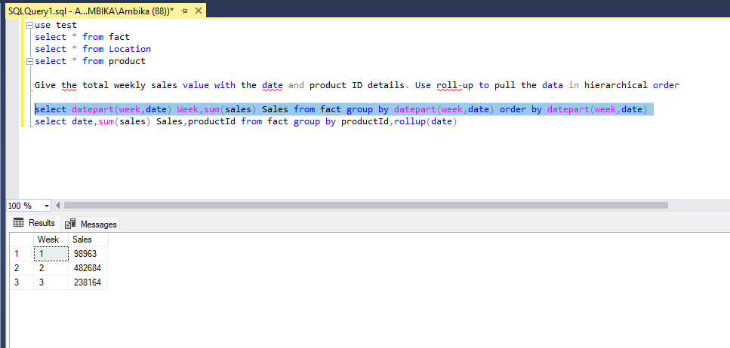

**24. Apply union and intersection operator on the tables which consist of**

**attribute area code.**

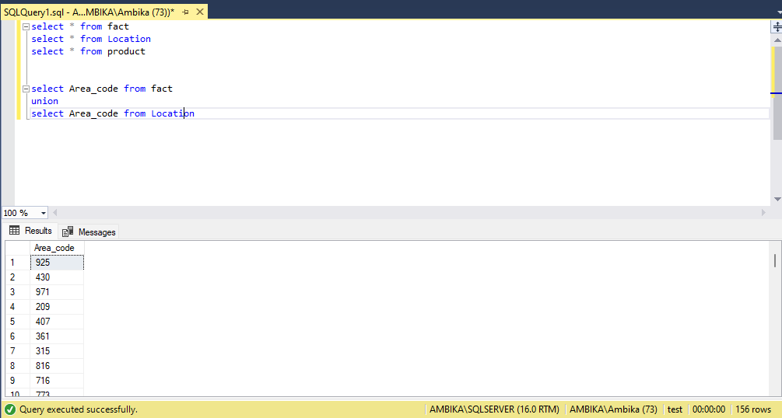

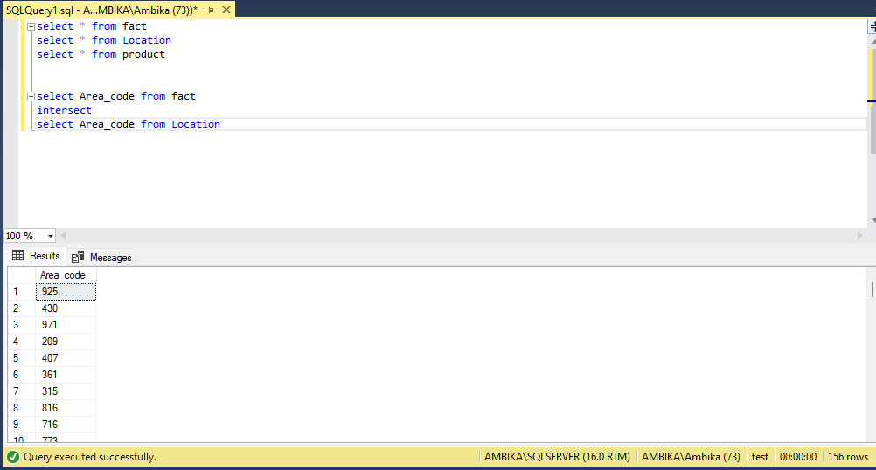

**25. Create a user-defined function for the product table to fetch a particular**

**product type based upon the user’s preference.**

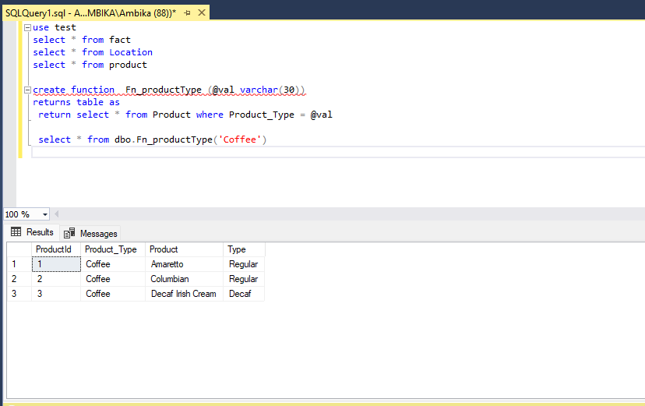

**26. Change the product type from coffee to tea where product IDis 1 and undo it.**

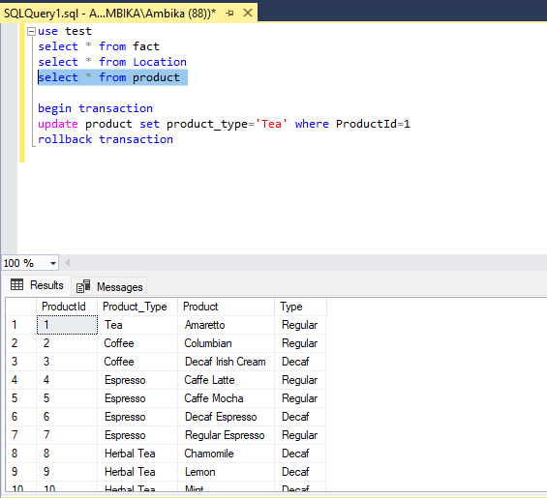

**After Rollback**

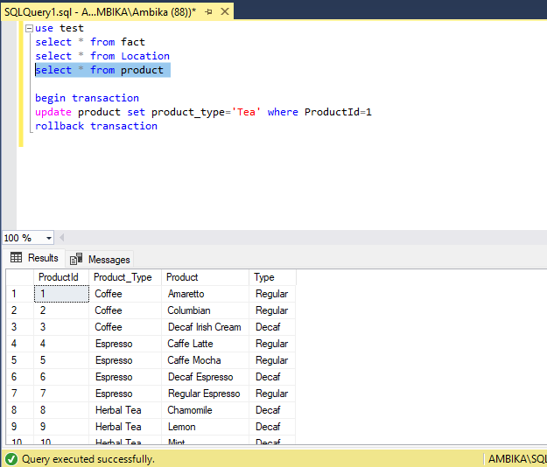

**27. Display the date, product ID and sales where total expenses are**

**between 100 to 200.**

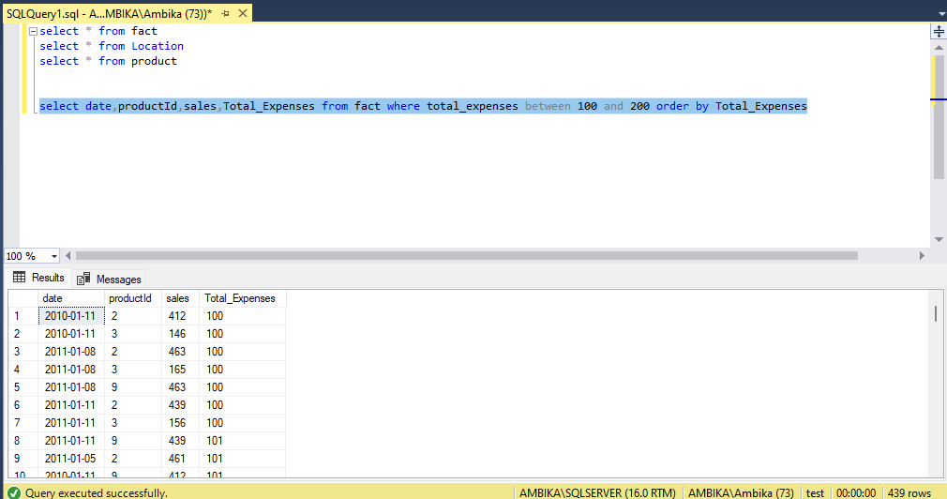

**28. Delete the records in the Product Table for regular type.**

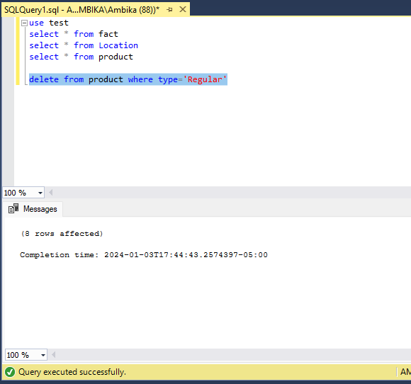

**29. Display the ASCII value of the fifth character from the column Product.**

