AWS VPC, Load Balancer, and Auto Scaling Setup

Assignment Tasks:
- High Availability Web Application
  - Design and deploy a highly available web application using:
    - Application Load Balancer
    - Auto Scaling Group
    - EC2 instances in multiple AZs
- High Availability Web Application
  - Design and deploy a highly available web application using:
    - Application Load Balancer
    - Auto Scaling Group
    - EC2 instances in multiple AZs
  - Use a custom AMI or user data script to install a sample web server.
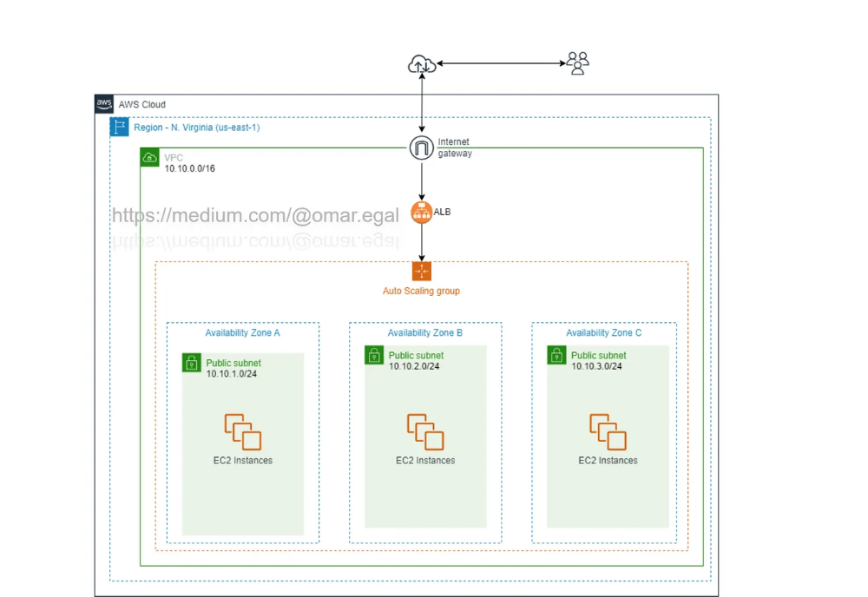

Overview
This document provides step-by-step instructions to create a Virtual Private Cloud (VPC), Load Balancer (LB), and Auto Scaling Group (ASG) in AWS. It also includes a User Data script to automatically install a sample web page on instances.

Prerequisites
1. An active AWS account.
2. Access to the AWS Management Console.

Step 1:
1. Create a VPC
Go to the VPC Dashboard in AWS Console.
Click “Create VPC”.
Choose VPC only.
Enter:
Name tag: e.g., MyVPC
IPv4 CIDR block: e.g., 10.0.0.0/26
Leave other settings as default or adjust as needed.
Click Create VPC.
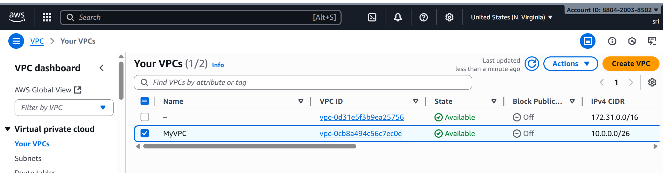

2. Create 2 Public Subnets
Go to Subnets > Create subnet.
Select your newly created VPC.
Create two subnets:
Subnet 1:
Name tag: PublicSubnet1
Availability Zone: e.g., ap-south-1a
CIDR block: e.g., 10.0.0.0/27
Subnet 2:
Name tag: PublicSubnet2
Availability Zone: e.g., ap-south-1b
CIDR block: e.g., 10.0.0.32/27
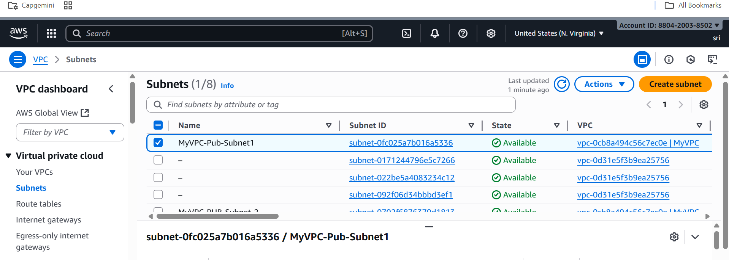
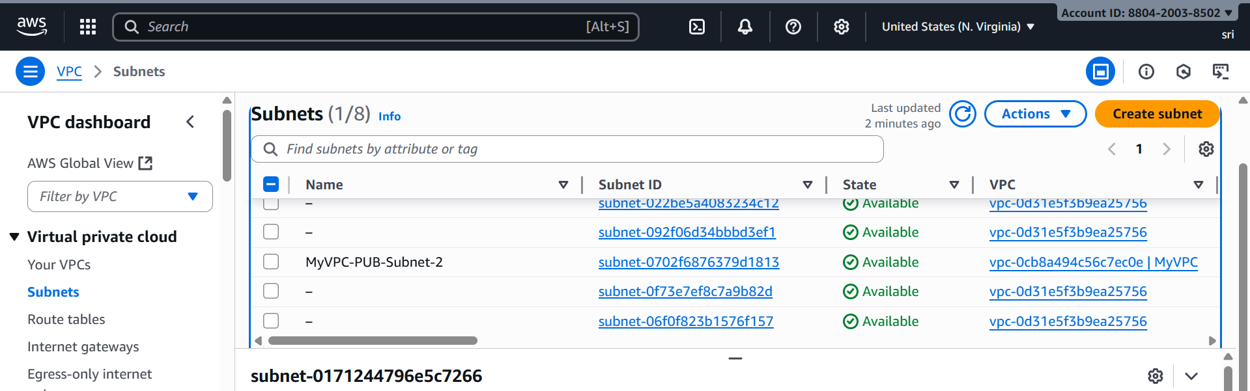
3. Create an Internet Gateway (IGW)
Go to Internet Gateways > Create internet gateway.
Name tag: e.g., MyIGW
Click Create internet gateway.
After creation, select the IGW and click Actions > Attach to VPC.
Choose your VPC and attach.
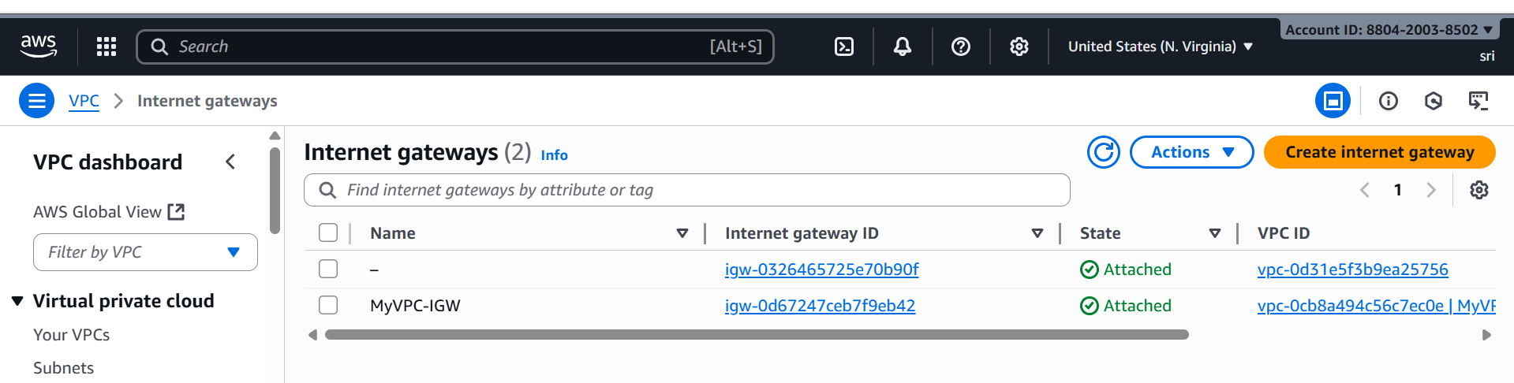

4. Modify Subnet Settings to Enable Auto-Assign Public IP
Go to Subnets, select each public subnet.
Click Actions > Modify auto-assign IP settings.
Enable Auto-assign IPv4.
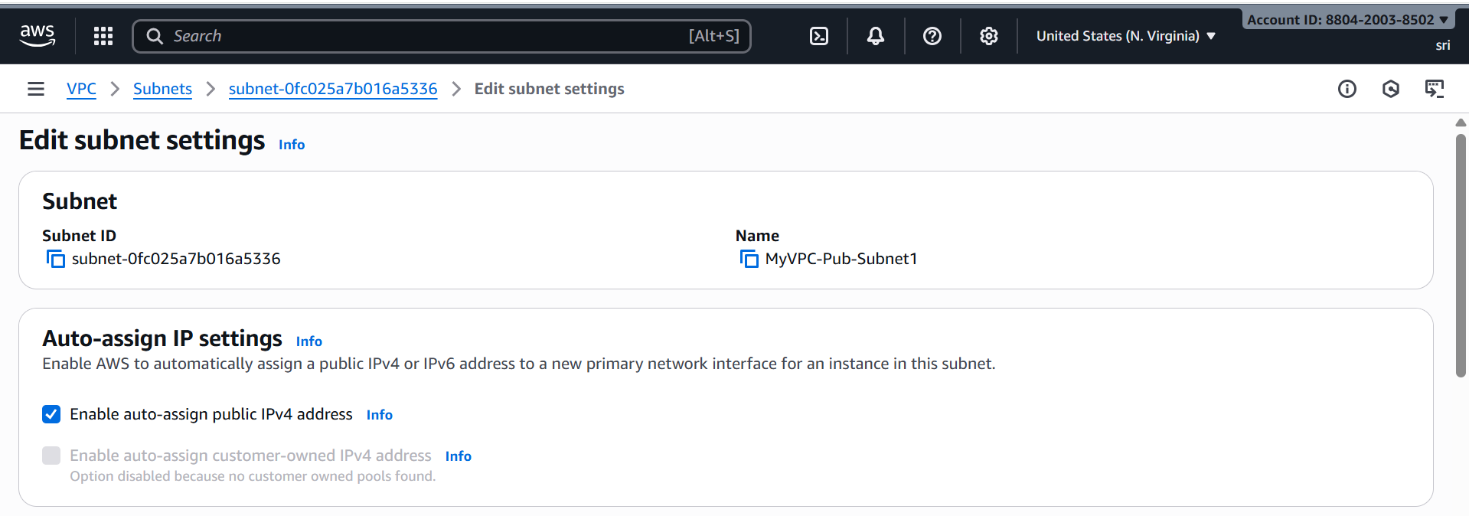
Save.

Step 5: Create a Launch Template
1. Go to EC2 → Launch Templates → Create launch template.
2. Enter a Name (e.g., WebServerTemplate).
3. Choose Amazon Linux 2 AMI.
4. Choose instance type (e.g., t2.micro).
5. Under Advanced Details → User data, paste the script below:
#!/bin/bash
sudo yum update -y
sudo yum install -y httpd
sudo service httpd start
sudo service httpd enable
echo "<h1> Welcome |serving from $(hostname -f)</h1>" > /var/www/html/index.html
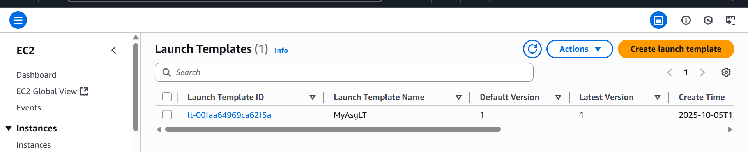

Step 6: Create an Auto Scaling Group
1. Go to EC2 → Auto Scaling Groups → Create Auto Scaling group.
2. Select your Launch Template.
3. Choose your VPC and subnets.
4. Attach to a new Load Balancer (see next step).
5. Set desired capacity = 2, minimum = 2, maximum = 5.
6. Review and create the group.
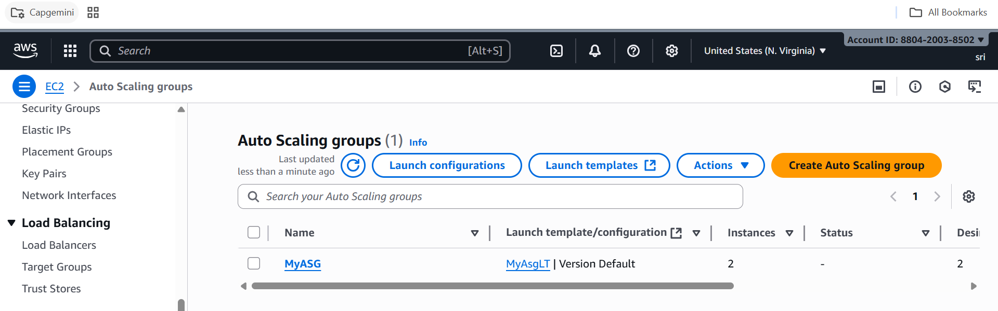

Step 7: Create an Application Load Balancer
1. Go to EC2 → Load Balancers → Create Load Balancer.
2. Select Application Load Balancer.
3. Choose a name (e.g., MyALB) and scheme 'Internet-facing'.
4. Select at least two public subnets.
5. Create a new target group (type: instance).
6. Attach your Auto Scaling Group to this target group.
7. Review and create the Load Balancer.
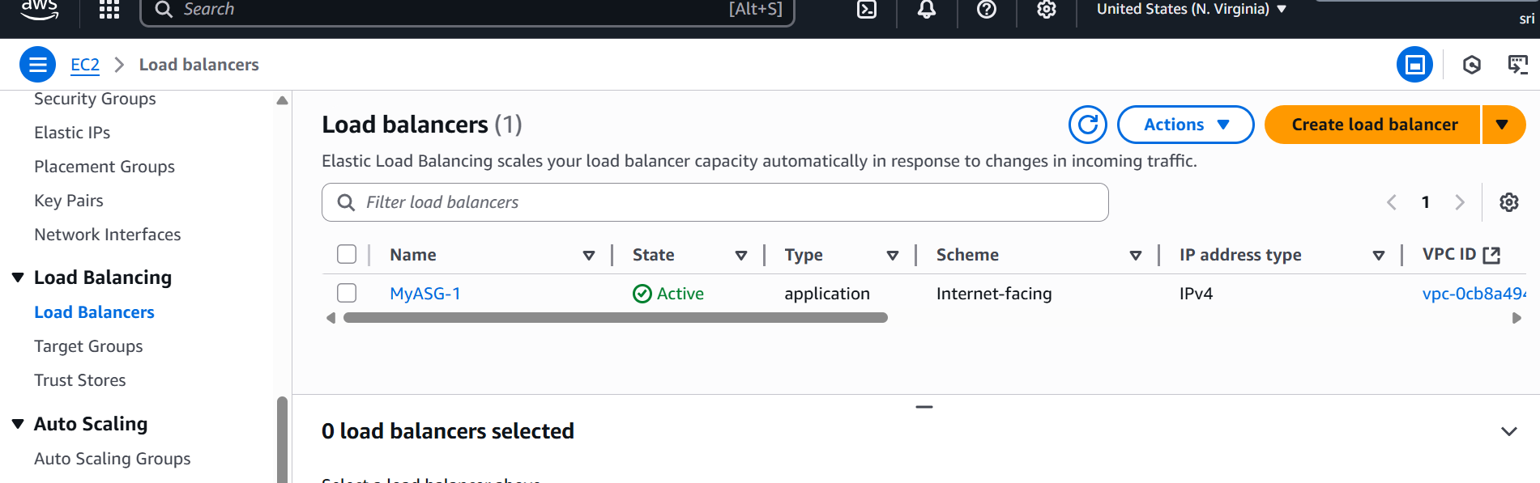

Step 7: Verification
1. Once the instances are launched, go to EC2 → Instances → copy the public DNS or ALB DNS name.
2. Open it in a browser: http://<ALB-DNS-Name>.
3. You should see the message:
'Welcome to My Sample Web Page - Deployed via User Data!'

