Lesson 06 Demo 02

Setting up Jenkins Pipeline Job from Git

Objective: To set up a Jenkins pipeline job from Git version control system to enable automated CI for building, testing, and potentially deploying software upon code changes

Tools required: Jenkins, Git and Linux

Prerequisites: None

Steps to be followed:
- Create a Git repository
- Push the pipeline script into the Git repository
- Create a pipeline script-based freestyle job

Step 1: Create a Git repository

Note: If you do not have a GitHub account, visit the official website at https://github.com/signup and create a new account
- Open the browser in your lab, go to github.com, and Sign in to your account
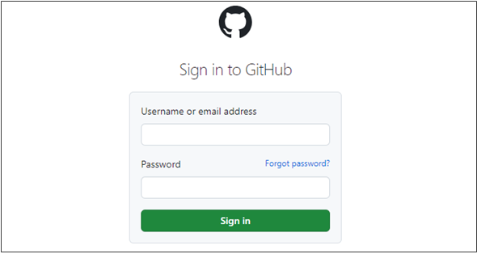

- Click on New as shown in the screenshot below:
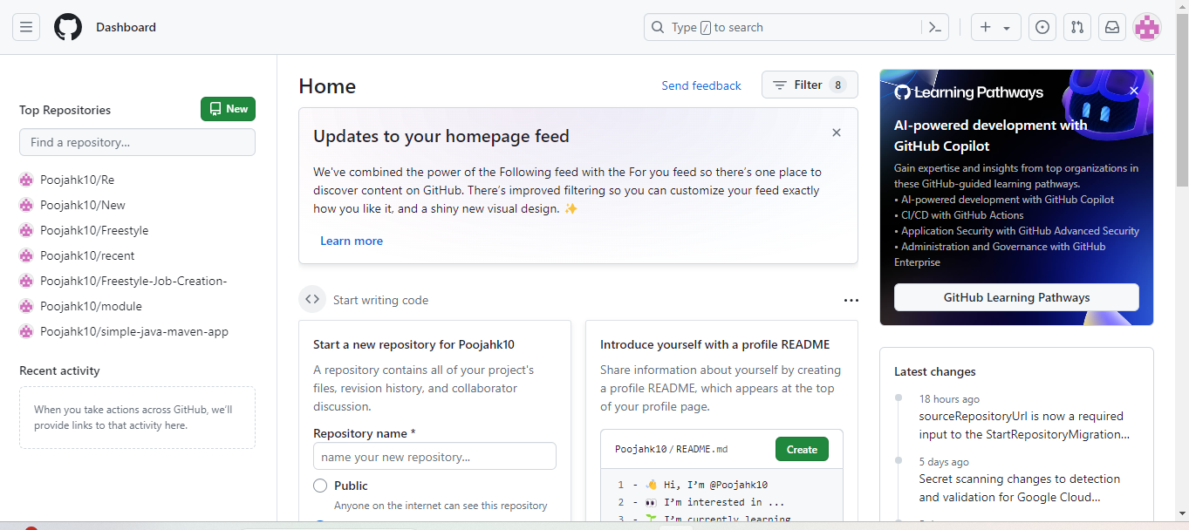

- Enter a desired name for your repository and choose Public as shown in the screenshot below:
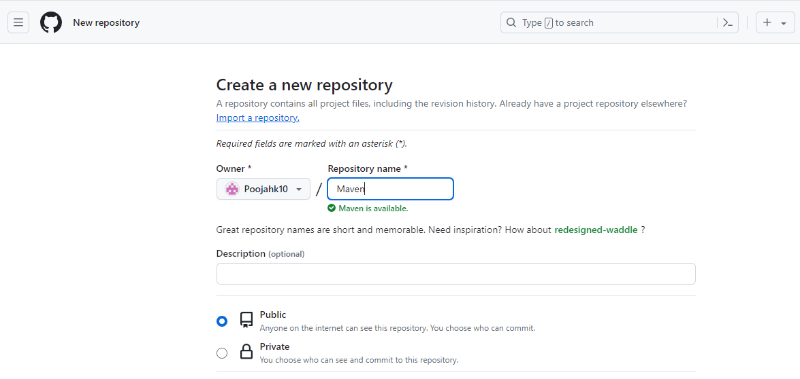

- Click on Add a README file and then click on Create repository as shown in the screenshot below:

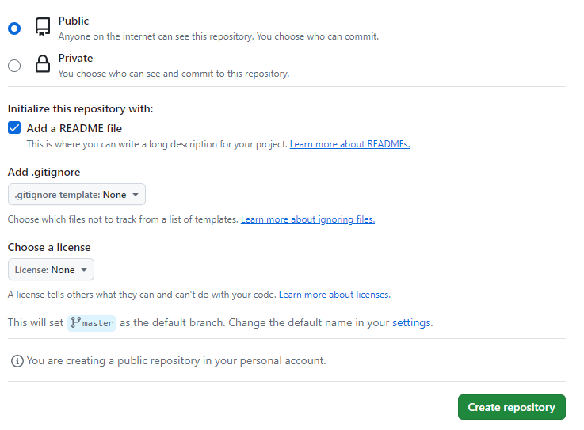

- Click on Code as shown in the screenshot below:
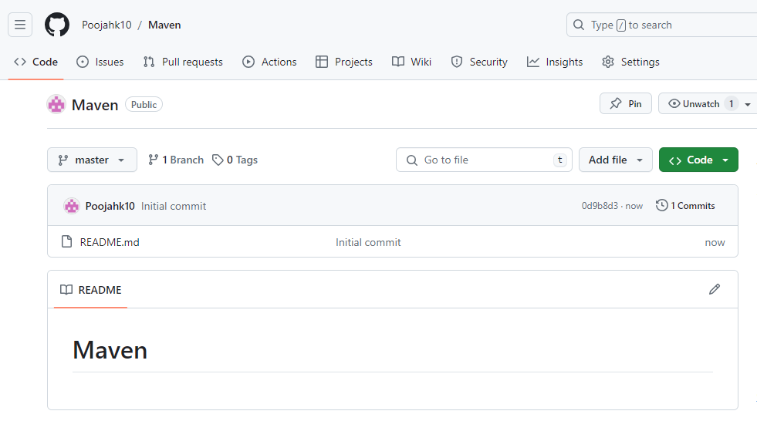

- Copy the repository URL as shown in the screenshot below:

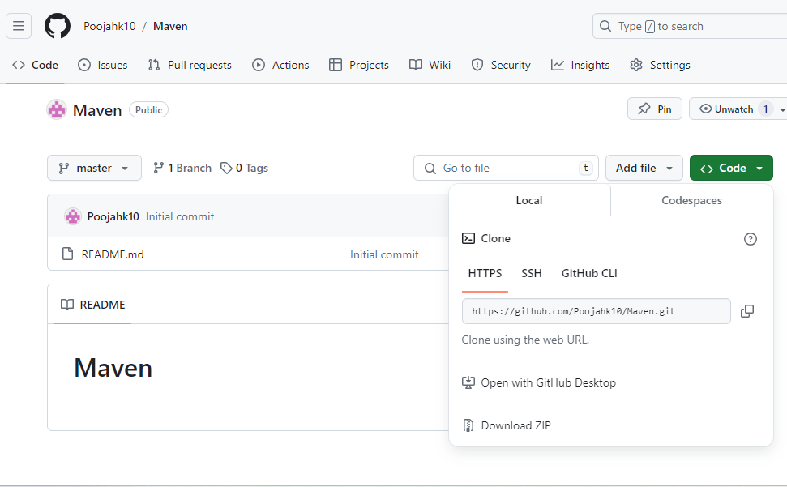
Step 2: Push the pipeline script into the Git repository
- Open the Linux terminal in your lab and clone the repository using the below command:
git clone RepositoryURL
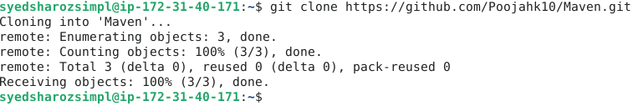
- Navigate inside the repository that you had created using the below command:
cd RepositoryName
- Initialize the Git using the below command:
git init
- Create a file using the below command:
nano demofile
- Paste the below pipeline script inside the file as shown in the screenshot below:

pipeline
{
agent any
tools
{
maven 'MAVEN_HOME'
}

stages
{
stage('Welcome Stage')
{
steps
{
echo 'Welcome to Jenkins Pipeline'
}
}

stage('Clean Stage')
{
steps
{
sh 'mvn clean'
}
}
stage('Clean Success Stage')
{
steps
{
echo 'clean success'
}
}
stage('Test Stage')
{
steps
{
sh 'mvn test'
}
}
stage('Build & Install Stage')
{
steps
{
sh 'mvn install'
}
}

stage('Build Success')
{
steps
{
echo 'Build successful'
}
}
}
}
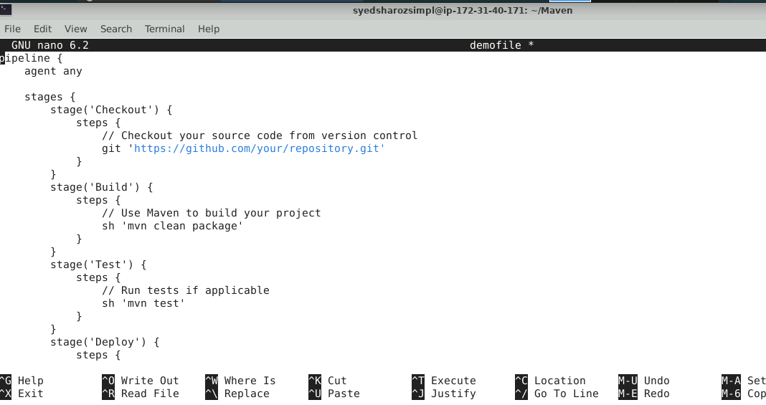
- Stage and commit the changes using the below commands:
git add .
git commit -m “initial commit”
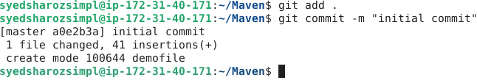

- Push the file to the Git repository using the below command:
git push
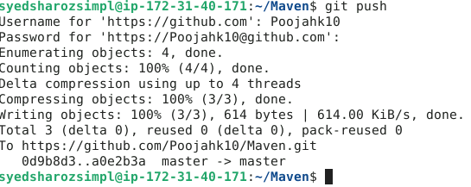
- Navigate to your Git repository to check for the file that is pushed as shown in the screenshot below:
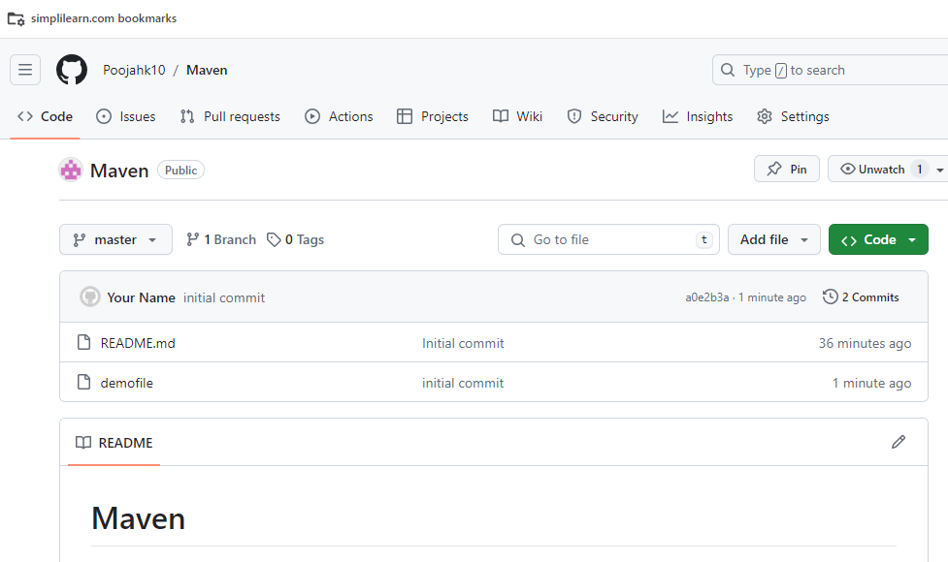

Step 3: Create a pipeline script-based freestyle job
Note: Use the given credentials to access Jenkins in the lab: Username is admin and Password is admin
- Open the browser, go to the Jenkins Dashboard by typing localhost:8080 in your browser, provide the credentials, and click the Sign in button

- Click on New Item as show in the screenshot below:
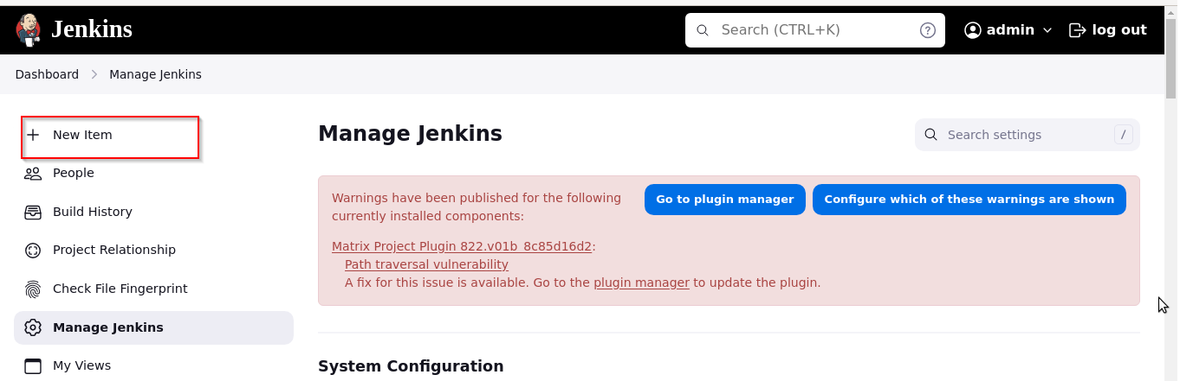

- Enter a desired name for the project, select Freestyle project, and then click on OK as shown in the screenshot below:
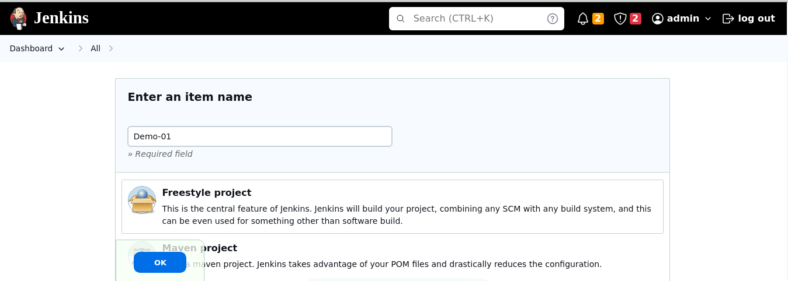
- Click on Source Code Management as shown in the screenshot below:
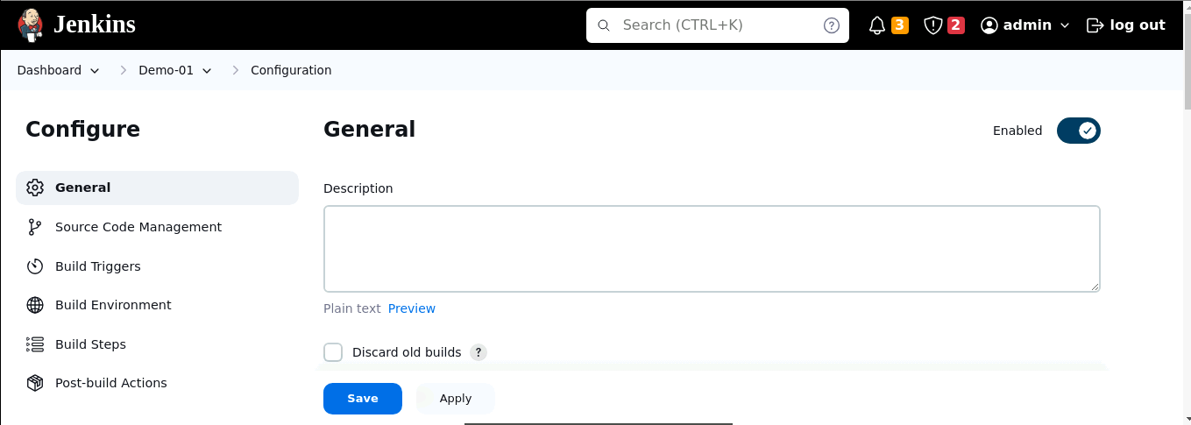

- Click on Git as shown in the screenshot below:
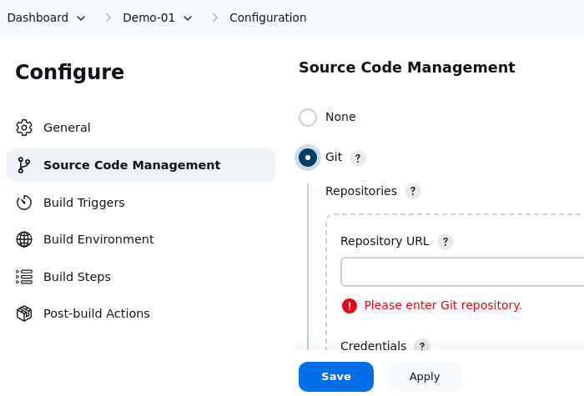
- Enter the repository URL and click on Add as shown in the screenshot below:
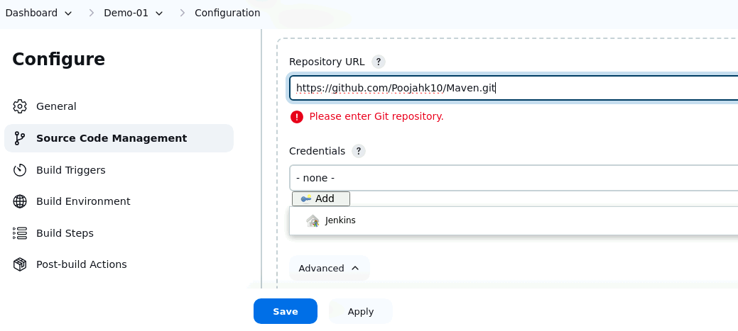

- Enter a desired name for the Username as shown in the screenshot below:
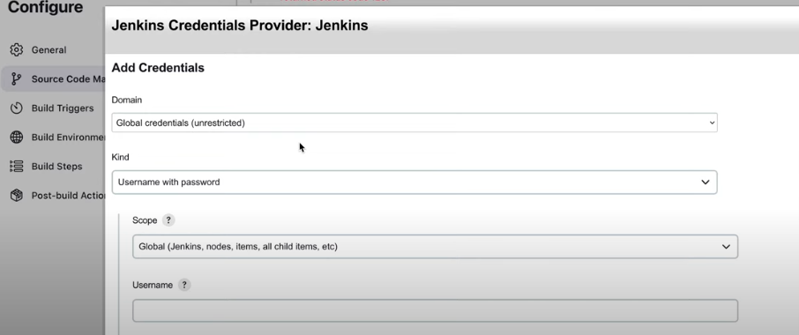
- Paste the Git token under Password section and then click on Add as shown in the screenshot below:
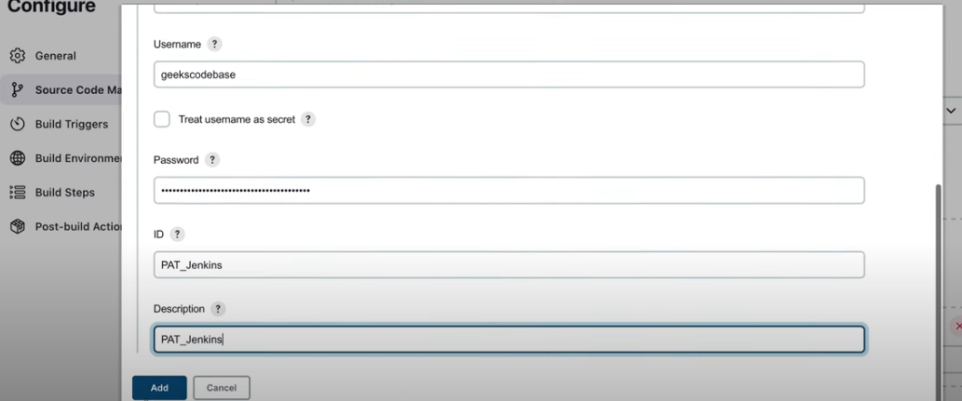

- Click on Save as shown in the screenshot below:
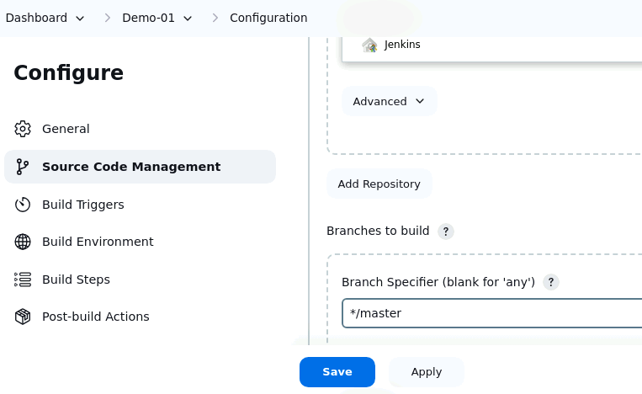
- Click on Build Now in the left section after the creation of the job as shown in the below screenshot:
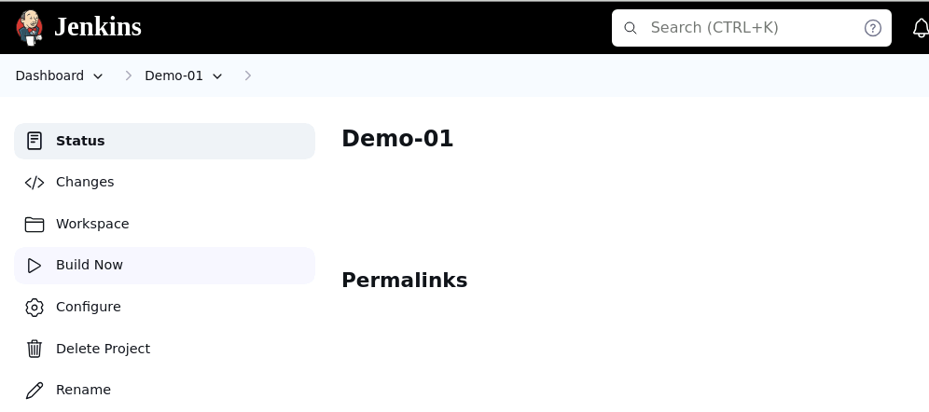

- Click on Build History as shown in the screenshot below:
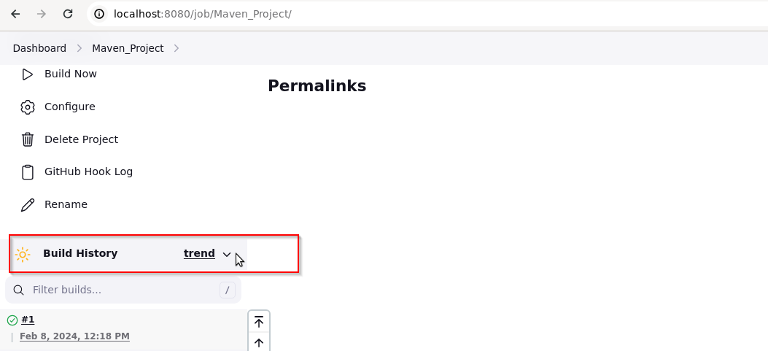
- Verify that the output indicates the status (successful) as shown in the screenshot below:
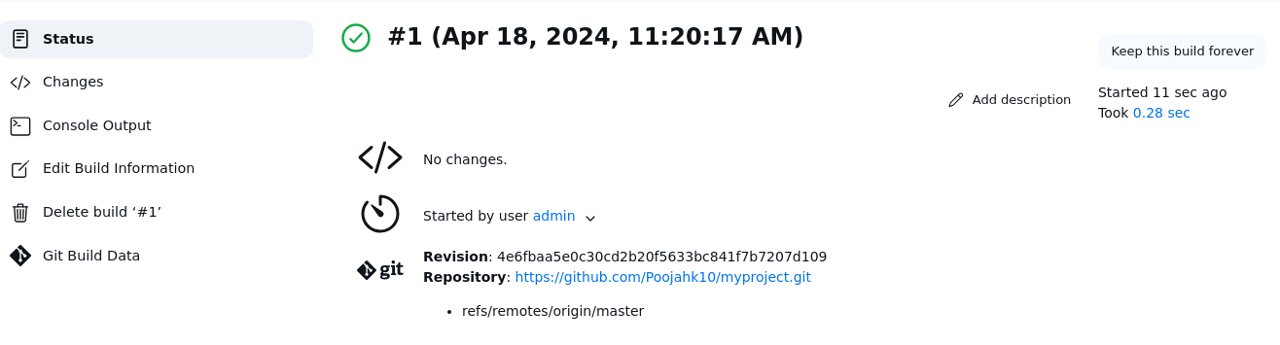
By following these steps, you have successfully set up the Jenkins freestyle job from the Git version control system to enable automated CI for building, testing, and potentially deploying software upon code changes.

