Machine Learning Model Development and Evaluation
YuvaIntern | Virtual Data Science with Python Apprentice Intern
Week 4 Project Report
Name: Ambika Kumari A S
Organization: YuvaIntern

1. Introduction
This project develops and evaluates a basic machine learning classification model using Python. The complete workflow covers data preparation, preprocessing, model selection, training, prediction, evaluation, visualization, error analysis, and possible improvements.

2. Problem Statement
The goal is to classify Iris flowers into Setosa, Versicolor, or Virginica using their sepal and petal measurements.

3. Dataset Description
The public Iris dataset contains 150 observations, with 50 observations from each of three species. Four numerical features are available: sepal length, sepal width, petal length, and petal width. The target variable represents the species class.

4. Data Preparation and Preprocessing
The data was checked for its structure and separated into four numerical input features and one target variable. A stratified 80:20 train-test split was used so that each species was represented proportionally in both sets. StandardScaler was fitted only on the training data and then applied to both training and test data, avoiding information leakage.

5. Model Selection
Logistic Regression was selected because it is a simple, interpretable supervised classification algorithm and is appropriate for a multi-class classification problem. It provides class probabilities that can also be used for ROC analysis.

6. Model Training
The standardized training data was used to train Logistic Regression with a maximum of 200 iterations. The trained model was then used to predict the species labels of the unseen test set.

7. Evaluation Metrics
The model was evaluated using accuracy, weighted precision, weighted recall, and weighted F1-score. A confusion matrix was used to inspect class-level prediction errors, and one-vs-rest ROC curves with AUC values were used to assess class discrimination.
Metric | Score
Training Accuracy | 0.958
Test Accuracy | 0.933
Weighted Precision | 0.933
Weighted Recall | 0.933
Weighted F1-score | 0.933
Test Error Rate | 0.067

8. Visualization 1: Model Performance Metrics
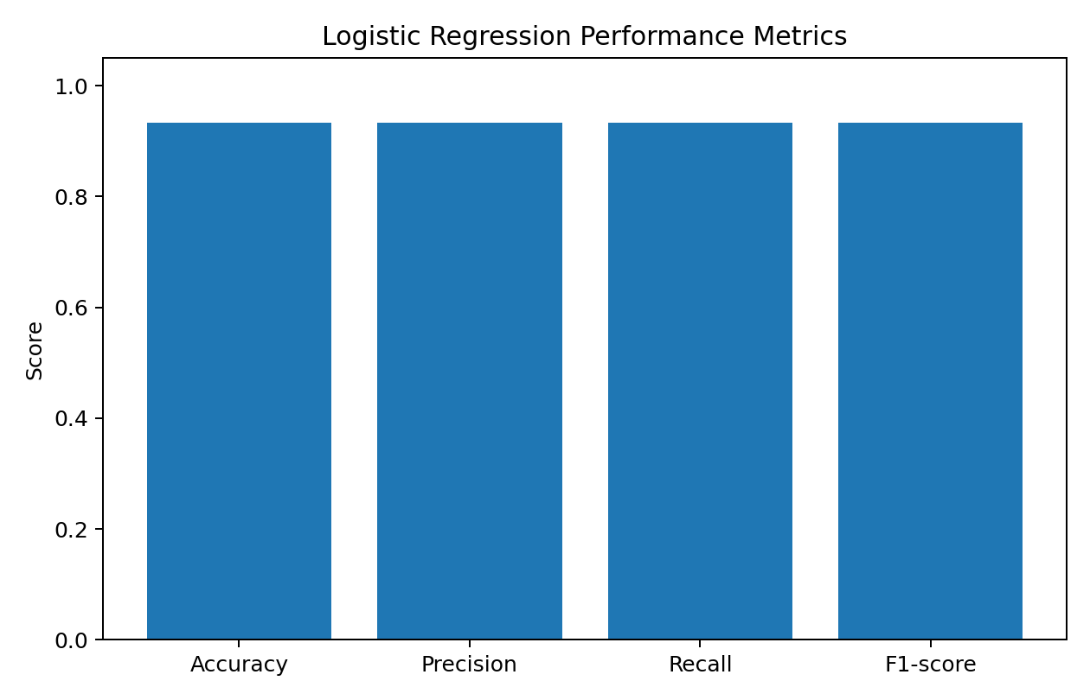
The bar chart compares accuracy, precision, recall, and F1-score. Similar high scores indicate consistent classification performance across the evaluation measures.

9. Visualization 2: Confusion Matrix
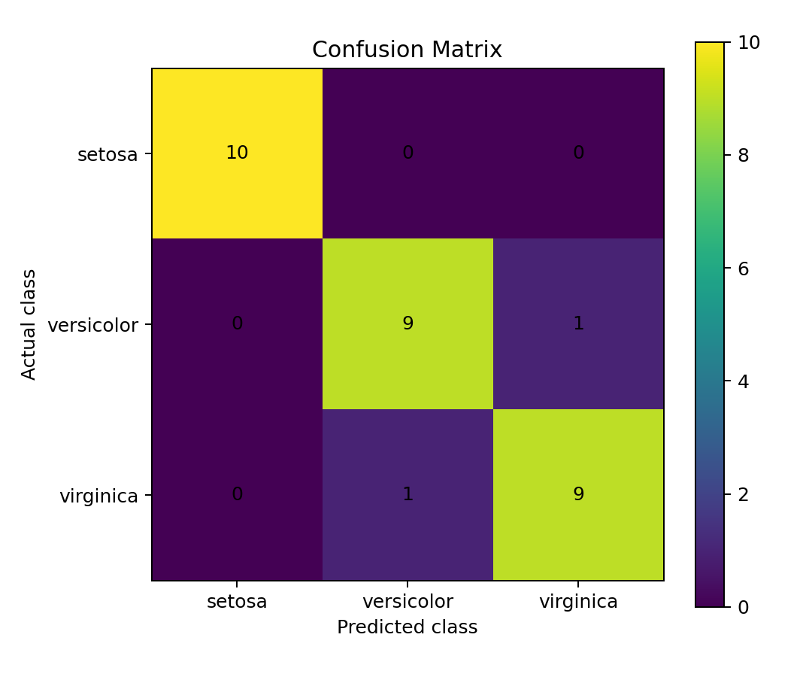
The confusion matrix shows the number of correct and incorrect predictions for each species. Diagonal values represent correct classifications.

10. Visualization 3: ROC Curves
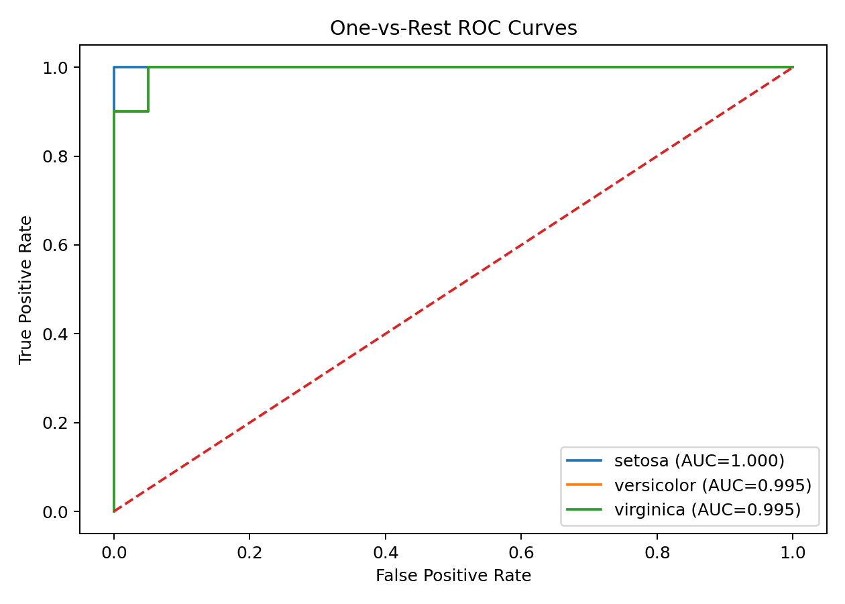
The one-vs-rest ROC curves show the trade-off between true positive rate and false positive rate for each class. AUC summarizes discrimination ability.

11. Visualization 4: Training vs Test Accuracy
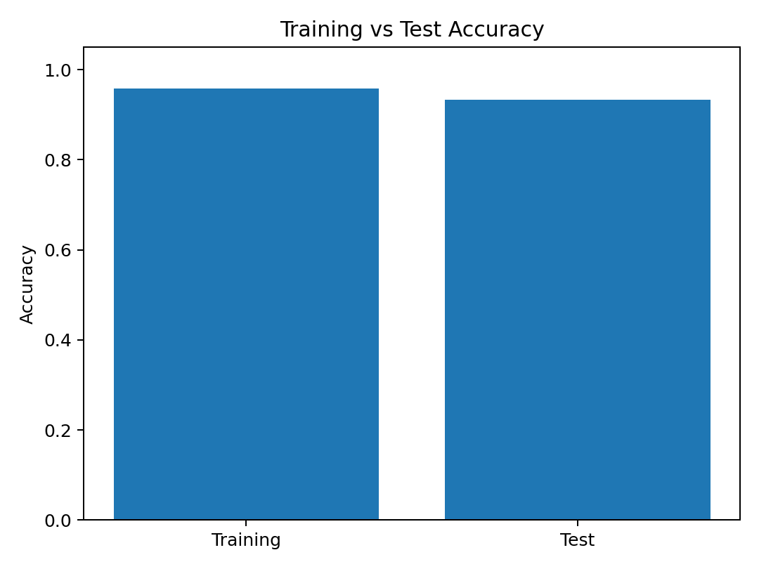
Comparing training and test accuracy provides a simple check for possible overfitting. A very large gap would indicate that the model performs much better on training data than unseen data.

12. Error Analysis
The test error rate is 6.7%. The confusion matrix indicates where misclassifications occur. Because the test set is relatively small, even one or two incorrect predictions can noticeably change the percentage. Therefore, performance should be interpreted together with the confusion matrix and other metrics rather than accuracy alone.

13. Overfitting and Underfitting
Training accuracy is 0.958, while test accuracy is 0.933, giving a gap of 0.025. The relatively small gap does not provide strong evidence of severe overfitting in this experiment. Underfitting is also not strongly indicated because the model achieves high test performance. However, the dataset is small, so stronger validation would be useful before deploying a model.

14. Strengths of the Model
- Simple and computationally efficient classification approach.
- Standardized preprocessing helps place features on comparable scales.
- The model provides interpretable evaluation metrics and class probabilities.
- The workflow is reproducible because the train-test split uses a fixed random state.

15. Limitations and Improvements
- The Iris dataset is small and simple, so the results may not represent performance on complex real-world data.
- A single train-test split can produce results that vary with the chosen sample.
- Cross-validation could provide a more reliable estimate of generalization performance.
- Hyperparameter tuning could be used to optimize the model.
- Other algorithms such as Decision Trees, Random Forest, Support Vector Machines, or k-Nearest Neighbors could be compared.
- Additional error analysis and class-wise metrics can help identify difficult classes.

16. Conclusion
The Logistic Regression model successfully classified the Iris species with a test accuracy of 93.3% in this experiment. The evaluation included precision, recall, F1-score, confusion matrix, ROC curves, and training-versus-test comparison. The small training-test performance gap suggests that severe overfitting is not evident in this split. The project demonstrates a complete basic machine learning pipeline and also highlights why model performance should be evaluated using multiple metrics and supported by visual analysis.

17. Python Code
import pandas as pd
from sklearn.datasets import load_iris
from sklearn.model_selection import train_test_split
from sklearn.preprocessing import StandardScaler
from sklearn.linear_model import LogisticRegression
from sklearn.metrics import accuracy_score, precision_score, recall_score, f1_score, confusion_matrix
iris = load_iris(as_frame=True)
df = iris.frame.copy()
X = df.drop(columns=["target"])
y = df["target"]
X_train, X_test, y_train, y_test = train_test_split(
X, y, test_size=0.20, random_state=42, stratify=y
)
scaler = StandardScaler()
X_train = scaler.fit_transform(X_train)
X_test = scaler.transform(X_test)
model = LogisticRegression(max_iter=200, random_state=42)
model.fit(X_train, y_train)
y_pred = model.predict(X_test)
print("Accuracy:", accuracy_score(y_test, y_pred))
print("Precision:", precision_score(y_test, y_pred, average="weighted"))
print("Recall:", recall_score(y_test, y_pred, average="weighted"))
print("F1-score:", f1_score(y_test, y_pred, average="weighted"))
print("Confusion matrix:")
print(confusion_matrix(y_test, y_pred))

18. Reproducibility
Install the required libraries with: pip install pandas scikit-learn matplotlib. Run week4_machine_learning.py to reproduce the core model training and evaluation workflow.

