Abrupt versus Gradual Motor Learning

plot(cars)

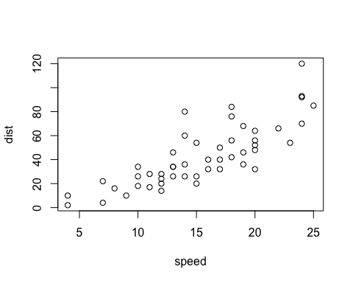

Add a new chunk by clicking the *Insert Chunk* button on the toolbar or by pressing *Cmd+Option+I*.

When you save the notebook, an HTML file containing the code and output will be saved alongside it (click the *Preview* button or press *Cmd+Shift+K* to preview the HTML file).

The preview shows you a rendered HTML copy of the contents of the editor. Consequently, unlike *Knit*, *Preview* does not run any R code chunks. Instead, the output of the chunk when it was last run in the editor is displayed.

# Load Packages

library(svglite)  
library(optimx)  
library(ez)

# Load R scripts

source('orderEffects.R') # this file deals with the order effects and runs the ANOVA  
source('ExtentofLearning.R') # this file deals with the extent of learning and runs the ANOVA  
source('Figures.R') # this file creates the 4 figures  
source('ReboundANOVA.R') #this file has the ANOVAs for the rebounds

# Overview

This document discusses the figures and statistics used to investigate abrupt versus gradual motor learning. The main sections here will be looking at the Order Effects, the Extent of Learning, and the Rebound.

# Plotting All of the Behavioural Data

plotAllData()

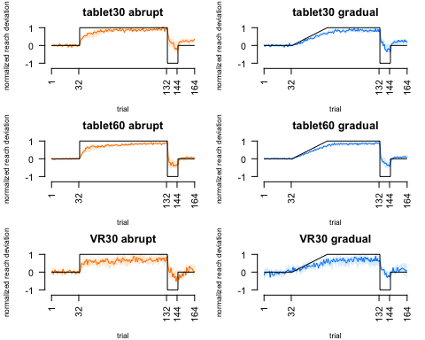

# Order Effects of Within-Subjects Design

This was done only on data from the abrupt condition, with groups (30° digitizing tablet, 60° digitalizing tablet, 30° VR setups) with the blocks (first, second, last training) as our within-subject factors, and order as our between-subject factors. The orange bars here represent the mean reach deviations of the participants who performed the abrupt condition first, and the blue bars represent the mean reach deviations of the participants who performed the gradual condition first. All of the data has been normalized to the size of the rotation.

plotOrderData()

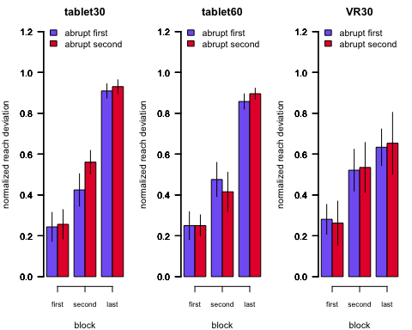

Here is the 2x2 ANOVA on the first block of the training phase with setup (tablet30, VR30) and order as our between subjects factors.

setup_order_first_ANOVA()

## Warning: Data is unbalanced (unequal N per group). Make sure you specified  
## a well-considered value for the type argument to ezANOVA().

## Coefficient covariances computed by hccm()

## $ANOVA  
## Effect DFn DFd F p p<.05 ges  
## 1 setup 1 45 7.517479e-02 0.7852009 0.0016677648  
## 2 order 1 45 8.675569e-05 0.9926096 0.0000019279  
## 3 setup:order 1 45 3.707611e-02 0.8481765 0.0008232354  
##   
## $`Levene's Test for Homogeneity of Variance`  
## DFn DFd SSn SSd F p p<.05  
## 1 3 45 0.003589728 1.791413 0.0300578 0.9928865

Here is the 2x2 ANOVA on the first block of the training phase with rotation (tablet30, tablet60) and order as our between subjects factors.

rotation_order_first_ANOVA()

## Warning: Data is unbalanced (unequal N per group). Make sure you specified  
## a well-considered value for the type argument to ezANOVA().

## Coefficient covariances computed by hccm()

## $ANOVA  
## Effect DFn DFd F p p<.05 ges  
## 1 rotation 1 54 4.433960e-08 0.9998328 8.211037e-10  
## 2 order 1 54 1.047404e-02 0.9188637 1.939261e-04  
## 3 rotation:order 1 54 8.733415e-03 0.9258898 1.617037e-04  
##   
## $`Levene's Test for Homogeneity of Variance`  
## DFn DFd SSn SSd F p p<.05  
## 1 3 54 0.009090661 1.790872 0.09136994 0.9644904

Here is the 2x2 ANOVA on the second block of the training phase with setup (tablet30, VR30) and order as our between subjects factors.

setup_order_second_ANOVA()

## Warning: Data is unbalanced (unequal N per group). Make sure you specified  
## a well-considered value for the type argument to ezANOVA().

## Coefficient covariances computed by hccm()

## $ANOVA  
## Effect DFn DFd F p p<.05 ges  
## 1 setup 1 45 0.1813596 0.6722375 0.004014035  
## 2 order 1 45 1.0792741 0.3044101 0.023422117  
## 3 setup:order 1 45 0.4903144 0.4873917 0.010778436  
##   
## $`Levene's Test for Homogeneity of Variance`  
## DFn DFd SSn SSd F p p<.05  
## 1 3 45 0.06857067 1.976227 0.5204665 0.670374

Here is the 2x2 ANOVA on the second block of the training phase with rotation (tablet30, tablet60) and order as our between subjects factors.

rotation_order_second_ANOVA()

## Warning: Data is unbalanced (unequal N per group). Make sure you specified  
## a well-considered value for the type argument to ezANOVA().

## Coefficient covariances computed by hccm()

## $ANOVA  
## Effect DFn DFd F p p<.05 ges  
## 1 rotation 1 54 0.3496452 0.5567813 0.006433256  
## 2 order 1 54 0.2706992 0.6049898 0.004987944  
## 3 rotation:order 1 54 1.5241497 0.2223380 0.027450212  
##   
## $`Levene's Test for Homogeneity of Variance`  
## DFn DFd SSn SSd F p p<.05  
## 1 3 54 0.1040763 1.92981 0.9707552 0.413331

Here is the 2x2 ANOVA on the last block of the training phase with setup (tablet30, VR30) and order as our between subjects factors.

setup_order_last_ANOVA()

## Warning: Data is unbalanced (unequal N per group). Make sure you specified  
## a well-considered value for the type argument to ezANOVA().

## Coefficient covariances computed by hccm()

## $ANOVA  
## Effect DFn DFd F p p<.05 ges  
## 1 setup 1 45 1.403321e+01 0.0005088901 * 2.377172e-01  
## 2 order 1 45 8.285122e-02 0.7747916047 1.837755e-03  
## 3 setup:order 1 45 1.055228e-04 0.9918493387 2.344945e-06  
##   
## $`Levene's Test for Homogeneity of Variance`  
## DFn DFd SSn SSd F p p<.05  
## 1 3 45 0.37747 1.176885 4.811049 0.005450052 *

Here is the 2x2 ANOVA on the last block of the training phase with rotation (tablet30, tablet60) and order as our between subjects factors.

rotation_order_last_ANOVA()

## Warning: Data is unbalanced (unequal N per group). Make sure you specified  
## a well-considered value for the type argument to ezANOVA().

## Coefficient covariances computed by hccm()

## $ANOVA  
## Effect DFn DFd F p p<.05 ges  
## 1 rotation 1 54 1.66485575 0.2024469 0.029908561  
## 2 order 1 54 0.78070381 0.3808429 0.014251438  
## 3 rotation:order 1 54 0.06487721 0.7999146 0.001199988  
##   
## $`Levene's Test for Homogeneity of Variance`  
## DFn DFd SSn SSd F p p<.05  
## 1 3 54 0.002300623 0.2941218 0.1407962 0.9351133

# Extent of Learning

Here we are checking if there are any differences in the extent of learning in the abrupt and gradual conditions during the last training and last reversal blocks. The data is shown for the 3 groups (30° digitizing tablet, 60° digitalizing tablet, 30° VR setups). The orange bars here represent the mean reach deviations of the abrupt condition, and the blue bars represent the mean reach deviations of gradual condition. All of the data has been normalized to the size of the rotation.

plotExtentofLearning()

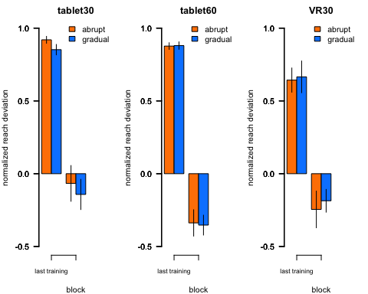

Here is the 2x2 ANOVA on the last block of the training phase with setup (tablet30, VR30) as our between subjects factor and condition (abrupt, gradual) as our within-subjects factor.

setupLastTrainingANOVA()

## Warning: Data is unbalanced (unequal N per group). Make sure you specified  
## a well-considered value for the type argument to ezANOVA().

## $ANOVA  
## Effect DFn DFd F p p<.05 ges  
## 2 setup 1 47 14.5655912 0.0003947903 * 0.135021569  
## 3 condition 1 47 0.3114509 0.5794400832 0.003278042  
## 4 setup:condition 1 47 0.5557560 0.4596874362 0.005834367

Here is the 2x2 ANOVA on the last block of the training phase with rotation size (tablet30, tablet60) as our between subjects factor and condition (abrupt, gradual) as our within-subjects factor.

rotationLastTrainingANOVA()

## Warning: Data is unbalanced (unequal N per group). Make sure you specified  
## a well-considered value for the type argument to ezANOVA().

## $ANOVA  
## Effect DFn DFd F p p<.05 ges  
## 2 rotation 1 56 0.0664637 0.7975020 0.0006688023  
## 3 condition 1 56 1.6698185 0.2015899 0.0128371730  
## 4 rotation:condition 1 56 1.8893761 0.1747481 0.0145006050

Here is the 2x2 ANOVA on the last block of the reversal phase with setup (tablet30, VR30) as our between subjects factor and condition (abrupt, gradual) as our within-subjects factor.

setupLastReversalANOVA()

## Warning: Data is unbalanced (unequal N per group). Make sure you specified  
## a well-considered value for the type argument to ezANOVA().

## $ANOVA  
## Effect DFn DFd F p p<.05 ges  
## 2 setup 1 47 0.66169357 0.4200646 0.0094984816  
## 3 condition 1 47 0.06553617 0.7990677 0.0004444087  
## 4 setup:condition 1 47 0.52223131 0.4734722 0.0035303801

Here is the 2x2 ANOVA on the last block of the reversal phase with rotation size (tablet30, tablet60) as our between subjects factor and condition (abrupt, gradual) as our within-subjects factor.

rotationLastReversalANOVA()

## Warning: Data is unbalanced (unequal N per group). Make sure you specified  
## a well-considered value for the type argument to ezANOVA().

## $ANOVA  
## Effect DFn DFd F p p<.05 ges  
## 2 rotation 1 56 3.8512554 0.05468455 0.0496695156  
## 3 condition 1 56 0.4542212 0.50310972 0.0019430584  
## 4 rotation:condition 1 56 0.1926988 0.66236899 0.0008252463

# Rebound

Here we are checking if there are any differences in the rebound between the abrupt and gradual conditions for the 3 groups (30° digitizing tablet, 60° digitalizing tablet, 30° VR setups). The orange bars here represent the mean reach deviations of the abrupt condition, and the blue bars represent the mean reach deviations of gradual condition. All of the data has been normalized to the size of the rotation.

plotReboundData()

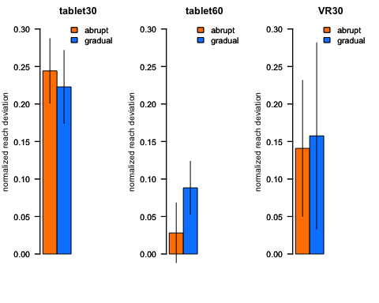

Here is the 2x2 ANOVA on the rebound with setup (tablet30, VR30) as our between subjects factor and condition (abrupt, gradual) as our within-subjects factor.

setupReboundANOVA()

## Warning: Data is unbalanced (unequal N per group). Make sure you specified  
## a well-considered value for the type argument to ezANOVA().

## $ANOVA  
## Effect DFn DFd F p p<.05 ges  
## 2 setup 1 47 1.194170708 0.2800596 1.389171e-02  
## 3 condition 1 47 0.009604493 0.9223471 9.104023e-05  
## 4 setup:condition 1 47 0.075266249 0.7850203 7.129990e-04

Here is the 2x2 ANOVA on the rebound with rotation size (tablet30, tablet60) as our between subjects factor and condition (abrupt, gradual) as our within-subjects factor. These rebounds here have not been normalized to the rotation size.

rotationReboundANOVA()

## Warning: Data is unbalanced (unequal N per group). Make sure you specified  
## a well-considered value for the type argument to ezANOVA().

## $ANOVA  
## Effect DFn DFd F p p<.05 ges  
## 2 rotation 1 57 3.1237329 0.08251257 0.030290417  
## 3 condition 1 57 0.7032853 0.40518516 0.005277652  
## 4 rotation:condition 1 57 1.5115425 0.22395482 0.011274656

Here is the 2x2 ANOVA on the rebound with rotation size (tablet30, tablet60) as our between subjects factor and condition (abrupt, gradual) as our within-subjects factor. These rebounds have been normalized to the rotation size.

normalized_rotationReboundANOVA()

## Warning: Data is unbalanced (unequal N per group). Make sure you specified  
## a well-considered value for the type argument to ezANOVA().

## $ANOVA  
## Effect DFn DFd F p p<.05 ges  
## 2 rotation 1 57 14.2558022 0.0003827086 * 0.131407866  
## 3 condition 1 57 0.2490659 0.6196543344 0.001723414  
## 4 rotation:condition 1 57 1.1780314 0.2823262885 0.008099336

Here is a paired t-test comparing the abrupt and gradual conditions in the tablet30 group.

getReboundTtest(group = 'tablet30')

##   
## Paired t-test  
##   
## data: x and y  
## t = 0.3902, df = 29, p-value = 0.6992  
## alternative hypothesis: true difference in means is not equal to 0  
## 95 percent confidence interval:  
## -0.0904250 0.1330629  
## sample estimates:  
## mean of the differences   
## 0.02131896

Here is a paired t-test comparing the abrupt and gradual conditions in the tablet60 group.

getReboundTtest(group = 'tablet60')

##   
## Paired t-test  
##   
## data: x and y  
## t = -1.172, df = 28, p-value = 0.2511  
## alternative hypothesis: true difference in means is not equal to 0  
## 95 percent confidence interval:  
## -0.16530566 0.04498778  
## sample estimates:  
## mean of the differences   
## -0.06015894

Here is a paired t-test comparing the abrupt and gradual conditions in the VR30 group.

getReboundTtest(group = 'VR30')

##   
## Paired t-test  
##   
## data: x and y  
## t = -0.10966, df = 18, p-value = 0.9139  
## alternative hypothesis: true difference in means is not equal to 0  
## 95 percent confidence interval:  
## -0.3351880 0.3019316  
## sample estimates:  
## mean of the differences   
## -0.01662817