1429028_case study:

Created Pipeline case-study:

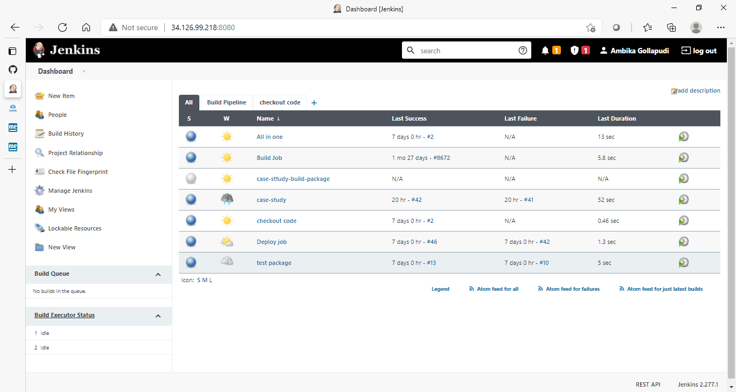

Checking out from GIT:  
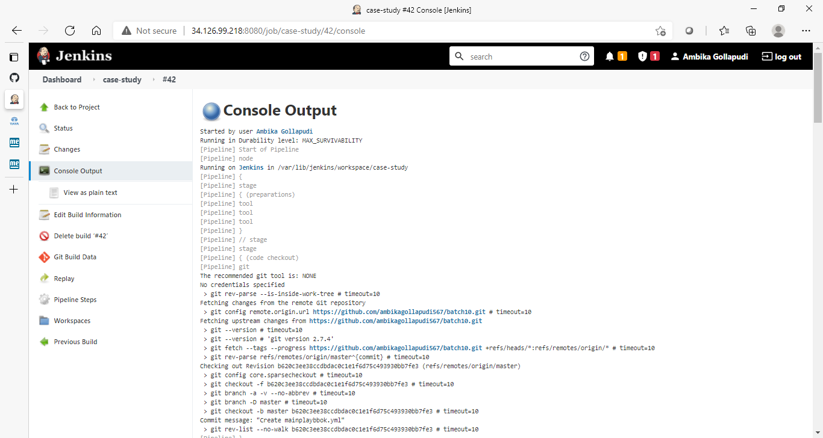

Test and package using junkins runtime

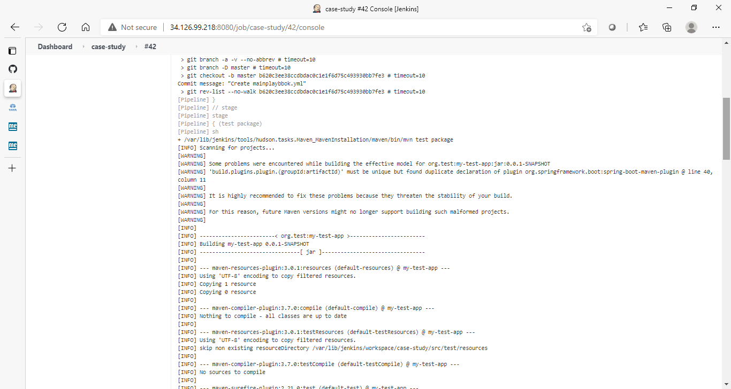

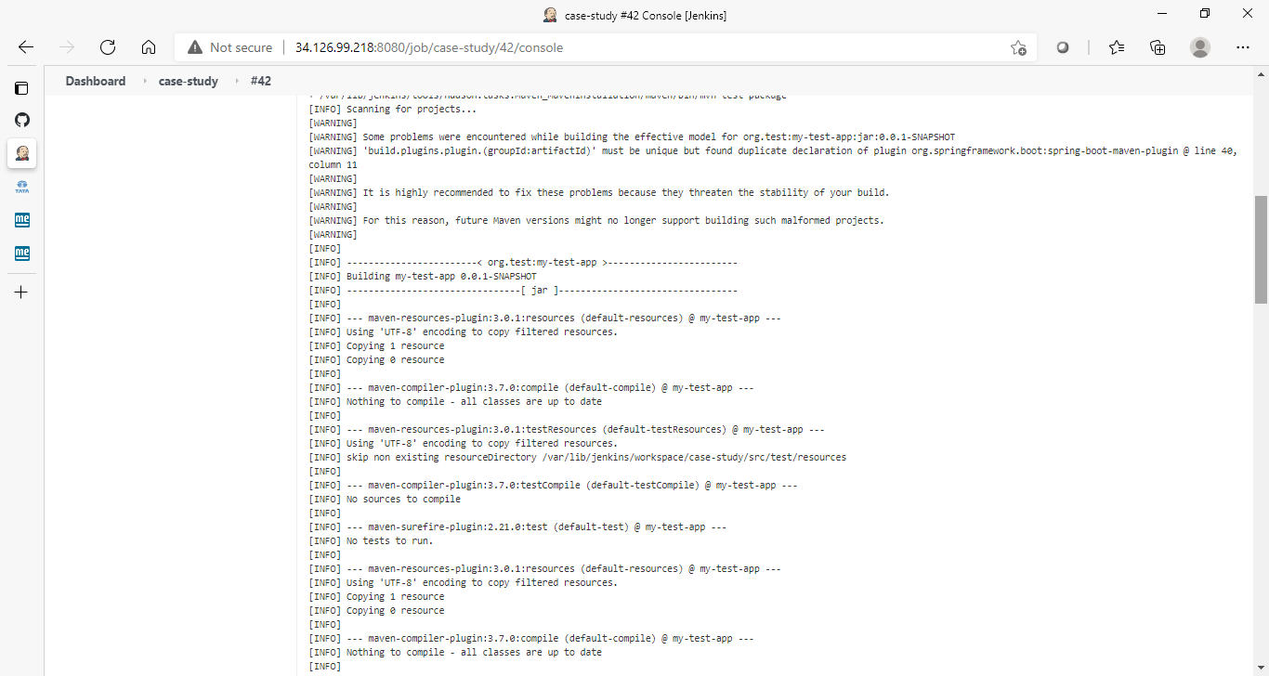

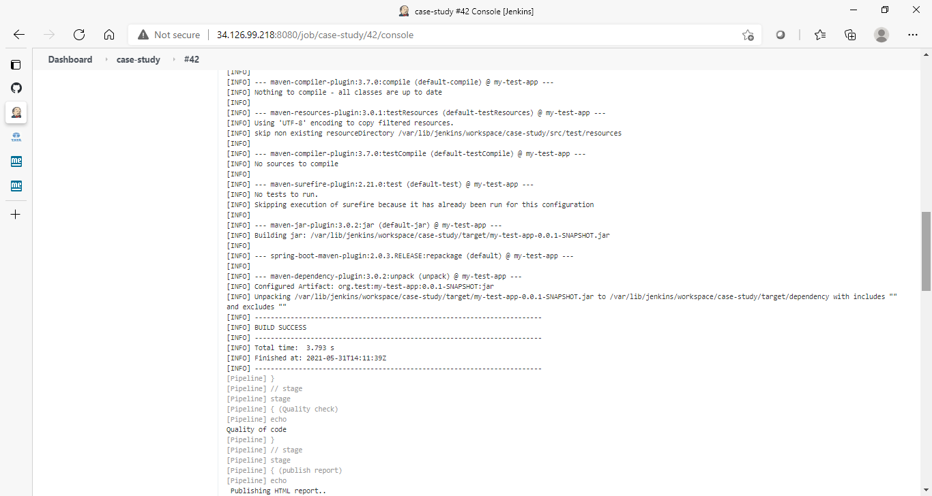

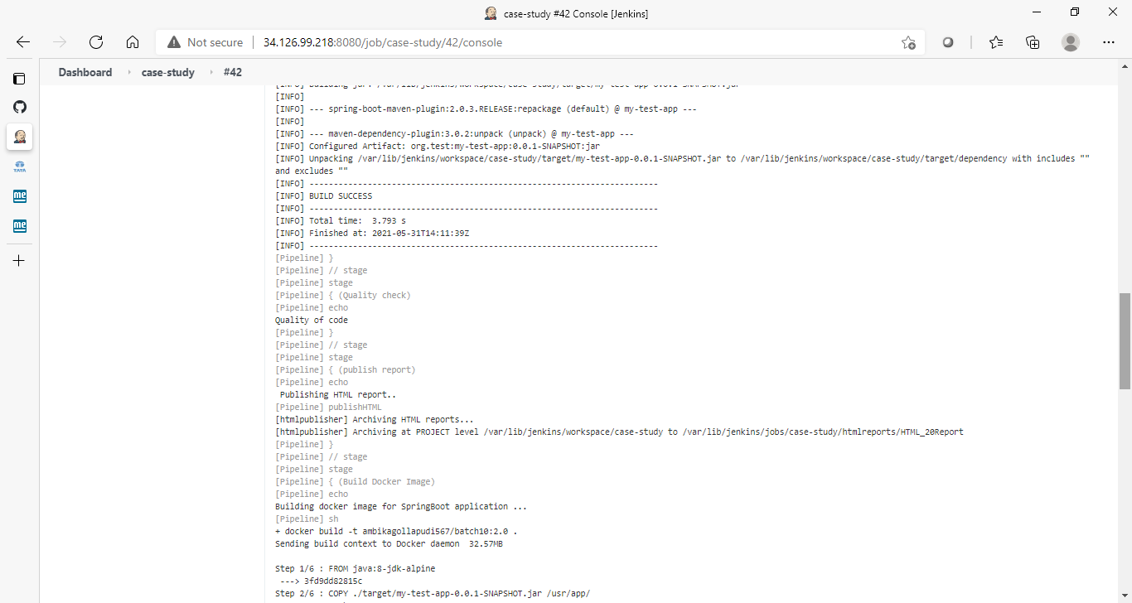

SonarQube:

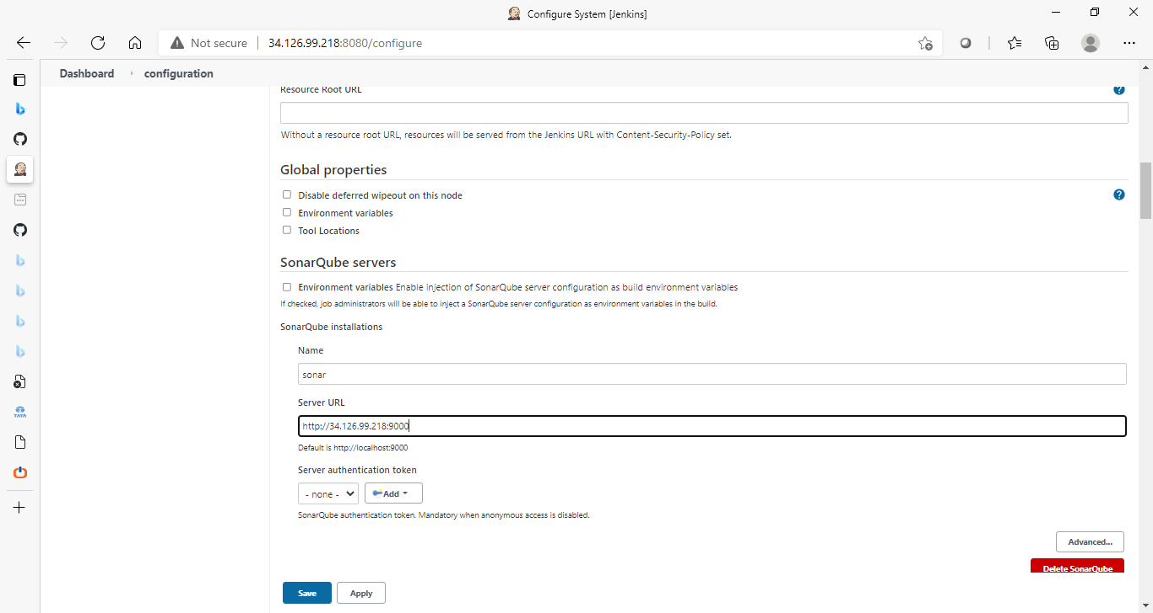

Used Jenkins Provided Docker:

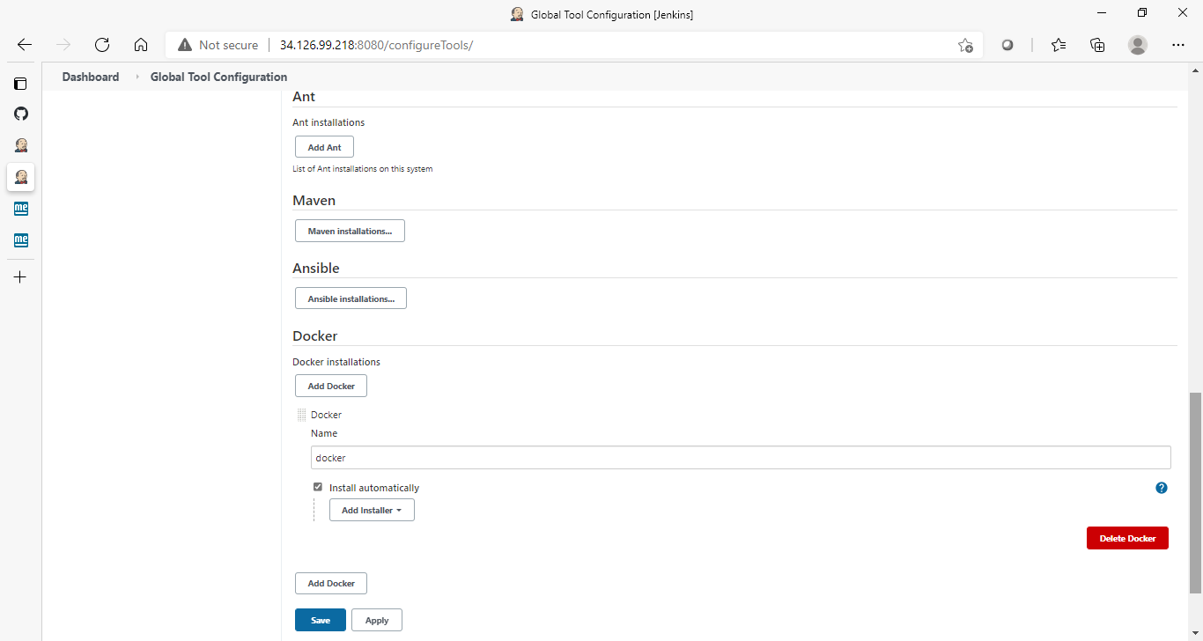

Creating an image with Dockerfile:



Binding credentials for password security:

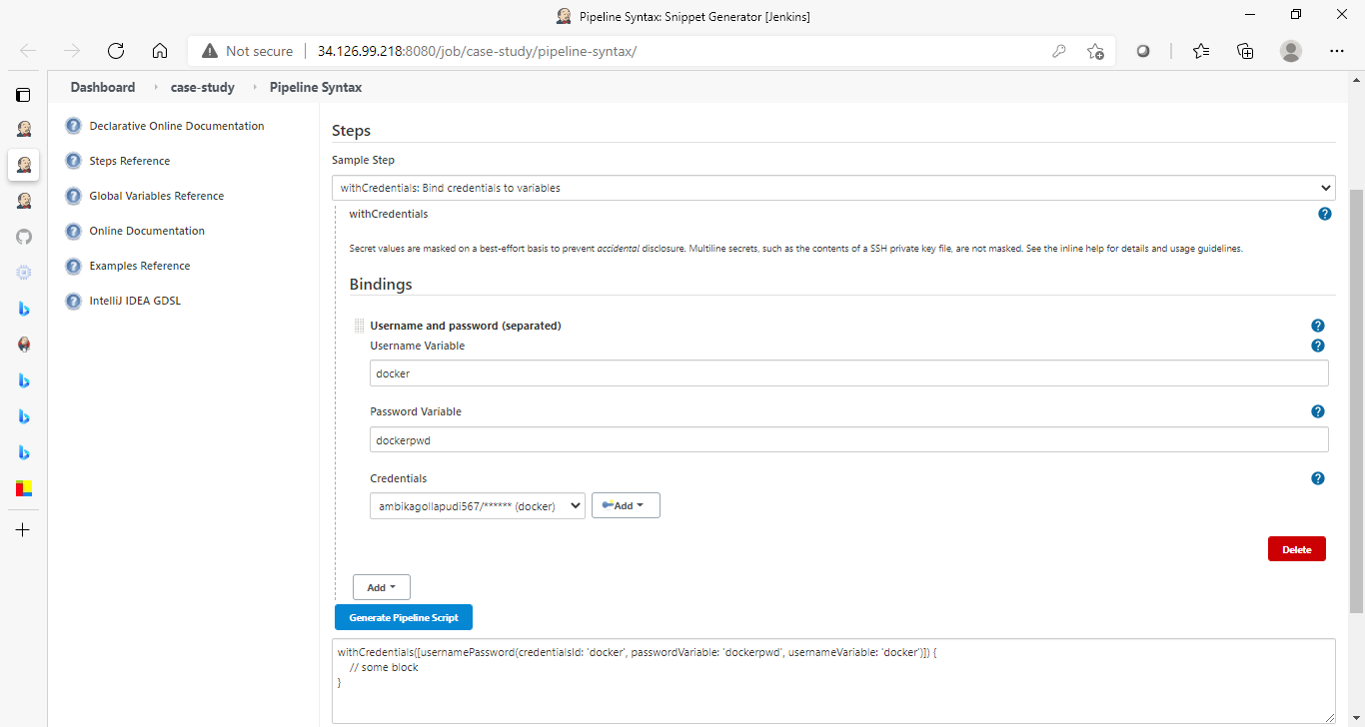

Pushing image to DockerHub:

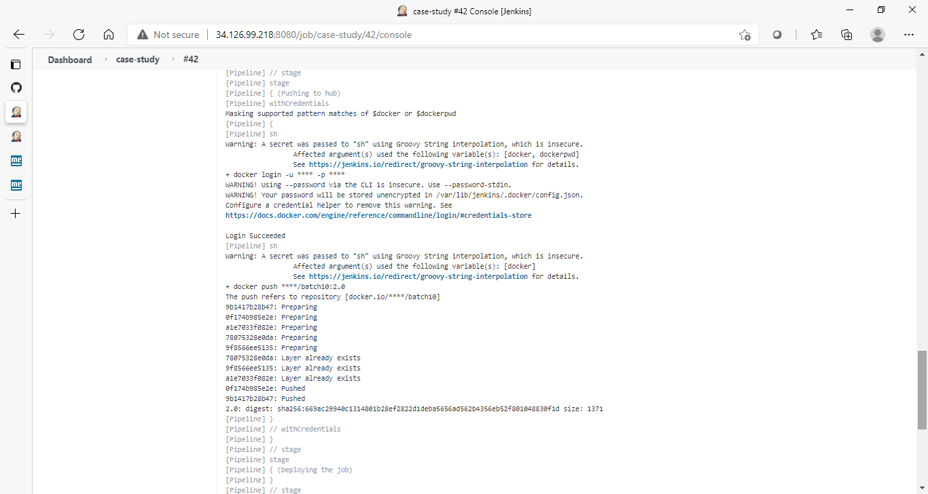

Ansible:

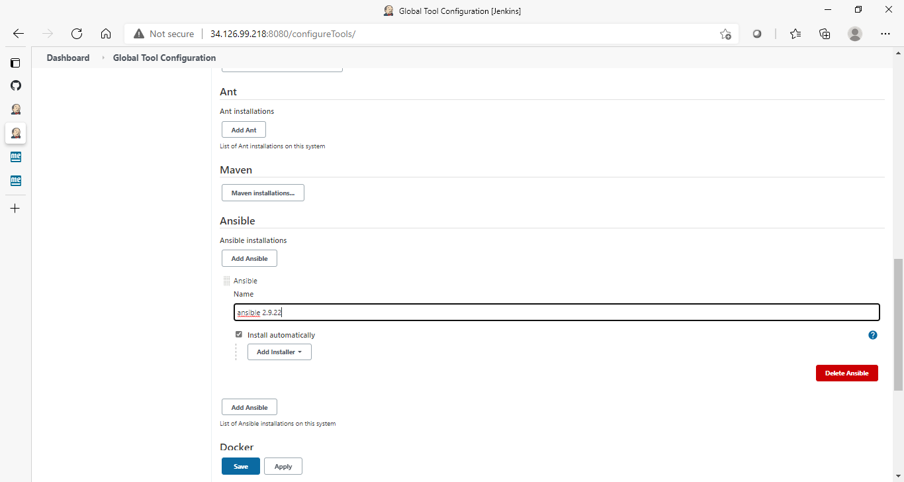

Email for bad builds

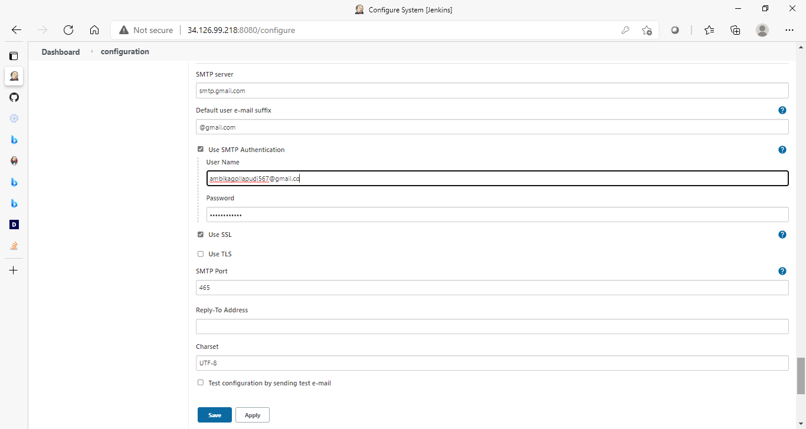

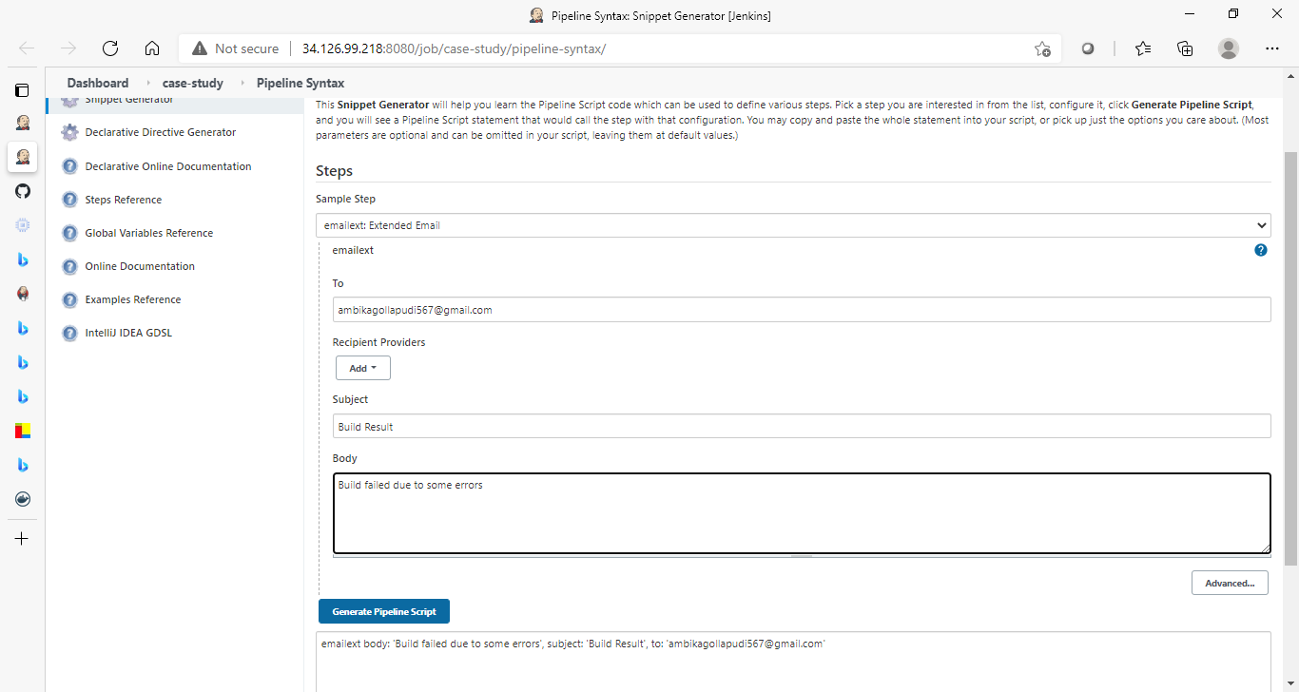

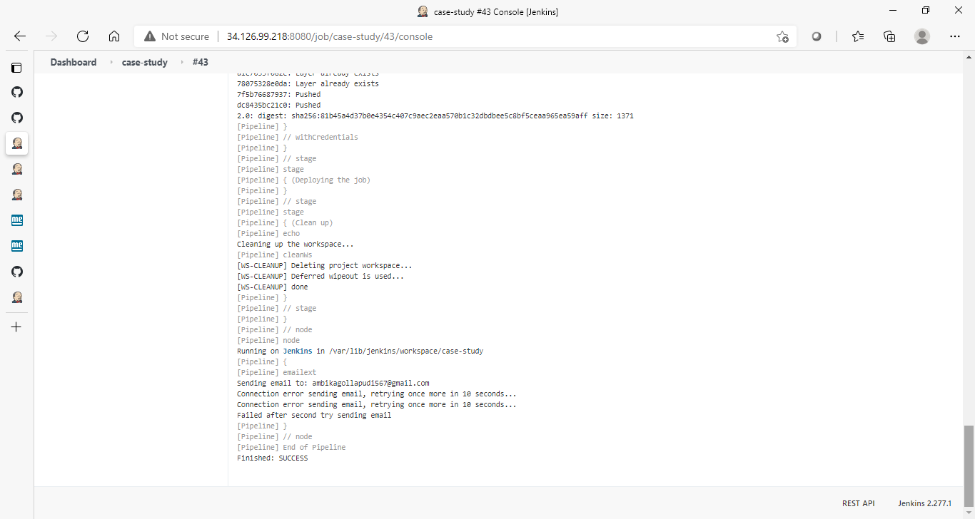

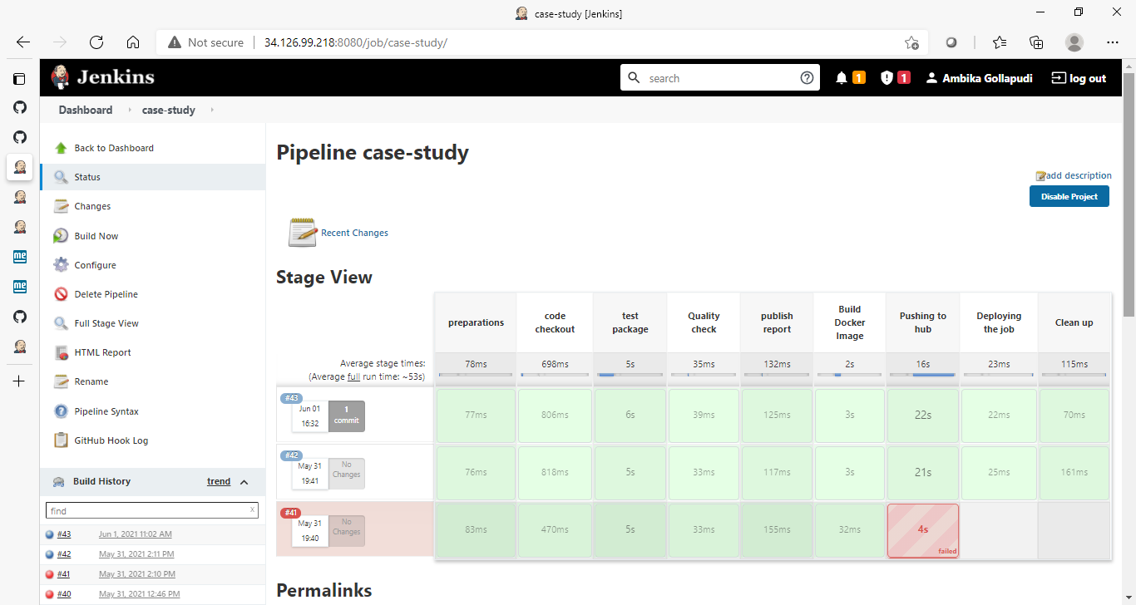

Webhook:

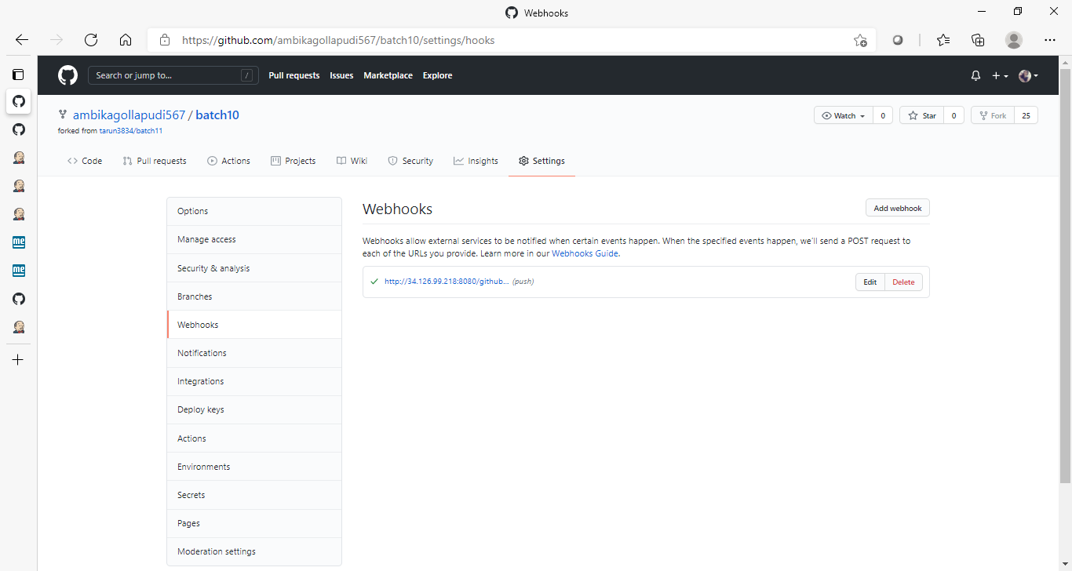

Last changed at 11:02 and job build again 11:02

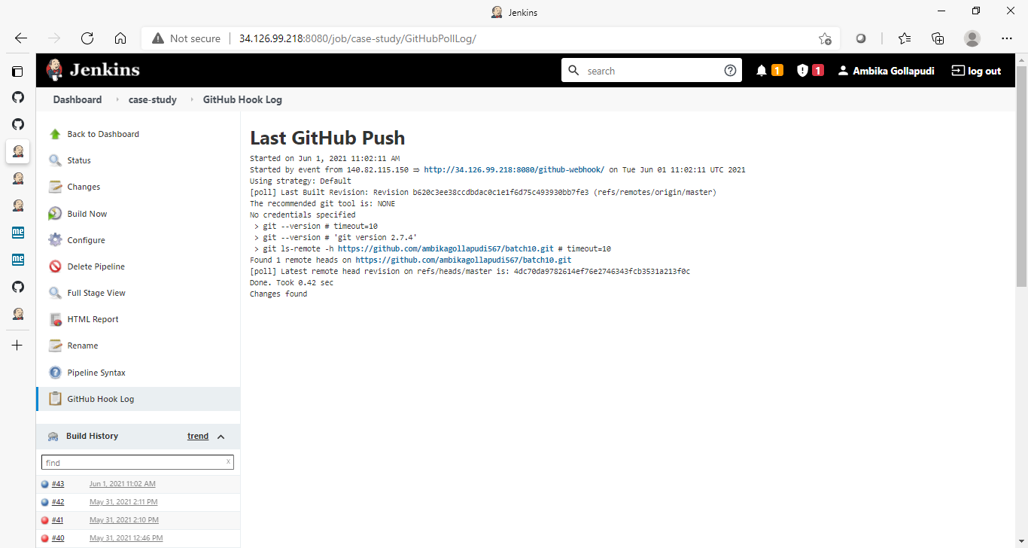

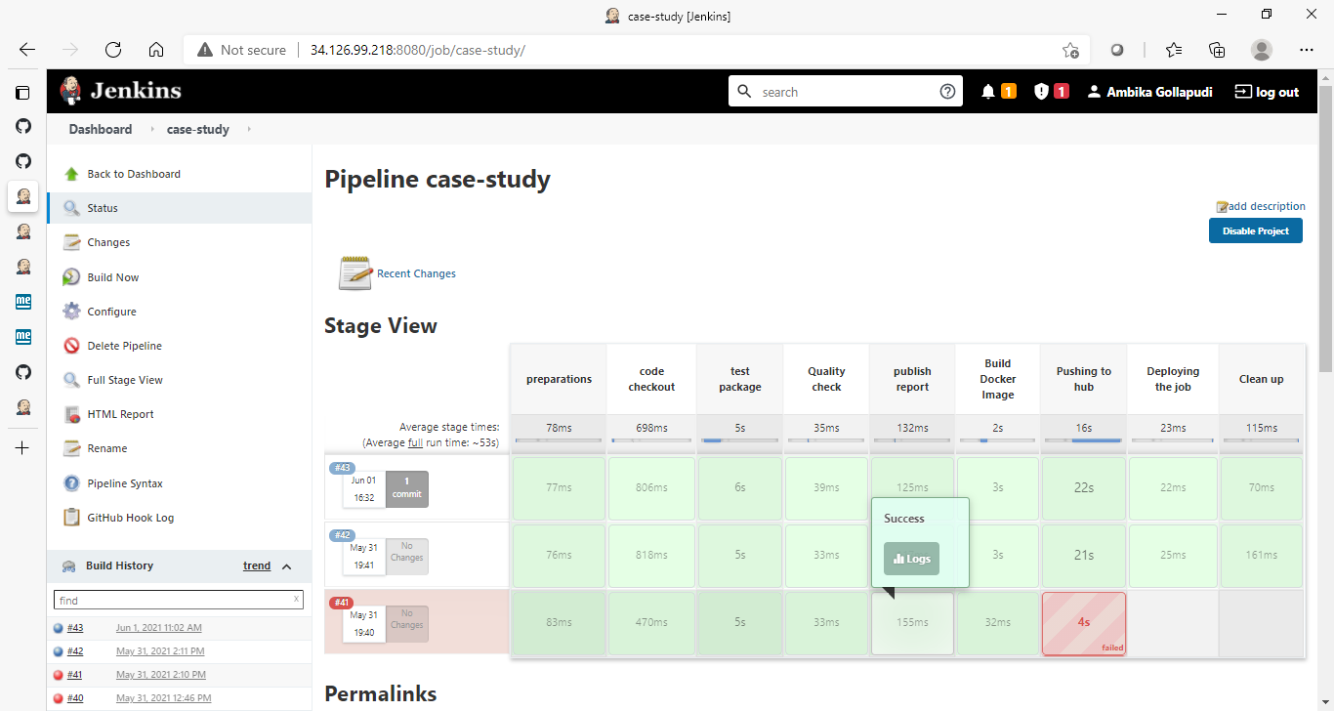

Pipeline Code:

try{

node{

def mavenHome

def mavenCMD

def scannerHome

def scannerCMD

def dockerHome

def dockerCMD

def tagName = "2.0"

stage('preparations'){

mavenHome = tool name: 'maven', type: 'maven'

mavenCMD= "${mavenHome}/bin/mvn"

scannerHome= tool name: 'sonar'

scannerCMD="${scannerHome}/bin/sonar"

docker = tool name: 'docker', type: 'org.jenkinsci.plugins.docker.commons.tools.DockerTool'

dockerCMD = "$docker/bin/docker"

}

stage('code checkout'){

git 'https://github.com/ambikagollapudi567/batch10.git'

}

stage('test package'){

sh "${mavenCMD} test package"

}

stage('Quality check'){

echo("Quality of code")

// sh "${mavenCMD} -f pom.xml sonar:sonar"

}

stage('publish report'){

echo " Publishing HTML report.."

publishHTML([allowMissing: false, alwaysLinkToLastBuild: false, keepAll: false, reportDir: '', reportFiles: 'index.html', reportName: 'HTML Report', reportTitles: ''])

}

stage('Build Docker Image'){

echo "Building docker image for SpringBoot application ..."

sh "docker build -t ambikagollapudi567/batch10:${tagName} ."

}

stage('Pushing to hub'){

withCredentials([usernamePassword(credentialsId: 'docker', passwordVariable: 'dockerpwd', usernameVariable: 'docker')]) {

// some block

sh "docker login -u ambikagollapudi567 -p ${dockerpwd}"

sh "docker push ambikagollapudi567/batch10:${tagName}"

}

}

stage("Deploying the job")

{

// sh "ansible-playbook mainplaybbok.yml"

ansiblePlaybook credentialsId: 'ansible', installation: 'ansible 2.9.22', inventory: '/etc/ansible/hosts', playbook: ' mainplaybbok.yml'

}

stage('Clean up'){

echo "Cleaning up the workspace..."

cleanWs()

}

}}

catch(Exception err){

echo "Exception occured..."

(currentBuild.result="FAILURE") && node("master"){

emailext body: 'Build failed due to some errors', subject: 'Build Result', to: 'ambikagollapudi567@gmail.com'

}

//send an failure email notification to the user.

}

finally {

(currentBuild.result!="ABORTED") && node("master"){

emailext body: 'Congrats ...Build Success!!!!', subject: 'Build Result', to: 'ambikagollapudi567@gmail.com'

}

//send an failure email notification to the user.

}

Deployed Application:

