SubCircuit Tutorial
To open OSCAD,
Go to desktop and double click on oscad. Then click on “Run”. Maximize the OSCAD window
OR
Type “oscad” in terminal window command prompt. Maximize the OSCAD window

You will see the OSCAD window shown in Figure.
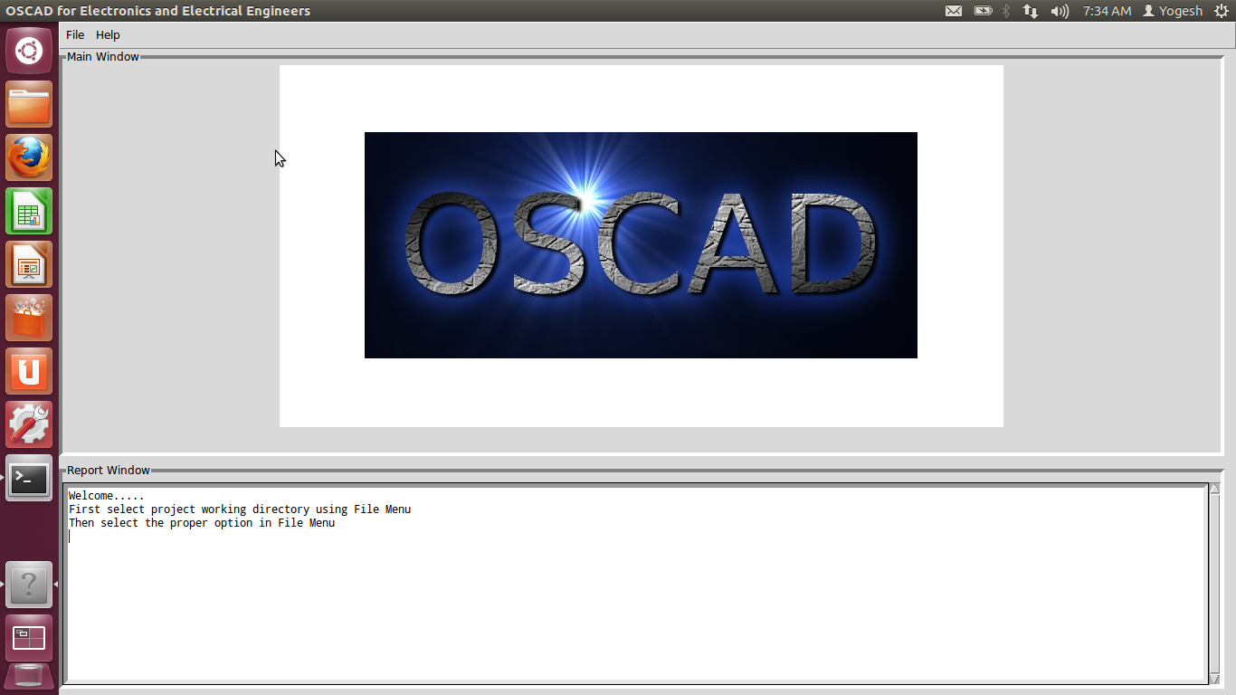
Figure 1. OSCAD Main Window

Opening an existing project.

- Change directory to a project directory.
- Press F5, This will ask for choose directory
- Select /home/(login_name)/Downloads/Example/nonInverting Amplifier
- Press OK
In report window, you will see the message “Changing directory to /home/(login_name)/Downloads/Examples/nonInvertingAmplifier”. Verify whether the chosen directory is correct or not.
- Open the project
- Press F3. This will ask for the project name.
- Press OK.
This will open OSCAD project window.
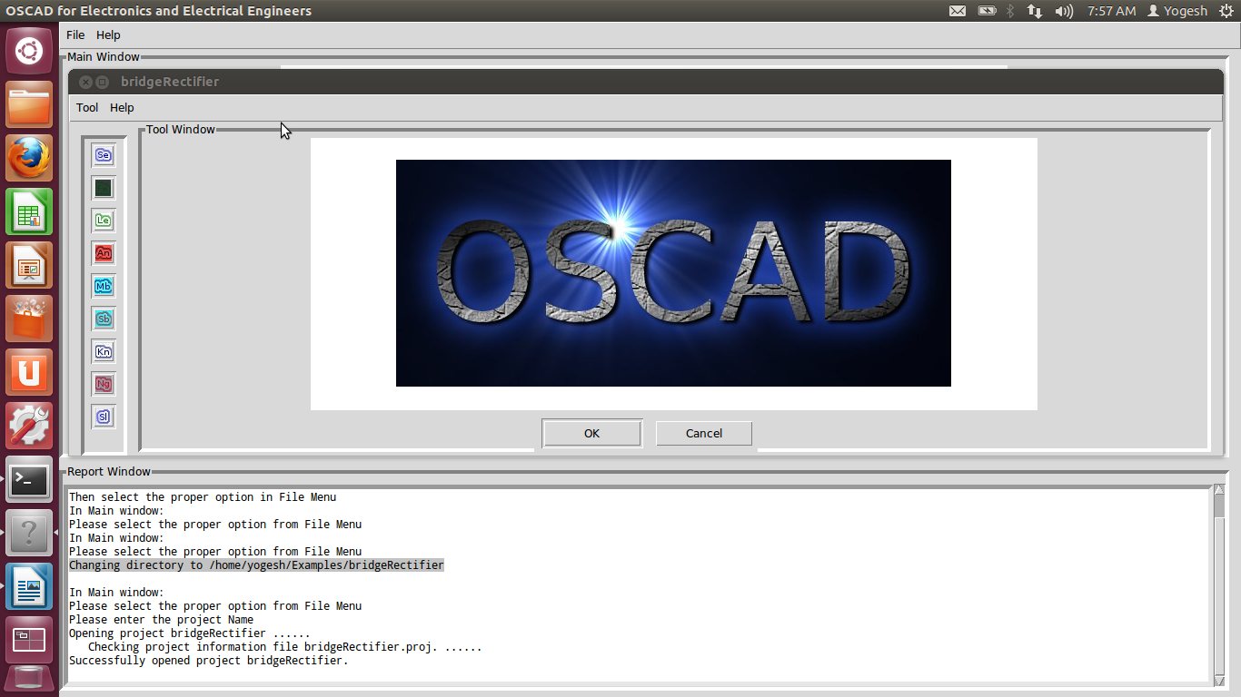
- Open schematic editor (Visit http://65.111.177.118/drupal6/sites/default/files/st_videos/KiCad/C2/Designing-circuit-schematic-in-KiCad-/Designing-circuit-schematic-in-KiCad--English-V2.ogv for help)
- Press F2. This will open schematic diagram. There may be a warning “Some Library are missing”. In such case, set Library path using step 4
You will schematic window shown in Figure. Use zoom + button to adjust the schematic size.

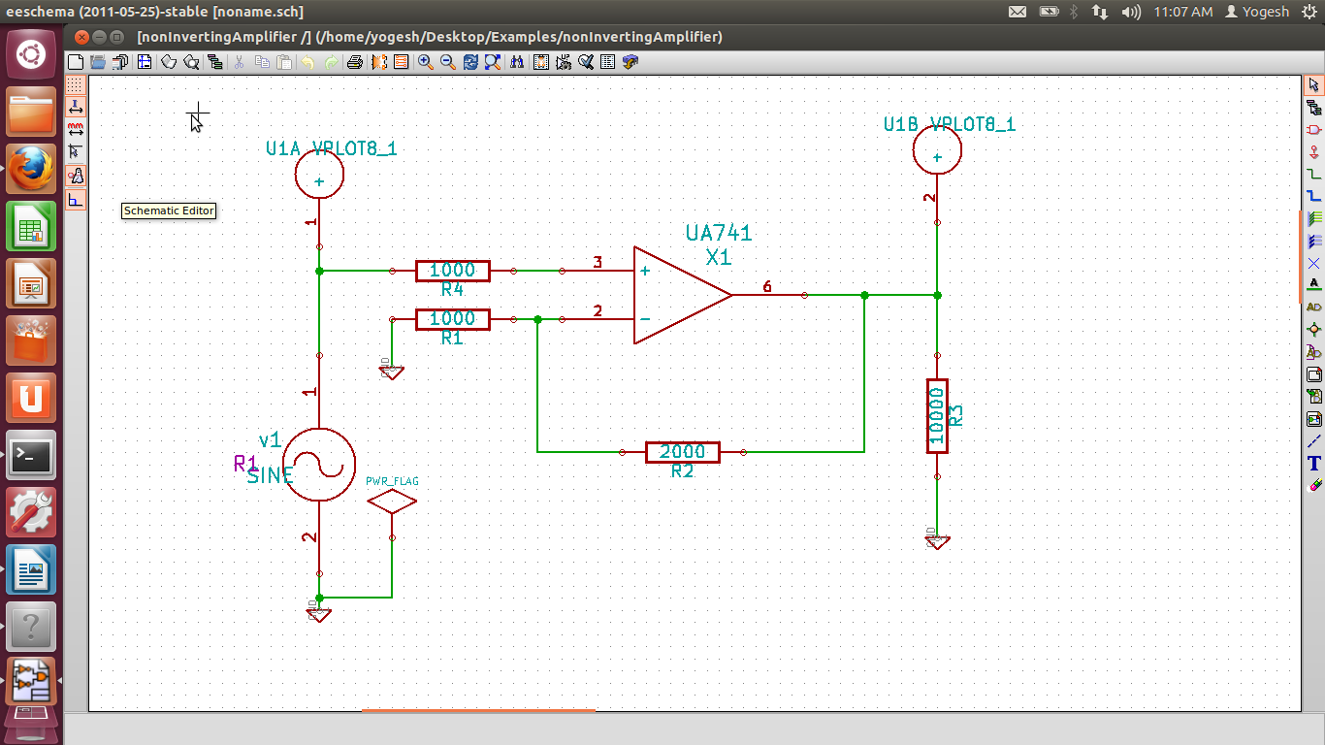
- Set Library path
- Choose library from preference (main menu of schematic editor)
- In user defined search path, click on add button.
- Choose (Home_directory)/OSCAD/library and Press Open
- The message “Use a relative path” will be displayed. Press “No”
- Press OK. This will ask for “Save setting for project” Press “Save”
This will set OSCAD library path.
- Annonate Schematic
- Click on “Annotate” button (4th button from right on top button window). Press Annotation.
- Press OK and close the window.

- Perform electrical check rules
- Click on “electrical check rules” button (3rd button from right on top button window). Press Test ERC.
- If there is an error, message will be displayed.
- Correct the errors if any.
- Close the window.

- Generate netlist for Spice
- Click on “Generate Netlist” button (5th button from right on top button window).
- Click on the Spice tab.
- Uncheck “Prefix references 'U' and IC with 'X' ” (This will appear in new version only)
- Press “NetList” and then click on “Save”
This will generate spice netlist for simulation

- Close Schematic editor.

- Open sub-circuit editor.
- Press F6. It will open subcircuit Editor. On the screen you will all the components in the circuit which require subcircuit definition. In our example, diode uA741 requires proper model.
- Select uA741 Press Cancel if you want to import it from library (Go to step 12) otherwise press OK (Go to step 10).

10. This will open schematic editor (Eeschema)
- Draw following circuit. (Visit http://65.111.177.118/drupal6/sites/default/files/st_videos/KiCad/C2/Designing-circuit-schematic-in-KiCad-/Designing-circuit-schematic-in-KiCad--English-V2.ogv for help)
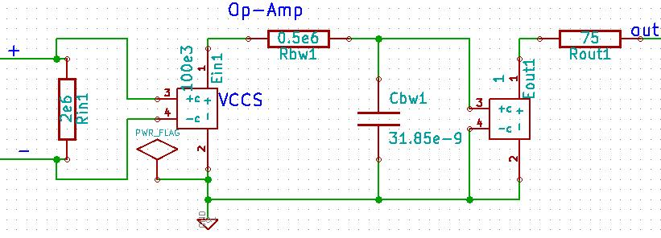
- Connect external pin to “port” (from portSpice library).
- The part number should be same as pin number of the component. To select part number, right click on the “port”, press edit. This will open the component property window. Select proper part number. Final subcircuit will look like below:
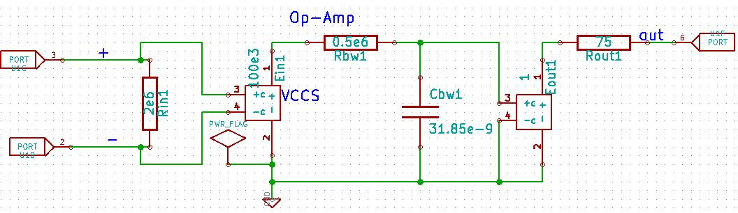
- Perform electrical check rules
- Click on “electrical check rules” button (3rd button from right on top button window). Press Test ERC.
- If there is an error, message will be displayed.
- Correct the errors if any.
- Close the window.
- Generate netlist for Spice
- Click on “Generate Netlist” button (5th button from right on top button window).
- Click on the Spice tab.
- Uncheck “Prefix references 'U' and IC with 'X' ” (This will appear in new version only)
- Press “NetList” and then click on “Save”
- This will generate spice netlist for simulation.
- Save and Close the editor
- Now, subcircuit uA741 will created. Press OK.
- You can export the sub-circuit definition to the subcircuit libray. Press F3, Select the component and Press OK.
- Close subcircuit editor. Go to step 12

11. To import definition of sub-circuit from library. Press F4. Select the component and Press OK.

12. Open Analysis inserter.
- Press F5. This will open Analysis inserter window.
- Click on Transient Tab.
- Change stop time to 40 ms.
- Change step time to 100 us.
- Press “add simulation data”.
- Press Save in File menu.
- Again Press Save. It will ask `do you want to replace existing file?' Press Replace.
- Close Analysis inserter.

12. Open Kicad to Ngspice netlist converter
- Press F8. It will open terminal window.
- It will ask for parameter for sine wave.
- Add parameters for sine source v1
- Enter offset value (Volts/Amps): 0
- Enter amplitude (Volts/Amps): 5
- Enter frequency (Hz): 50
- Enter delay time (seconds): 0
- Enter damping factor (1/seconds): 0

13. Run ngspice
- Press F9.
- Observe the output.
- Close the terminal window.

