OSCAD Installation instructions:

1) Download OSCAD Software and Examples from http://www.ee.iitb.ac.in/student/~syogesh/oscad/
- Open web browser (e.g., firefox)
- Open website http://www.ee.iitb.ac.in/student/~syogesh/oscad/ .
- Click on OSCAD_installer.tgz. Select “Open With” and Press OK. Then click on Extract. One window will open, select destination as `Downloads' folder and click “Extract” again. This will extract OSCAD_installer in `Downloads' folder.
- Click on Examples.tgz. Select “Open With” and Press OK. Then click on Extract. One window will open, select destination as `Downloads' folder and click “Extract” again. This will extract examples in `Downloads' folder.

2) Please download scilab 5.4.0 for 32 or 64 bits (Linux) from http://www.scilab.org/products/scilab/download
- Open web browser (e.g., firefox)
- Open website http://www.scilab.org/products/scilab/download .
- Click on Scilab 5.4.0 for 64 bits or Scilab 5.4.0 for 32 bits (to check whether your machine is 32 bits or 64 bits, in terminal, enter command “uname -m”. If output is i686 then it is 32 bits machine. If output is x86_64 then your machine is 64 bits) under Linux section.
- Save it to `Downloads' folder.
- Open Downloads folder
- Double click on scilab-5.4.0.bin.linux-x86_64.tar.gz or scilab-5.4.0.bin.linux-i686.tar.gz.
- Then click on Extract. One window will open, select destination as `Downloads' folder and click “Extract” again. This will create scilab-5.4.0

3) Start Installation of OSCAD using terminal window
- Open terminal
- Change directory to OSCAD_installer i.e., Type “cd Downloads/OSCAD_installer” in the terminal command prompt
- Run installOSCAD.sh i.e., Type “./installOSCAD.sh” in the terminal command prompt.
- Go to step 3

Figure 1-- Start Installation of OSCAD using terminal window

4) Installation of Pre-requisite softwares (Kicad, ngspice and python )
- If some pre-requisite softwares are not installed, installation script will install it.
- Let us assume Kicad is not installed then you have to do following things:
- If you are connecting internet via proxy then press 'y' when “Do you want to set proxy for internet connection (y/n): ” message come otherwise press 'n'.
- Enter password your login password when message “[sudo] password for username:” is displayed.
- If you press 'y' to set proxy for internet connection, it will ask for your proxy information Please enter username and password of internet proxy.
- Next message will be “Do you want to continue [Y/n]?” Press 'y'
- Now Kicad is installed on your computer.
- Similarly install ngspice and python.
- Go to step 5
Figure 2 -- Installation of Pre-requisite softwares
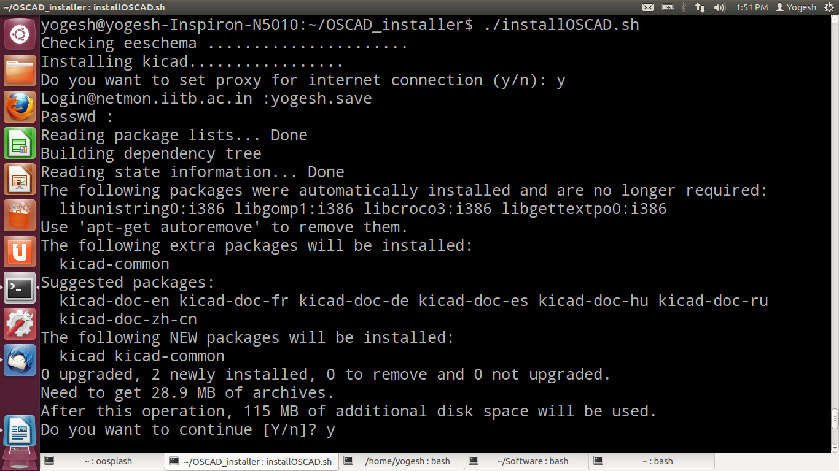

5) Installation of python modules
- If some pre-requisite python are not installed, installation script will install it.
- Let us assume python-imaging-tk is not installed then you have to do following things:
- If you are connecting internet via proxy then press 'y' when “Do you want to set proxy for internet connection (y/n): ” message come otherwise press 'n'.
- Enter password your login password when message “[sudo] password for username:” is displayed.
- If you press 'y' to set proxy for internet connection, it will ask for your proxy information Please enter username and password of internet proxy.
- Now python-imaging-tk is installed on your computer.
- Similarly install other python modules.
- If there is an error in this step, please refer to solution given at the end of the document.

Figure 3 -- Installation of python modules
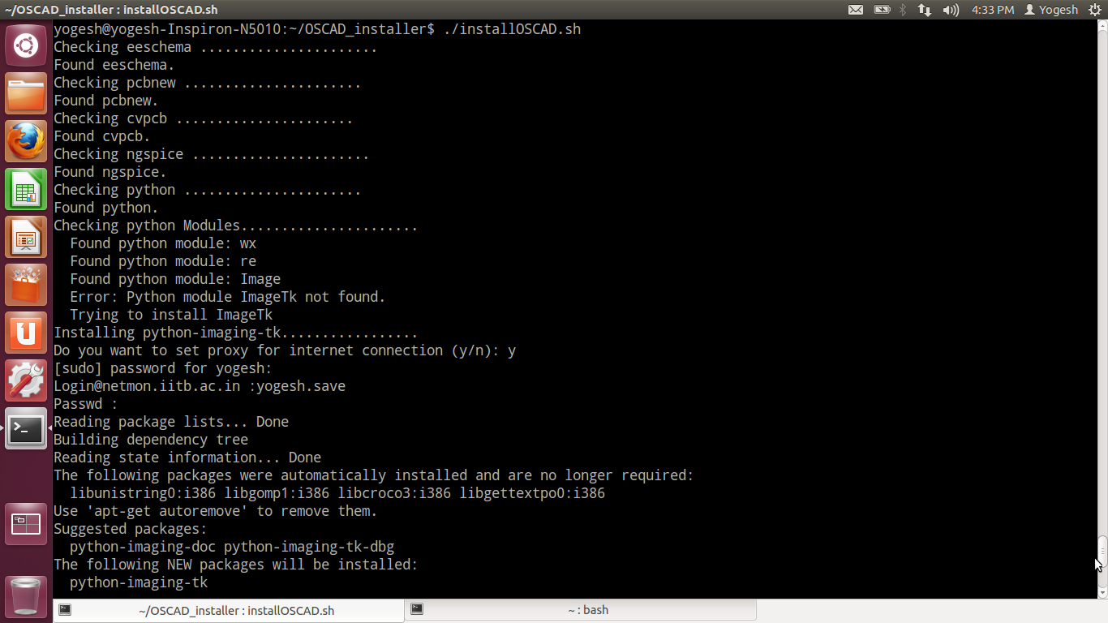

6) Installation of Scilab:
- Press 'y' when message “Do you have scilab5.4 or above? (y/n) “ is displayed.
- If scilab is installed at “Downloads/scilab-5.4.0”, press enter when the message “Please give path of scilab installation directory (e.g., /home/username/Downloads/scilab-5.4.0):” is displayed. Otherwise give complete path of scilab-5.4.x software.
- This will link scilab-5.4.0 to OSCAD

Figure 4 – Installation of Scilab.
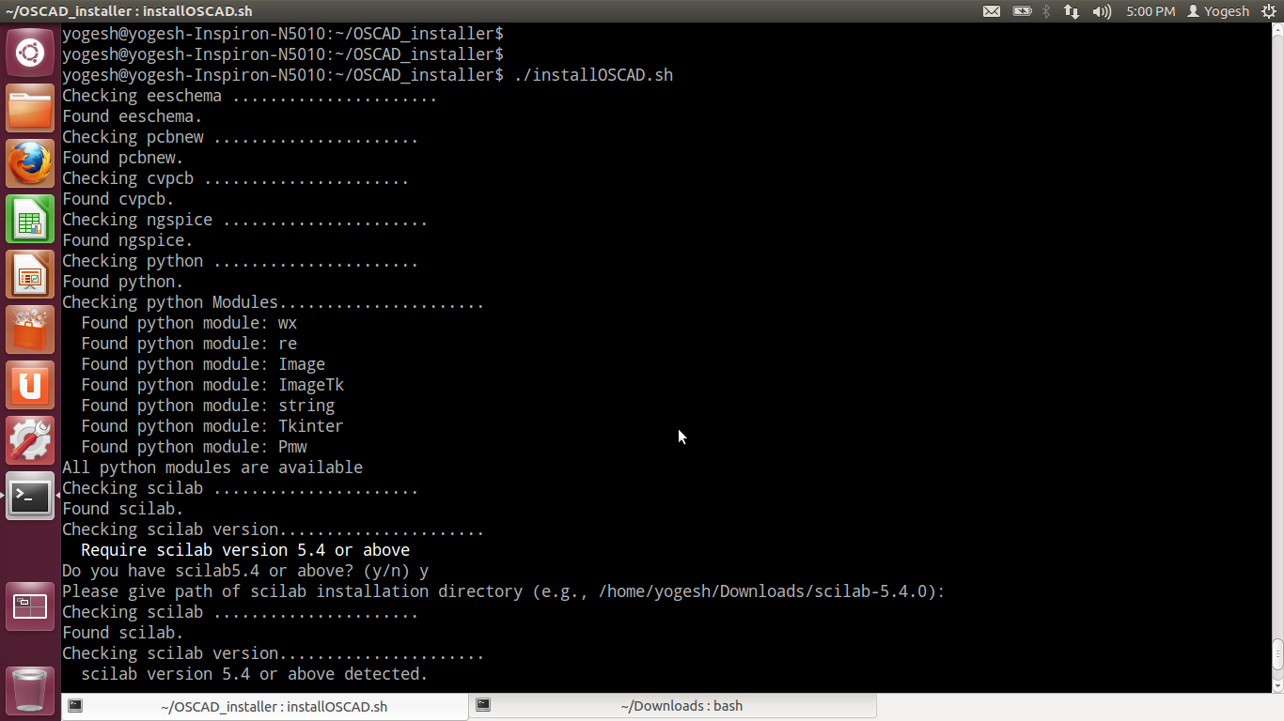

7) Metanet – Graph library installation.
- If you are connecting internet via proxy then press 'y' when “Do you want to set proxy for internet connection (y/n): ” message come otherwise press 'n'.
- If you press 'y' to set proxy for internet connection, it will ask for your proxy information Please enter username and password of internet proxy.
- Now metanet graph library is installed in scilab-5.4.0.

8) Select Installation directory
- Press Enter if you want to install OSCAD in your home directory when message “Please select installation directory (e.g., /home/(username)): ” is displayed. If you want to install in some other place, enter complete path.
- Enter your login password to complete installation.

Figure 5 – Metanet Graph library installation
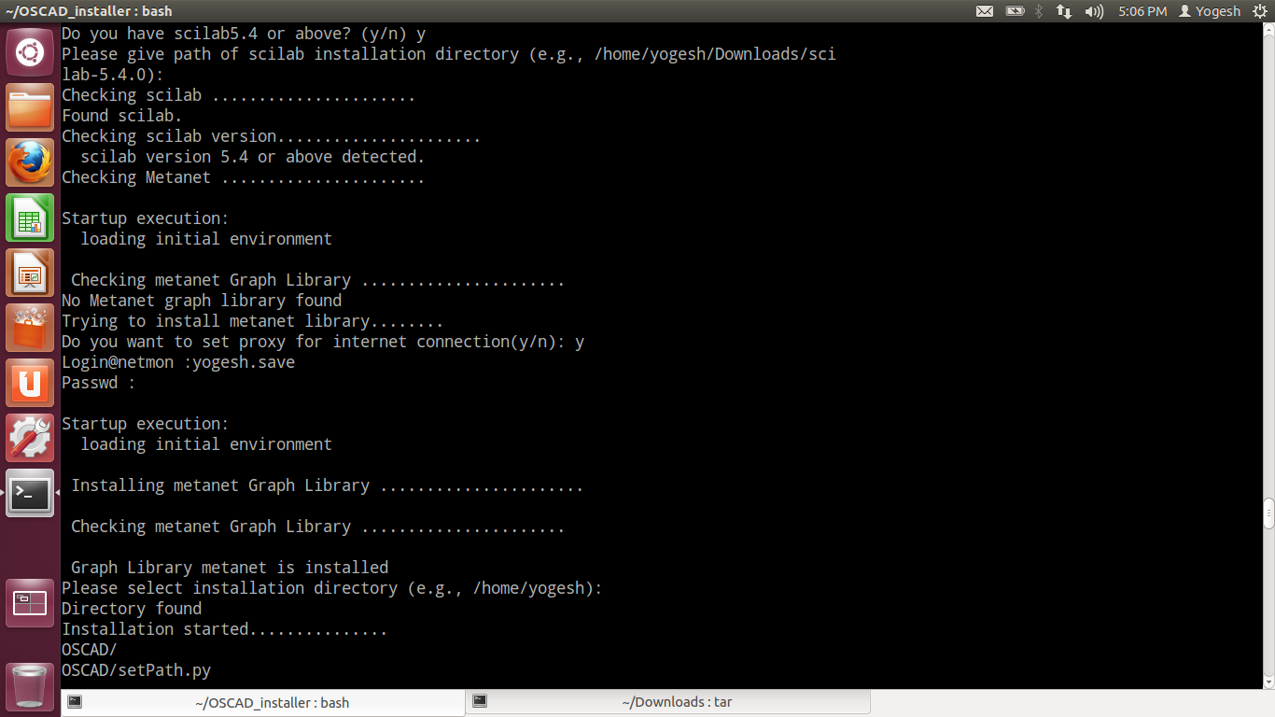

Error messages and Solutions

1) Please download scilab 5.4.0 for 64 bits (Linux) from http://www.scilab.org/products/scilab/download
Solution:
- Open web browser (e.g, firefox)
- Open website http://www.scilab.org/products/scilab/download .
- Click on Scilab 5.4.0 for 64 bits under Linux section.
- Save scilab-5.4.0.bin.linux-x86_64.tar.gz to Downloads folder.
- Open scilab-5.4.0.bin.linux-x86_64.tar.gz.

2) Please download scilab 5.4.0 for 32 bits (Linux) from http://www.scilab.org/products/scilab/download
Solution:
- Open web browser (e.g., firefox)
- Open website http://www.scilab.org/products/scilab/download .
- Click on Scilab 5.4.0 for 32 bits under Linux section.
- Save scilab-5.4.0.bin.linux-i686.tar.gz to Downloads folder.
- Open scilab-5.4.0.bin.linux-i686.tar.gz.
- Run ./install_OSCAD.sh from the terminal which was previously opened.

3) Unable to find scilab5.4.0 or above in the specified location
Solution:
- Check the location of scilab5.4.0
- Run ./install_OSCAD.sh from the terminal which was previously opened.
- Specify path of scilab5.4.0 correctly (e.g. /home/(your_login_name)/Download/scilab5.4.0)

4) Require scilab version 5.4 or above
Problem:
- Current version of scilab is not compatible to OSCAD
Solution:
- Install latest version from http://www.scilab.org/products/scilab/download

4) Please re-run the ./installOSCAD.sh If you are getting this error first time
Please Install Python Library: python-module using package manager

Some python modules are not available. Kindly install them

Solution:
- Please re-run the ./installOSCAD.sh If problem persists install python-module using synaptic package manager.

