High Precision GPS for Drones

Documentation

*1.Introduction*

Drones have influenced our lives in many aspects; this includes delivering things, photography, videography, but most important used in the Searching and Rescuing Missions. Our project aim was to Search and Save animals in the field that eventually might be harmed by agricultural machinery while crop harvesting. In this specific case accuracy play an important role. For our project it was decided to implement a function as High Precision GPS for the drone. For this reason, specific components has been used Emlid Reach M+, Emlid Reach RS+ and LoRa Radio.

* 1. *Accuracy or Precision?*

Accuracy refers to the deviation of a measurement from a standard or true value of the quantity being measured. We can talk about the accuracy of a single measurement and the accuracy for a group of measurements refers to the deviation of the group`s mean value from the standard or true value. Highly scattered results can produce an accurate average. Accuracy is expressed in percentage error E%, or inaccuracy. Accuracy is of vital importance for drone mapping.

Precision tells us how close a group of measurements are to one another. The closer the data replicates, the more likely the results will be similar in the future. For this reason, good precision has predictive value, it gives the confidence in future results. Precision is usually calculated and discussed in terms of standard deviations and coefficient of variation(CV) (http://blog.wheaton.com/accuracy-vs-precision-know-the-difference/, n.d.).

Because precision is concerned with the closeness of two or more measurements to each other rather than to a standard value, it’s possible for a group of values to be precise without being accurate, or to be accurate without being precise.

People frequently use archery or darts to help explain these two terms. Accuracy is the ability to shoot an arrow or dart near the bulls-eye. Precision is the ability to hit the target close to the same spot, no matter where that spot is, several times in a row.

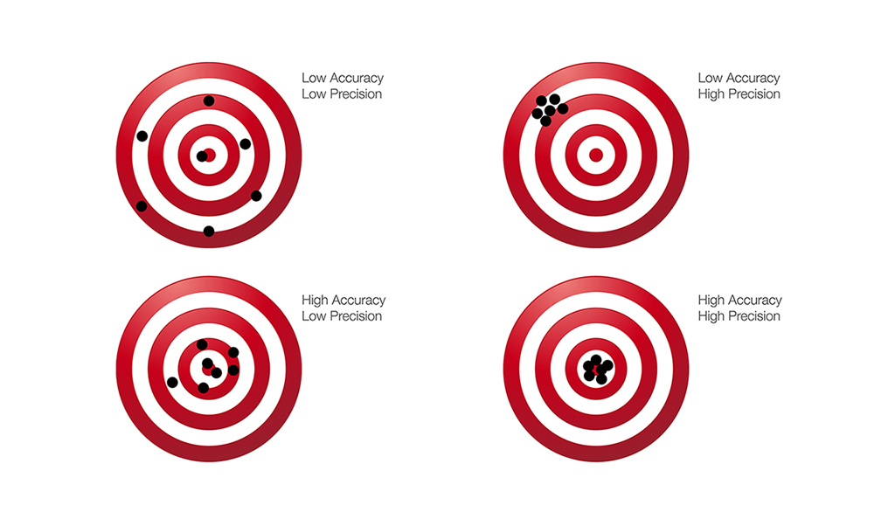

Figure 1 (Precision and Accuracy cases)

*1.2 Real-time Kinematic (RTK)*

The use of Real-time kinematic (RTK) measurement enhances the positioning, giving a more accurate reading of feature locations of up to a 2 cm accuracy. It uses the GNSS carrier phase to modulate signals between satellite and the receiver .The receiver in the base station sends a differential signal to the GNSS receiver in the UAV through communication link and correction is applied by the RTK. However, the accuracy and precision of photogrammetric products of the drone and its significance for rapid mapping application are not yet known. Precise measurements are essential for direct geo-referencing to use it for rapid mapping applications and RTK plays a critical role for this purpose (EKASO, 2018 February).

When you fly a not-RTK drone with an onboard GPS receiver or a receiver along with the camera, camera positions are influenced from satellites, so their positions are recognized by several distance measurements. Normally, we can expect an inaccuracy of up to several meters, especially in Z directions, depending on the equipment quality and the satellite geometry.

In case of data-link connection, such as Wi-Fi in our case, an RTK drone will connect to a base station via the laptop which controls the flight. The camera positions are calculated in real-time, referring to ground references, the locations of which are accurately measured for a long period of time. The calculations helps correct the camera positions up to two to three centimetres of accuracy, both horizontal and vertical. However, it is not always working perfectly. There was encounter interrupted connections which interfere the real-time corrections the drone. The system gives float solutions or even gets back to standalone mode. The drone positions are RTK-float, indicating a big uncertainty around the corrections (Dai Shi, n.d.).

 Real Time Kinematics (RTK), in which a Global Navigation Satellite System (such as GPS, GLONASS, Galileo or BeiDou) is used with a fixed (and precisely located) ground reference station to reduce and remove common positioning errors. In a nutshell, **RTK GPS** provides extremely precise geotagging of the exact location and alignment of the drone when each image is taken.  This system enhances the precision of position data received from satellite-based positioning systems, does not require laying out Ground Control Points and results in the survey grade accuracy required for many applications.

*RTK GPS* used for our project consists of three segments

1. **base station (Reach RS+)**
2. **one rover user (Reach M+)**
3. 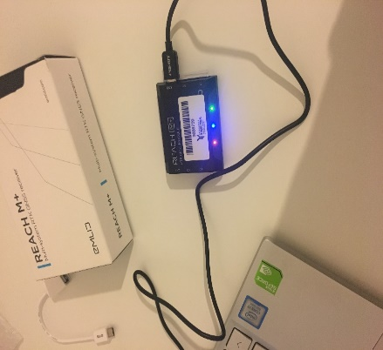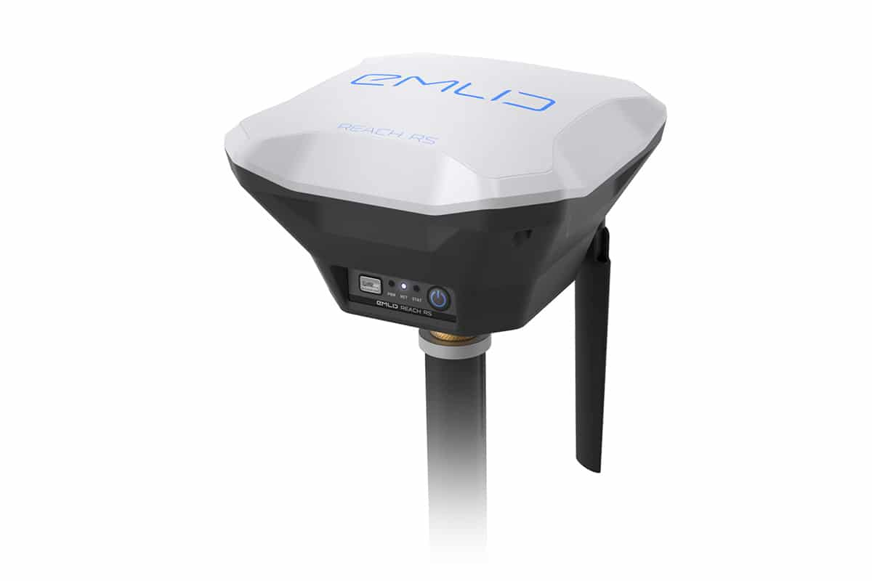**communication channel (LoRa Radio)**

Reach RS+ Reach M+

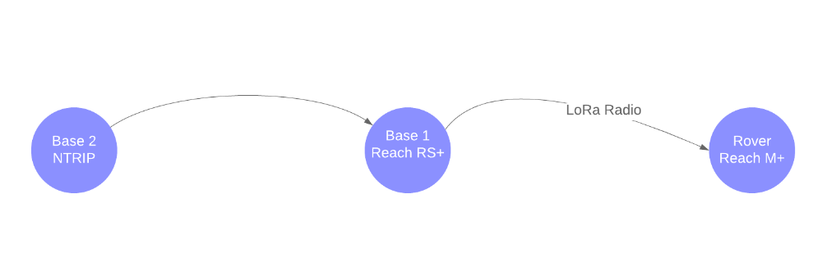

The **base station** (the exact location of which is known) monitors satellite signals and sends real time correction information to the **rover user** through the **communication channel.** By combining the rover measurements with those of the reference station, these receivers can determine an exact position within the tolerance required.

RTK relies on a data link between the mobile unit making the measurements and at least one other GNSS receiver providing reference data.  This real-time link is absolutely necessary – differential GPS corrections can be applied in the field only as long as a real-time data link between the reference receiver and the mobile unit is maintained.

*2.Work Package Description*

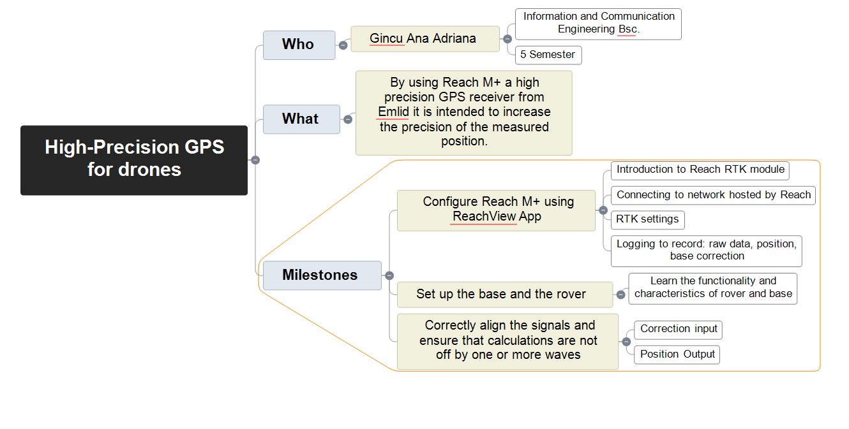

*3.Implementation*

First Step was to understand the functionality of Reach M+ and to connect to Wi-Fi network that Reach module creates when powered for the first time.

Reach M+ can cause some problems while connecting to Wi-Fi. After connection you have to access http://192.168.42.1  and change the Wi-Fi address to the home network. After that you will have access to ReachView where all the necessary configuration could be added.

**ReachView Status**

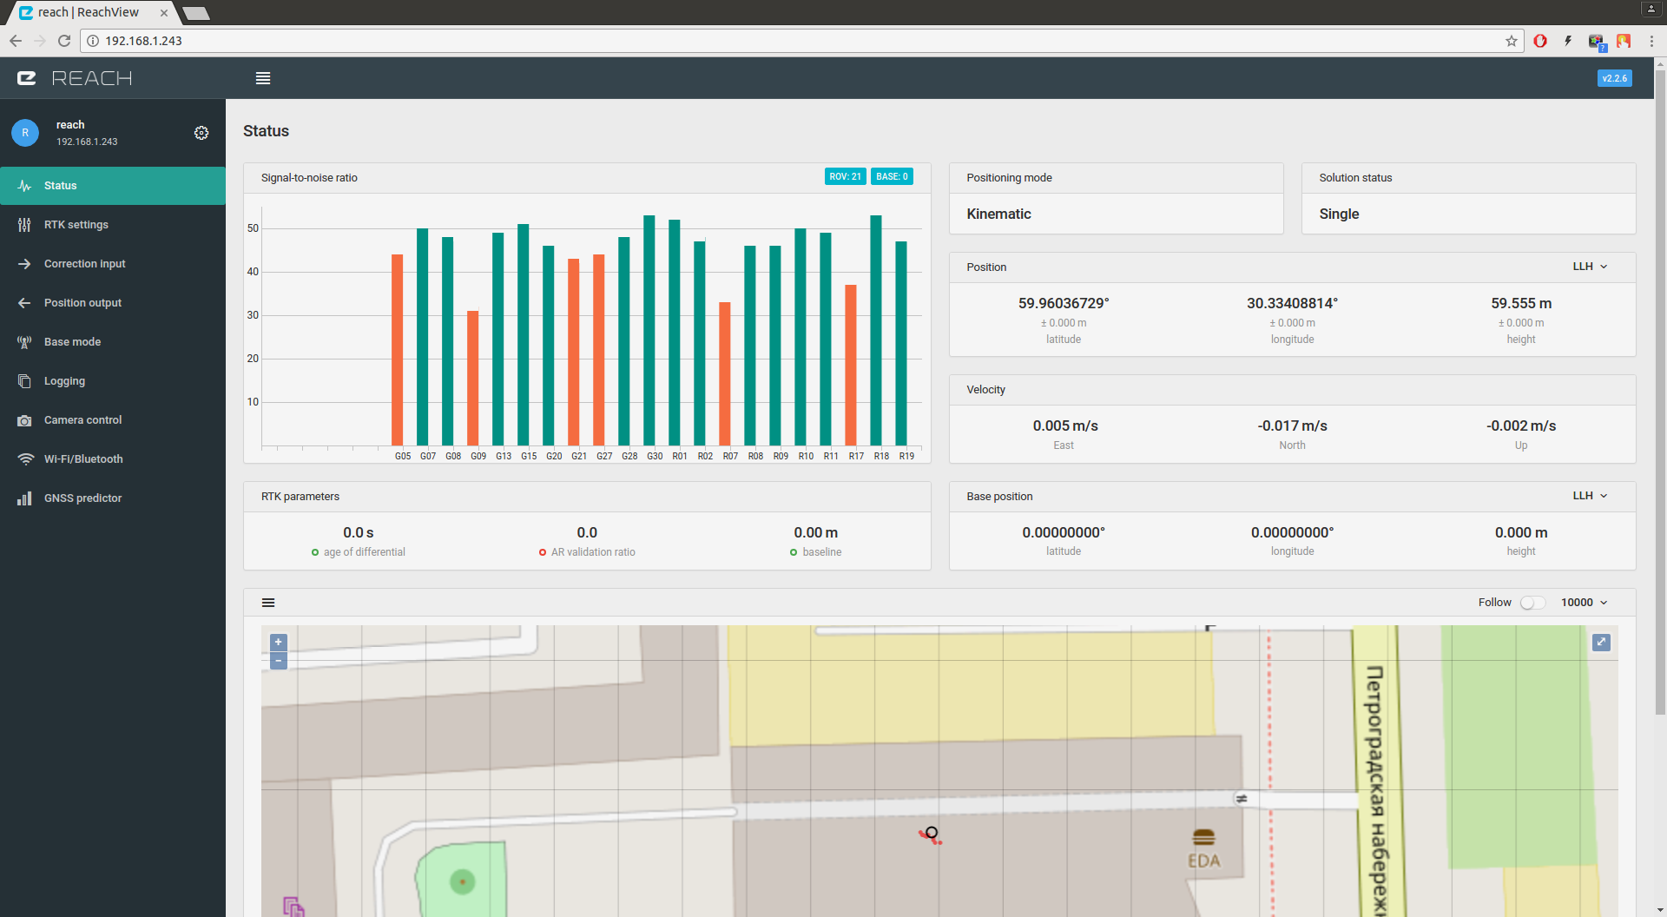

RTK positioning requires excellent reception of signals from GNSS satellites. SNR (Signal to Noise Ratio) is the primary indicator of how good the reception is. The graph lists all satellites that fit in your screen size and corresponding SNR. Data is updated in real-time.Satellites that can be included to SNR: Glonass, GPS, SBAS,Galileo, QZSS,Beidou.When the SNR value is above the range we set for example(45) the bar will be marked green. Grey bars indicate SNR of the base station. The greener bars we get the better results we will have as an outcome. On the top of the SNR chart we can see indicators of numbers of satellites visible to rover and base receivers.

*RTK parameters*

* Age of differential = In case of a steady correction stream, age of differential will indicate link latency.
* AR validation ratio = Shows how many times is the best solution better than the next one.
* Baseline = The distance from rover to the base

Another important feature is *Solution Status*

* Single means that rover has found a solution relying on it’s own receiver and base corrections are no applied
* **Float** means that base corrections are now taken into consideration and positioning is relative to base coordinates, but the integer ambiguity is not resolved. Precision in float mode is submeter-level
* **Fix** means that positioning is relative to the base and the integer ambiguity is resolved. Precision in standalone mode is centimeter (Emlid, n.d.)-level.

**RTK Settings**

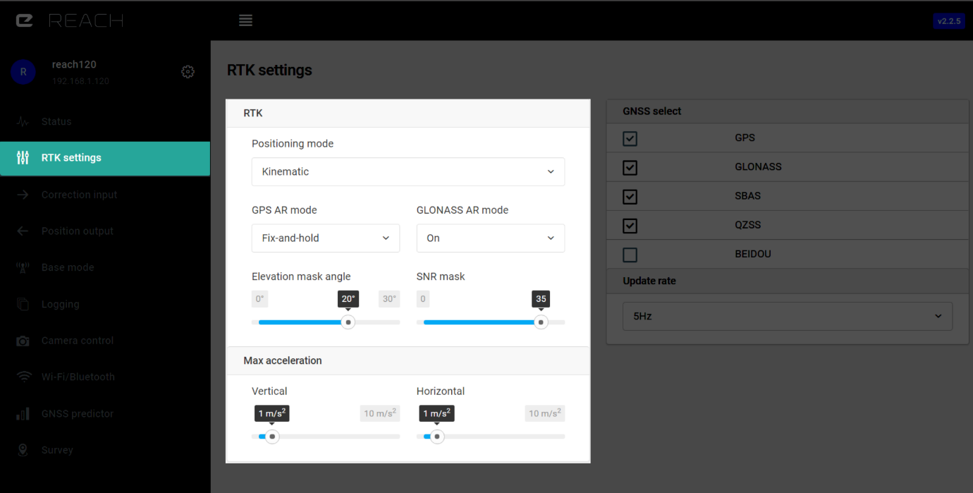

### *Positioning Mode*

* **Single** - standalone positioning mode, does not provide improved precision.
* **Kinematic** - most used positioning mode, assumes that receiver is moving.
* **Static** - an assumption is made that Reach is static. Constraining the system helps to resolve ambiguities faster as well as produce measurements with higher precision.

*Elevation Mask*

Satellites lower than set elevation will be excluded from computation. Default setting is 15 degrees. Usually satellites with lower elevation provide too noisy measurements.

*SNR Mask*

Satellites with low SNR will be excluded from computation. Default setting is 35.

**Correction Input**

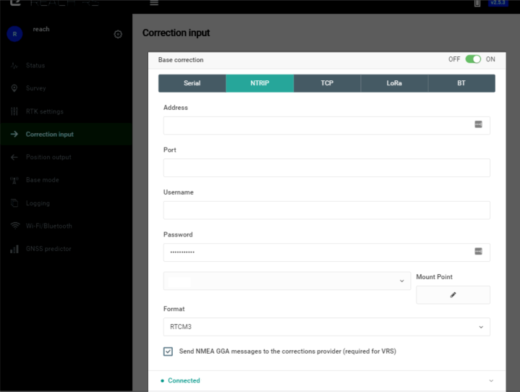

NTRIP is industry standard way of transferring GNSS corrections over Internet, with ReachView you can use any public service or your own private caster. NTRIP does not support point-to-point communication e.g. you can not use it to transfer corrections from one Reach to another directly. In NTRIP terminology there are servers, clients and caster. Server sends correction to a caster and clients can receive them by connecting to that caster.

In order to receive correction from NTRIP caster you need to know:

* IP address or domain name of the caster
* Port
* Username
* Password
* Mount point
* Format (usually RTCM3)

**Reach RS/RS+** has internal LoRa radio which is used for receiving or sending corrections. For **Reach M+** external LoRa radio is available, it can be connected via USB or S1/S2 port. The radio works only in one way, it could either be configured to send corrections (on base) or to receive them (on rover). In our case it was used to receive corrections.Using LoRa modulation it is possible to hit up to 19km in line of sight or a few km in urban areas with just 20 dBm power output. As long as frequency and air rate settings match an unlimited number of rovers can listen for correction from the same base.

# Bibliography

Dai Shi, L. C. (n.d.). *https://www.pix4d.com/blog/rtk-ppk-drones-gcp-comparison*.

EKASO, D. D. (2018 February). *ACCURACY ASSESSMENT OF REAL-TIME KINEMATICS (RTK) MEASUREMENT ON UNMANNED AERIAL VEHICLES (UAV) FOR DIRECT GEO-REFERENCING.*

Emlid. (n.d.). *https://docs.emlid.com/reachm-plus/common/reachview/correction-input/*.

*http://blog.wheaton.com/accuracy-vs-precision-know-the-difference/*. (n.d.).