Playwright Test Automation Framework
From Manual Test Cases to Automated Scripts using Copilot Chat

Complete Methodology: Manual Testing → Excel → Copilot Chat → Automation Scripts

Document Type | Complete Framework Setup with Copilot Integration
Audience | QA Engineers, Testers, Developers
Framework | Playwright + TypeScript
Key Tool | GitHub Copilot Chat with Instructions.md
Created Date | May 15, 2026
Status | Production Ready with Screenshots

Table of Contents
- 1. Introduction & Framework Overview
- 2. System Requirements & Installation
- 3. Phase 1: Environment Setup
- 4. Phase 2: Manual Test Case Creation
- 5. Phase 3: Creating Instructions.md for Copilot
- 6. Phase 4: Using Copilot Chat to Automate Tests
- 7. Phase 5: Project Structure & Organization
- 8. Phase 6: Complete Automation Workflow
- 9. Copilot Rules & Best Practices
- 10. Testing & Execution
- 11. Troubleshooting & Tips

1. Introduction & Framework Overview
This comprehensive guide demonstrates how to create end-to-end automated tests for web applications using Playwright and TypeScript, with AI assistance from GitHub Copilot Chat. The unique approach in this framework leverages an Instructions.md file to guide Copilot in generating high-quality, consistent, and maintainable test automation code.

1.1 The Three-Phase Automation Methodology
Phase | Description
Phase 1: Manual Testing | Create detailed manual test cases in Excel with steps, data, and expected results
Phase 2: Instructions Setup | Create Instructions.md file with Copilot rules, patterns, and best practices
Phase 3: AI-Assisted Automation | Use Copilot Chat with Instructions.md to convert manual tests to automated scripts

2. System Requirements & Installation

2.1 System Prerequisites
Requirement | Specification
Operating System | Windows 10/11, macOS 11+, or Linux
RAM | 8GB minimum (16GB recommended)
Disk Space | 3GB free space
Internet | Required for GitHub Copilot and npm packages

2.2 Required Software
Software | Version | Purpose | Download
Node.js | 18.x LTS+ | JavaScript runtime | nodejs.org
VS Code | Latest | Code editor | code.visualstudio.com
Playwright | 1.40+ | Testing framework | npm install
GitHub Copilot | Subscription | AI code assistant | github.com/copilot
TypeScript | 5.x | Type-safe JavaScript | npm install
Git | Latest | Version control | git-scm.com
Excel Reader | 0.18.5 | Read test cases | npm install xlsx

3. Phase 1: Environment Setup with Screenshots

3.1 Step 1: Download and Install Node.js
- Go to https://nodejs.org/
- Click the LTS (Long Term Support) download button
- Run the installer and accept the license agreement
- Select default installation location
- Complete the installation
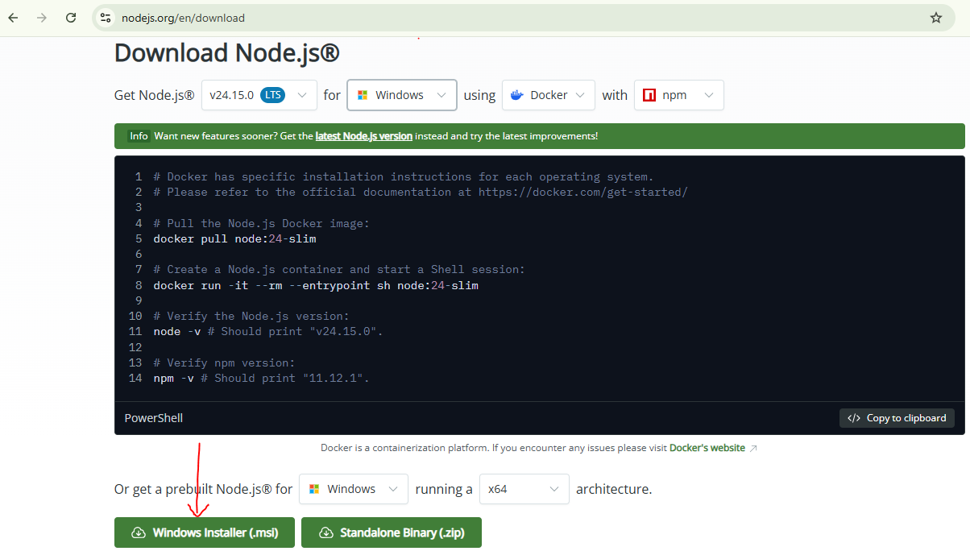
Verify Installation:
Open command prompt and run node --version && npm --version
Command Prompt Verification
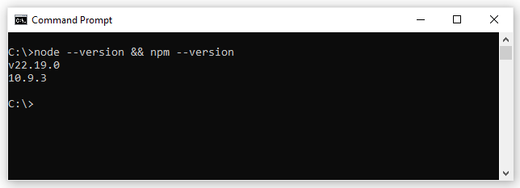

3.2 Step 2: Install Visual Studio Code
- Go to https://code.visualstudio.com/
- Click download for your operating system
- Run the installer
- Accept license and choose installation options
- Complete installation and launch VS Code
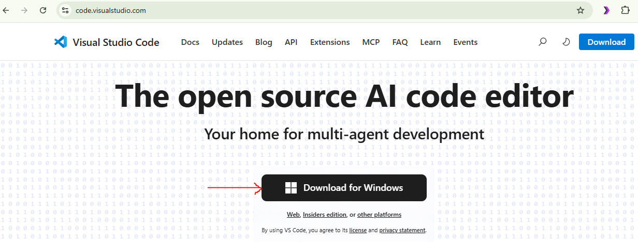

VS Code Welcome Screen 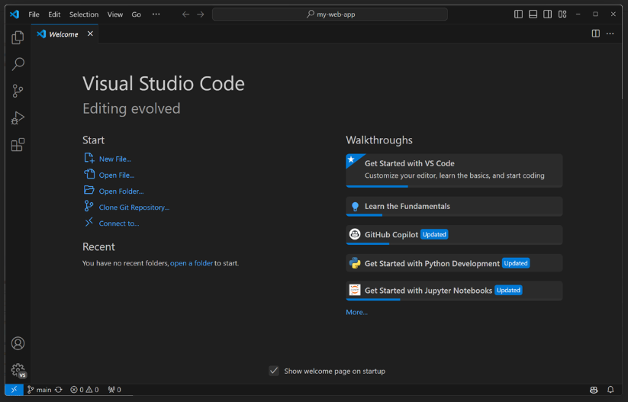

3.3 Step 3: Install Essential Extensions
Open Extensions panel (Ctrl+Shift+X) and install:
VS Code Extensions Panel
- Playwright Test for VS Code: Run and debug tests directly in VS Code
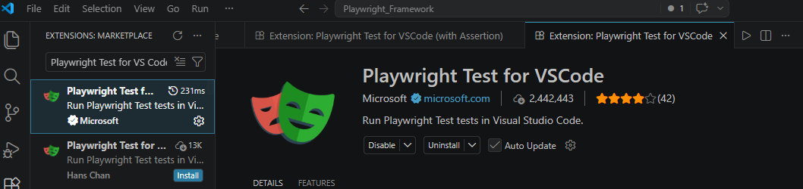

- GitHub Copilot Chat: Chat interface for AI assistance
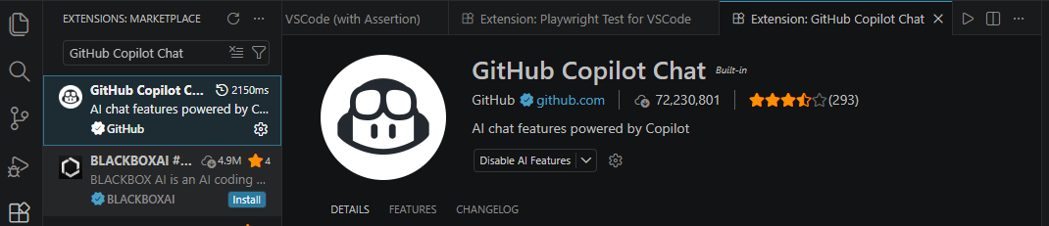

- Playwright MCP: Server that interacts with web browser based on AI instructions
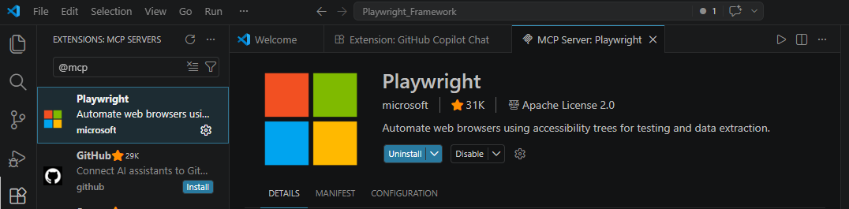

3.4 Step 4: Create Project Directory
New Folder Creation Steps:
- Create folder: C:\Users\YourName\Playwright_Framework
- Open VS Code
- File → Open Folder → Select the Playwright_Framework folder
- VS Code will open with the empty project
Project Opened in VS Code 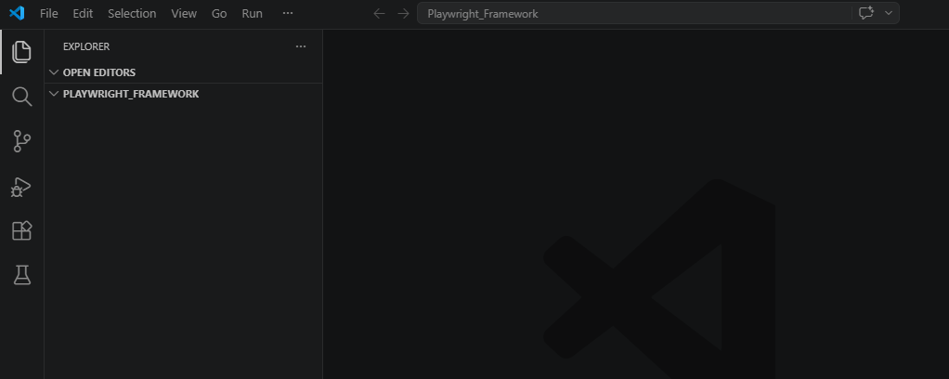

3.5 Step 5: Open Terminal, Install TypeScript and Initialize Node Project
Terminal in VS Code: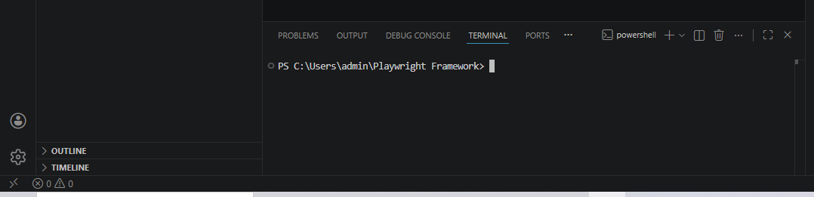

1. Install typescript globally:
npm install -g typescript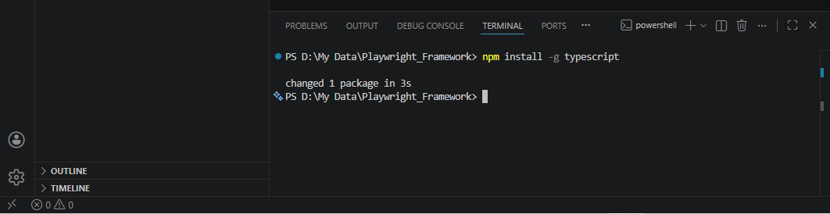
2. To run .ts files directly:
npm install -g ts-node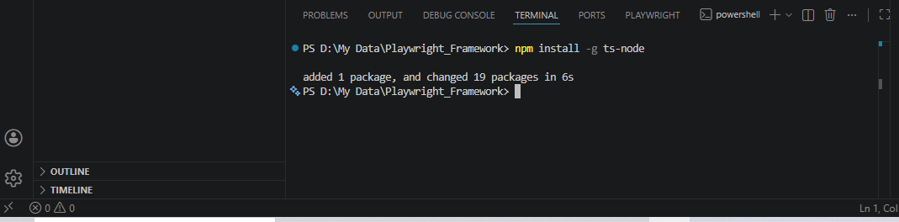
3. Initialize Node project (will create package.json):
npm init -y 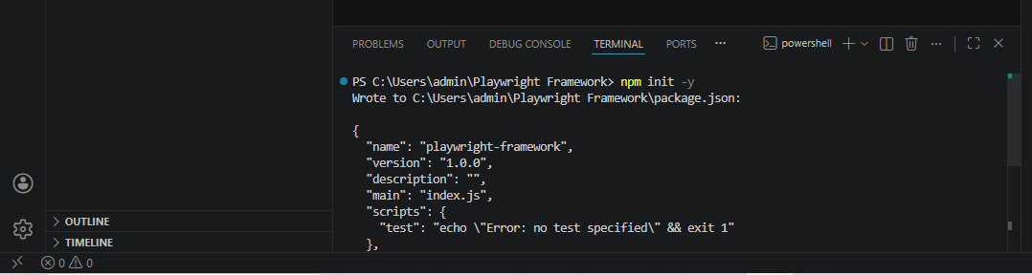
4. Package.json Created: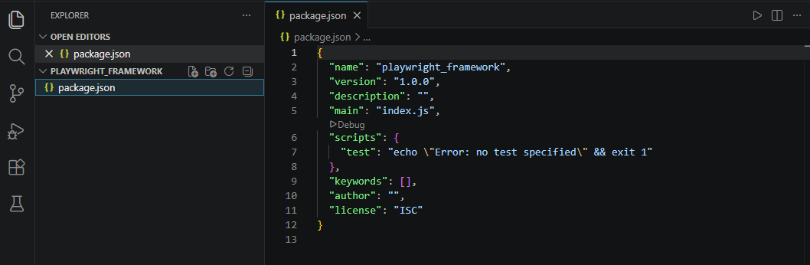

4. Phase 2: Manual Test Case Creation
Manual test cases are the foundation of automation. They document the expected behavior of the application and serve as blueprints for automation scripts.

4.1 Test Case Template & Format

Excel Columns Required:
- TestCaseID - Unique identifier (TC-001)
- TestCaseName - Descriptive name of the test
- Module - Feature/Module being tested
- Description - Detailed description
- Priority - High/Medium/Low
- Severity - Critical/Major/Minor
- Preconditions - Setup requirements
- TestData - Input values and test data
- Steps - Numbered execution steps
- ExpectedResult - Expected outcome
- PostConditions - Cleanup steps
- Status - Pass/Fail/Not Executed
Excel Test Case Sheet: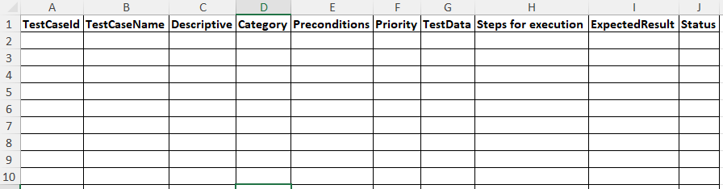

4.2 Example Manual Test Cases
Example 1: User Login Test
TestCaseID | TC-001
TestCaseName | Verify valid user login
Module | Authentication
Priority | High
Preconditions | User account exists; User not logged in
TestData | Username: testuser@example.com; Password: Test@123
Steps | 1. Navigate to login page  2. Enter email  3. Enter password  4. Click Login
ExpectedResult | User logs in successfully; Dashboard displays
Status | Not Executed

Excel Test Case Entry (e.g.)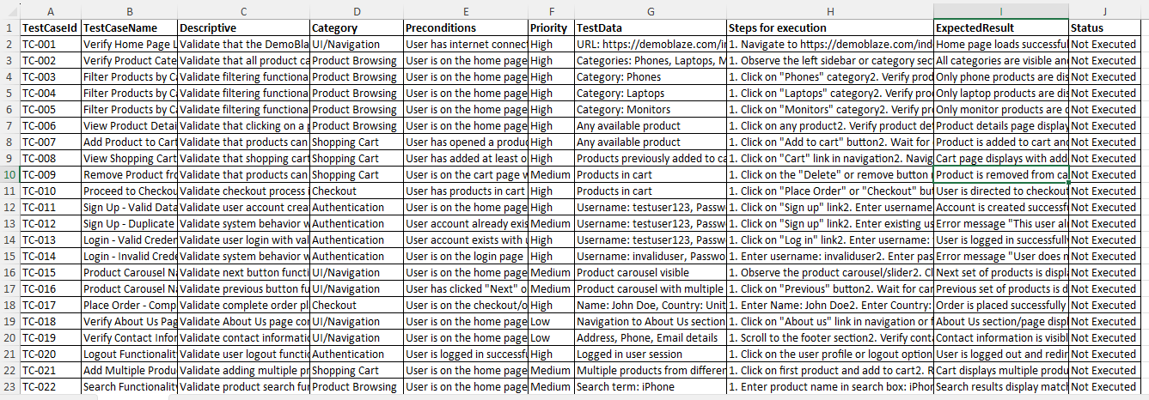

5. Phase 3: Creating Instructions.md for Copilot
The Instructions.md file is crucial - it tells GitHub Copilot Chat how to generate automation scripts. It contains rules, patterns, best practices, and DemoBlaze application details.

5.1 Why Instructions.md Matters
GitHub Copilot is an AI model that learns from patterns. By providing clear instructions, rules, and examples, Copilot generates consistent, high-quality code that follows your framework's conventions.
- Ensures consistent code quality and style
- Guides Copilot to use Page Object Model correctly
- Prevents common mistakes in test automation
- Reduces manual code review and fixes
- Speeds up automation script generation
- Maintains framework standards across all tests

5.2 Instructions.md File Structure
Create file: Instructions_DemoBlaze.md at project root
Instructions File Created:
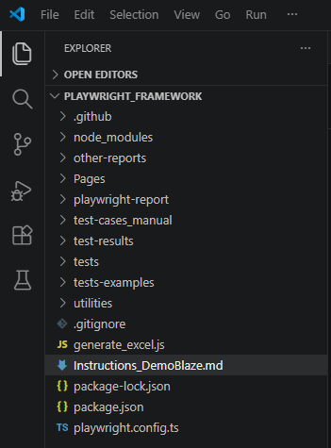

5.3 Key Sections in Instructions.md
- Quick Start: Explains how user provides test case info
- Target Application Details: URL, features, and capabilities of the app being tested
- Test Case Source Format: Expected Excel format and columns
- Critical Rules: Mandatory rules for Copilot to follow
- Rule Examples: Before/After code examples showing correct patterns
- Application-Specific Selectors: DemoBlaze page locators and element IDs
- Test Naming Conventions: How to name test methods and classes

5.4 Critical Rules to Include
- Rule 1: Always Display Test Case First AND Wait for Confirmation
- Rule 2: Capture BOTH Action AND Validation Locators
- Rule 3: Never Guess Locators — Verify First
- Rule 4: Use Locator Priority (data-testid > id > class > XPath)
- Rule 5: Use Page Object Model with Proper Structure
- Rule 6: Element Names Must Use "Locator" Suffix
- Rule 7: Avoid Complex Assertions in Test Methods
- Rule 8: No Hard Waits — Use Playwright Built-in Waits
- Rule 9: Implement ALL Test Steps — No Partial Implementation
- Rule 10: Follow Test Method Naming Convention
Instructions.md Content: 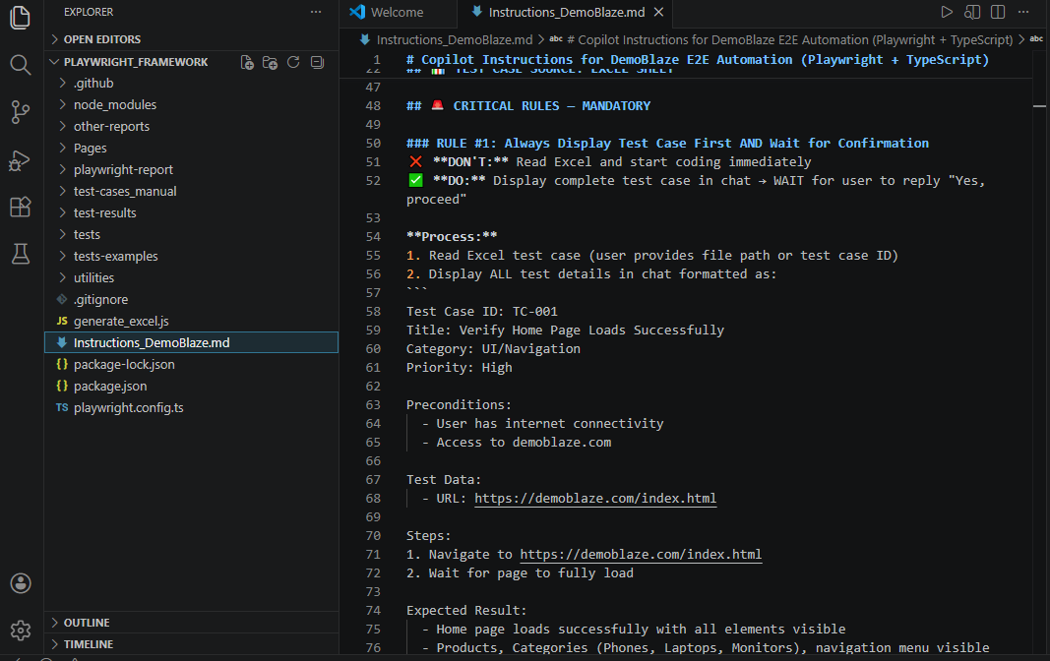
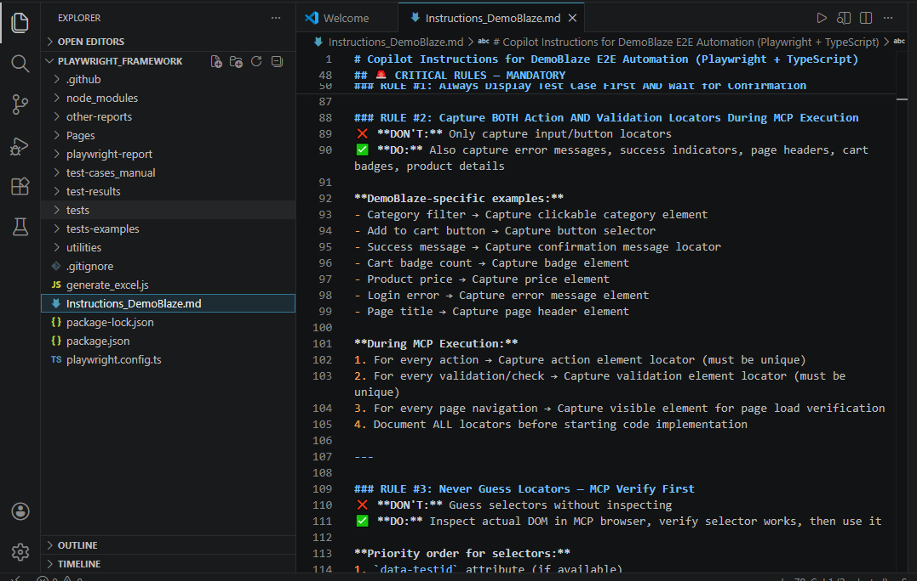

6. Phase 4: Using Copilot Chat to Automate Tests
This is where the magic happens. GitHub Copilot Chat uses the Instructions.md file to generate high-quality, framework-compliant test automation code.

6.1 Step 1: Open Copilot Chat
- Open Copilot Chat in VS Code (Ctrl+Shift+I or View → Copilot Chat)
- Click the paperclip icon to attach Instructions_DemoBlaze.md
- Or use @ symbol: type @Instructions_DemoBlaze.md
- Copilot will read and understand the instructions
Copilot Chat Interface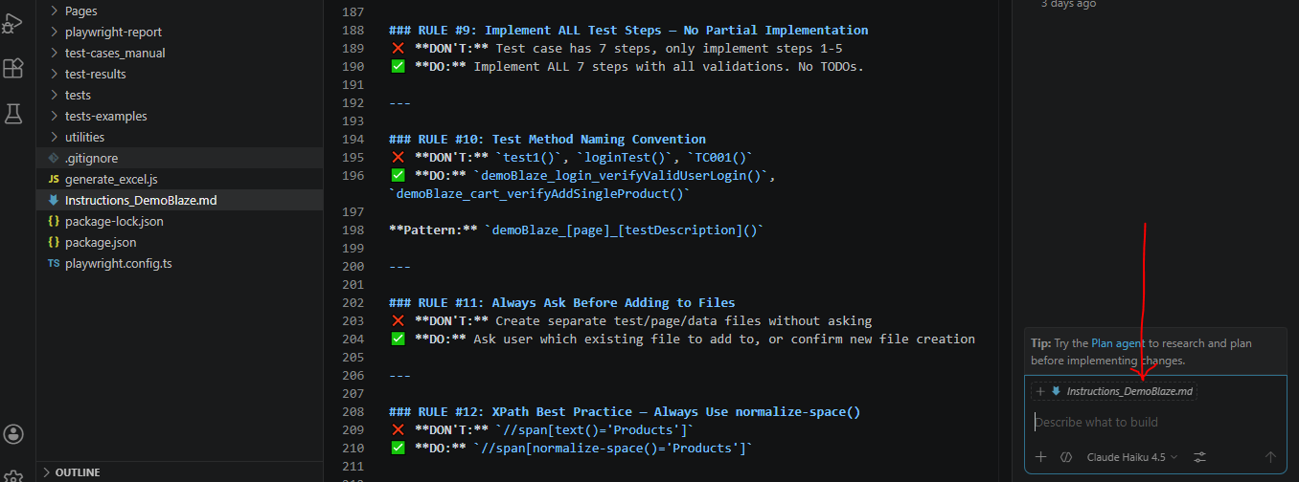

6.2 Step 2: Provide Test Case Details
Format your request to Copilot as:
Chat Input:
Using Instructions_DemoBlaze.md, automate TC-001
Output:
Will provide loginPage.ts and homePageTest.spec.ts files with code.

Copilot Chat Prompt: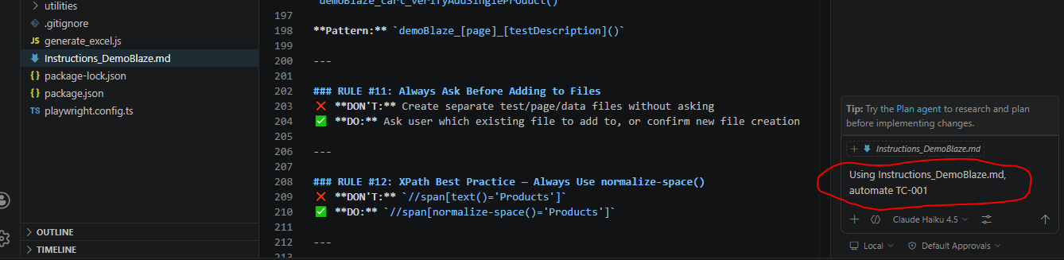

6.3 Step 3: Copilot Generates Code
Copilot will generate:
- Login Page Object (loginPage.ts) with locators and methods
- Test Specification (homePageTest.spec.ts) with test cases
- Complete TypeScript code following all Instructions.md rules
Copilot Generated Code: 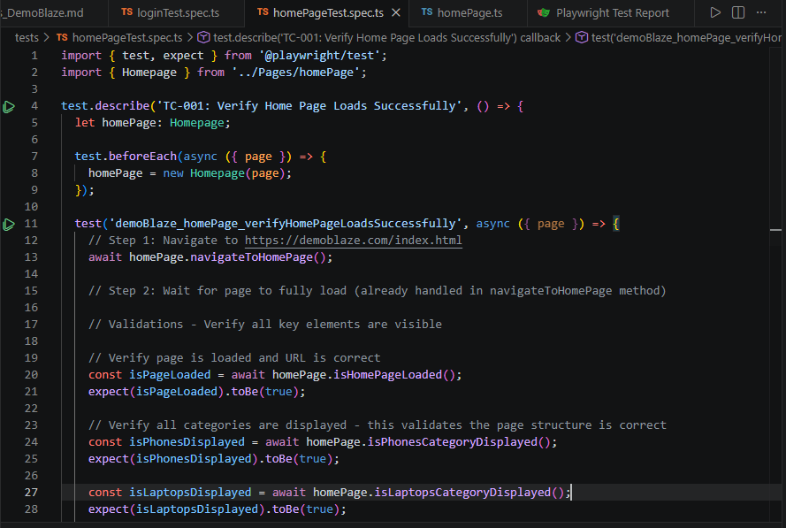
Execution Report: 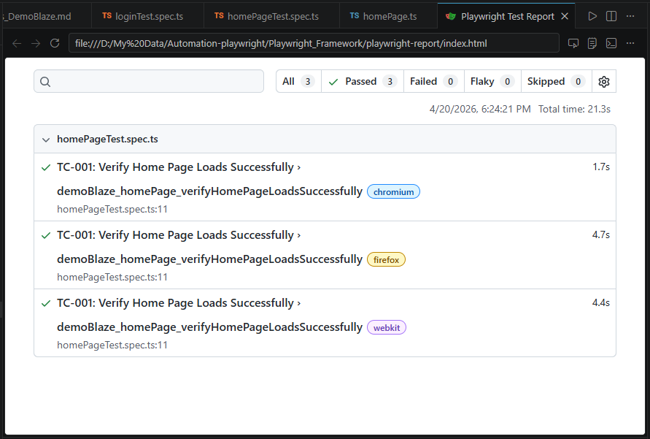

6.4 Step 4: Copy Code to Files (if the files are not created)
- Copy the Page Object code from chat
- Create Pages/loginPage.ts file and paste code
- Copy the Test Specification code
- Create tests/homePageTest.spec.ts file and paste code

Files Created in VS Code:
- loginPage.ts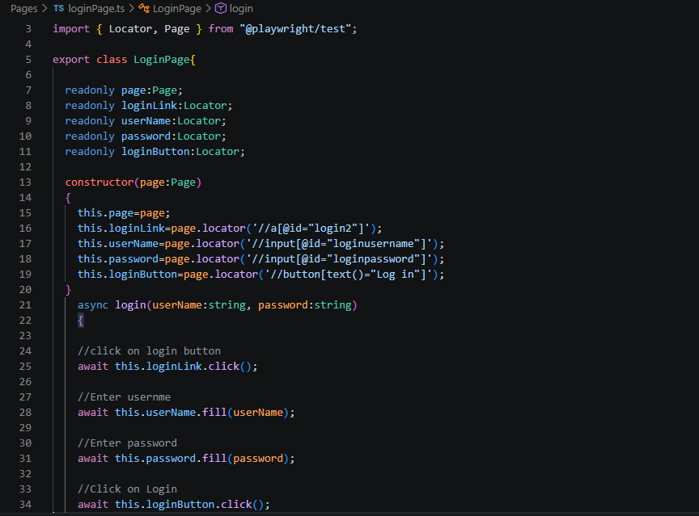

- homePageTest.spec.ts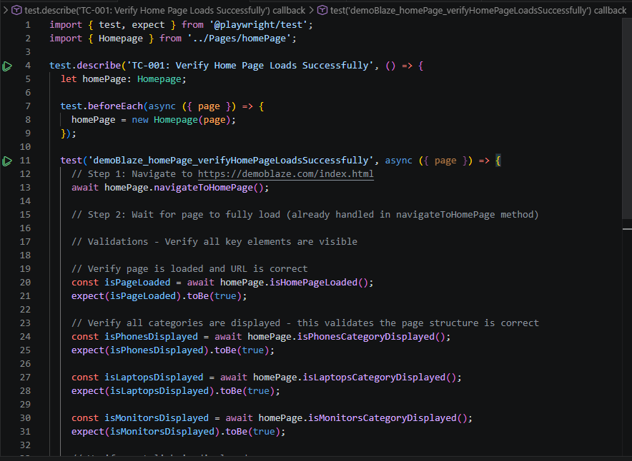

7. Phase 5: Project Structure & Organization

7.1 Complete Folder Structure
Playwright_Framework/
├── Pages/
│ ├── loginPage.ts
│ ├── homePage.ts
│ └── cartPage.ts
├── tests/
│ ├── auth.spec.ts
│ ├── shopping.spec.ts
│ └── checkout.spec.ts
├── utilities/
│ ├── testData.ts
│ └── helpers.ts
├── test-cases_manual/
│ └── TestCases.xlsx
├── Instructions_DemoBlaze.md
├── playwright.config.ts
├── package.json
└── README.md

Project Explorer Structure: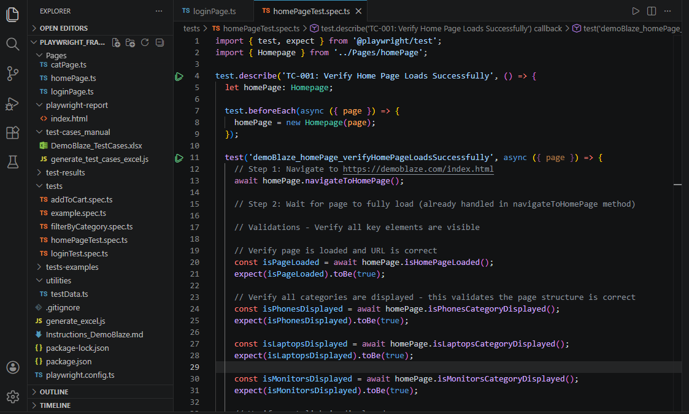

8. Phase 6: Complete Automation Workflow
- 1. Manual Test Case: Document test in Excel with all details
- 2. Review & Approve: Stakeholders review the manual test case
- 3. Copilot Request: Use Copilot Chat with Instructions.md
- 4. Code Generated: Copilot generates Page Object and Test files
- 5. Code Review: Review generated code, verify locators
- 6. Execute Test: Run test and verify it works
- 7. Update Status: Mark test as "Automated" in Excel

Complete Automation Workflow:
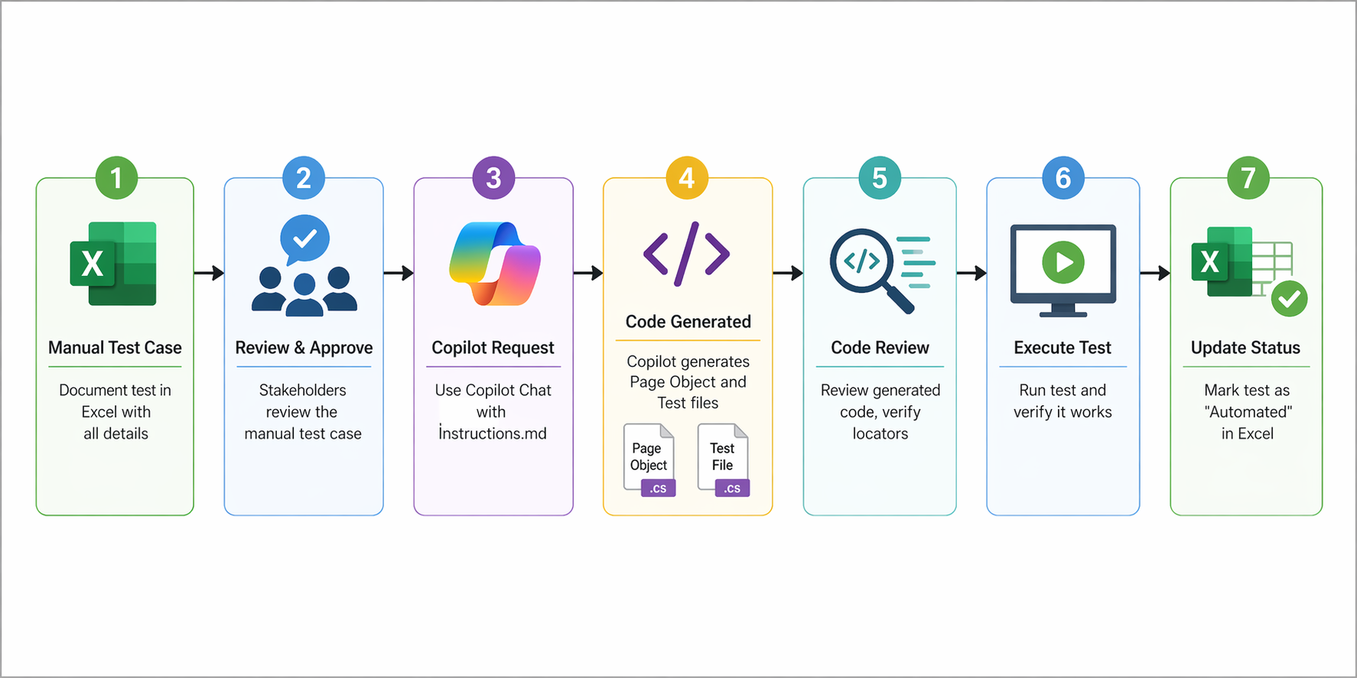

9. Copilot Rules & Best Practices

9.1 The 10 Critical Rules Summary
- Rule 1: Always Display Test Case First:
- Display complete test case, WAIT for "Yes, proceed" before coding
- Rule 2: Capture Both Locators:
- Capture action locators (buttons) AND validation locators (messages)
- Rule 3: Never Guess Locators:
- Inspect actual DOM, verify selector works before using
- Rule 4: Use Locator Priority:
- Prefer data-testid > id > class > CSS > XPath
- Rule 5: Use Page Object Model:
- Declare elements as properties, use methods for interactions
- Rule 6: Use Locator Suffix:
- Element names: loginButtonLocator (not loginButton)
- Rule 7: Avoid Complex Assertions:
- Create assertion methods in page objects, keep tests clean
- Rule 8: No Hard Waits:
- Use waitFor() with state conditions instead of setTimeout()
- Rule 9: Implement ALL Steps:
- Complete all test steps and validations, no partial implementations
- Rule 10: Follow Naming:
- Pattern: demoBlaze_[page]_[description]() like demoBlaze_login_verifyValidUserLogin()

10. Testing & Execution

10.1 Essential Test Commands

All Tests:
npx playwright test
Specific File:
npx playwright test tests/auth.spec.ts
Specific Test:
npx playwright test -g "verify valid user"
Headed Mode:
npx playwright test --headed
Debug Mode:
npx playwright test --debug
Chromium Only:
npx playwright test --project=chromium
Verbose:
npx playwright test --verbose
View the generated HTML report:
npx playwright show-report

11. Troubleshooting & Tips

11.1 Common Issues and Solutions
Issue | Solution
Element not found | Check locator is correct using page.screenshot(), check DOM
Test timeout | Increase timeout in playwright.config.ts, add waitFor()
Flaky tests | Use waitFor() with state conditions, avoid setTimeout()
Copilot code incorrect | Provide detailed Instructions.md, ask Copilot to refactor
Module not found | Run npm install, check import paths in files
Tests slow | Enable parallelization, optimize waits, reduce delays
Report not generating | Verify HTML reporter in config, check file permissions

11.2 Tips for Success:
- Keep Instructions.md updated with new patterns and application selectors
- Review Copilot-generated code before using it in production
- Use meaningful variable names ending with "Locator"
- Test generated code in headed mode first (--headed flag)
- Maintain test data separately in utilities/testData.ts
- Use Page Object Model consistently across all tests
- Add comments to complex test logic
- Run tests regularly to catch failures early
- Update locators when application UI changes
- Use Git version control for all test code

Conclusion:

You now have a complete guide for building and maintaining a Playwright test automation framework with GitHub Copilot Chat assistance. This methodology enables you to:
- Create well-structured manual test cases in Excel
- Use Instructions.md to guide Copilot in code generation
- Generate consistent, maintainable automation scripts
- Execute tests and view comprehensive HTML reports
- Scale your test suite efficiently
- Maintain code quality and framework standards

Quick Start Checklist:
- ☐ Install Node.js and VS Code
- ☐ Install Playwright and dependencies
- ☐ Create project structure (Pages, tests, utilities)
- ☐ Create Instructions_DemoBlaze.md with 10 critical rules
- ☐ Create first manual test case in Excel
- ☐ Request Copilot Chat to generate automation code
- ☐ Copy generated code to Page Object and Test files
- ☐ Run: npx playwright test
- ☐ View report: npx playwright show-report
- ☐ Repeat for more test cases

