**5. Implement programs for estimating & eliminating trend in time series data- aggregation, smoothing**

**AIM:**

Implement programs for estimating & eliminating trend in time series data- aggregation, smoothing.

**PROCEDURE:**

**1.**Import the necessary libraries: 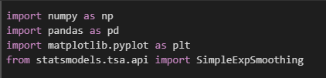

**2.** Load the dataset :



**3.**Ensure relevant columns exist.



**4.** Aggregate ASD classification per age → Compute rolling mean (moving average) → Apply exponential smoothing for trend estimation.

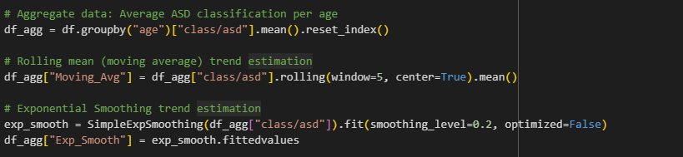

**5.** Create subplots for visualization:Original Data (Aggregated);Moving Average Trend;ExponentialSmoothing;Detrended Data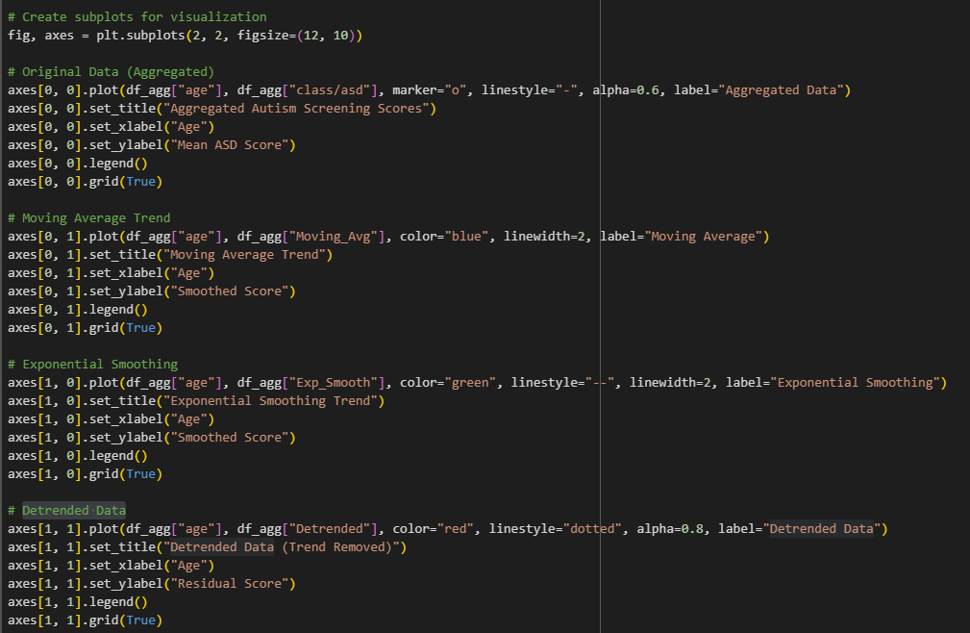

**OUTPUT**

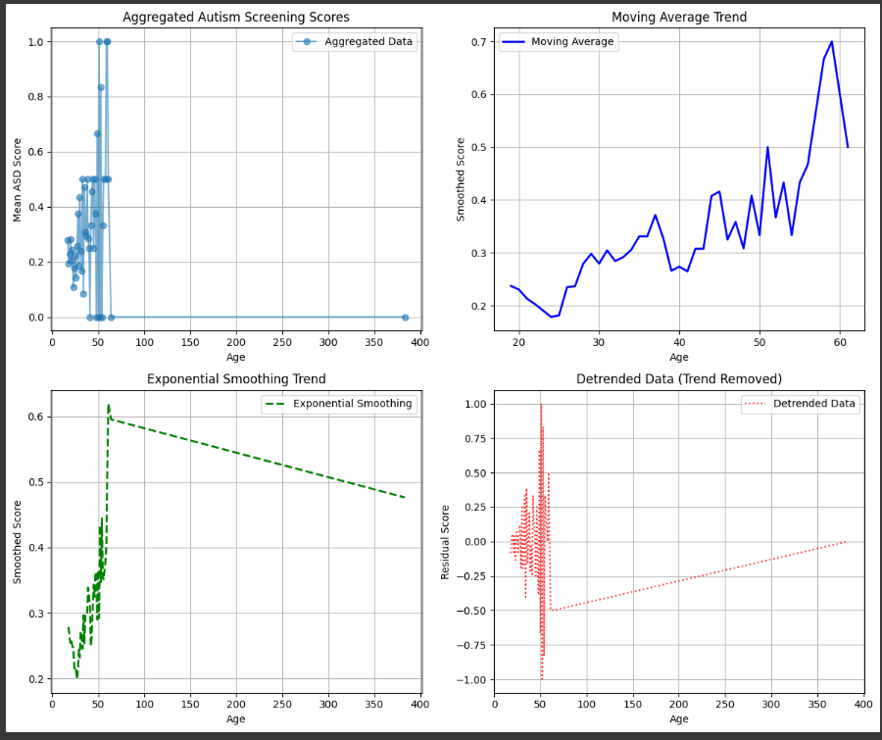

**RESULT:**

The program to check stationary on the autism screening dataset has been implemented successfully.