**6. Implement program to apply moving average smoothing for data preparation and time series forecasting.**

**AIM:**

Implement program to apply moving average smoothing for data preparation and time series forecasting.

**PROCEDURE:**

**1.**Import the necessary libraries:



**2.** Load the dataset :



**3.**Ensure relevant columns exist.



**4.** Apply Moving Average Smoothing AND Split into train and test sets (80% train, 20% test)

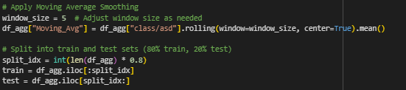

**5.** Forecast using Moving Average 

**6.**Plotting the result

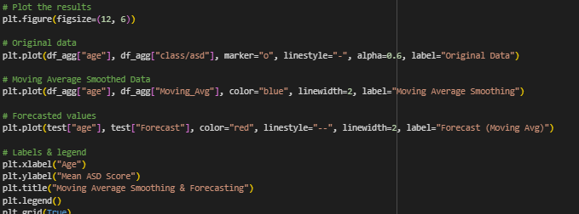**OUTPUT**

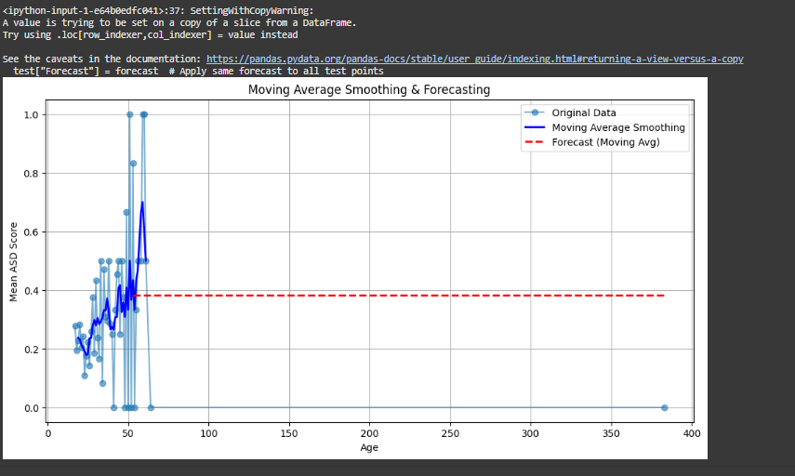

**RESULT:**

The program to implement to apply moving average smoothing on the autism screening dataset has been implemented successfully.