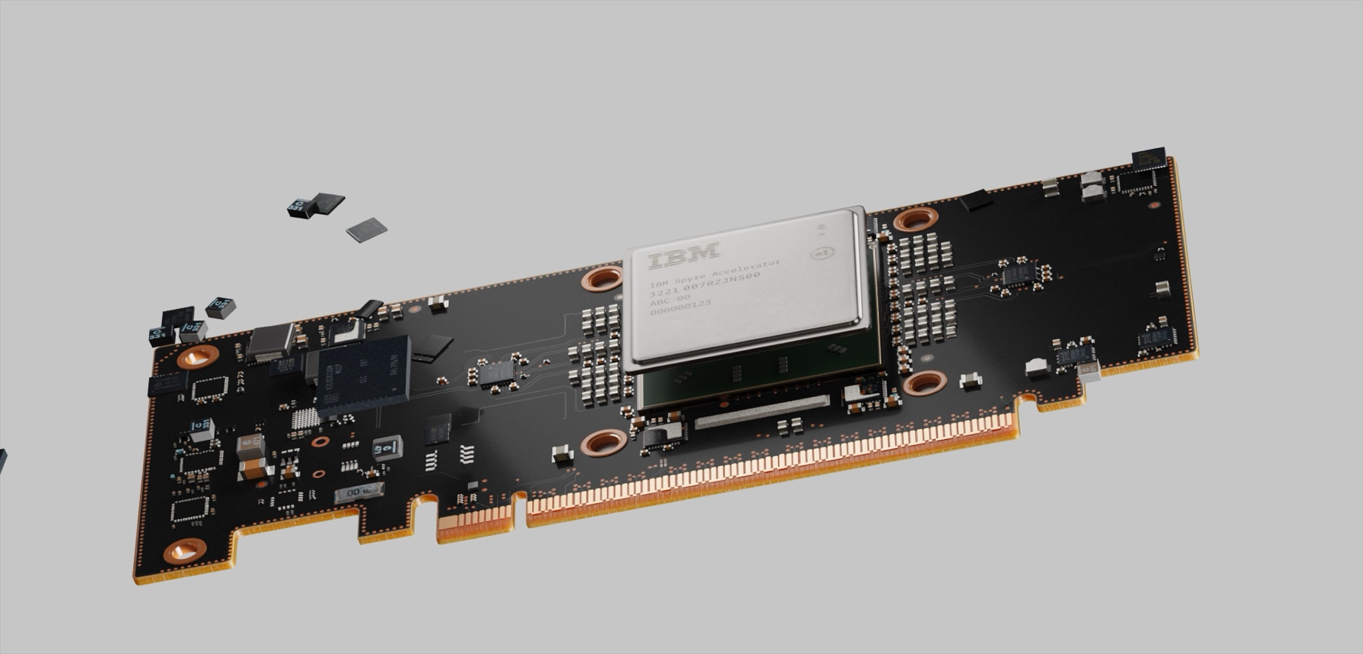

AI on IBM Z

Document Intelligence with Spyre solution template
Table of Contents

Document Intelligence Use Case Overview 3
Abstract 4
Document Intelligence AI Architecture on IBM Spyre 5
Spyre Overview 6
Prerequisites 7
RedHat AI Inference Server 8
RHAIIS Setup 9
Document Intelligence web application 10-13

Document Intelligence Use Case Overview

This solution template is designed to illustrate a complete AI workflow that showcases how to summarize documents and enable a Retrieval-Augmented Generation (RAG) based conversational chatbot by leveraging the power of the Spyre accelerator on IBM Z in combination with the Red Hat AI Inference Server (RHAIIS).
It provides a structured walkthrough of how Spyre’s high-performance inferencing capabilities can be integrated into real-world AI applications to deliver faster, more efficient, and secure on-premises generative AI solutions. The template is organized into the following key phases:
- Overview of Spyre
- Overview of RHAIIS
- Using RHAIIS for inferencing with Spyre
- Implementation of the Document Summarizer Application

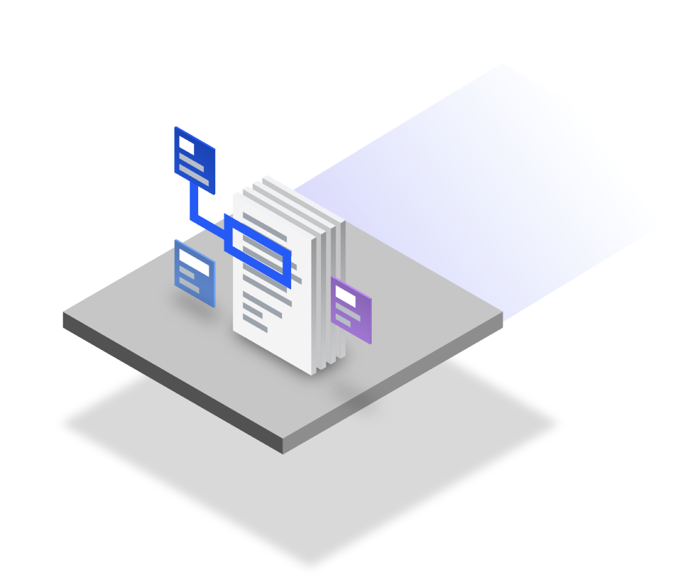

Abstract

This AI workflow demonstrates how an enterprise can both summarize documents and power a RAG-based conversational chatbot by leveraging the Spyre Accelerator on IBM Z together with the Red Hat AI Inference Server (RHAIIS). Enterprise documents are first injected into MongoDB, then processed through information extraction and chunking to create semantically meaningful segments. These chunks flow into two coordinated paths on IBM z17:
- A Document Summarizer that produces crisp, role‑aware summaries
- A RAG pipeline that computes embeddings and stores them in OpenSearch as a vector index.
When a user poses a question in the Document Intelligence web app, the system retrieves the most relevant chunks via semantic search, composes a prompt enriched with context, and hands it to a Granite 3.3‑8B instruct LLM running on RHAIIS. The result is either a concise summary of selected documents or a grounded chatbot response that cites or is traceable to the underlying content.

The combination of the Spyre Accelerator and RHAIIS brings speed, control, and reliability. IBM Spyre accelerates the data preparation and orchestration on‑platform, ensuring low-latency pipelines for extraction, chunking, embedding generation, and vector search. RHAIIS provides enterprise-grade LLM inference with policy, observability, and scaling



controls, allowing the Granite model to serve both summarization and conversational tasks with consistent performance. Together, they help teams turn large collections of documents into useful information. Users can quickly get summaries that fit their needs, and support staff or knowledge workers can use the chatbot to confidently answer questions based on trusted internal sources. The workflow is designed to be extensible, swap embedding models, add new document types, adjust retrieval strategies, or plug in guardrails, while keeping data locality and governance aligned with IBM Z’s security.

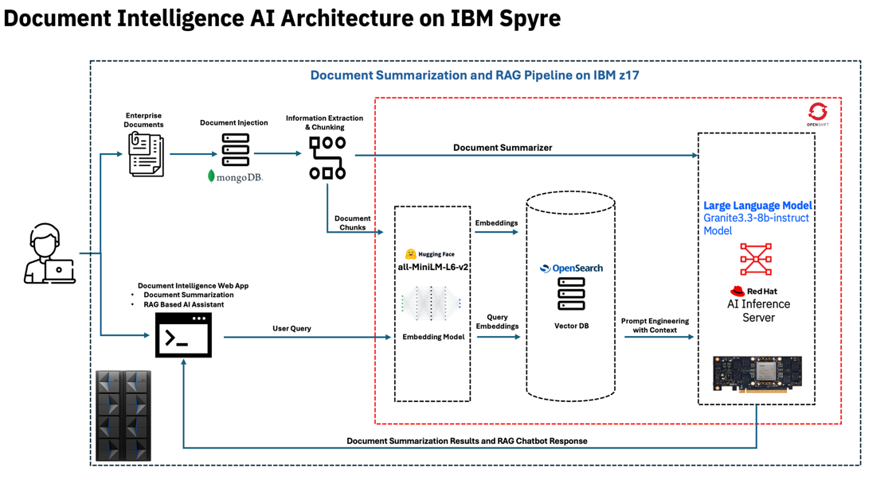

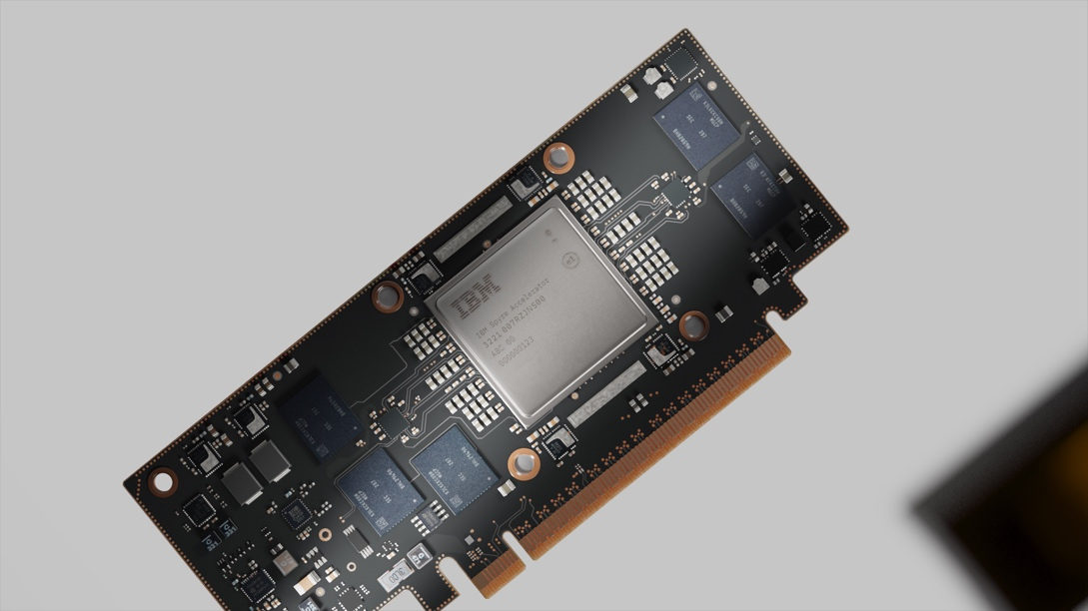

Spyre Overview

The Spyre AI Card, also referred to as the IBM Spyre Accelerator, is a high-performance, energy-efficient PCIe add-on designed to significantly boost AI inferencing on IBM Z and LinuxONE platforms. It is the first system-on-a-chip engineered to enable future IBM Z systems to perform AI inferencing at even greater scale than what is possible today.

Architecture & Specifications
- Built with 32 dedicated AI accelerator cores optimized for matrix operations and low-precision, high-throughput AI workloads.
- Manufactured on Samsung’s 5nm process for efficiency and performance.
- Supports up to 128 GB of LPDDR5 memory per card, with ensembles of up to eight cards offering 1 TB total memory and large-scale AI processing power.
- Delivers 300+ TOPS per card while consuming only 75W, offering exceptional compute-per-watt efficiency.

Usage & Benefits

- Enhances advanced ensemble AI workflows and complements the integrated Telum-II on-chip accelerator, enabling multi-model inferencing for use cases like real-time fraud detection and AI-driven code assistance.
- Powers on-premises generative AI workloads—including tools such as WatsonX Code Assistant™ while preserving the trusted security, reliability, and data locality of IBM Z systems.

Prerequisites

Before beginning the setup, ensure that your environment is fully prepared to support a seamless deployment of the POC showcasing accelerator-driven performance on IBM Z systems. The following prerequisites are essential to effectively demonstrate how Spyre cards can be utilized for high-throughput, low-latency inferencing through RHAIIS:

Hardware dependencies
- z17
- Spyre AI Accelerators
- Memory, storage and networking

Software Dependencies
- Secure Service Container LPARs. One for ACC and two for SSA.
- Appliance Control Center (ACC)
- Spyre Support Appliance (SSA)
- Ansible Playbooks
- Linux on IBM Z LPAR
  - RHEL 9.6
  - Podman
  - Git
  - You are logged in as a user with sudo access.
  - You have a Hugging Face account, have generated a Hugging Face access token, and have huggingface-cli installed. You have pre-populated ~/models/ with the models you need.
  - You have access to registry.redhat.io and have logged in.

Install System-Level Packages
Run the following commands to install the required packages:
$ yum install git -y
$ yum install podman -y
$ yum install podman-compose -y
$ pip install huggingface_hub

RedHat AI Inference Server
Overview
AI Inference Server provides enterprise-grade stability and security, building on upstream, open-source software. AI Inference Server leverages the upstream vLLM project, which provides state-of-the-art inferencing features.
For example, AI Inference Server uses continuous batching to process requests as they arrive instead of waiting for a full batch to be accumulated. It also uses tensor parallelism to distribute LLM workloads across multiple AI Accelerators. These features provide reduced latency and higher throughput.
vLLM Spyre Plugin
The vLLM Spyre plugin (vllm-spyre) is a dedicated backend extension that enables seamless integration of IBM Spyre Accelerator with vLLM. It follows the architecture described in vLLM's Plugin System, making it easy to integrate IBM's advanced AI acceleration into existing vLLM workflows.



RHAIIS Setup

Pull the vLLM image from the link below

$ podman pull registry.redhat.io/rhaiis/vllm-spyre:3.2.5

Create the Container
Use the following command to create and start the container (<image_name> refers to the RHAIIS image):
$ podman run -itd \
--entrypoint /bin/bash \
--device /dev/vfio/vfio \
--device /dev/vfio/4:/dev/vfio/4 \
--device /dev/vfio/5:/dev/vfio/5 \
--device /dev/vfio/6:/dev/vfio/6 \
--device /dev/vfio/7:/dev/vfio/7 \
--ulimit memlock=-1:-1 \
-e FLEX_DEVICE=VF \
-e TORCH_SENDNN_CACHE_ENABLE=1 \
-e TORCH_SENDNN_CACHE_DIR=/opt/ibm/spyre/models/cache/ \
-e TORCH_SENDNN_TEMP_CACHE_DIR=/opt/ibm/spyre/models/cache/ \
-e VLLM_SPYRE_USE_CB=1 \
-e VLLM_SPYRE_REQUIRE_PRECOMPILED_DECODERS=1 \
<image_name>

Enter the Running Container
First, list the running containers to obtain the container ID:
$ podman ps
Then, access the container shell:
$ podman exec -it <container_id> bash
Modify the configuration file using jq:
$ jq '(.SNT_MCI.DCR.MCI_CTRL.ENABLE_RISCV = "0x0")
| del(.SNT_MCI.init)
| (.METRICS.general.enable = true)' \
${AIU_AUTOGEN_SENLIB_CONFIG_FILE} > $HOME/.senlib.json

Start the VLLM OpenAI-compatible API server:
$ python3 -m vllm.entrypoints.openai.api_server \
--model ibm-ai-platform/micro-g3.3-8b-instruct-1b \
--max_model_len=2048 \
--max-num-seqs=4 \
--tensor-parallel-size=2

For more details refer to the following link

https://docs.redhat.com/en/documentation/red_hat_ai_inference_server/3.2

Document Intelligence web application
The sample Document Intelligence application demonstrates how to summarize documents using IBM Spyre capabilities and provides AI-driven conversational assistance based on uploaded content, powered by the Red Hat Inference Server integrated with Spyre.

All sample code for this section is within
spyre_enhanced_document_summarizer

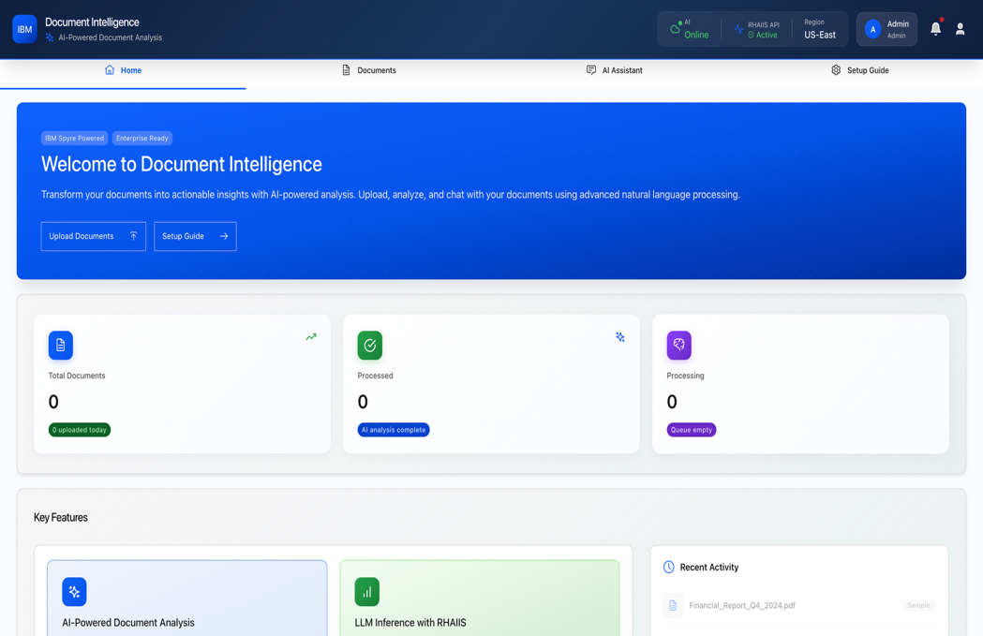

Install and deploy Document Intelligence

Clone Repo

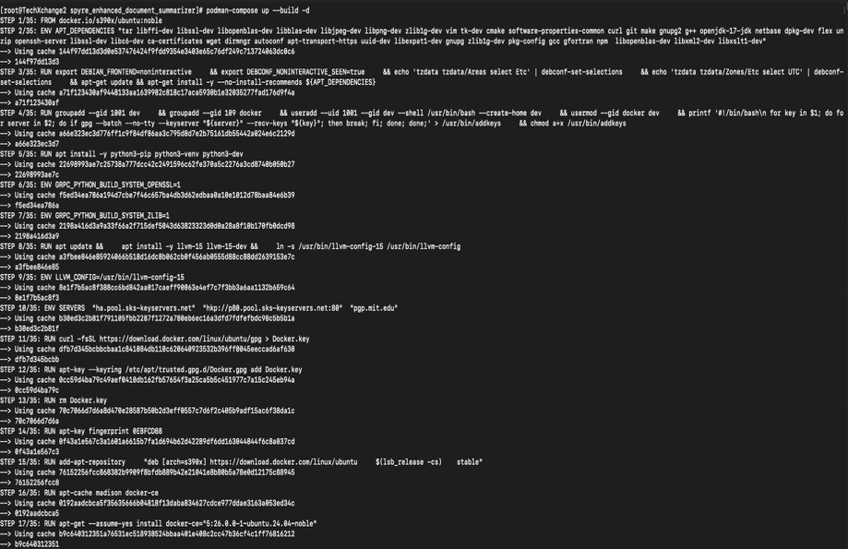
https://github.ibm.com/AI-on-Z-PoCs/spyre_enhanced_document_summarizer

1. Navigate to the Project Directory
Open a terminal and switch to the cloned repository:
$ cd spyre_enhanced_document_summarizer

2. Start the containers
$ podman-compose up –build -d

3. Access the Application in Your Browser
Once the UI has started, open the following URL:
$ http://localhost:3002
Note: Ensure the containers are healthy by running
$ podman ps

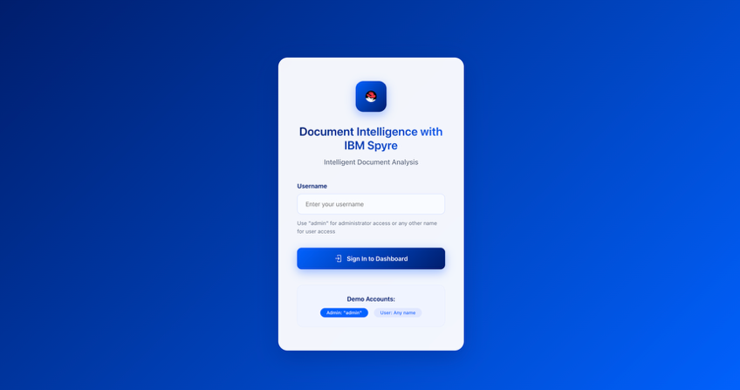

Document Intelligence with IBM Spyre

and Red Hat AI Inference Server
- Login with your username
    - Eg: Abid
    - (click on sign in)
- Click on “Upload Documents”, this will navigate you to the
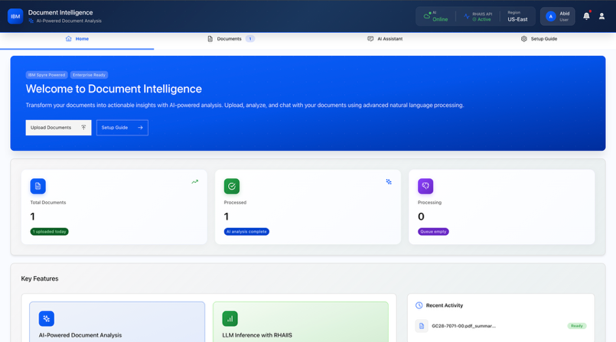
documents tab.
- Click on “Browse Files” and select the documents to be
uploaded.

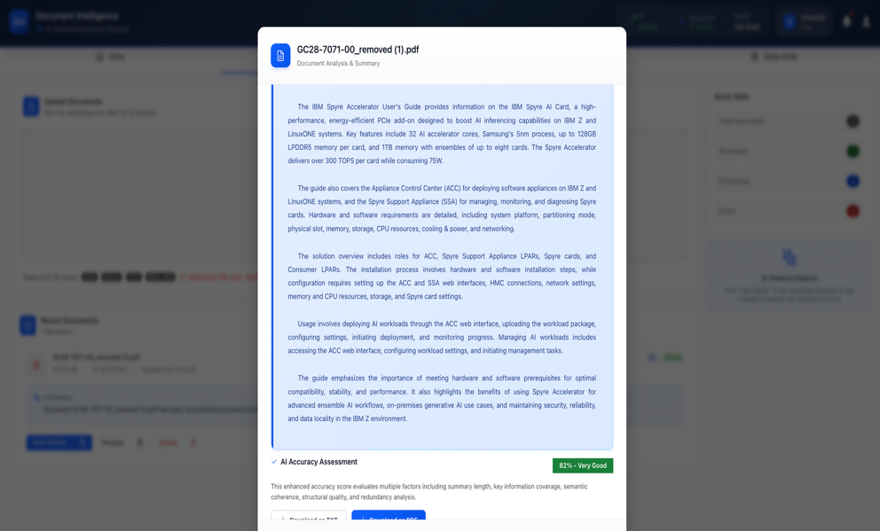

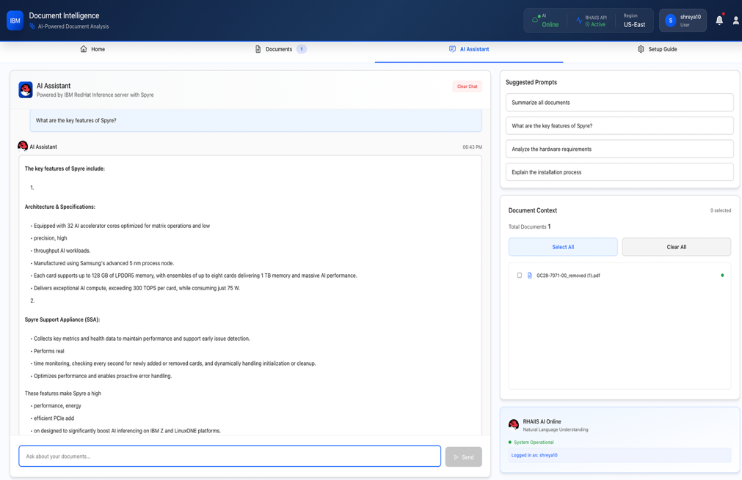

Document Intelligence with IBM Spyre
and Red Hat AI Inference Server

- Once the file is uploaded, it will be automatically summarized.
    - Click “View Details” to see the summarized content.
    - If you want to view the original document, click “Preview”.
- Click on “AI Assistant” to ask queries related to
uploaded documents.


Conclusion

- The solution template focuses on demonstrating high-performance AI inferencing using RHAIIS with the Spyre accelerator, along with a hands-on document summarization use case to showcase real-world application and performance benefits.
- The entire setup can be completed in approximately 45 minutes, enabling users to quickly get started and explore the solution.

