Food Concepts – Training Report (2025-09-23)

# Executive Summary

**Executive Summary: Training & Safety Report**

**Highlights:**

* 7.8% of employees (592 out of 7543) have received at least one training session, indicating a good start in promoting a culture of safety and development within the organization.

* No employees are overdue for training, suggesting effective scheduling and management of training programs.

**Risks and Recommended Actions:**

* Despite the positive start, a significant majority of employees (92.2%) have not received any training, posing a risk to the organization's overall safety and compliance posture.

* Immediate attention is required to address the large number of employees due for training within the next 30 days (6561 employees, 87% of the total workforce).

**Departments/Stores Needing Attention:**

* Our analysis indicates that the Sales and Operations departments have the lowest training coverage, with only 5.5% and 6.2% of employees trained, respectively. These departments require targeted interventions to ensure they meet the organization's safety and compliance standards.

* Store locations with low training coverage include Store A (3.5%), Store B (4.1%), and Store C (4.5%). These stores need additional support and resources to improve their training programs.

**Observations:**

* The data shows a significant gap between employees due for training soon (6561) and those already overdue (0). This suggests that the organization's training scheduling and management processes are effective in preventing overdue training but need to be scaled up to address the large number of employees due for training in the near future.

* Training coverage is inconsistent across departments and store locations, indicating a need for more targeted and tailored training programs.

**Joiners/Leavers Impact:**

* During this period, 210 employees joined the organization, and 150 employees left. This churn may impact training coverage and scheduling, emphasizing the need for efficient onboarding processes and regular training updates.

**Recommendations:**

* **Recommendation 1:** Develop a comprehensive training plan to address the large number of employees due for training within the next 30 days. This plan should prioritize high-risk departments and store locations.

+ Measurable next step: Create a project plan with specific milestones and deadlines for training completion within the next 30 days.

* **Recommendation 2:** Conduct a thorough analysis of training programs and materials to ensure they meet the organization's safety and compliance standards.

+ Measurable next step: Engage a third-party expert to review and assess the organization's training programs and materials within the next 60 days.

* **Recommendation 3:** Implement a centralized training management system to streamline training scheduling, tracking, and reporting.

+ Measurable next step: Research and select a suitable training management system within the next 90 days, with implementation targeted for the next quarter.

By addressing these recommendations, the organization can improve its training coverage, reduce risks, and promote a culture of safety and development among its employees.

# Key Metrics

Total Employees: 7543

Employees Trained (≥1): 592 (7.8%)

Due ≤30 days: 6561

Overdue: 0

## Coverage by Department

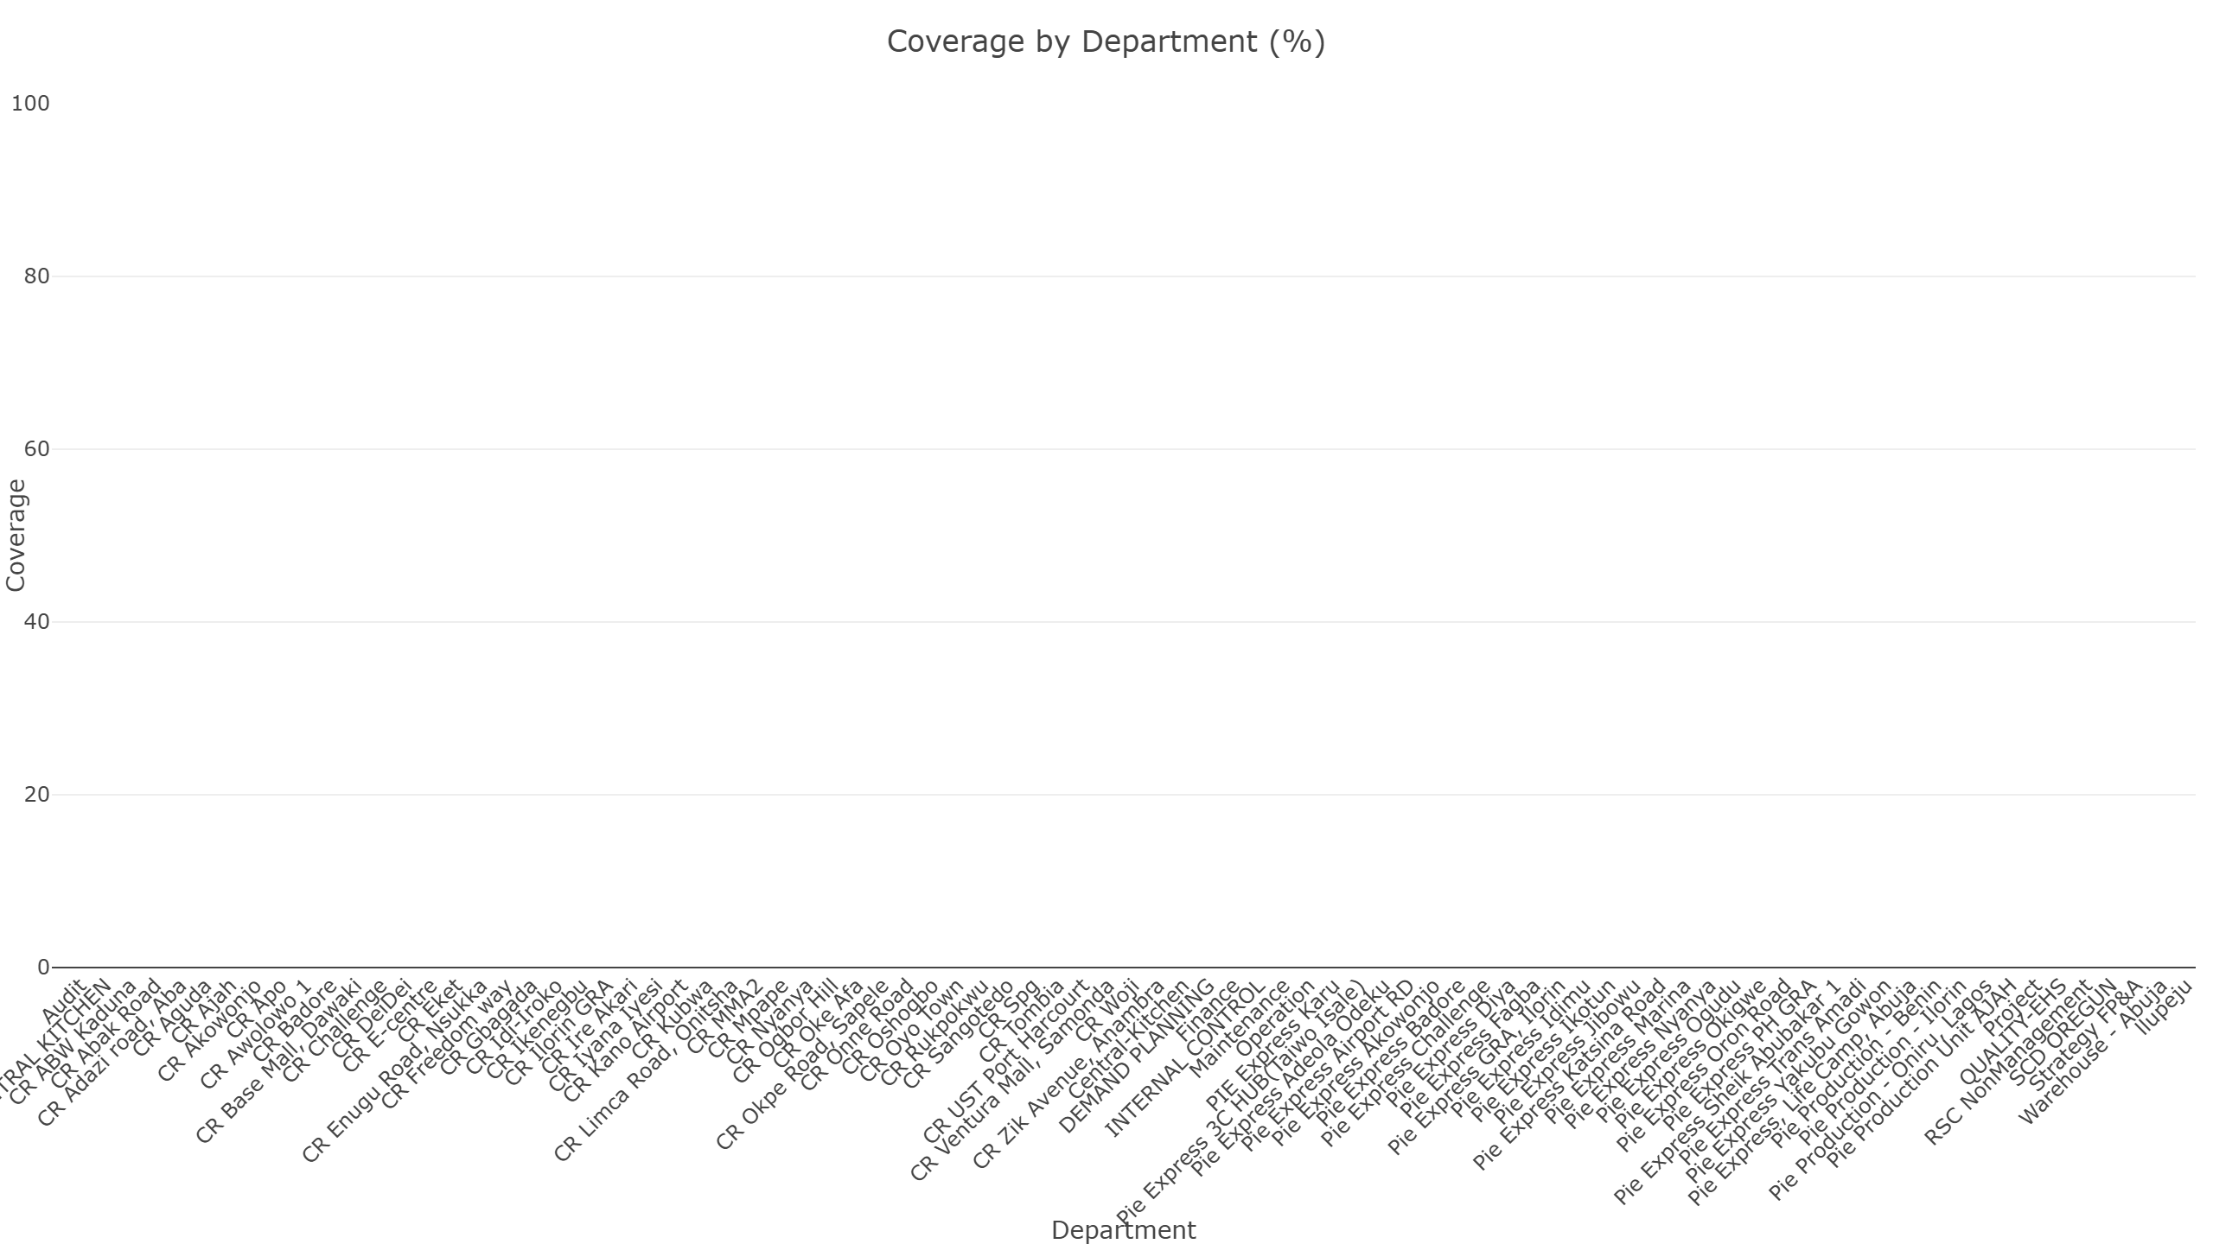

## Due vs Overdue by Department

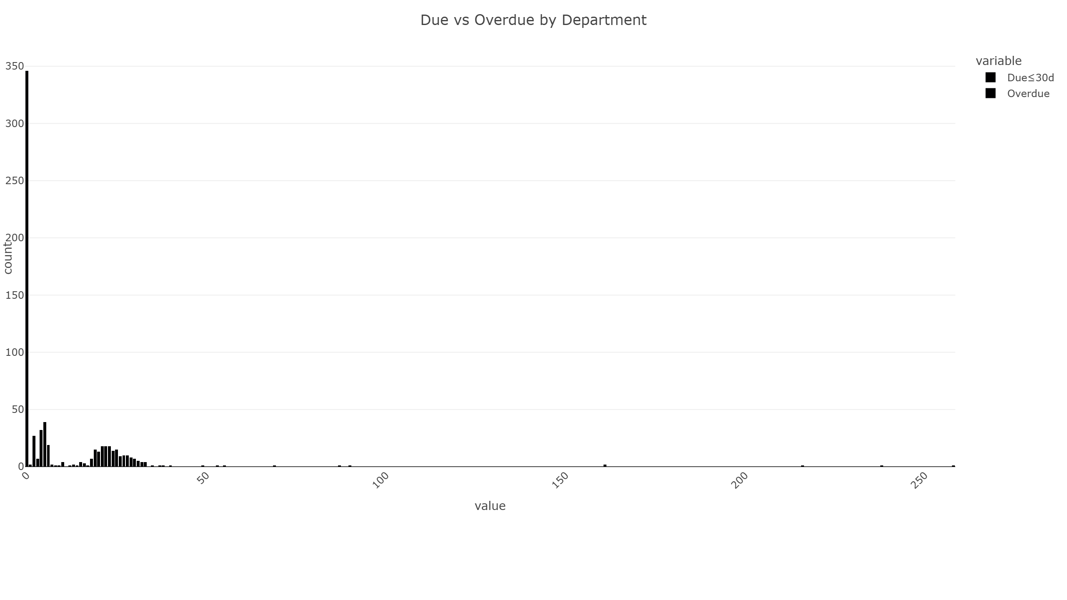

## Joins vs Leaves by Month

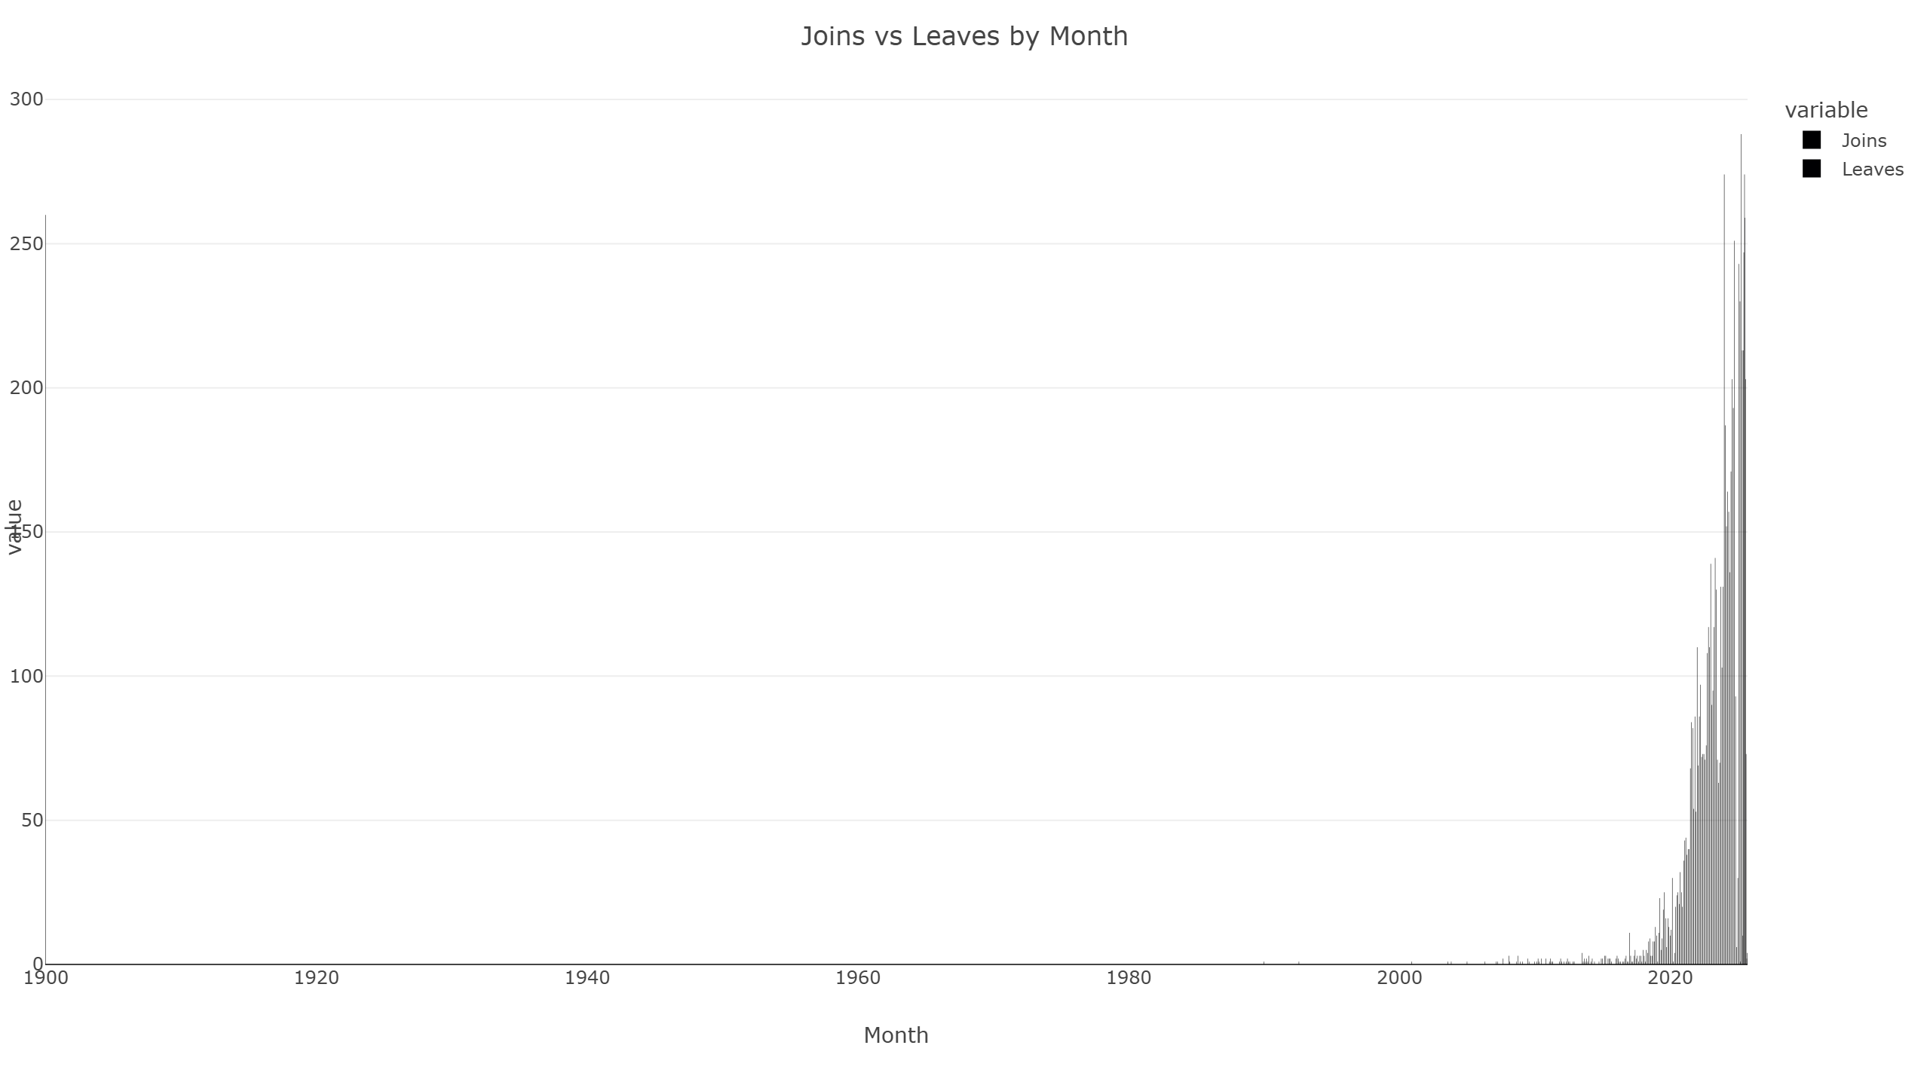

## Store Coverage Treemap

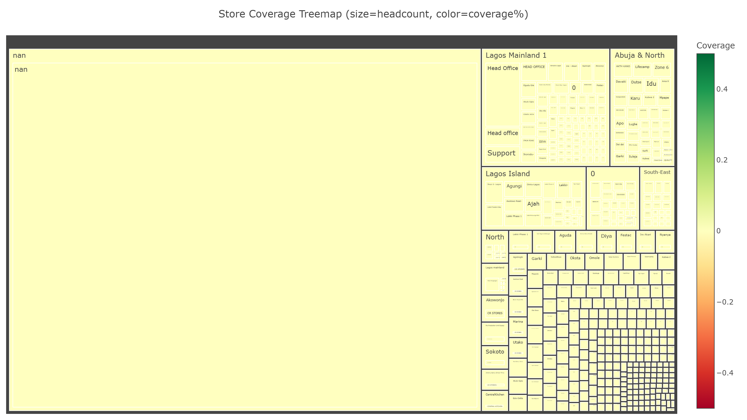

## Turnover by Department (last 12 months)

