RoaringForkCode

Amanda Braun

4/16/2020

USGS.pH.data <- read.csv("./Data/Raw/RoaringForkpHRaw.csv")  
  
today <- Sys.Date()  
  
USGS.pH.data$ActivityStartDate <- as.Date(USGS.pH.data$ActivityStartDate, format = "%Y-%m-%d")   
  
  
  
USGS.pH.data.2000.2020 <- filter(USGS.pH.data, ActivityStartDate > "2000-01-01" )  
  
#MonitoringLocationIdentifier == "USGS-09073300" ~ "Upper Roaring Fork",  
 #MonitoringLocationIdentifier == "USGS-09073400" ~ "Upper Roaring Fork",  
 #MonitoringLocationIdentifier == "USGS-391140106492001" ~ "Upper Roaring Fork",  
 #MonitoringLocationIdentifier == "USGS-391220106573800" ~ "Upper Roaring Fork",  
 #MonitoringLocationIdentifier == "USGS-391239106501900" ~ "Upper Roaring Fork",  
 # MonitoringLocationIdentifier == "USGS-391345106550000" ~ "Upper Roaring Fork",  
 #MonitoringLocationIdentifier == "USGS-391531106525200" ~ "Upper Roaring Fork",  
  
USGS.pH.data.2000.2020.Streams <- USGS.pH.data.2000.2020 %>%   
 mutate(Section = case_when(  
 MonitoringLocationIdentifier == "USGS-391740106550701" ~ "Middle Roaring Fork",  
 MonitoringLocationIdentifier == "USGS-392032107001900" ~ "Middle Roaring Fork",  
 MonitoringLocationIdentifier == "USGS-392110107011300" ~ "Middle Roaring Fork",  
 MonitoringLocationIdentifier == "USGS-392158107020000" ~ "Middle Roaring Fork",  
 MonitoringLocationIdentifier == "USGS-09081000" ~ "Middle Roaring Fork",  
 MonitoringLocationIdentifier == "USGS-392337107052200" ~ "Middle Roaring Fork",  
 MonitoringLocationIdentifier == "USGS-392449107111400" ~ "Middle Roaring Fork",  
 MonitoringLocationIdentifier == "USGS-392453107131100" ~ "Middle Roaring Fork",  
 MonitoringLocationIdentifier == "USGS-09085000" ~ "Outlet Roaring Fork",  
 MonitoringLocationIdentifier == "USGS-392844107170900" ~ "Outlet Roaring Fork",  
 MonitoringLocationIdentifier == "USGS-09085000" ~ "Outlet Roaring Fork",  
 MonitoringLocationIdentifier == "USGS-392847107171100" ~ "Outlet Roaring Fork",  
 MonitoringLocationIdentifier == "USGS-392946107182100" ~ "Outlet Roaring Fork"  
 ))%>%   
 drop_na(Section)  
  
#USGS.pH.data.2000.2020 <- filter(USGS.pH.data, ActivityStartDate > "2000-01-01" )  
  
  
#USGS.SC.data.2000.2020 <- filter(USGS.SC.data, ActivityStartDate > "2000-01-01" )  
  
#USGS.pH.data.2000.2020.USGS.391345106550000 <- filter(USGS.pH.data.2000.2020,  
 # ActivityStartDate > "2000-01-01")%>%   
 #filter(MonitoringLocationIdentifier == "USGS-09073400")

#write.csv(USGS.SC.data, file = "./Data/Processed/USGS_Site02085000_Flow_Processed.csv", row.names=FALSE)

#SC.plot <- ggplot(USGS.SC.data, aes(x = ActivityStartDate, y = ResultMeasureValue)) +  
 # geom_line() +  
 #geom_smooth() +  
 #labs(y = expression("Specific Conductance("*mu*S * cm**-1*")"), x = "Date") +  
 #ggtitle("Specific Conductance of Roaring Fork River")  
#print(SC.plot)  
  
  
#SC.plot.2000.2020 <- ggplot(USGS.SC.data.2000.2020, aes(x = ActivityStartDate, y = ResultMeasureValue)) +  
 #geom_line() +  
 #geom_smooth() +  
 #labs(y = expression("Specific Conductance("*mu*S * cm**-1*")"), x = "Date") +  
 #ggtitle("Specific Conductance of Roaring Fork River")  
#print(SC.plot.2000.2020)  
  
#SC.plot.2000.2020.HW <- ggplot(USGS.SC.data.2000.2020, aes(x = ActivityStartDate, y = ResultMeasureValue)) +  
 # geom_line() +  
 #geom_smooth() +  
 #labs(y = expression("Specific Conductance("*mu*S * cm**-1*")"), x = "Date") +  
 # ggtitle("Specific Conductance of Roaring Fork River")  
#print(SC.plot.2000.2020.HW)  
  
#pH.plot <- ggplot(USGS.pH.data, aes(x = ActivityStartDate, y = ResultMeasureValue)) +  
 #geom_line() +  
 #geom_smooth() +  
 #labs(y = "pH", x = "Date") +  
 #ggtitle("pH of Roaring Fork River")  
#print(pH.plot)  
  
#pH.plot.2000.2020 <- ggplot(USGS.pH.data.2000.2020, aes(x = ActivityStartDate, y = ResultMeasureValue)) +  
 #geom_line() +  
 #geom_smooth() +  
 #labs(y = "pH", x = "Date") +  
 #ggtitle("pH of Roaring Fork River")  
#print(pH.plot.2000.2020)

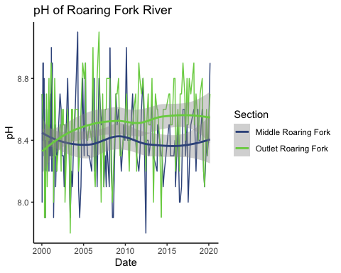

pH of Middle and Outlet Sections of Roaring Fork River, Eagle County, Colorado

##when I tried this it said Insufficient values in manual scale. 45 needed but only 2 provided. because there were 45 sites and I only provided 2 colors. color = MonitoringLocationIdentifier - this can be added back into the first ggplot line when I can pick a color scheme that has 45 colors, or divide out the data   
 #scale_color_manual(values = c("steelblue4", "darkorange4")) +

## R Markdown

This is an R Markdown document. Markdown is a simple formatting syntax for authoring HTML, PDF, and MS Word documents. For more details on using R Markdown see <http://rmarkdown.rstudio.com>.

When you click the **Knit** button a document will be generated that includes both content as well as the output of any embedded R code chunks within the document. You can embed an R code chunk like this:

summary(cars)

## speed dist   
## Min. : 4.0 Min. : 2.00   
## 1st Qu.:12.0 1st Qu.: 26.00   
## Median :15.0 Median : 36.00   
## Mean :15.4 Mean : 42.98   
## 3rd Qu.:19.0 3rd Qu.: 56.00   
## Max. :25.0 Max. :120.00

## Including Plots

You can also embed plots, for example:

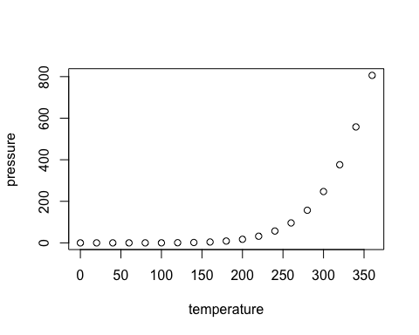

Note that the echo = FALSE parameter was added to the code chunk to prevent printing of the R code that generated the plot.