|  |  |  |
| --- | --- | --- |
| STARCLASS |  |  |
| DATE  STARTING 13-11-2022  SUBMITING 13-12-2022 | SUPERVISER  Ms.ambreen mehmood | batch  2206B1 |
|  |  |  |

| SERIAL NO. | enrollment | STUDENT nAME |
| --- | --- | --- |

|  |  |  |
| --- | --- | --- |
| 1. | Student1391242 | M.MUDABBIR |
| 2. | Student1362293 |
| AHMED |  |  |

***NAVBAR***



***HOME PAGE***



***FOOTER***

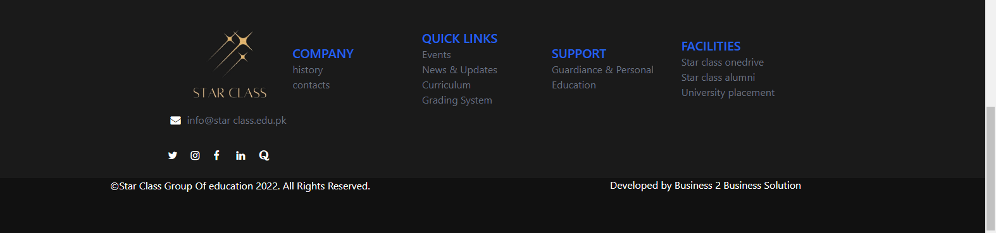

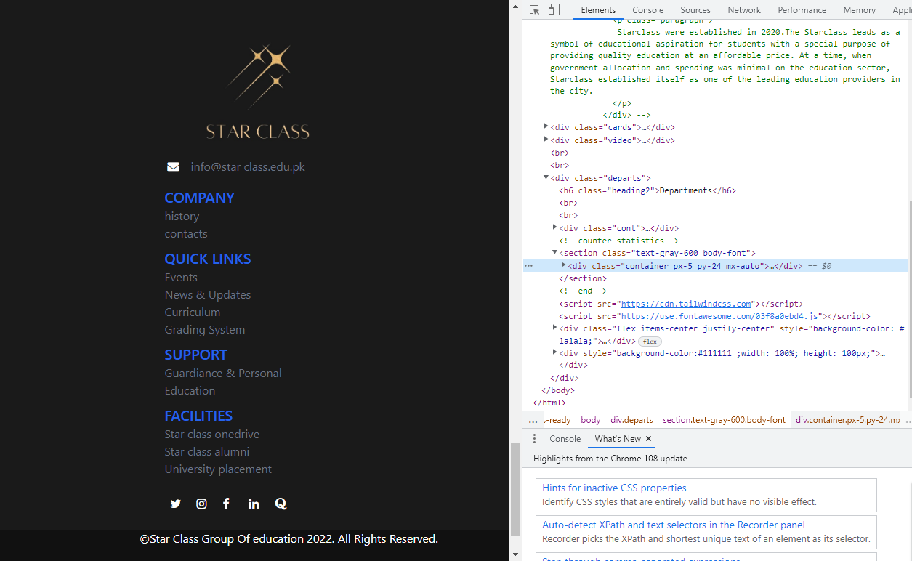

***SLIDER***

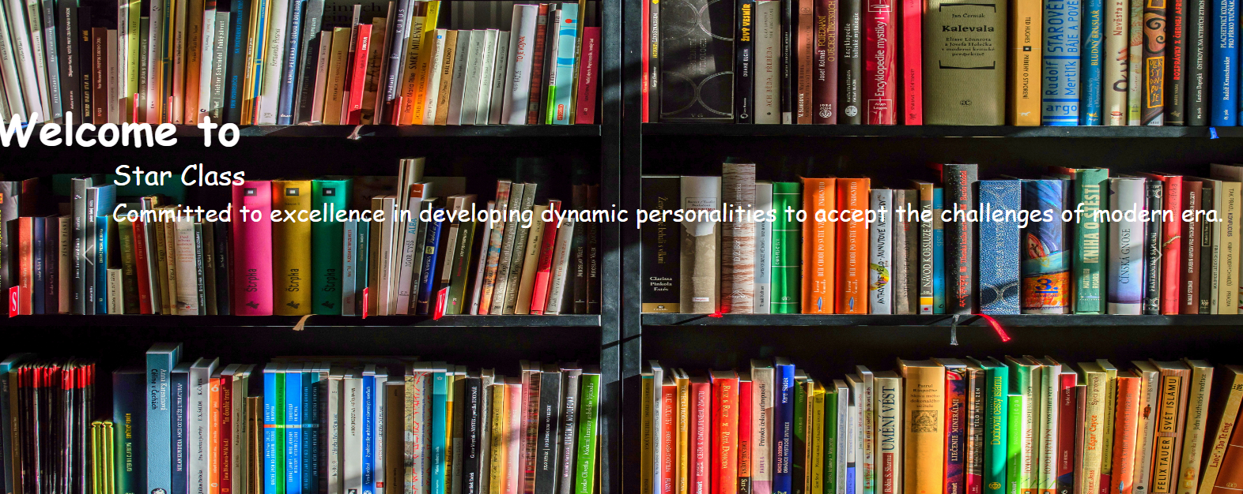

***Thank You For Reading The Documentation.***

***Please Follow The Instructions Above !!***