Industrial Internship Report on
Expense Tracker
Prepared by
Ambrin Begam F
Executive Summary
This report provides details of the Industrial Internship provided by upskill Campus and The IoT Academy in collaboration with Industrial Partner UniConverge Technologies Pvt Ltd (UCT).
This internship was focused on a project/problem statement provided by UCT. We had to finish the project including the report in 6 weeks’ time.
My project was (Expense Tracker)
This internship gave me a very good opportunity to get exposure to Industrial problems and design/implement solution for that. It was an overall great experience to have this internship.

TABLE OF CONTENTS
1 Preface 3
2 Introduction 4
2.1 About UniConverge Technologies Pvt Ltd 4
2.2 About upskill Campus 8
2.3 Objective 9
2.4 Reference 9
2.5 Glossary 10
3 Problem Statement 11
4 Existing and Proposed solution 12
5 Proposed Design/ Model 13
5.1 High Level Diagram (if applicable) 13
5.2 Low Level Diagram (if applicable) 13
5.3 Interfaces (if applicable) 13
6 Performance Test 14
6.1 Test Plan/ Test Cases 14
6.2 Test Procedure 14
6.3 Performance Outcome 14
7 My learnings 15
8 Future work scope 16

Preface
Summary of the whole 6 weeks’ work.
About need of relevant Internship in career development.
Brief about Your project/problem statement.
Opportunity given by USC/UCT.
How Program was planned
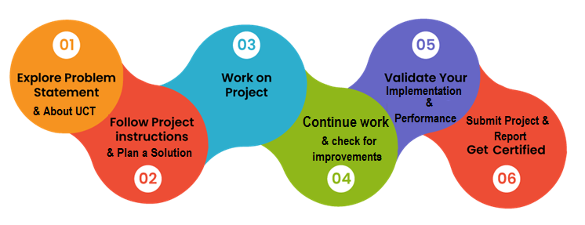
Your Learnings and overall experience.
Thank to all (with names), who have helped you directly or indirectly.
Your message to your juniors and peers.

Introduction

About UniConverge Technologies Pvt Ltd
A company established in 2013 and working in Digital Transformation domain and providing Industrial solutions with prime focus on sustainability and RoI.
For developing its products and solutions it is leveraging various Cutting Edge Technologies e.g. Internet of Things (IoT), Cyber Security, Cloud computing (AWS, Azure), Machine Learning, Communication Technologies (4G/5G/LoRaWAN), Java Full Stack, Python, Front end etc.
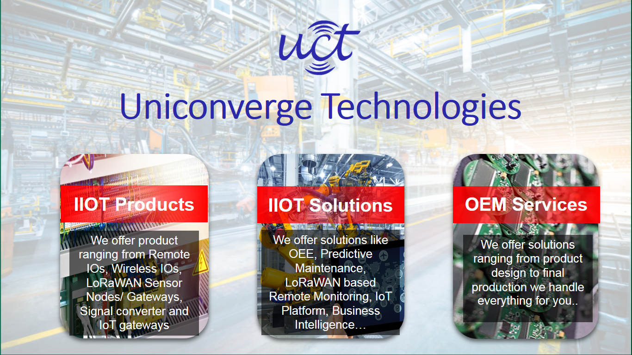
- UCT IoT Platform ()
UCT Insight is an IOT platform designed for quick deployment of IOT applications on the same time providing valuable “insight” for your process/business. It has been built in Java for backend and ReactJS for Front end. It has support for MySQL and various NoSql Databases.
- It enables device connectivity via industry standard IoT protocols - MQTT, CoAP, HTTP, Modbus TCP, OPC UA
- It supports both cloud and on-premises deployments.
It has features to
• Build Your own dashboard
• Analytics and Reporting
• Alert and Notification
• Integration with third party application(Power BI, SAP, ERP)
• Rule Engine

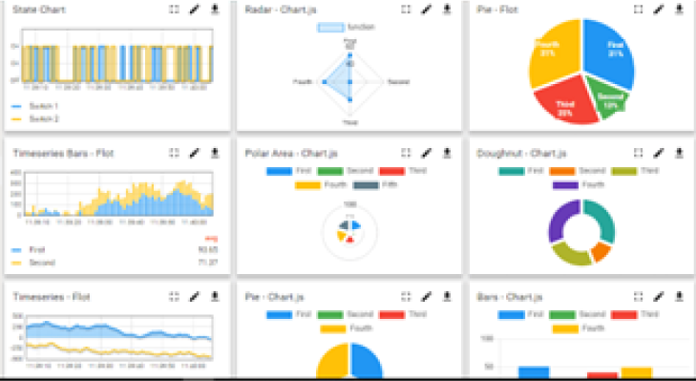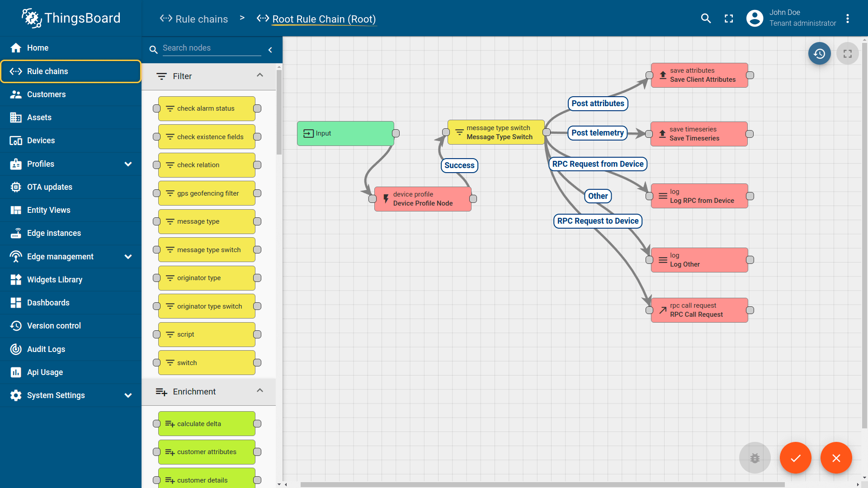

- Smart Factory Platform ()
Factory watch is a platform for smart factory needs.
It provides Users/ Factory
- with a scalable solution for their Production and asset monitoring
- OEE and predictive maintenance solution scaling up to digital twin for your assets.
- to unleased the true potential of the data that their machines are generating and helps to identify the KPIs and also improve them.
- A modular architecture that allows users to choose the service that they what to start and then can scale to more complex solutions as per their demands.
Its unique SaaS model helps users to save time, cost and money.
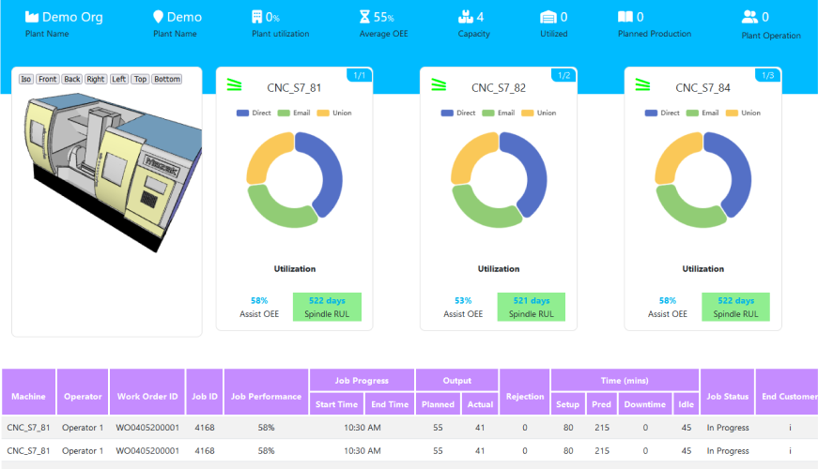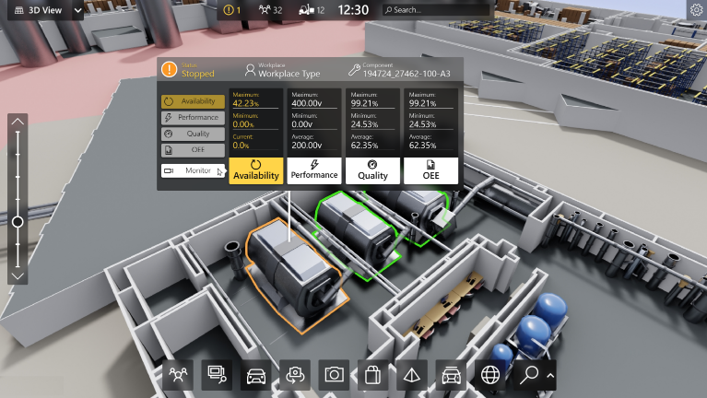

- 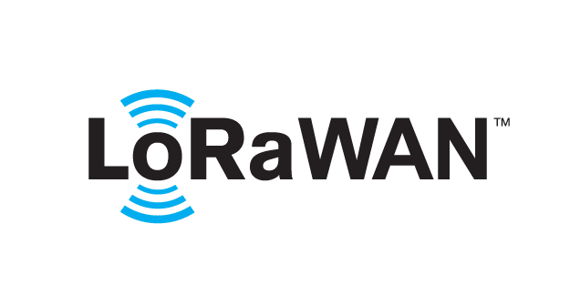 based Solution
UCT is one of the early adopters of LoRAWAN teschnology and providing solution in Agritech, Smart cities, Industrial Monitoring, Smart Street Light, Smart Water/ Gas/ Electricity metering solutions etc.
- Predictive Maintenance
UCT is providing Industrial Machine health monitoring and Predictive maintenance solution leveraging Embedded system, Industrial IoT and Machine Learning Technologies by finding Remaining useful life time of various Machines used in production process.
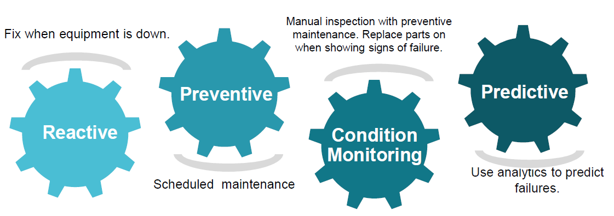

About upskill Campus (USC)
upskill Campus along with The IoT Academy and in association with Uniconverge technologies has facilitated the smooth execution of the complete internship process.
USC is a career development platform that delivers personalized executive coaching in a more affordable, scalable and measurable way.




Seeing need of upskilling in self paced manner along-with additional support services e.g. Internship, projects, interaction with Industry experts, Career growth Services
https://www.upskillcampus.com/
upSkill Campus aiming to upskill 1 million learners in next 5 year

The IoT Academy
The IoT academy is EdTech Division of UCT that is running long executive certification programs in collaboration with EICT Academy, IITK, IITR and IITG in multiple domains.

Objectives of this Internship program
The objective for this internship program was to
☛ get practical experience of working in the industry.
☛ to solve real world problems.
☛ to have improved job prospects.
☛ to have Improved understanding of our field and its applications.
☛ to have Personal growth like better communication and problem solving.

Reference
[1] TutorialsPoint – Java Programming Tutorials
[2] GeeksforGeeks – Java Collections and File Handling Concepts
[3] Oracle Java Documentation – Core Java Programming Guide

Glossary
Terms | Acronym
Human Computer Interaction | HCI
Application Programming Interface | API
Integrated Development Environment | IDE
Object-Oriented Programming | OOP
Java Database Connectivity | JDBC

Problem Statement
The objective of this project is to develop a Console-Based Expense Tracker Application using Core Java. The system helps users record, manage, and analyze their personal expenses efficiently.
The application allows users to add expense details such as date, amount, category, and description. It also provides features to view expense summaries, filter expenses based on specific conditions, and manage expense categories.
The main goal of the system is to help users track their spending habits, organize financial records, and analyze expenditure patterns in a simple and user-friendly console interface.

Existing and Proposed solution

- Existing Solutions
Many existing expense tracking applications are available such as mobile apps and financial management tools. These applications allow users to record expenses and generate reports.
However, these solutions have some limitations:
- Some applications require internet connectivity.
- Many systems are complex for beginners.
- Some tools are paid applications with limited free features.
- They may include unnecessary advanced features that are not required for basic expense tracking.
- Proposed Solution
The proposed system is a simple console-based expense tracker developed using Core Java. The application allows users to:
- Record daily expenses
- Manage expense categories
- View spending summaries
- Filter expenses based on date or category
- Modify or delete expense records
- Value Addition
The system provides:
- A simple and lightweight console interface
- Efficient expense management
- Better understanding of spending patterns
- Use of Core Java concepts such as OOP, collections, and exception handling

4.1Code submission (Github link)
https://github.com/ambrinbegam/upskillCampus
4.2 Report submission (Github link) :
https://github.com/ambrinbegam/upskillCampus

Proposed Design/ Model
The expense tracker application follows a menu-driven console architecture. Users interact with the system by selecting options from a menu to perform various operations such as adding expenses, viewing summaries, or managing categories.
The system processes user inputs, stores the expense information in memory or files, and displays relevant results.
The design includes three stages:
- User input stage
- Data processing stage
- Output display stage

5.1High Level Diagram (if applicable)
User
↓
Console Interface
↓
Expense Tracker Application
↓
Expense Data Storage
↓
Expense Summary / Reports

Figure 1: HIGH LEVEL DIAGRAM OF THE SYSTEM

Low Level Diagram (if applicable)
User Input
↓
Menu Selection
↓
Expense Management Module
↓
Category Management Module
↓
Data Processing
↓
Display Results

Interfaces (if applicable)
The application uses a console-based user interface.
Main menu options include:
- Add Expense
- View Expenses
- Filter Expenses
- Manage Categories
- Generate Reports
- Delete or Modify Expenses
The system also includes:
- Data Flow Management
- Input Validation
- Error Handling
- Memory-based storage using Java collections

Performance Test

The performance of the expense tracker system is evaluated based on several constraints such as memory usage, execution speed, and accuracy of data management.
Since the system is a console-based Java application, it requires minimal system resources and can run efficiently on most computers.
Possible constraints include:
- Memory limitations when storing large numbers of expenses
- Input errors from users
- Data handling efficiency
These constraints were addressed using efficient data structures and proper exception handling

Test Plan/ Test Cases
Test Case | Input | Expected Output
Add Expense | Amount, Date, Category | Expense recorded successfully
View Expenses | Select option | Display expense list
Filter Expenses | Date / Category | Display filtered results
Delete Expense | Expense ID | Expense removed

Test Procedure
- Launch the application.
- Select menu options from the console interface.
- Enter expense details.
- Verify whether the expense is recorded and displayed correctly.
- Test filtering and report generation features.

Performance Outcome
The system successfully records and manages expense data with quick response time and minimal memory usage. The application provides accurate summaries and handles invalid inputs using exception handling.

My learnings

Through this project, I learned how to design and develop a console-based application using Core Java. I improved my understanding of object-oriented programming, collections, file handling, and exception handling.
This project also helped me understand how real-world financial management applications are structured and how software systems handle user data and operations.
These skills will help me build more advanced applications in the future and strengthen my programming knowledge for career growth in software development.

Future work scope

In the future, the expense tracker system can be enhanced with several additional features such as:
- Graphical User Interface (GUI)
- Database integration using MySQL
- Monthly and yearly expense reports
- Graphical expense analysis charts
- Mobile or web-based version of the application
These improvements will make the system more powerful and suitable for real-world usage.

