

MOI UNIVERSITY

SCHOOL OF INFORMATION SCIENCES

DEPARTMENT OF INFORMATION TECHNOLOGY

PROJECT TITLE: TECHNICAL PROFILLING SYSTEM

By

AMBROSE ADEYA AHAWO

REGISTRATION NO: IF/03/17

COURSE: BSc. In INFORMATICS

1.CHAPTER ONE

1.1 Background Information

Unemployment has been a major fight in Kenya. Hundreds of scholars go through the education system but still jobs aren’t coming their way. Unemployment is defined by the Bureau of Labor Statistics (BLS) as people who do not have a job, have actively looked for work in the past four weeks, and are currently available for work. Also, people who were temporarily laid off and were waiting to be called back to that job are included in the unemployment statistics. The BLS reports this in the U-3 report, a part of the monthly jobs report.

The BLS measures unemployment through monthly household surveys called the Current Population Survey. It has been conducted every month since 1940, as part of the government's response to the Great Depression. It has been modified several times since then and experienced a major redesign in 1994. That included a revamping of the questionnaire, the use of computer-assisted interviewing, and revisions to some of the labor force concepts.

The BLS does not count everyone who is jobless as unemployed. It excludes those who have not looked for work within the past four weeks. The Bureau also removes them from the labor force. Most people leave the labor force when they retire, go to school, have a disability that keeps them from working, or have family responsibilities. The BLS doesn't count people who would like to work but they aren't actively looking for work.

The BLS does keep track of those people, though. They are reported in the U-6 unemployment rate. Some people call this the real unemployment rate. It includes those who have looked for work within the past 12 months, but not within the past four weeks. The Bureau calls them "marginally attached to the labor force." A subset of the marginally attached is called discouraged workers. They have given up looking because they don't think there are jobs out there for them.

The line chart below compares the U-6 or "real rate" with the U-3 or commonly reported rate. The shaded area in between both lines shows how the two rates differ during the same period.

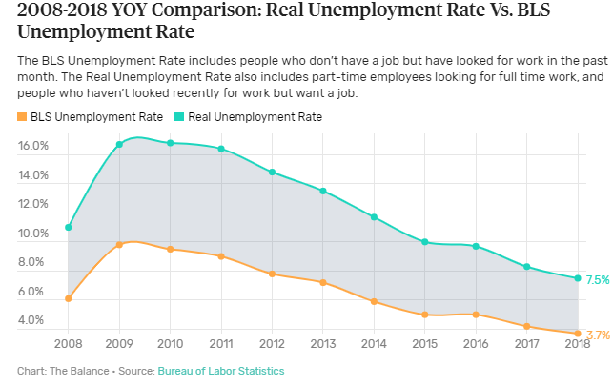

The Kenyan government is to blame for all these since it is responsible for creating employment opportunities for its citizens. Below are some of the reasons why most Kenyans lack jobs;

Corruption
This will never fail to be the reason for almost all vices in the country, it has taken over the wellbeing of the country with leaders being the initiators. The mentality of 'you can't find a job in Kenya without connections' is never wrong and seems to never be wrong in the coming future. It has gained ground and is here to stay. You can hardly find a job in Kenya without 'connections' and this is caused by tribalism and nepotism which are norms in the country today.
Low level of education
Kenyans have gone to school yeah, but not a good number though lately, people are venturing into education. However, a good percentage of Kenyans lack proper education maybe because they couldn't afford school fees or access good educational facilities. This has been a nightmare for people seeking employment. No company would employ you if you don't meet the level of education they consider.
Government offering contracts to foreigners’ firms
This is a major point to blame the government for. Kenya has universities offering good engineering courses but you will never find graduates from these universities in road construction sites or generally the construction industry. All you find are Chinese engineers doing both the managerial and handwork with only a few Kenyans providing unworthy manpower which shouldn't be the case - this is our country.
The emergence of non-certified colleges and universities
There are some colleges and universities that have emerged and are not ISO-certified to provide formal education to Kenyans. An example is the Nairobi Aviation College which was some years back said to be non-certified. The government declared all certificates from that institution null even after a number of Kenyans happily graduated from there and they lost their jobs meaning they had to start afresh. This has affected the employment sector with companies discriminating against small colleges and universities and considering bigger ones.
Poor industrial sector
Industrialization in Kenya is good, yeah, but it isn't enough to offer proper and enough employment to Kenyans. A good number of Kenyans have enough services to give out but they have no places to give out. The Kenyan government should, therefore, put efforts on promoting the industrial sector of the nation to offer better and enough employment to Kenyans

Normally, when people struggle so much looking for a certain job, they end settling for any other occupation out there, maybe just to pay the bills. This leads to undesired employment. Quality skills and talents which could have been very important in a certain filed are lost to other unrelated industries. This possess a big impact in the building of economy.

1.2 Problem Statement

Unemployment rates are particularly high among graduate and especially among school leaves, giving rise increasingly to the problems of "educated unemployment". Paradoxically, graduate unemployment seems to be correlated with levels of education attained in some cases. This is particularly true for school leavers where the proportion of the unemployed with secondary education increased from 24 to 51 percent between 1974 and 1985. graduate employment rates are probably 3 - 4 times higher than those of older workers, and in many countries in the region open unemployment among graduate as a group in the labor could be as 40 - 50 percent.

Moreover, graduates and new entrants to the labor force are as well placed as experienced workers to find employment in new opportunities or to go into self-employment. The problems of graduate unemployment reflect the contraction of jobs in the modern sector and declining rate of job creation in that sector. It also suggests serious labor market distortions related to the development and utilization of human resources in the context of changing economic circumstances. further, the problem of graduate unemployment is linked to the fact of many African countries, as already noted, continue to record relatively high rates of population growth, and the population structure of some of those countries is overwhelmingly young will children of school going age accounting for as much as half of the total population in some cases.

1.3 Objectives of the study

Unemployment has brought hardship and object poverty to many families. The levels of adult dependency have increased, so the rate of saving in our economy is declining.
The problem has also led to increase in crime waves and rates. All these could spell doom for the nation. It is deemed fit to embark on this study as a contribution towards the eradication of the problems of unemployment and its accompanying problems and hardship to the individual and in general.

- Primary motive of carrying out this study is the desire to contribute in any meaningful way the idea of how the growing rate of unemployment can be dealt with in order to reduce its consequences to at least a minimum.
- To properly channel necessary talents and skills to the necessary required fields
- To help scholars effectively market their talents and skills to potential employers.

1.4 Research Questions

The data and information that will be used in conducting this research study will include both primary and secondary data which involves personal observation, book, journals, company, documents, internet downloads and a number of others white ups and presentations which are relevant to this study.

Personal interview will also be carried out with entrepreneurs manage and finance personal in addition to issue questionnaires. The method of data analysis to a adopted and used in this research study will used of statistical tools which are the simple percentage alongside the chi - square tests. This research study is not an exception to hypothesis formulation and testing. The researcher intends to formulate and test the research hypothesis as follows

Research hypothesis; -
The stress to obtain the necessary information required from this research work has been given rise to the following hypothesis.

Ho: The current Educational system is not serving our societal need.
Hi; The current educational system is not serving our societal need
Ho: What means could the graduates’ unemployment be eradicated.
H1: There is no means graduates unemployment be eradicated
Ho: The government address itself to the problems of Graduate unemployment galore?
Hi; The government has not address itself to the problems of graduate unemployment galore

1.5 Justification

The case study or area where the problem has more impact in view of the problems created by unemployment in the country Kenya despite government conscious efforts to create employment opportunities in the country, the interest on this problem is to determine through facts and figure the level of, and trend in unemployment in the country with the view to making lasting policy, recommendations that will ameliorate the problem of unemployment.

1.6 Feasibility study

Before carrying out this study, necessary analysis has been carried including all relevant factors.

Description

This study intends to offer an online Technical Expertise Profiling System through which scholars can find out job vacancies available in their related field. One is expected to have his/her own valid certificates through which potential employers can consider the level of education needed.

Technical Feasibility

It refers to whether the software that is available in the market fully supports the present application. It studies the pros and cons of using particular software for the development and its feasibility. It also studies the additional time needed to be given to people to make the application work.

In the present system the user interface is user friendly and does not require much expertise and training. It just needs mouse click to do operations and to generate the desired information. The software that is used for developing is highly suitable for the present applications since the users require fast access to the web pages with a high degree of security. This is achieved through integration of web server and database server in the same environment.

Operational Feasibility

It refers to the feasibility of the product to be operational. Some products may work very well at design and implementation but may fail in the real time environment. It includes the study of human required and their technical expertise.

In the present system, the entering the details, updating the details and data generations are perfect and quick in operations.

Economic Feasibility

It refers to the benefits or outcomes we are deriving from the product as compared to the total cost we are spending for developing the product.

In the present system, the development of new product greatly enhances the accuracy of the system and reduces the delay in the processing of applications and generating the data. The errors can be greatly reduced and at the same time providing the great level of security. Here we don’t need additional equipment except memory of required capacity. No need for spending money on client for maintenance because the database used is web enabled database.

CHAPTER TWO: LITERATURE REVIEW

With its youth population of nearly 10 million, more than 20 per cent of its overall population, Kenya is currently experiencing a so-called ‘youth bulge’ (defined as a situation when at least 20 per cent of a country’s population is between the age of 15 to 24). In other contexts, this situation has proven to be a major asset for national economies, when these young people were able to find appropriately paying employment, or other ways of gaining personal economic independence. The large number of young Kenyans thus offers the potential to be a force for a positive economic future of the country, both collectively and as individual agents of progress and change.

The term ‘demographic dividend’ provides a strategic lens to conceptualize the potential (economic) future of the country: if Kenya is able to provide the appropriate education and jobs to its growing youth population, this could allow it to experience a boost in economic growth resulting from the ‘dividend’ of a well-equipped and economically independent youth. This scenario is by no means guaranteed; it is contingent on a decrease in the number of ‘dependents’ in the country which would require two major shifts, namely 1) a further decrease in Kenya’s birth rate (currently at 3.9 children per woman) and 2) higher employment numbers for its young generation.

The latter is the focus of this report. Kenya’s economy has presented volatile yet comparably high growth rates in the last two decades. However, this generally positive macro-economic development has not translated into benefits for its youth. While annual GDP growth of more than 5 per cent has been regularly recorded, Kenya’s youth unemployment rate has shown little to no positive development, and stands at a staggering 22 per cent for 2016 (according to ILO estimates). In addition, underemployment appears to be a rampant phenomenon for young Kenyans. The danger of a ‘lost generation’ is running high in Kenya; and most countries in Africa record significantly lower youth unemployment rates than this relatively strong economy. With 500,000 to 800,000 young Kenyans entering the job market each year, its economy has not been able to provide the necessary amount of employment opportunities – formal and informal alike.

Economic progress has primarily benefitted the older generation; young females in rural locations constitute the largest share of unemployed Kenyan youth (in absolute numbers), while their counterparts in urban areas are most likely to be unemployed (in relative terms). Gender and living location are defining factors, but youth unemployment is rampant throughout Kenya. Education is regularly considered a key element for better employment opportunities, and Kenya has made progress in recent years with enrolment numbers for primary education now officially at 100 per cent. In contrast, however, with only 3.3 per cent of women and 4.7 per cent of men enrolled in tertiary education, Kenya is falling behind many other African nations and the education provided/obtained often lacks the necessary skillsets the job market actually requires.

Relevant technical skills could be taught in Technical and Vocational Education and Training (TVET) programs and colleges, but these have seen a comparably slow increase in enrolment numbers due to the focus on basic education by governmental and Youth Employment in Kenya Samuel Hall 5 international actors. Despite recent efforts and initiatives in this regard, TVET and labor-market adapted university education still leave major room for improvement to appropriately equip Kenya’s youth, especially young women. Little or misdirected preparedness for the labor market is one of the major complaints from employers.

Faced with few opportunities, much competition and in some cases additional personal vulnerabilities (for example, impoverished backgrounds and poor health conditions), most of Kenya’s young generation relies on the possibilities the informal sector offers, employment and self-employment alike. Kenya’s dual, but intertwined, economy is characterized by an informal sector that provides 83 per cent of all current employment opportunities – formal and comparably well-paid wage employment is only available for very few of Kenya’s youth. Instead, informal employment and self-employment in the following sectors create the major job market ‘pools’:

- Agriculture: rural youth in Kenya primarily earn their living in informal jobs within the agriculture sector, including pastoralism. Despite a lack of precise data, (informal) work in various agricultural activities is considered the largest ‘employer’ of Kenyan youth. However, currently the sector is not of key concern for governmental actors in terms of growth, investment and innovation strategies, and it is defined by high vulnerability to natural impacts (e.g. droughts).
- Service Sector: as an umbrella term, the service sector not only combines various activities but is also the second most important area for young Kenyans to earn a living. Especially in urban areas – such as Nairobi, Mombasa and many secondary towns across the country – labor activities in the food industry, in markets, in the transport sector and in waste management are highly common forms of income for young Kenyans. In addition, but highly dependent on the location, jobs in the growing ICT and creative industries (especially in Nairobi and often formal) and in tourism (e.g. on the Kenyan coast) provide some other service sector opportunities.

While they remain niche phenomena, the reality of criminal activities and prostitution as forms of income generation for male and female youth alike in Kenya cannot be denied. Reliable numbers do not exist, but Kenyan youth do not seem to focus livelihood strategies. In contrast, young Kenyans throughout the country – especially in urban centres – are often tech-savvy and tech-literate individuals. Hence, with Kenya a country with comparably good mobile internet coverage and high individual internet use (in comparison to other sub-Saharan African countries), this creates the foundation for the country’s growing ICT scene. Particularly for educated youth, jobs in software and app development, in business-process outsourcing and in creative/editorial tasks become more and more attractive and available.

However, such job opportunities are rarely available to the rural majority of Kenya’s young generation. Accordingly, bridging the gap between technology and the agricultural sector could not only create new jobs, but could also increase the attractiveness of the sector for Kenyan youth. Although the ICT sector is one of the six economic sectors of growth in the government’s Kenya Vision 2030 (along with Energy, Finance, Tourism, Manufacturing, and Micro, Small and Medium Enterprises), it cannot and will not be able to solve the country’s current ‘youth employment challenge’ by itself. Instead, job creation and interventions for such need to Youth Employment in Kenya Samuel Hall 6 including other sectors such as agriculture – currently and in the future the most important job market. The mix of unemployment, underemployment, inactivity, and poor-quality jobs (informal, unskilled, and low-paid) continues to disproportionately affect 15-24-year-old youth more than the rest of the working-age population of Kenya – and will continue to do so, unless the Kenyan governments initiates systemic reforms.

By 2030, Kenya will need to solve a difficult equation: on the one hand, a working-age population at approximately 60 per cent; on the other, high levels of informal jobs, unemployment, and underemployment. In spite of the very positive image of the modern services sector (finance, ICT), it only accounts for a minor percentage of employment among youth. It is therefore urgent to promote a transformational agenda, for instance, by optimizing the fiscal revenues from the emerging oil industry, by investing in and promoting technical education such as TVET programs, and by including low-income but work-intense sectors into development strategies (e.g. certain agricultural sub-sectors).

In addition, any interventions and support programs should not only be concerned with the macro-economic lens of harnessing a ‘demographic dividend’, but must be focused on the individual capacity, ingenuity and agency of young Kenyans. For the tasks of positively engaging with its current ‘youth employment challenge’, from individual to national level, Kenya can learn from other countries, but it must adapt programs and ideas to its own realities. Being able to do so depends on reliable and up-to-date data on youth employment in Kenya and in its 47 counties. Unfortunately, such data is currently lacking: neither large scale survey data nor sufficient sector assessments and case studies are available. Accordingly, the following future research efforts are recommended:
- Employment statistics: Reliable youth (un)employment data at the county and sectoral level is necessary for any future evidence-based interventions and programming.
- Labor market and skills assessments: A national labor market assessment and skills inventory is needed to better understand the skills mismatch, and to allow for the development of policies to address this.
- Sectoral case studies and assessments: These will allow of the measurement of the real potential for youth employment in certain sectors (such as ICT, agriculture, tourism, the transport industry and others) and better understand the specificities of situations at the individual level.
- Gender-sensitive assessments: Gender-specific research regarding the vulnerabilities faced by male and female you are necessary to support the design of gender-sensitive approaches. Despite current limitations in terms of precise data, analyzing current literature and available information still allows for identifying key aspects of potential interventions. Actors engaged in youth employment issues in Kenya should focus their future efforts on the following areas:
- Curricular revision of secondary, tertiary and technical level education, to allow young Kenyans to become a readily employable, skilled workforce.
- Promoting supervised internships and apprenticeships across all sectors and education levels. Youth Employment in Kenya Samuel Hall 7
- Supporting young people in creating their own (formal or informal) employment opportunities, by teaching entrepreneurial skills, values and personal attributes such as communication, finance, leadership, strategic thinking, navigating conflict, and the ability to recognize one’s own potential and capacity.
- Holistic programming for Kenya’s ‘youth employment challenge’ with unbiased approaches, supporting the creativity and resilience of existing sectors and individuals, rather than focusing on the formal or informal.

Employment creation policies in Kenya has been seen as greater factor for economic growth and development (ILO, 1995; Republic of Kenya, 1964). The underlying parameter, in this case, has been that faster economic growth would lead to employment creation and that income generation through employment would lead to improvement in the standards of living and eradication of poverty. Unemployment on the other hand affects the economic growth of any country, including Kenya. This is because unemployment of the people especially the youth. The term “unemployment” has been defined by different scholars in different ways.

According to Karl Pribam (1946), “unemployment” is when the supply of labor power is more than the number of available openings. In this regard, unemployment is realized when the market has excess supply of the required labor power. Karl says that to create market equilibrium, labor supply should match with the labor demand. If either of them is more, the market loses its equilibrium. Madan’s (1965) defined “unemployment is the absence of opportunities of jobs for people willing to and actively looking for a job. The definition is based on the supply-demand phenomenon. He argues that this grossly ignores the aspect of value in employment. In as much as market equilibrium is emphasized, the labor value should be emphasized on.

Fairchild (1978) in his research, acknowledges the importance of the value in employment. He says unemployment is enforced and involuntary separation from remunerative work on the part of the normal working force during normal time, at normal wages and under normal conditions. Beverigde (1931) supported the findings of Fairchild. He stated that when “unemployment is like a headache or a high temperature” which he says is unpleasant. This is philosophical claim that makes unemployment felt. The heat, he says, is felt economically through exhaustion of the country’s economy.

S.A Farah, Hussein A. Ali, (2018) on their research “a study on the perception of business students on the future job market” observes that employers’ quality perception on university graduates in Kenya today is low. A research done in Garissa, Kenya and published on international journal of scientific Research and Management (IJSRM) finds that one major factor of unemployment in Kenya is the lack creation of opportunities that can absorb the high number of graduates. Tribalism, nepotism and favourism were also major factors that have locked many deserving young Kenyans seeking jobs. The study concludes that the government should step in to avert the problem.

Youth, as understood by the Kenyan policy milieu, comprises a large group of people that represents two thirds of the population of working age, and many of them face the hardships of unemployment. While the national unemployment rate is about 10 percent, which is high for a country with large informal and traditional sectors, youth unemployment rates are usually much higher (Figure 3.1). The highest unemployment rates are for people around 20 years old, at 35 percent. Young people joining the labor market early—say, between 15 and 16 years of age —start with high unemployment rates of above 20 percent, but rates are even higher for older age groups and are highest for young people aged 18 to 20 years. After that age, unemployment rates decrease rapidly. Young people aged around 25 and 30 years old show an unemployment rate of 25 percent and 15 percent, respectively, and as young people approach adulthood, rates get closer to 10 percent. According to this, not only is Kenya’s employment challenge a youth issue, it is a more pronounced issue among those younger than 25 years of age.

The largest number of unemployed youths are between 18 and 25 years; there are more than 125,000 unemployed people in each one-year age cohort (Figure 3.2). Only the youngest and oldest of the youth have less than 50,000 unemployed in each one-year age cohort. Again, this number is higher than that of any age in adulthood.

In this regard, the underemployment of Kenyan youth is a highly neglected yet serious issue, neither accounted for in official statistics of the Kenya National Bureau of Statistics (KNBS) or International Labor Organization (ILO0, nor reliably and thoroughly addressed by academic literature. Underemployment can be defined as “overstaffing or a situation whereby one’s job does not permit total use of his/her skills, abilities or productive capacity” or as “working on part-time, working under unsatisfactory working conditions to the worker or working on a full-time job on which the candidate over qualifies” (Ndayambaje et al 2016).

According to either of these definitions, and despite a lack of accurate data on the issues, a few studies (for example, Vuluku et al 2013), as well as reports by organizations and the media, indicate that underemployment is a crucial problem that leaves affected youth behind as dependents, despite their actual economic activity. This seems to be the case for youth in rural areas, as an “estimation from the 2009 population census points to pervasive underemployment —hidden unemployment— which is transposed into a high share of labor in subsistence agriculture” (World Bank 2016b). It also affects educated and/or urban youth, as a recent story in the Financial Times highlights:

“When Oliver Kigalu enrolled for his engineering degree seven years ago, he never thought he would end up working as a construction labourer. But that is how the 26-year-old now makes his living. ‘When you leave college so many people are looking for jobs but it’s very hard to get a decent one,’ he says, as he queues for work outside a half-built factory in Ruaraka in northern Nairobi. ‘I’m not using my qualification at all, but the important thing is to make money and get food.’” (Aglionby 2017)

Cases like this shine a light on the struggle of even educated youth to find appropriate employment; they also showcase the individual challenges of Kenyan youth in becoming active agents of change and progress in their country. While youth unemployment and, especially, underemployment are by no means fully explored in existing literature on the Kenyan context, and not at all at the county level, a general situational analysis exposes a country on the edge – between a prosperous socioeconomic future made possible by productively utilizing its current ‘youth bulge’ or a gambled away ‘demographic dividend’.

The complete absence of data on underemployment in Kenya, not just youth related, highlights another crucial challenges (youth) labor market focused interventions in Kenya and many other African nations:

“One of Africa’s biggest challenges has been lack of statistical information to inform public policy, and initiatives that governments and partners pursue to address the challenge of unemployment, underemployment and informality. […] The larger problem is that, if you cannot measure it, then you cannot monitor progress. You can’t tell your story yet even when you make progress you do not know it because you don’t have the figures to demonstrate trends.” (Aeneas Chuma, ILO Regional Director for Africa, quoted in: Banzi 2017)

The conceptual framing of engaging with the economic and employment realities of youth and of national economies by addressing the potential and risks of a ‘demographic dividend’ has gained significant momentum on the African continent in recent years: “Over the last ten years, it has become evident that a demographic dividend lens offers a strategic basis for focusing and prioritizing investments in people in general and the youth in particular” (African Union n.d.).

The economic-demographic phenomenon called ‘demographic dividend’ has, for example, occurred in several East Asian countries – such as Malaysia, South Korea and Thailand – between 1970 and 2000, and contributed a quarter to a third of the economic growth in this period (UNFPA & AFIDEP 2015). It explains an accelerated economic output when the ratio of working-age adults significantly increases relative to dependents, for example children and unemployed persons, and when more women join the workforce due to reduced child rearing responsibilities.

Simply and relatively speaking, more (young) people, especially women, enter the working age population than leave it, and they are put to productive use. After this initial phase, a second phase of the ‘demographic dividend’ can occur “by the enhanced human capital investments per child, and increased savings and investments that households and governments make as a result of increased incomes and reduced costs of taking care of children” (UNFPA & AFIDEP 2015). However, this is not a process that will just happen naturally but it is highly dependent on the economic utilization of a country’s young population:

“The demographic dividend concept describes the boost in economic growth that society can experience when a well-equipped demographic — in this case young people — has the education and jobs. If you have the same number of young people, but lots of dependents and big families, that is not going to lead to the boost that we are describing. Typically, countries will benefit when they are equipping young people [with education and skills] and they are also making a transition from having lots of dependents to better family planning. The dependency ratio is a key element of the demographic dividend.” (Natalia Kanem, UNFPA Acting Executive Director, in: Lieberman 2017)

These requirements – a well-equipped demographic with education and jobs as well as a reduced percentage of dependents (discussed later in this report) – are exactly what Kenya has been struggling with:

- Regarding education, while there have been significant advancements in primary and secondary education, enrolment in tertiary education remains relatively low with 2009 rates at 4 per cent, compared to 6.8 per cent for SSA in 2010 and 30.6 per cent in the Middle East and North Africa for the same. This has been noted as potentially contributing to the relatively high inactive portion of youth, for whom participation in tertiary education cannot explain lack of employment (ILO & IILS 2013).
- Regarding jobs, as previously shown, Kenya’s economy has not be able to provide its young generation with sufficient jobs, hence “the majority of the youth in Kenya are still under- or unemployed, and vulnerable” (Sikenyi 2017).

While estimations by the World Bank and by the National Transfer Accounts indicate the potential for a decrease of the percentage of dependents in Kenya by 2030: “For example, the youth dependency ratio is projected to fall to 0.6 by 2030,” from 1.0 in 2010 – this is not guaranteed – “if the youth unemployment rate remains high, Kenya’s effective youth dependency rate will go down only to 0.7” (World Bank 2016b: 67). In general, an impactful decline in dependency ratios is highly dependent on two factors: 1) a further decline in fertility rates with a more significant pace than since the 1990s and 2) adequate labour income for its young generation. (NTA 2013; World Bank 2016b).

In sum, Kenya still has the opportunity to harness its potential ‘demographic dividend’ in the coming years and decades, but only if, simultaneously, birth rates decline and its young generations rely less on their families in the future – the latter requires a growing number of well-paying jobs, especially in agriculture and the informal sector: “labor income is critical if Kenya is to achieve a robust demographic dividend” (NTA 2013: 3). To support such positive development on the continent, the African Union has recently prepared a road map, providing general guidelines for key activities in four pillars - namely: Employment and Entrepreneurship; Education and Skills Development; Health and Wellbeing; and Rights, Governance and Youth Empowerment (African Union n.d.).

While the roadmap can provide ideas for a programmatic engagement with an ‘demographic dividend’, its successful utilization in the Kenyan context is far from guaranteed. Past examples from South Africa have shown that countries are often unable to provide an appropriate policy landscape and/or to attract necessary investment in relevant sectors, education and such like (Drummond et al 2014). Positive examples have happened in vastly different contexts and it is not easily possible to replicate interventions that led to a positive use of the ‘demographic dividend’.

Kenya, despite its current economic boom and long-standing geopolitical role in (East) Africa, also struggles with corruption, political tension and increasing inequality, among other challenges. While this also calls for Kenya’s young generation to take their present and future into their hands, government, civil society, economic actors and more have the duty to ensure that these youth have the right tools and opportunities at hand to do so in a productive and peaceful fashion. How the current realities and coping mechanisms within the ongoing ‘youth employment challenge’ and its larger context in Kenya are lived and experienced will be explored.

While Kenya prioritizes education at the primary level, offering free and universal access to it across the country, both quality and access to higher levels of education are limited, posing clear challenges to the preparedness of Kenyan youth for the employment market and their attractiveness to employers. Fewer than 5 per cent of Kenyan youth enroll at university, while TVET courses – which could link up well to the existing labour market – are perceived as less prestigious and suffer from outdated curricula and limited resources.

Despite similar enrolment rates, gender appears as a key differentiator in employment rates, with young women significantly less likely to be employed. Both choices in types of courses followed and cultural and social explanations have been offered for this. Additional barriers to youth employment identified include: a skills mismatch between youth and what employers are looking for; a labour market not prepared to incorporate youth; finally, individual vulnerabilities such as poverty and ill health.

Although there is free and universal access to primary education in Kenya, enrolment significantly declines after this level for several reasons, including prohibitive costs and pervasive poverty levels, particularly in rural areas (Balwanz 2012; Maronga et al 2015). Because comparative and reliable data is difficult to come by – the official figures of over 100 per cent primary enrolment rate in 2015 are difficult to credit, and secondary enrolment rates of 50 per cent only available from 2009 (World Bank Data 2017a) – it is difficult to form an accurate picture of education trends in Kenya. The 2009 rate of 50 per cent does suggest a substantial drop-off between primary and secondary enrolment.

The free access to primary education policy has contributed to an 87 per cent literacy rate for those between 15 and 24 years of age in Kenya (Escudero & López Mourelo 2013; UIS n.d.), while the overall Kenyan population of 15 years and older has a lower literacy rate of 79 per cent as of 2014 (UIS n.d.). Taken from 2015 UNESCO statistics, primary school enrolment rate in Kenya is at 108.9 per cent (World Bank Data 2017a). However, this does not necessarily give an accurate picture of the proportion of the population attending primary school. Firstly, the rate is over 100 per cent as it can include over-aged and under-aged students in the number. As Kenya has high rates of late entry into school (Wanzala 2016), it is likely that this percentage includes the enrolment of older students.

The enrolment percentage also does not reflect attendance rates, which are significantly lower than the enrolment rate (fhi 360 n.d.; UNESCO 2012; UNICEF 2015) – between 25 and 30 per cent of Kenyan primary school aged children are out of school based on attendance (2008 data; UNICEF, 2015) – and drop-out rates, which are high (UNICEF 2015), with both of these phenomena being particularly high in poorer regions such as Kenya’s North East (Wanzala 2016). One ILO report focusing on Youth Employment in Kenya Samuel Hall 26 Garissa in the North East shows primary enrolment rates at only 26 per cent (ILO n.d.). This makes it very difficult to form an accurate picture of education trends in Kenya. Comparable primary and secondary school enrolment data is hard to come by, but the 2009 secondary enrolment rate of 50 per cent (World Bank Data 2017a), suggests a substantial difference between primary and secondary enrolment.

As a point of comparison, the UNICEF ESAR OOSC Study, although somewhat out of date (data from 2001 to 2009) notes transition rates between primary and lower secondary ranging from just over 10 per cent in Burundi to close to 95 per cent in Ethiopia (UNICEF 2015).5 Current enrolment data suggests this primary education does reach both males and females successfully across the country (World Bank Data 2017b), but that the quality of this education differs. This basic level of education alone does not equip young people with the skills and knowledge they need for employers to deem them employable (AfDB 2015).

There is very limited access to university education in Kenya, and enrolment is low (Escudero & López Mourelo 2013). This can be attributed to several facts. University fees are far out of reach for the majority of the population, particularly those from rural or marginalized communities (Havergal 2015). University education requirements are similarly out of reach for the vast majority of students who have dropped out of school after primary level.
- Only 3.3 per cent of women and 4.7 per cent of men are enrolled in tertiary education in Kenya (Escudero & López Mourelo 2013), compared to 6 per cent total enrolment in sub-Saharan Africa and 26 per cent globally in 2015 (The Africa-America Institute 2015).
- For those who have graduated from universities, there is a large gap in understanding how university education is impacting young people’s ability to find work (Gitonga 2014; British Council 2016). There are indications of high unemployment rates among tertiary educated youths (up to about 25 per cent; UNDP 2013), although this may, to some extent be voluntary, due to the undesirable low wages and insecurity in the informal sector – where the majority of available jobs are – and their preference to wait for private and public-sector employment (AfDB 2015).
- Finally, university graduates may not be acquiring appropriate skills for the labour market, or acquiring them to the required level, due to low engagement between employers and universities and decreasing state funding amidst increasing enrolment figures (British Council 2016).

Youth Employment in Kenya Samuel Hall 27 An alternative option for those having completed primary school is Technical and Vocational Education and Training (TVET) (Nyerere 2009). In Kenya, TVET can be attained through various means, including Youth Polytechnics, Technical Training Institutes, Institutes of Technology, National Polytechnics, as well as government owned National Industrial Vocational Centres, various government ministries, universities offering TVET diplomas, some secondary schools including TVET skills in their curriculums, the private sector and the informal sector (Simiyu 2009; Nyerere 2009; Hope 2012; Maronga et al 2015; KEPSA n.d.).

Despite the inarguable importance of TVET in Kenya’s strategy to combat youth unemployment, some issues persist (Simiyu 2009):

- Although there has been an increase in numbers of youth enrolled in TVET institutions (KNBS 2017), accurate recent data is lacking. The MasterCard Foundation (2017) estimates that 92 per cent of Kenyan youth (defined here as those aged 15-35) have had no vocational or professional training.
- There are no national standard examinations (Ngure 2015).
- TVET programs are generally more affordable than formal schooling programs, but may not currently improve graduates’ access to employment due to skills mismatches (Hope 2012).
- Public opinion of the institutions can be low, owing to parental expectations of their children’s careers, TVET institutes being perceived as a ‘last resort’ (Simiyu 2009). Indeed, while public university enrolment has grown significantly recently (see Figure 8), public TVET course enrolment has stayed relatively static.

There is strong agreement amongst academics, researchers, and the Kenyan Government, that education and training in Kenya, particularly that imparted through TVET institutes, falls short in providing youth with the appropriate and relevant skills needed to succeed in the labour market (AfDB 2015; Ngure 2015):

- Curricula are outdated, are not derived from local labour market demands, and are not flexible enough to respond to evolving challenges globally (Simiyu 2009; Ngure 2015).
- Some argue that the skills learned through TVET institutions, including interpersonal skills, critical analysis, teamwork, and the ability to analyze numerical data, are “below what is required in the job market”, and that new policies need to have an ever evolving curriculum to ensure that training “coincided with the needs and opportunities…in the labour market” (Murgor 2013).

Too few places exist in private sector internship, apprenticeship and entrepreneurial training programs, considering the numbers applying (Hope 2012). Private sector inclusion criteria mean internships are available to urban youth only (KEPSA n.d.), excluding the vast numbers of unemployed rural youth. Although there are various community level micro-loans opportunities such as Harambee or Chama (Ochanda 2013; KWFT Bank 2017), government loans for micro and small enterprises are only available to those who have been selected by a constituency-level committee, leaving the system open to corruption (Hope 2012).

Kenya’s previous focused campaign to improve access to primary education for all has resulted in the majority of international funding in the country for education being funneled into basic education provision, including funding from DFID, USAID and the World Bank, leaving little for TVET institutions (Nyerere 2009). The informal sector of TVET, that is to say, education and training provided on-the job within the informal sector of the economy, absorbs a vast quantity of students, but is unacknowledged and unaccredited, and is therefore often overlooked for funding (Nyerere 2009).
Male and female tertiary education rates do not differ significantly, with females taking up a 49.1 per cent share in TVET enrolment and similar rates in university enrolment (Murgor 2013; ILO & IILS 2013). However, unemployment, underemployment and inactivity of females is estimated to be double that than of males (KEPSA n.d.). This suggests that although there have been factors encouraging female access to education, young females are still far less prepared for the labour market than males – or less prepared for sectors with higher employment rates (such as construction). Several explanations have been proposed for this:

- Some researchers theorize that this may be because of the types of skills taught in female dominated subjects differ to those taught in male dominated areas. Murgor (2013) suggests that women have lower skills in science and technology areas, which are in high labour demand. He also found that numeracy, leadership, and selfconfidence are less likely to be fostered in female dominated subjects, and that curricula are perpetuating traditional stereotypes rather than meaningfully challenging them (Murgor 2013).
- Another suggestion is that females drop out of further education and training at a higher rate than males, due to factors such as pressure to get married, discrimination by teachers, and family preference to educate male children first (AfDB 2015).
- At the university level, Gitonga (2014) found that males and females tend to seek work in different sectors, and follow different strategies for seeking employment. It was discovered that male graduates preferred to work in the for-profit sector, and that they marketed their skills directly to companies, whereas females preferred to work in the non-profit sector, and relied on their social networks to secure employment opportunities (Gitonga 2014). This data is limited to a very small sample, however, and there is room for more in-depth studies on university graduates

Despite the marked difference in female and male employment rates, it is widely recognised that female involvement in the labour market is fundamental to Kenya’s economic growth. It increases the direct contributions to household welfare, increases female participation in shaping and making decisions, broadens the country’s tax base, and improves opportunities for the following generation (Anyanwu 2016). Steps have been taken to increase female participation in the labour force include advocating for an increase in TVET funding to be in line with that of universities, and to waive tuition fees altogether for females enrolled in engineering and science courses (Ngure 2015).

Although youth participation in the labour market is low across genders, female participation has been under 30 per cent for the past decade, with female youth participation rates in 2013 at 29.5 per cent compared with male participation at 36 per cent (Escudero & López Mourelo 2013; Wamuthenya 2010; Omolo 2012; Owino et al 2016). While there is not sufficient empirical evidence on why young females are so much more vulnerable to unemployment than young males, particularly in the formal sector (Owino et al 2016), several educational, political, social and cultural factors are at play (ILO & IILS 2013; UNDP 2013):

- Education, discussed previously, creates a barrier for females in that education up to the tertiary level is considered important for employment in the formal sector – while enrolment rates of men and women are similar, their different choice of courses impacts their employability (Keya & Lubanga 2016; Wamuthenya 2010; Owino et al 2016).
- Politically, despite gains in legislation and policies which address gender discrimination in the labour force, implementation and enforcement of these policies remains weak and ineffective (Keya & Lubanga 2016; Njambi & Misiani 2016).
- Some policies, although positive for gender empowerment, and designed to protect women and their rights, may inadvertently lead to a negative reaction from potential employers. For example, four months paid maternity leave is mandatory for new mothers, which protects women’s right to actively participate in the labour force, but may lead to employers hesitating before hiring women of child-bearing age (Keya & Lubanga 2016).
- Social and cultural norms, including domestic duties expected of women, and low access to financial credit or owning land, significantly impede young women’s ability to find employment (Njambi & Misiani 2016; ILO & IILS 2013). Domestic duties including washing, cooking, cleaning and childcare, are all culturally expected of women. These duties are considered a voluntary contribution to the household, and there is very little consideration for how these intensely time-consuming activities exclude young women from formal employment (Njambi & Misiani 2016).
- The patriarchal culture in Kenya has resulted in women traditionally having very little right to own or inherit land, and limited access to traditional means of financial credit relative to males (Njambi & Misiani 2016; ILO & IILS 2013). This creates a significant barrier in young women’s ability to engage in entrepreneurial activities or self-employment, as they are less likely to have such resources on which to draw.

The widespread mismatch in skills and inappropriate curricula means that Kenyan employers are finding graduates, male and female alike, are not sufficiently prepared for the workplace, and that industry is advancing faster technologically than the institutions training graduates (AfDB 2015; Nyerere 2009). Employers feel outdated instructional methods, unmaintained equipment, trainers not undergoing continual learning, inflexible curricula, and low life skills training contribute to this (Nyerere 2009).

Another issue is that despite the opportunity for graduates to apply for mid-level jobs in other countries, either by emigrating or working remotely, the local curricula are not incorporating global labour demands (Ngure 2015). Higher education nonetheless does improve employability – but not necessarily from a content perspective: the access of those students who have attained university level education to social and professional networks, invaluable for entrance to the labour market, is significantly higher than those who do not (Gitonga 2014).

Despite these fairly negative perceptions, employers perceive education, particularly TVET, as being important in preparing young people for the labour market, and improvements must therefore be made to meet to demands (Ngure 2015). Currently, the Global Competitiveness Report notes Kenya as ranked 97/138 for higher education and training, dragged down by its secondary and tertiary education rates. For those who are in school, the picture is somewhat more positive, with Kenya 68/138 on quality of math and science education, and 45/138 on the quality of management schools (World Economic Forum 2017); these scores are based on the perception of employers. The lack of preparedness of the workforce is reported as a lower priority problem than structural issues such as lack of infrastructure and corruption (World Economic Forum 2017). Other reports do note that employers have positive perceptions of graduates possessing good communication skills, professionalism, safety consciousness and openness to innovation (Ngure 2015), which are amongst the transferrable skills highly valued by industry (MasterCard Foundation 2017).

CHAPTER THREE: SYSTEM DESIGN

3.1: Database Model (Data Representation)

A model is the single, definitive source of data about our data. It contains the essential fields and behaviors of the data we are storing. Generally, each model maps to a single database table.

The basics:
- Each model is a Python class that subclasses django.db import models
- Each attribute of the model represents a database field.
- With all these, Django gives an automatically-generated database-access API;

Model Definition:
- Education
- Experience
- Skill
- Account
- Media
- Job

Entities and Use Cases

Job
This represents the job object in the database.
The attributes are represented as ovals below.
The industries attribute represents another relation to the industries relation.
The industries attribute refers to a collection of items from the jobs_jobs_industries

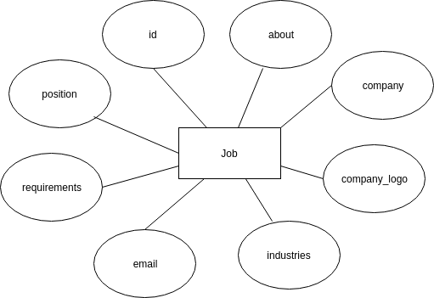

Experience
This entity contains details about the experience and the user to whom the experience belongs to.
The user is specified in the user_id

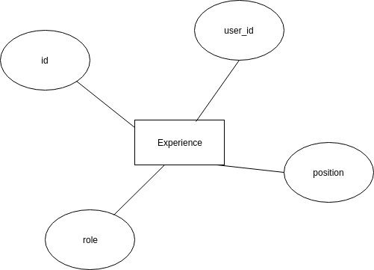

Media
This entity represents documents uploaded by the user to his/her account.
The media entity contains the file to be uploaded and the user_id. This is the user to whom the uploaded file belongs to.

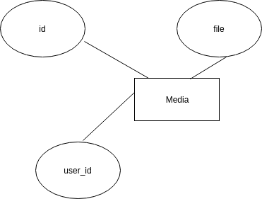

Skill
This is a skill that a user is proficient with.
A skill contains details about the skill and also the user_id of the user to whom the skill belongs to.

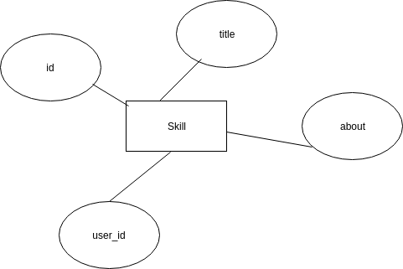

Education
This is the education that a user went through.
An education entity contains details about the education and also the user_id of the user to whom the education belongs to.

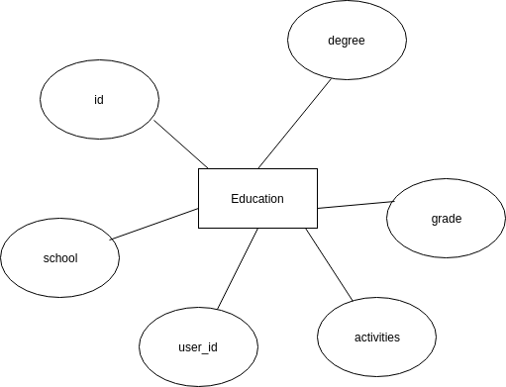

Account
This entity extends the user entity. It is an account for a user.
It contains extra attributes that are not contained in the Django ‘user’ entity schema.
It is used to store extra information about a user
The interests of a user are got from the Industries relation in a many to many fashions.

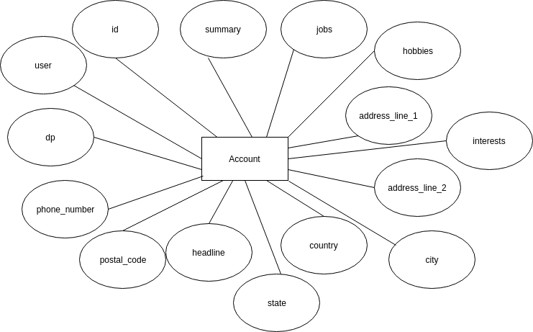

User
This entity is created by the Django framework. Its attributes are predefined and thus in order to add extra attributes one extends the User model. The following line imports the User model from Django framework from django. contrib. auth. models import User
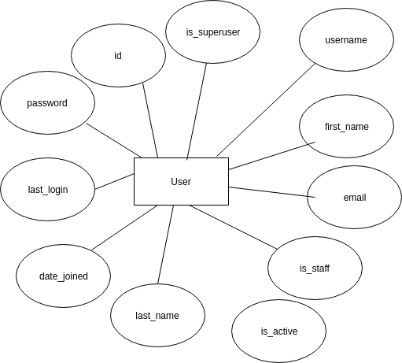

Entity Relationship Diagrams

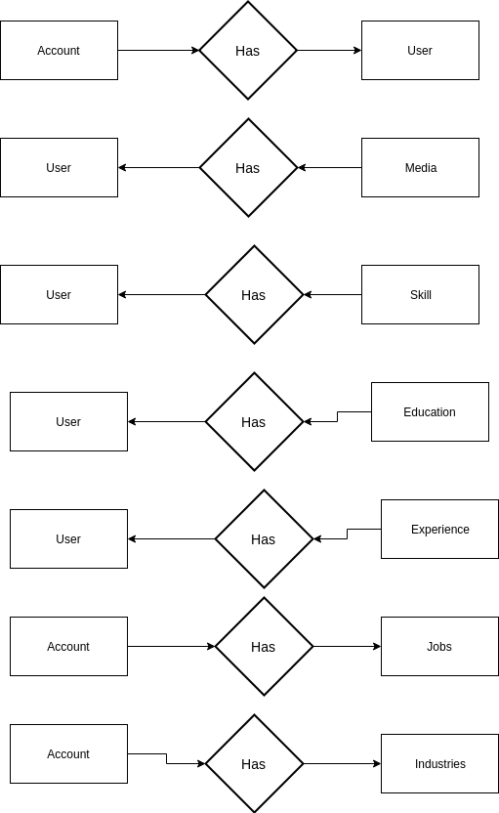

1

Use Case Diagrams

Shortlisting A job
When a user short-lists a job, the system adds the new job into the user_accounts_jobs relation which is referred to by the jobs attribute of the account relation.

The user_account_jobs relation stores a job and the user to whom it has been shortlisted for.
Two data stores are in use here:
- Jobs – This is used to select the job that has been chosen for shortlisting
- user_accounts_jobs – This is used to store the shortlisted job and to whom the job has been shortlisted.
The shortlisted jobs are viewed by accessing the jobs attribute of a user.

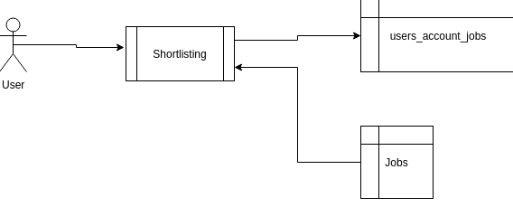

Removing Shortlisted Job

The selected job is retrieved from the users_accounts_jobs relation and it is deleted. The users_account_jobs relation does not contain the actual jobs. It just contains records of the ids of jobs and ids of accounts that the jobs match to.
It is a lookup field. This means that deleting records from this relation does not delete the jobs in the Jobs relation.

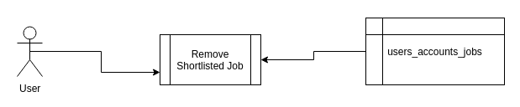

Uploading Media

In uploading media, only one data source is used. This is the media data store.
Input consists of the file to be uploaded.
Once the file is uploaded, it is stored in the media data store.

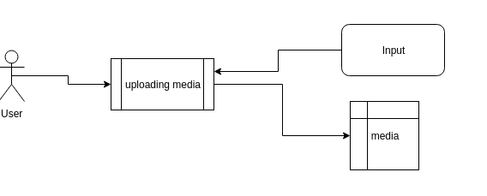

Deleting Media
In order to delete a media object, the selected media object is retrieved from the users_media relation and is deleted.
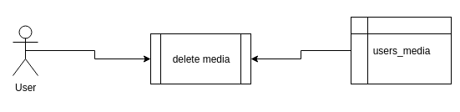

Adding Interests to Account

Two data stores are in use here:
- jobs_industry – This data store is represented by the entity Industries.
- users_account_interests – This data store is referenced to by the interests’ attribute of the account entity of a user.
An industry is selected from the jobs_industry relation and its ‘id’ added to the users_accounts_interests together with the user_id to whom the industry has been added as an interest.

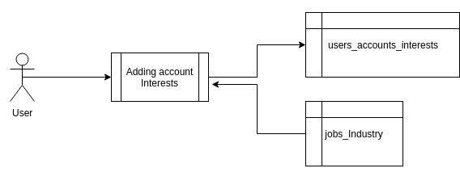

Removing Interests from Account

The interest object is selected from the users_account_interests table and it is deleted. Take in mind that this does not delete the industry object from the industries table.

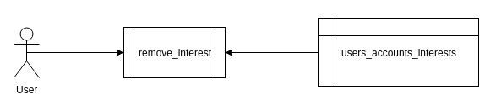

Adding Skills to User Account
The process takes in skill information as input and stores it in the users_skill data store represented by the entity skill.

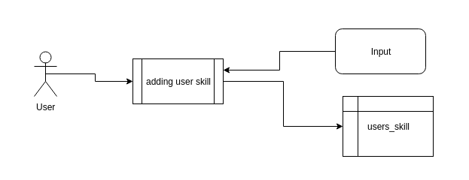
Delete Skill

The skill object is selected from the users_skills (Skills) table and it is deleted
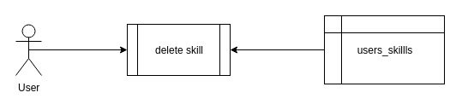

Adding Experience

Input about the experience is taken in by the process. This information is then stored in the users_experience relation. Each experience is related to a user via a foreign key.
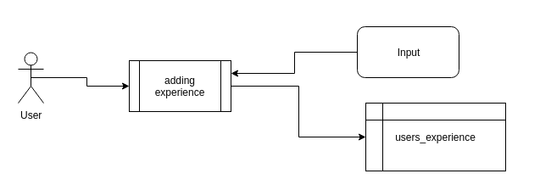

Delete Experience

The experience object is selected from the users_experience (Experience) table and the row is deleted.

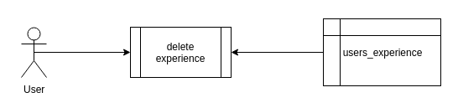

Adding Education

Input about the education is taken in by the process. This information is then stored in the users_education relation. Each education is related to a user via a foreign key.

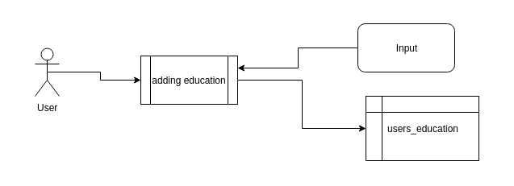

Delete Education
The education object is selected from the data store users_education (Education) and the row is deleted
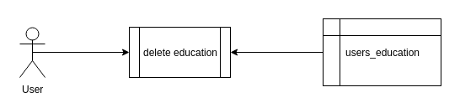

View Recommendations

When a user wants to view job recommendations, two data stores are used to process his/her request:
- users_accounts_interests – This contains industries that the user is interested in
- Jobs – This contains all the job objects
All jobs that have the same industries as those contained in the users_accounts_interests table rows of the specified user are returned to the user as recommendations.

This means that a comparison is made on contents of the attribute ‘industries’ of the job entity and industries contained in rows of the users_accounts_interests where the account is the account of the logged in user.

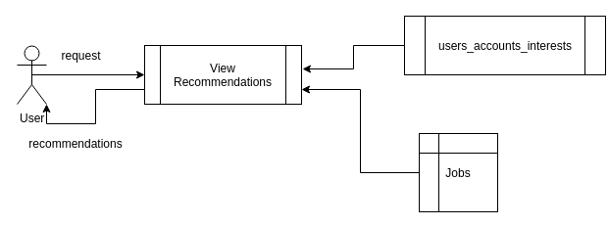

Search Jobs
The search is made on the ‘Jobs’ table.
The company and position_attributes of the jobs are matched against the string searched for. If matches are found, the jobs are returned to the user.

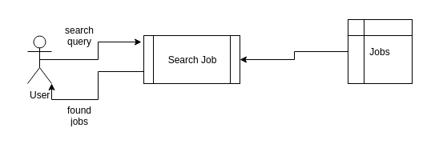

Search People

The search is made on the ‘Users’(auth_user) table.
The user-name attribute of the users is matched against the string searched for. If matches are found, the users are returned to the user.

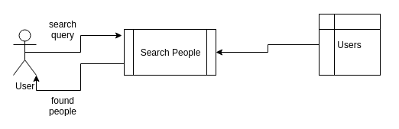

Sign Up

When a user wants to sign up, a user instance is created in the User relation. Also, an account object is created.
The account object created contains the just created user as the value of the user attribute of account.
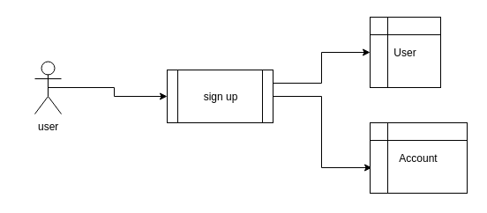

Login

When a user wants to log in, a user object is searched for in the ‘User’ relation containing the user-name provided. If found the password supplied is matched against the password of the user retrieved from the database.
If they match, the user is logged into the system.
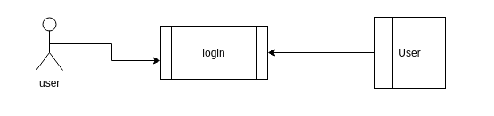

Complete Profile

Two data stores are in use here:
- User – The user object is retrieved from this relation
- users_account – The account object whose user attribute is the user currently logged in is retrieved from this relation
Once a user completes their profile, the specified attributes belonging to the user object and account object are modified as necessary

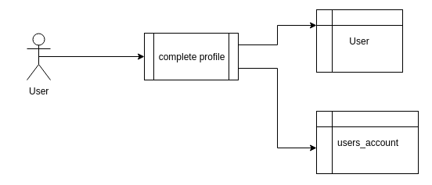

Database Conceptual Model

Below shows how the various tables in the database relate and the relationships.

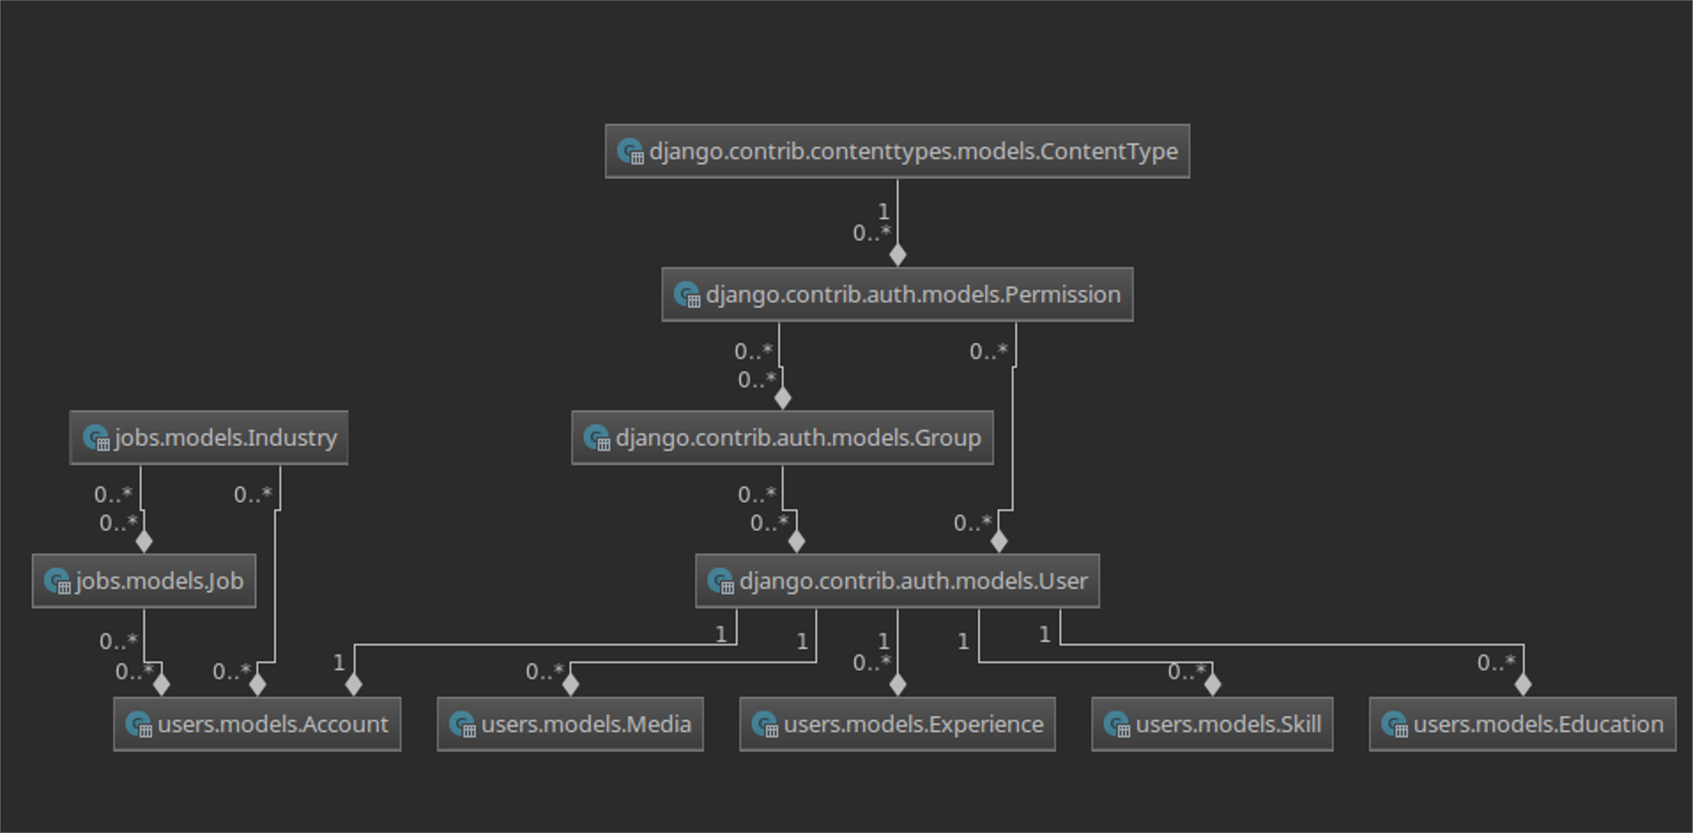

Relational Database Schema

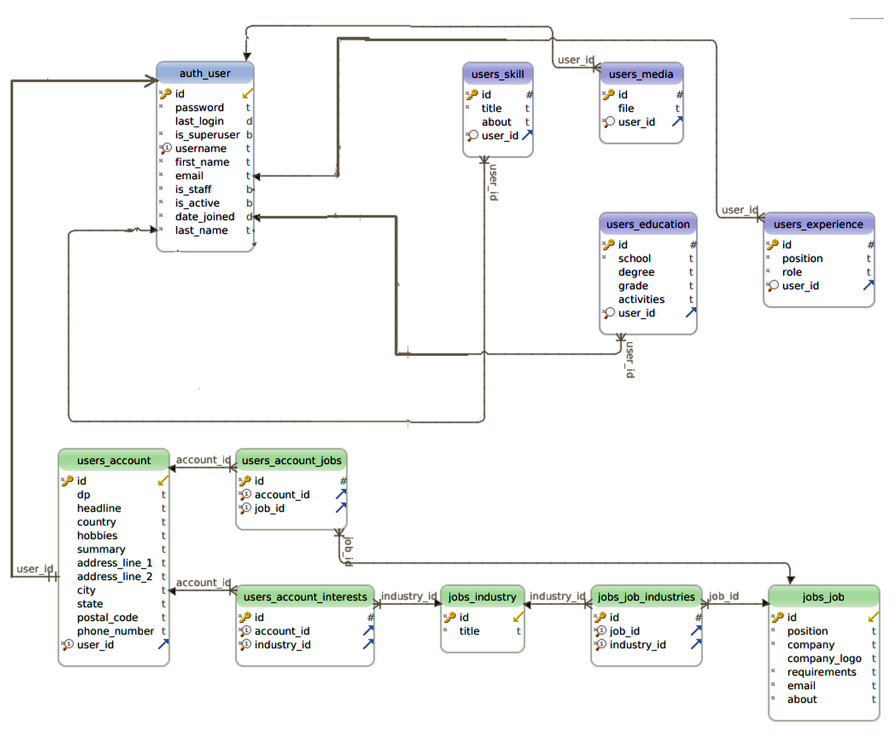

CHAPTER FOUR: RESULTS

Homepage

When a user accesses the site, he/she gets to view the most rated job occupations on the homepage. On this page, the user gets a brief glance of the top job vacancies on various industries. The user is free to shortlist any vacancy as desired.



Login/signup page

The system gives a user the possibility of creating an account. A user can only create one unique account; i.e. no user is allowed to hold more than one account. To create an account, a user needs to input the following details; -

- username
- email address
- preferred password (at least six or more characters)

The user should record the details since he/she will require them in the next login.





Site Administration

The system has a dedicated administrator dedicated to updating data and monitoring user activities. The administrator has access to all activities and has the power to revoke any suspicious activities at his/her own discretion.



Here is where the administrator defines the industries and updates the job vacancies.



Recommendations

Being a technical profiling system, it effectively generates special data to the user recommending him/her to the most related job vacancies irrespective of his/her interests.

First of all, the user must be signed into the system, complete his/her profile, upload necessary academic credentials.







CONCLUSION

The growing quality demand in the job sector makes it necessary to exploit the whole potential of stored data efficiently, not only the technical data, in order to improve availability of job vacancies, but also on management, in order to minimize costs and improve job applications.
In this sense, Technical Profiling system can contribute with important benefits to the job sector, as a fundamental tool to analyze the data gathered by different organizations and obtain models and patterns which can improve job application.

BIBLIOGRAPHY
- H. Kargupta et al., “Collective Data Mining: A New Perspective towards Distributed Data Mining,” Advances in Distributed and Parallel Knowledge Discovery, H. Kargupta and P. Chan, eds., MIT/AAAI Press, 2000,
- M. Cannataro and C. Comito, “A Data Mining Ontology for Grid Programming,” Proc. 1st Workshop Semantics in Peer-to-Peer and Grid Computing, 2003,
- M.J. Zaki, “Parallel and Distributed Association Mining: A Survey,” IEEE Concurrency, vol. 7, no. 4, 1999,
- A. Prodromidis and P. Chan, “Meta-Learning in Distributed Data Mining Systems: Issues and Approaches,” Advances of Distributed Data Mining, H. Kargupta and P. Chan, eds., MIT/AAAI Press, 2000,

