

**LEGO elevator controlled by Arduino UNO**

Ambrus Bence Tibor, D1O4NV

Automatic manufacturing systems project I.

University of Óbuda,

Kandó Kálmán Faculty of Electrical Engineering

21/02/2016

Preface:

This project is a subject in my 6th semester as an electrical engineering student. The basic concept is to design, build and control some kind of electric device. It was hard to make a choice but finally I decided to make a fully functioning mock-up elevator. I find it very interesting yet challenging to create something from scratch by myself.

In this short document I am going to represent the specification of my project based on given points of view.

Purpose, introduction:

When I did my first year at university I was told by other students that by the time I finish my studies I will be able to program the control of a lift. So I think this is the main reason I chose the elevator as my project.

The device I am going to build will be made of LEGO bricks. I chose this because it is easy to build anything from LEGO and I do not have access to DIY tools or garage and I can do it on my desk as well.

As for the programming part I have ordered an Arduino UNO from the internet because it can be easily used for controlling circuits and is widely supported by the community. I have wanted to start learning Arduino for a few months now, so this is a great „apropos” to do it.

Requirements:

By the end of the semester I would like my lift to be called from all the levels and controlled with the externally connected inner panel. It should be operated with small delay and within +-2mm accuracy.

Features:

I would like to build a 3 or 4 storey tall elevator with a cabin connected to a rope from the top. The rope will be connected to a stepper motor through a pulley, this will be responsible for the vertical moving. On each level there will be a pushbutton that can call the lift. There will be a panel connected to the cabin with buttons to each levels. Later (in Project II maybe) I would like to add more functions, buttons, sensors.

Input:

The input of the lift will be the pushbuttons on each levels and a panel responsible for the inner control.

Output:

On a 7 segment display the elevator will tell the user on which level it currently is. I will ask for response on the PC screen about the stepper motor’s actual status.

Block diagram

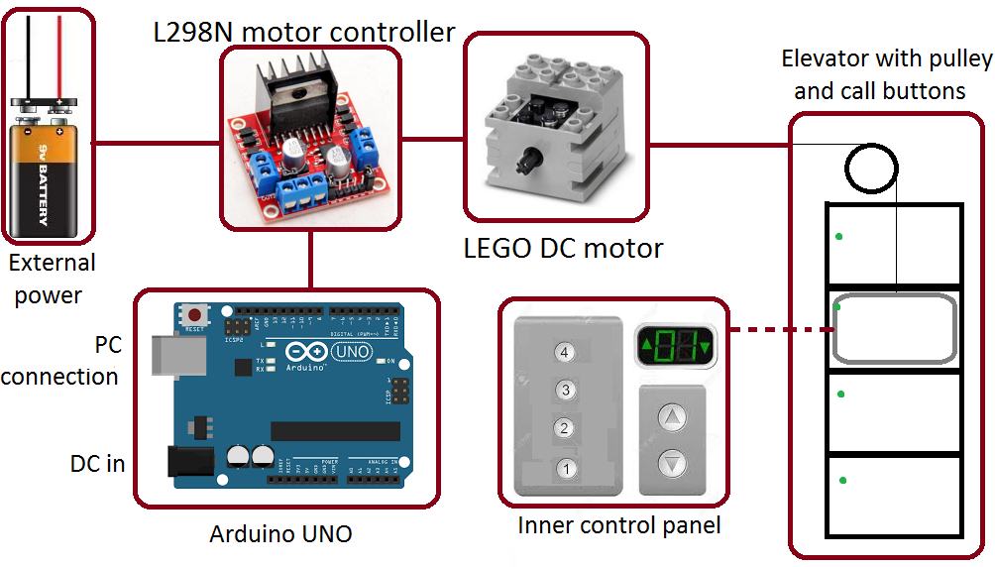

Implementation description:

The heart of the device is an **Arduino UNO Rev 3** microcontroller. Since it is open-source, I bought a Chinese copy for a few dollars but it has the same functionality.

Instead of a stepper motor which was the original idea I will use a LEGO DC motor. It is nice because it will fit other LEGO components thus I got it from a

The motor will be run by a circuit called **L298N** which is made for controlling DC motors.  
The motor needs about 6-12V of voltage so I’ll connect an **external power source**, e.g. a 9V battery.

The **inner control panel** will be a circuit made by me, and it will be connected to the lift cabin. Probably I’ll use a simple breadboard for testing. It will have buttons and a 7 segment display.

The **elevator** itself will be built of LEGO bricks, I have not started to design it. It will contain a cabin and a pulley on top for the rope.

Software:

Though Arduino has its own programming language which is built on C, I will stick with to standard C because it gives me more freedom and hopefully better memory usage than built-in libraries.

Gantt chart:

|  |  |  |  |  |  |  |  |  |  |  |  |  |  |  |
| --- | --- | --- | --- | --- | --- | --- | --- | --- | --- | --- | --- | --- | --- | --- |
|  | 8-Feb-2016 | 15-Feb-2016 | 22-Feb-2016 | 29-Feb-2016 | 7-Mar-2016 | 14-Mar-2016 | 21-Mar-2016 | 28-Mar-2016 | 4-Apr-2016 | 11-Apr-2016 | 18-Apr-2016 | 25-Apr-2016 | 2-May-2016 | 9-May-2016 |
| Week: | 1 | 2 | 3 | 4 | 5 | 6 | 7 | 8 | 9 | 10 | 11 | 12 | 13 | 14 |
| Idea pitching | x |  |  |  |  |  |  |  |  |  |  |  |  |  |
| First specification |  |  |  |  |  |  |  |  |  |  |  |  |  |  |
| Extended specification |  |  |  |  |  |  |  |  |  |  |  |  |  |  |
| Building the lift |  |  |  |  |  |  |  |  |  |  |  |  |  |  |
| Building the circuits |  |  |  |  |  |  |  |  |  |  |  |  |  |  |
| Program to test circuits |  |  |  |  |  |  |  |  |  |  |  |  |  |  |
| Lift control program |  |  |  |  |  |  |  |  |  |  |  |  |  |  |
| 1st demo |  |  |  |  |  |  |  |  |  |  |  |  |  |  |
| Adjusting SW-HW |  |  |  |  |  |  |  |  |  |  |  |  |  |  |
| Final demo |  |  |  |  |  |  |  |  |  |  |  |  |  |  |

Blue: now. Yellow/red: important dates.

Budget plan:

* I have ordered my Arduino for 3 USD. It’s coming from China, but I’m worried about shipping time... Borrowing one from colleague as rescue until it arrives.
* The L298N motor driver cost 500 HUF, bought from a friend.
* The 9V battery is about 500 HUF, as well.
* The LEGO DC motor I also got for free (free as a beer).
* The LEGO I use is partly mine, partly from friends.
* I already had the breadboard and the jumper cables.
* Buttons, LEDs, resistors, capacitors are not really worth to mention, they are very cheap.

Milestones:

1. Building the elevator from LEGO
2. Connecting everything together
3. Write some program that does the first movements.
4. Requirement #1 verified
5. 1st demo (5th April)
6. Final demo (9th May)