Methods of Wind Turbine Placement with Computational Fluid Dynamics

*Using Star-CCM+ to Simulate Wind Flow Through KTH Campus as a Method of Locating High-Velocity Regions*

James Buckland

Bachelor Student in Mechanical Engineering

University of Illinois at Urbana-Champaign

Urbana, Illinois, USA

[bucklnd2@illinois.edu](mailto:bucklnd2@illinois.edu)

Tamás Pál

Master Student in Sustainable Energy Engineering

KTH Royal Institute of Technology

Stockholm, Sweden

[tamasp@kth.se](mailto:tamasp@kth.se)

**Abstract**—Computational simulation software is used to model the flow of wind through KTH Campus in Stockholm, to best determine the placement of an axial wind turbine for maximum energy production. A model is constructed in Star-CCM+ and run on a 64-bit i7 CPU for 1400 iterations. Campus is modeled using a polyhedral mesh with a surface re-mesher. North-facing boundaries are made velocity inlets, and South-facing boundaries are made flow-split outlets. Turbulence is calculated and set at the boundaries to provide stability and accuracy. Wind flows at 5 m/s from the north, with 10°C air at standard pressure and temperature as the working fluid. Turbulent, steady-state flow is modeled with a segregated flow model. The model returns two potential candidates, which are compared qualitatively and quantitatively. A final recommendation for wind turbine placement is made: a local wind velocity maximum off the south-west corner of Maskinteknik.

Keywords-component; computational fluid dynamics, wind modeling, renewable energy technology,

# Introduction

The project aim is to choose the most appropriate point for installing a wind turbine on the KTH Campus area. Locations of wind turbines are crucial to the performance and efficiency of their units. A wrongly chosen site can have a negative effect on a project. Turbines operate best in exposed settings like high altitudes or seashores where the wind blows without obstacles. [5] Highly populated residential areas should be avoided due to turbulent, swirling and decelerated flow which occurs in the proximity of buildings. [6] Based on the average wind velocity, installing turbines on rooftops is suitable, however the potential damages to property caused by vibrations should be also considered. [7] For these reasons, our project excludes rooftops as possible locations. A 3D CAD model of the campus is provided for the simulation. This model neglects changes in terrain elevation and obstacles around campus such as trees and buildings.   
  
According to the given conditions such as buildings and the unsteady flow caused by them as well as the comparatively low wind velocity, the most suitable type of wind turbine is a vertical axis wind turbine. [9] The lack of aerodynamic noise also facilitates the installation next to living areas. [11] This turbine can harvest the energy of the wind from 360 degree and has a typical height around 10 m. [12] As the obtained average wind history data is also collected at a level of minimum 10 m, the scenes were plotted at 12 m plane giving an average view of the wind speed along the turbine axis.

# General description of the problem and purpose of CFD simulation

To best position a wind turbine, a mathematical model of the speed and direction of wind on campus must be developed. The geometry of the buildings and the streets between them is too complex for anything but computational simulation. A numerical solver, CD-Adapco’s Star-CCM+, is employed to build and compute our model. Wind is simulated at a historical average of 5 m/s from the North. Although in reality wind speed and direction is subject to change, this model only accounts for an average wind speed across the desired operation time. The model covers a limited and specific range of land -- the 1 km2 of land on which campus lies, with cardinal-direction boundaries for wind inlets and outlets.

# Code chosen for solution of problem

CD-Adapco’s Star-CCM+ is used in the construction and simulation of our numerical model. A CAD model of campus geometry is supplied, and global physical values and unique physical conditions for specific boundaries and planes are set around the region of interest. Details of the physical models are be discussed below.

# Computing platform used for run

The software was run on a 64-bit Intel® Core™ i7 CPU 860 running Windows 7 Enterprise at 2.80GHz with 8GB of RAM. Although low-level trial runs were performed at low resolutions, the final simulation, run at highest possible resolution, took several hours to run at its highest possible resolution.

# Schematic diagram of the region of interest with all key dimensions, flow inlets and outlets

A schematic diagram of the region of interest is presented below. Bear in mind that the model is smaller than campus by a factor of 7. Campus and the region of interest were bounded by a regular octagon with total width of 150 m and side width of 60 m, with a height of 8 m, as seen in Fig. 1.

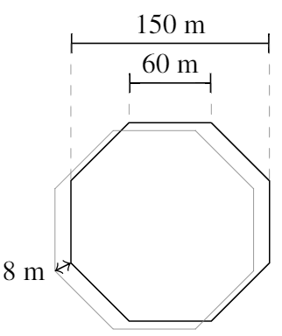

Figure : Dimensions of Region

The model was run with north-originating wind. To this effect, the N, NW, and NE faces were made inlets, and the S, SW, and SE faces were made outlets. The E, W, and Sky faces were made symmetry planes. (See Fig. 2.) Further detail is presented in Section VII: Boundary Conditions.

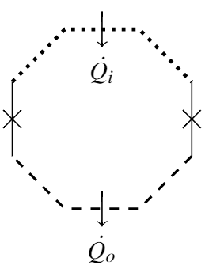

Figure : Flow Inlets and Outlets

# Grid design

An accurate mesh is vital in order to get results at a desired level of detail.[10] Every unit of surface and volume needs to be meshed according to its role in computing the flow along crucial surface parts of obstacles. At critical points, the mesh needs to be denser than at points where there is no flow blockage. For the optimization of the existing surface quality for volume meshing, a surface remesher is applied. It also adds finer mesh density on the surface boundaries, where more complex visualization is needed. This is based on curvature and surface proximity.

As a volume mesh, we used polyhedral mesh. (See Fig. 3). This mesh type is formulated directly from a hidden tetrahedral mesh which is generated within the process. Compared to the tetrahedral mesh, this solution provides faster convergence with fewer iterations, lower absolute residual value and faster solution runtime. [3] The polyhedral cells usually have an average of 14 cell faces. This means a higher grid density resulting in more a precise outcome. The base size of the polyhedral mesh was specified to 1 m.

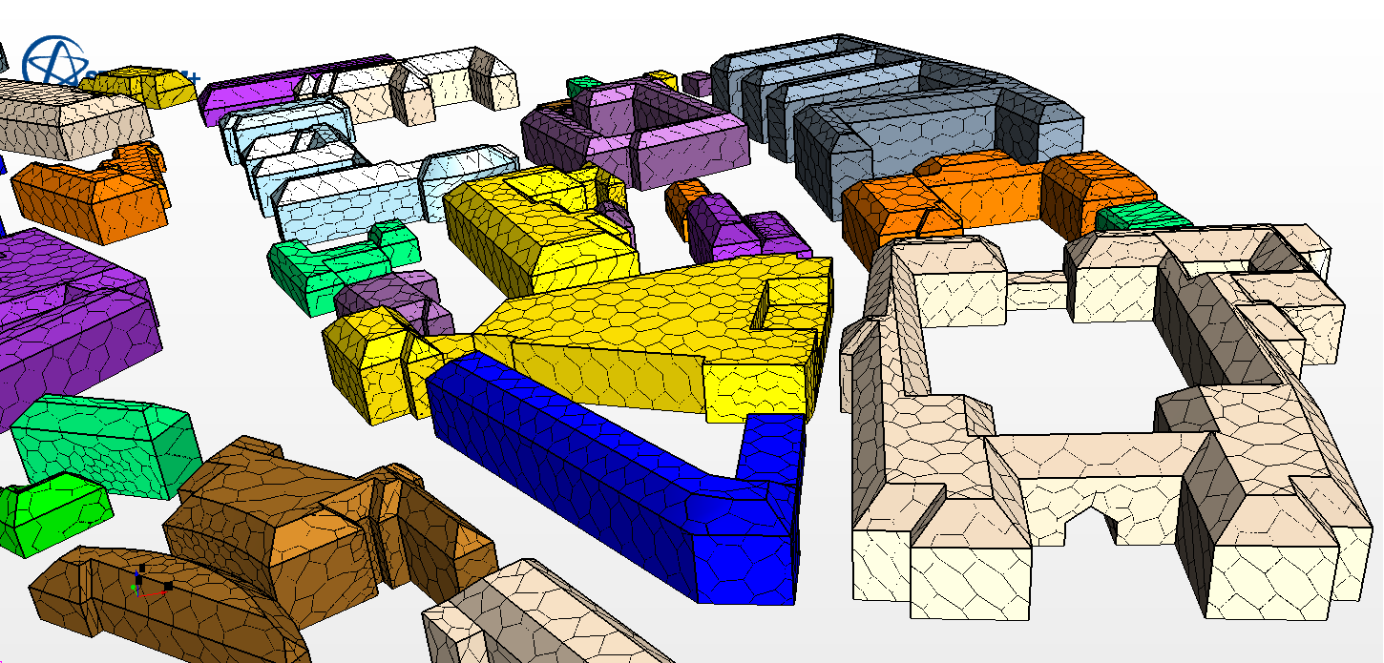

Figure : Polyhedral Mesh

# Boundary Conditions

Our simulation assumed a constant, steady-state flow of wind into the north face of the model, channeled through our model and emerging from the south face of the model. To accomplish this, the North, North-West, and North-East faces were defined as velocity inlets with set turbulent intensity and turbulent viscosity, as discussed in Section X: Modeling Option Selections. The South, South-West, and South-East faces were also defined as flow-split outlets, which allowed fluid flow to exit wherever it ended up on the south face, with no pressure or resistance. The surface of the earth and all of the buildings on campus were designated as walls. The sky, the East face, and the West face were all defined as symmetry planes, which allowed fluid flow directed through them to proceed uninhibited, while returning that same flow back into the system to preserve mass / momentum conservation.

# Initial conditions

The physics model used assumed several standard variable definitions, in keeping with the physical nature of reality. Pressure was defined universally at a constant zero bar relative to sea level. Temperature was also defined universally at a constant value of 280K, or 10°C, set using historical data [8]. Using the same study, we measured the average wind speed in Stockholm throughout any given year to be .

To specify turbulence values and initial turbulent conditions at inflow boundaries, we used fluid dynamics equations presented in *Guidelines for Specification of Turbulence at Inflow Boundaries* [2]. The height and width of the cross-sectional area of the model are known at and 1200 m, respectively. Thus the characteristic length scale is calculated at:

.

The kinematic viscosity of air at is known at:

The averaged Reynolds number for the maximum turbulence across the simulation is calculated to be:

.

The turbulent intensity is calculated to be:

.

The turbulent kinetic energy is calculated to be:

.

The turbulence of the model was specified by the intensity and the viscosity ratio. The viscosity ratio was set at:

as a result of so high a Reynolds number. The constant turbulent velocity scale was left at a default .

# Fluid Properties

The working fluid for this simulation is air at an average sea-level pressure of and an average Stockholm-climate temperature of 10°C, with a density of . Using historical data, the velocity of north-originating wind is approximated by a steady-state stream with a velocity of 5 m/s. Furthermore, the physical model assumes conditions -- relatively high temperature and relatively low pressure --  within those considered ideal, so that the Ideal Gas model can be employed.

# Modeling option selections:

## Steady-State Flow

The working fluid within the region is modelled as three-dimensional, steady-state ideal fluid interior flow through a surface. The fluid is steady-state at an average velocity, which will yield the same average results as the real-world unsteady wind speed at lower and higher actual wind velocities.

## Segregated Flow

The flow in question is low-speed and incompressible, so the segregated flow model is chosen. [1] This model solves continuity, momentum, and energy equations separately, which produces few errors or instabilities and solves quickly and with satisfactory accuracy.

## Turbulent Flow

Because the model is so turbulent, it has a high Reynolds number of . This means that the flow is turbulent in areas of complex geometry and laminar in areas with no obstacles. At low altitudes, near the ground and the bases of buildings, high and low pressure areas can be found, as well as wind tunnels, vortices, etc. At planes above the buildings on campus, the wind-streams around the buildings affect the speed and direction of the wind, but it remains laminar. For this reason, our model must be able to handle turbulence. Near the symmetry walls, the flow is laminar but there is no frictional reduction in speed.

# Solution algorithm choices –

Several standard solution algorithms were chosen, such as the ideal gas model and the decision to use a segregated solver, both discussed in Sections IX and X, respectively. In addition, the k-epsilon turbulence + realizable k-epsilon two-layer turbulence scheme was used, with

,

.

Several other near-default options were selected as well, such as the RANS (Reynolds-Averaged Navier Stokes) equations, and the industry-standard Two-Layer All y+ Wall Treatment.

# Iterative convergence criteria choices:

The residuals of this model were observed approaching convergence after approximately 1400 iterations at a range of resolutions and complexities. Thus, rather than programmatically determining a cutoff, the model was observed throughout its run, and terminated by visual criteria. Residuals such as total kinetic energy were found to resolve at a final residual value of 1E-4. All residuals eventually converged to values between 1E-4 and 1E-5. During trial runs, unphysical models generally revealed their instabilities or unrealities within a few hundred iterations. Thus, a final run of over a thousand iterations is a safe choice. In the final simulation, 1400 iterations produced an extremely convergent model. (See Fig. 4.) This was determined to be a reasonable decision [4].

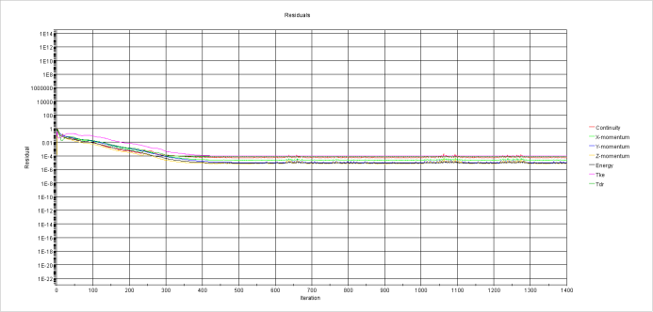

Figure : Residuals Performance across 1400 Iterations

# Results

A wind turbine of a certain height interacts with the wind layer at that particular height only, wind is laminar, but rarely moves vertically in space. A wind turbine of 12 m height, for example, interacts only with the buildings around it which intersect with that altitude layer. At 12 m, only two buildings on campus disrupt the flow of wind, the Maskin building complex, on north campus, and the Kemi (Chemistry) building complex, near the south-east portion of campus. These disruptions are visible in Fig. 5.

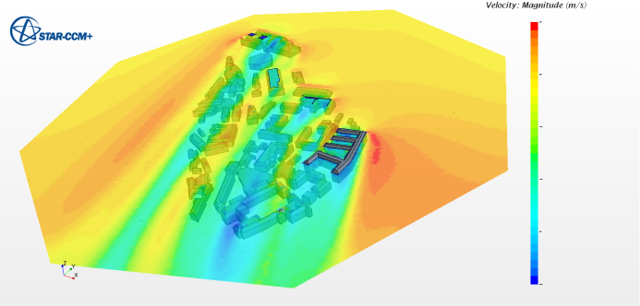

Figure : Wide-Angle View of Scalar Velocity Scene, 12m Altitude

Looking at a top-down view of campus (Fig. 6), we can see that a north-originating wind creates pockets of low-velocity air in the wake of the major blocks of buildings on-campus. This air is displaced towards the edges of campus, creating two streams of high-velocity air, ideal for placement of a 12m axial turbine.

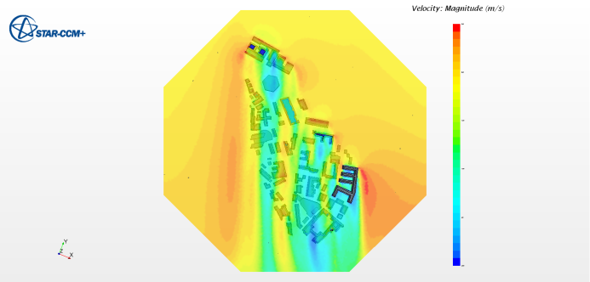

Figure : Top-Down View of Scalar Velocity Scene, 12m Altitude

Of these two streams of high-velocity air, one – the northern location – is a wind front adjacent to the east face of the *K* Building (#40, #38, #28), as seen at the local maxima in Fig. 7.

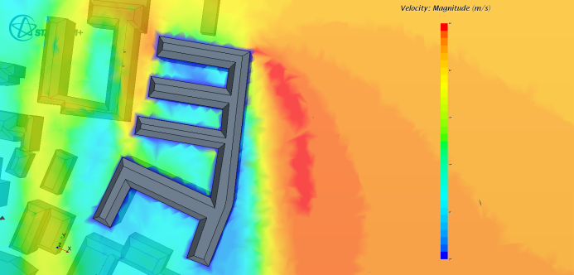

Figure : Close-up View #1 of Scalar Velocity Scene, 12m Altitude

The other of the two locations – the southern location – is at the south-west corner of the *M* Building (#70), as seen at the local maxima in Fig. 8.

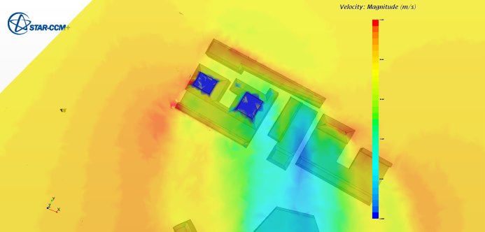

Figure : Close-Up View #2 of Scalar Velocity Scene, 12m Altitude

The two locations are very similar in many respects – both attain the maximum wind velocity anywhere on campus, both are relatively near to buildings, and both are nearby pockets of unusually low velocity. The determining factor, therefore, will be the relative turbulence of wind near the two regions. A wind turbine, axial- or rotor-based, relies on a steady stream of air with little turbulence or pitching. In Fig. 9, a green (mid-velocity) stream of air at a lower altitude can be seen curving eastwards, around the face of the building.

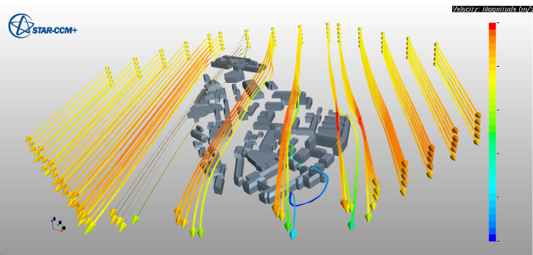

Figure : Wide-Angle View #1 of Streamline Scene

This curved streamline, seen in closer detail in Fig. 10, has effects on all the other streamlines above it, as well as to the set of streamlines located one unit eastwards. It can be seen in Fig. 8 that the wind at the southern has a relatively high vorticity – it is rotating slightly on its own axis. Compared to the same wide-angle streamline view in Fig. 9, the northern location has relatively little vorticity.

Another consideration in the performance at a wind turbine is an analysis on the velocity at a spot with a variable wind direction. Locations directly against walls perform well when the wind blows parallel to the wall face, or off a nearby corner, but perform badly when the wind blows perpendicular to that same wall face. Locations near corners, by comparison, do wall in most conditions, as wind is generally blowing past one of the two wall faces it is located nearby.

The northern location, therefore, could be expected to perform similarly under comparable wind conditions from any direction, whereas the southern location would perform similarly only with northern- or southern-originating wind.

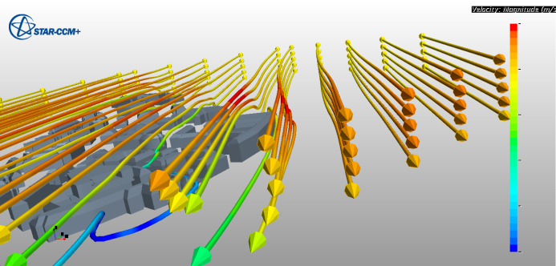

Figure : Wide-Angle View #2 of Streamline Scene

The final consideration is the relative nearness of any pockets of low-velocity wind created in the wake of nearby buildings. The *M* building complex creates a large area of low-velocity wind in its wake, as seen in Fig. 11, as does the *K* building complex, as seen in Fig. 12.

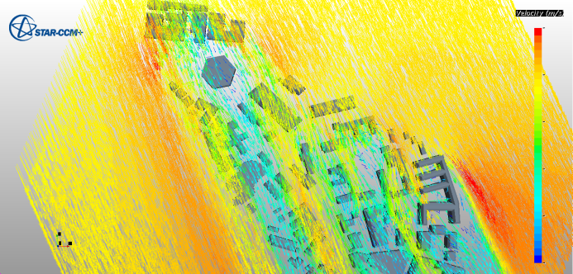

Figure 11: Top-Down View #1 of Vector Velocity Scene, 12m Altitude

However, the gradient from high- to low-velocity wind is more gradual at the northern location – there a more gradual drop in velocity heading eastwards across the region. The high-contrast wind region in the southern location has the same drop from high- to low-velocity wind over a shorter distance. (See Fig. 12.) This means that a slight fluctuation in wind direction would affect the southern location more than the northern location.

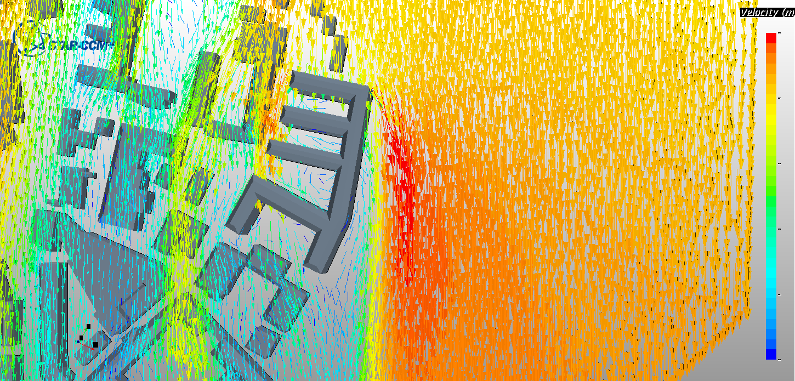

Figure 12: Top-Down View #2 of Vector Velocity Scene, 12m Altitude

A wind turbine is not expected to perform briefly and furiously, it is expected to perform at a steady pace under a majority of wind conditions. Therefore the northern-most location is the safer bet, despite its slightly lower velocity values in comparison to the southern location.

# Discussion

As vertical axis wind turbines are omnidirectional, they do not need to track wind direction and are not affected negatively by turbulent flows, the possible best location is the high-velocity stream next to the east face of K building while considering the highest exploitable potential. Along the edge of the building the wind speed reaches up to 7 m/s. The turbine needs to be located just right outside the turbulent layer, in the red zone. The above arguments are valid in case of constant wind direction from the North. Supposing a more realistic wind direction composition, the stream next to M building is the better choice due to it is more exposed to any direction. There are several manufacturers on the market offering axial turbines operating in a range of 1.5-10 m/s. Other students in the same course were conducting simulations with similar given values. The comparison of the models implies that the results of the present simulation are reasonable.

# Summary

This study was inherently limited due to the decision to model wind from only one direction. With this assumption, wind turbine placement becomes trivial. Without it, many such studies of this type are required from a range of directions, which could then be weighted with the frequency of wind direction as measured historically.

The simulation was run on a consumer-grade desktop computer with limited power – in a professional environment, it would be run at much higher resolution with more details in the environment such as tree cover and elevation.

Furthermore, underlying decisions such as segregated/coupled flow, polyhedral/tetrahedral mesh, and others were made with rendering considerations in mind. With a more powerful computer, different tools could have been chosen, and more accurate results might be possible.

The model presented above, taken literally, recommends a location just off the East face of the Chemistry building, for its wide swath of uninterrupted high-velocity wind. A more reasoned look at the model, taking into account variations in wind direction, would recommend another site, on north campus, at the south-west corner of the Machine building complex. Altogether, this simulation, like many simulations, provides relatively accurate results for an extremely narrow range of realistic cases.

1. "1.6 Choosing the Solver Formulation." FLUENT 6.1 Documentation. Fluent Inc., n.d. Web. 03 May 2015. <<http://jullio.pe.kr/fluent6.1/help/html/ug/node20.htm>>.
2. "Documentation | Star-CCM+." CD-Adapco, n.d. Web. 03 May 2015. <<http://www.cd-adapco.com/products/star-ccm%C2%AE/documentation>>.
3. Fernandez, Pablo. "Mesh Models in STAR-CCM+ - The Answer Is 27." The Answer Is 27. N.p., 21 Nov. 2013. Web. 03 May 2015. <<http://theansweris27.com/mesh-models-in-star-ccm/>>
4. "Has Your Simulation Converged?" Has Your Simulation Converged? N.p., n.d. Web. 03 May 2015. <<http://support.esi-cfd.com/esi-users/convergence/>>.
5. "Horizontal Axis Wind Turbine VS Vertical Axis Wind Turbine." Aeolos Wind Turbine Company, n.d. Web. 03 May 2015. <<http://www.windturbinestar.com/hawt-vs-vawt.html>>.
6. "Installing a Wind Turbine - Site Selection." Good Energy | Switch For Good. Good Energy Ltd, n.d. Web. 03 May 2015. <<http://www.goodenergy.co.uk/generate/choosing-your-technology/home-generation/wind-turbines/wind-turbine-site-selection>>.
7. Laino, David. Power Performance Test Report for the Windspire. Chattanooga, TN: Tennessee Valley Authority, Division of Energy Demonstrations and Technology, Electrical Utilization Group, 1984. Windwardengineering.com. Windward Engineering, LLC, 28 Feb. 2013. Web. 3 May 2015. <<http://windwardengineering.com/wp-content/uploads/2012/11/2013-02-28-PP-Test-Report-Windspire_vfs5.8-DJL-DAD-pg80.pdf>>.
8. "Observations in Sweden." SMHI Observations, Sweden. Sveriges Meteorologiska Och Hydrologiska Institut, n.d. Web. 03 May 2015. <<http://www.smhi.se/en/weather/sweden-weather/observations/>>
9. Ragheb, M. "Vertical Axis Wind Turbines." (n.d.): n. pag. 21 Mar. 2015. Web. 3 May 2015. <<http://mragheb.com/NPRE%20475%20Wind%20Power%20Systems/Vertical%20Axis%20Wind%20Turbines.pdf>>.
10. Smith, Richard. "Polyhedral, Tetrahedral, and Hexahedral Mesh Comparison." Symscape |Computational Fluid Dynamics Software. Symscape, n.d. Web. 03 May 2015. <<http://www.symscape.com/polyhedral-tetrahedral-hexahedral-mesh-comparison>>.
11. "The Wind Turbine for the Built-up Environment." (n.d.): n. pag. Turby. Web. <<http://www.wind-power-program.com/Library/Turby-EN-Application-V3.0.pdf>>.
12. "Vertical Axis Wind Turbines vs Horizontal Axis Wind Turbines." Windpower Engineering Development. WTWH Media, LLC., n.d. Web. 03 May 2015. <<http://www.windpowerengineering.com/construction/vertical-axis-wind-turbines-vs-horizontal-axis-wind-turbines/>>.