Venom Gene Pull Tutorial!
You will need:
-3 scorpion transcriptome .fasta files
-Scorpiones database (ToxCodAn-Genome)
-Import with Index_new.sh
-Blast script part 1: BLASTI_tblastn_Scorpiones_db_array.sh (match/ ID venom seq)
-Blast script part 2: BLASTII_py_for_all.sh (pulls sequences using IDs)
-Python script for part 2: getSeq.py
Disclaimer from README: some names involve "blastx" but this is an artifact of misnaming in an initial step, these are all tblastn, not tblastx (using transcriptomes with nucleotide db)
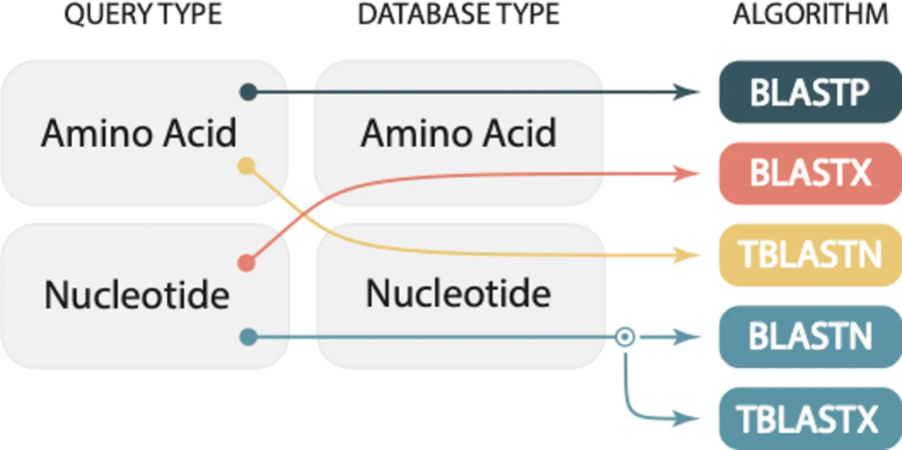

First let’s download that Scorpiones database:
1a. Use ssh to join your server, then in a new folder use the following command to download database:
wget https://raw.githubusercontent.com/pedronachtigall/ToxCodAn-Genome/main/Databases/Scorpiones_db.fasta
1b. Next we can create the BLAST indexes (10) using index.sh: Activate environment before running scripts
conda activate blast
bash index.sh
This will result in files “Scorpiones_db.*” where the * signifies different file endings (nin, nsq, etc)

1c. Now you can download those .fasta files for three scorpion species: Buthacus cf. arenicola= Bare_withid_centroids.fasta , Leiurus quinquestriatus= LquiE_withid_centroids.fasta , Chaerilus stockmannorum= C_stock_telson_ORP_centroids.fasta
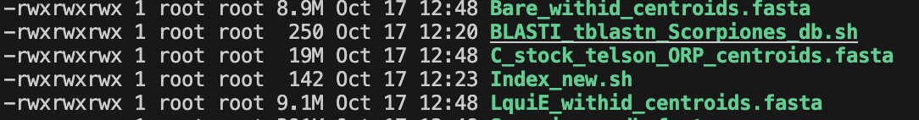
Ensure file sizes match those above (ls –lah)
After those, download the .sh and .py scripts in the Teams folder if you have not already.
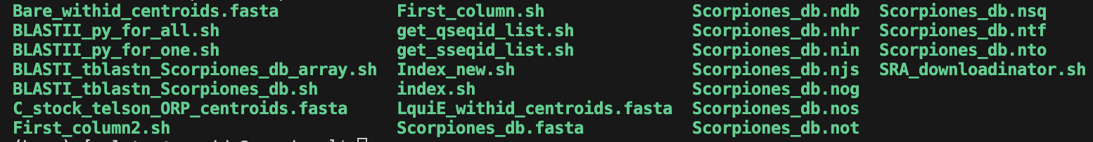

2a. Let’s take a look at the README file. Here you will see what is required, what does what, and how. (More or less).

2b. Next let’s look at the script for pulling venoms from a single transcriptome.
We can see that the command is as follows:
bash BLASTI_tblastn_Scorpiones_db.sh <fasta file>.fasta
Replace the <fasta file> and execute
bash BLASTI_tblastn_Scorpiones_db.sh Bare_withid_centroids.fasta
You will see this weird error pop up (a lot) but at the end you can check to see if it worked (should have).
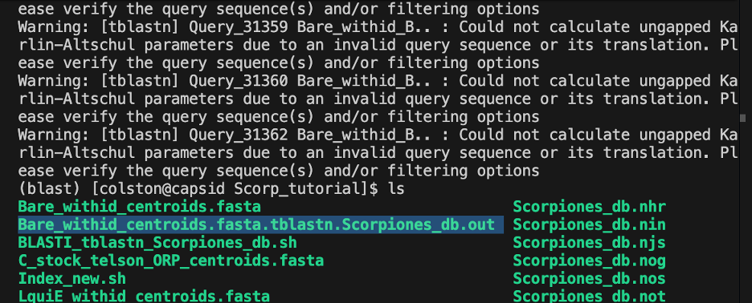
The output file will look like this:
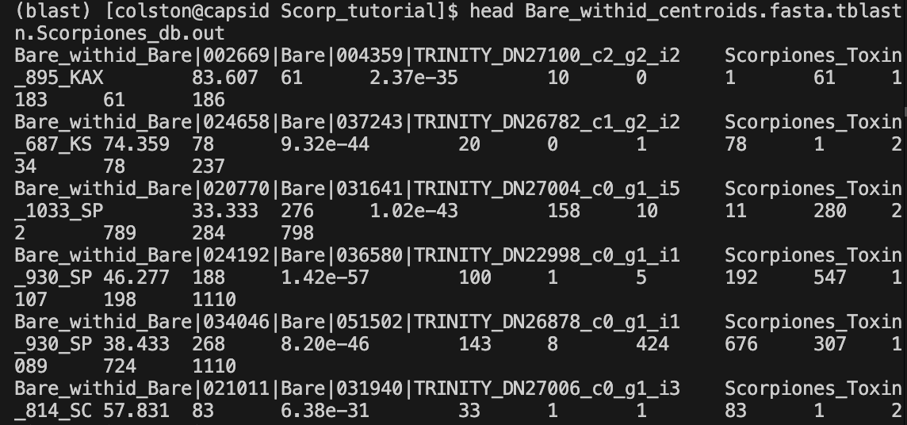
2c. I haven’t gotten to modify the second part which finds the sequences yet, but if we have time and you would like to we can take a look and see what needs modifying/ which parts of the script have to be pulled for it.

