

**Adam Cook, Isaac Goldberg,  
Jessica Liu, Matt Nichols**

# Introduction

Ballsy is a two-dimensional physics puzzle game in which the user must navigate Ballsy, a colorful beach ball, from a starting location to its best friend, the pail. The ball has a grappling hook that allows Ballsy to swing from surface to surface. When the grapple is not active, Ballsy continue to roll in whatever direction momentum carries it. The user can apply a gentle force with the keyboard, causing Ballsy to roll from side to side while on the ground or to swing while grappled. The user may also retract or extend the grapple with the keyboard.

# Controls

The Ballsy menus are controlled with the mouse. While in-game, **A/LEFT** applies a force pushing Ballsy to the left, **D/RIGHT** applies a force pushing Ballsy to the right, **W/UP** retracts the grapple (if Ballsy is currently grappled), and **S/DOWN** similarly extends the grapple.

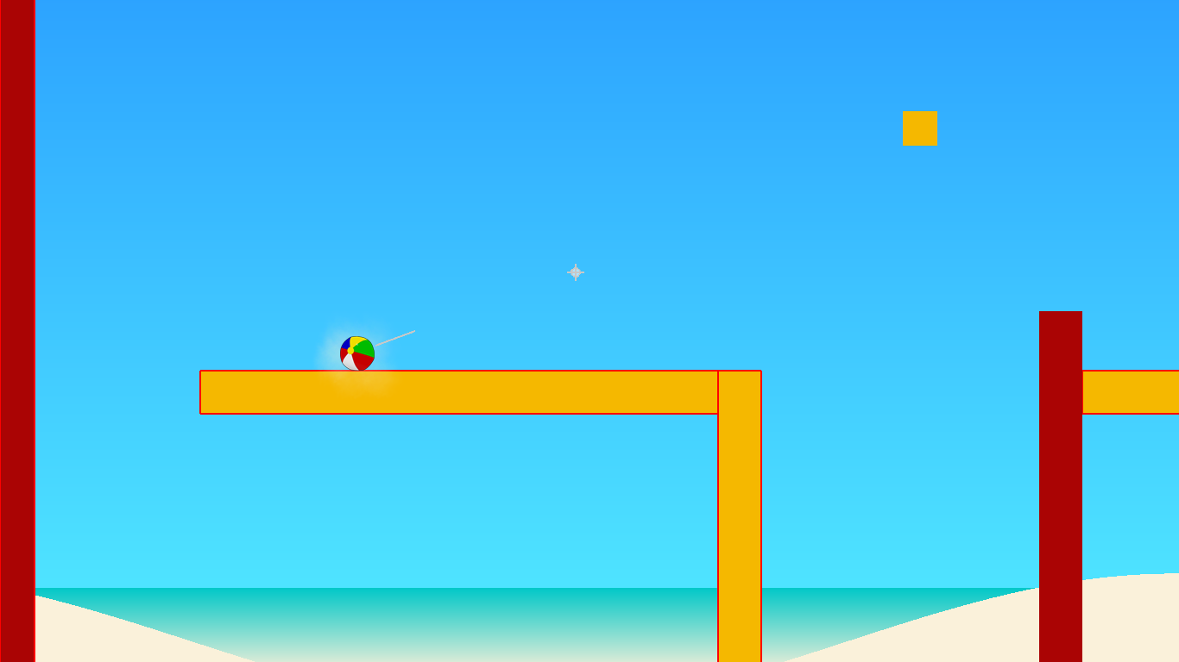

*Ballsy rolling from side to side from keyboard controls.*

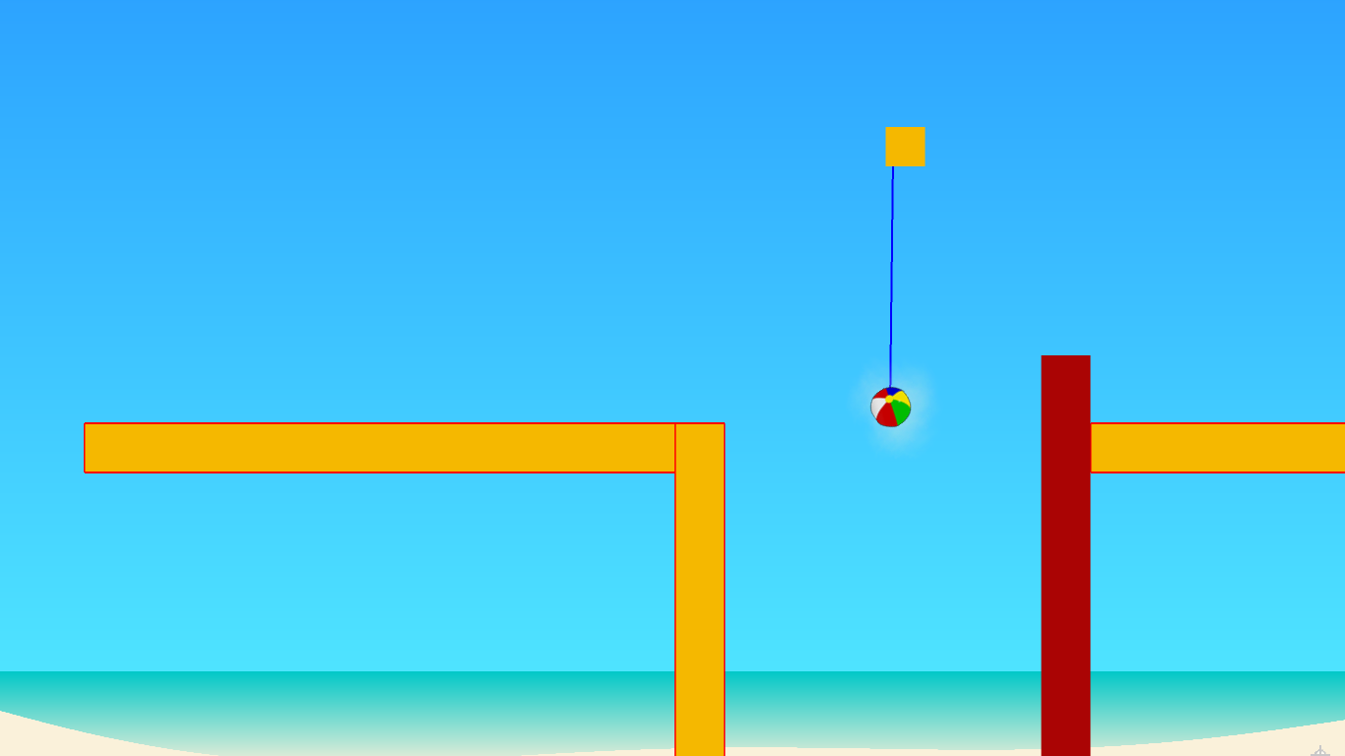

*Ballsy swaying from side to side and extending and retracting grapple using keyboard controls.*

# Game Elements

Ballsy levels may include any shape of object (rectangle, regular polygon, irregular polygon, circle), and these objects may have any of the following properties.

* **Grappleability**: Grappleable objects may be targeted by Ballsy’s grapple. If an object is grappleable, it will have no border, and it will have a thin border if cannot be targeted.
* **Deadliness**: If an object is deadly, it will be a dark red color. Should Ballsy come in contact with a deadly object, the user will have lost and the level will restart. Deadly objects are not necessarily ungrappleable.
* **Mobility**: Objects may be static within the world, meaning they are immobile and not affected by gravity. Conversely, objects may also be dynamic within the world, meaning they are affected by gravity and are mobile within the world.
* **Bounciness**: Colliding with some objects may result in a greater repelling force.
* **Friction**: Sliding on some objects may cause Ballsy to slow down more or less.
* **Density**: Objects may react to forces slower or faster depending on their densities.

# Interface

Ballsy begins at the main menu, from which the user can either begin a new game (starting at the first level), choose a level of choice, open the level editor, or quit the game.

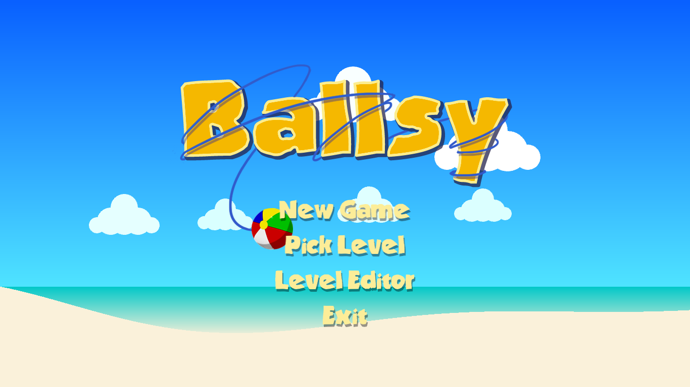

Selecting New Game will simply launch the first level of Ballsy. Selecting Pick Level opens the list of levels, with levels the user have not yet unlocked (by beating the prior level) inaccessible.

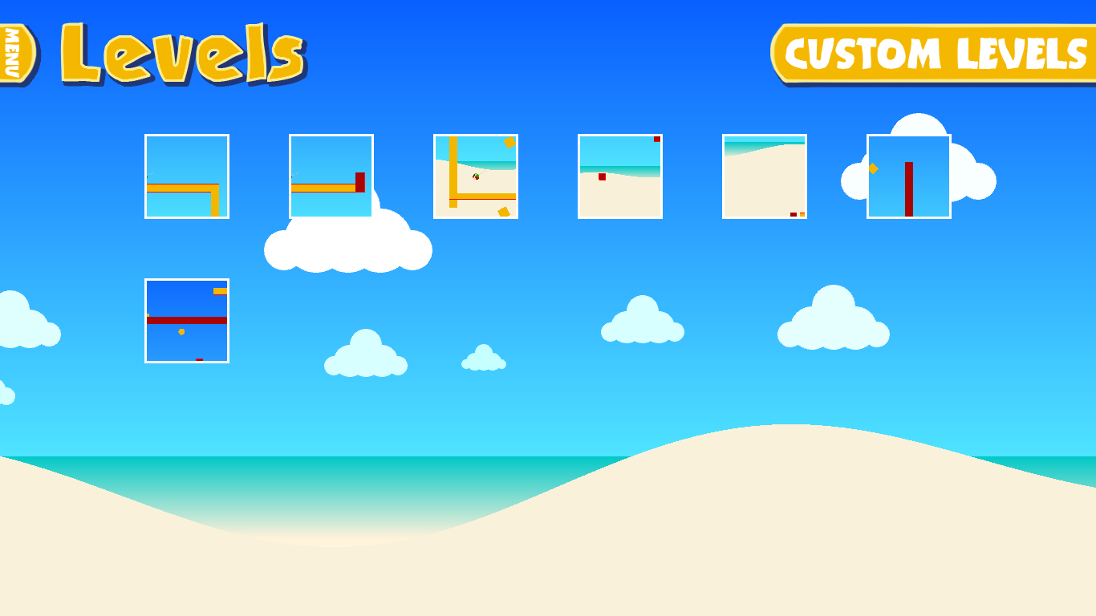

From this screen the user may choose any level, differentiated by auto-generated thumbnails, or select the Custom Levels tab, which brings the user to the list of levels the user or others have created with the Level Editor.

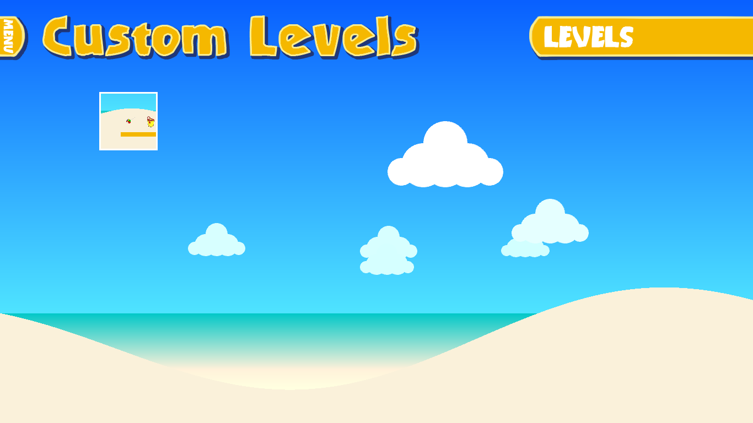

# Level Editor

Returning to the main menu, the user may enter the Level Editor:  
 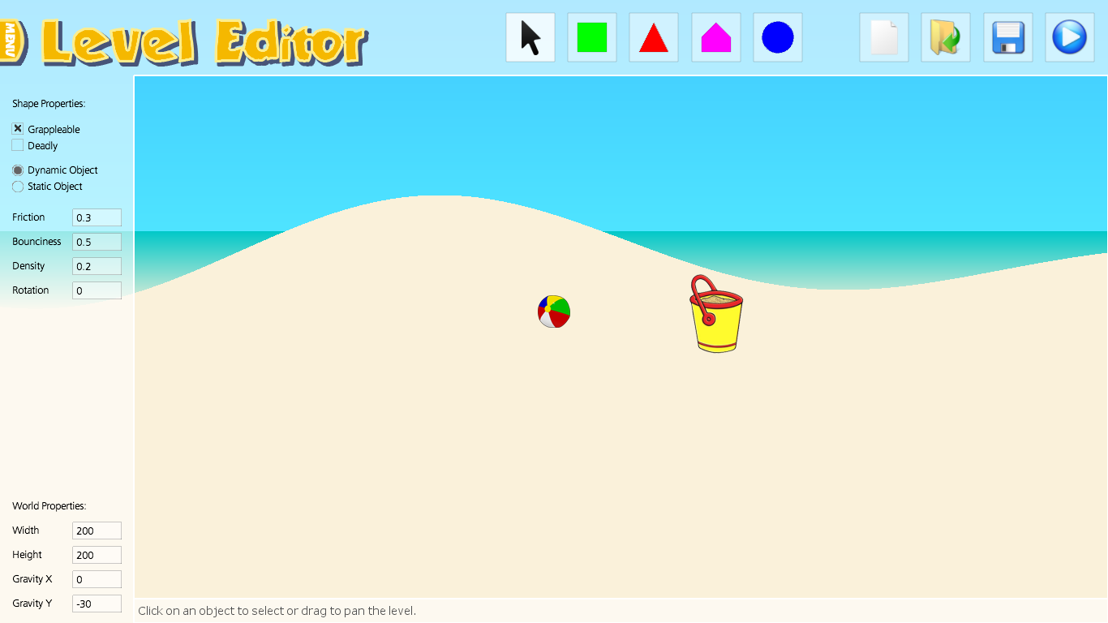

The Level Editor allows the user to build high-quality levels using the same tools used by the developers themselves. The level editor allows for the creation of rectangles, polygons of arbitrary number of sides, irregular polygons with an arbitrary number of convex points, and circles.   
  
For creating rectangles, regular polygons, and circles, it is as simple as clicking on the button and clicking somewhere within the level. For creating irregular polygons, the user must select the button and then select a sequence of convex points and **right click** to finalize the shape.

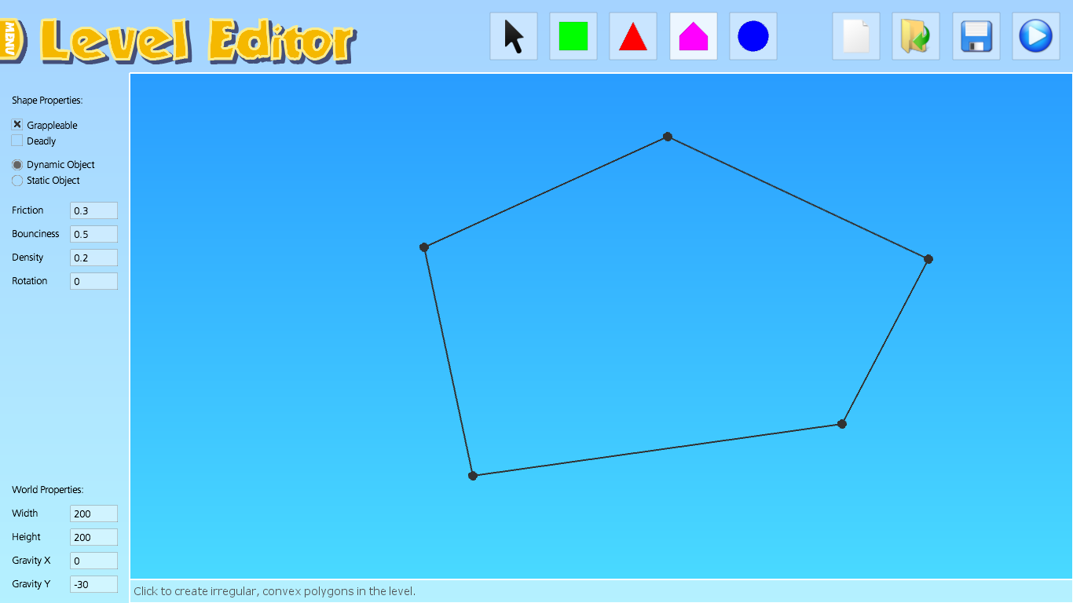

To select a shape, simply click on it while the cursor button is selected. Once selected, the shape may be rotated by holding **SHIFT** and dragging the mouse, resized by holding **Z** and dragging the mouse, or moved simply by clicking on the shape and dragging the mouse. Hitting **X** will snap the shape to the closest 90 degree rotation. The user may also set default shape attributes by selecting settings on the lefthand side when no shape is selected. Shapes may be deleted by selecting a shape and pressing **D**.

The user may also specify a path for the selected shape. This will cause the shape to continuously travel along a fixed sequence of points. The user may input a path by clicking **Add Path,** clicking points within the level, and then either clicking **End Path** or **right clicking**. If the object is a **static** object, then the object will follow the path regardless of the forces applied to it by other objects. If the object is **dynamic**, the object will attempt to follow the path, but can be affected by objects in its way. The speed for the object to travel along the path can be set, along with the amount it should rotate. *(See figure on final page.*)

In addition to setting shape properties, the user may set world properties. This allows the user to set the gravity (allowing for interesting effects with gravity only along the X-axis or upside-down), and the width and height of the level.

