# RColorBrewer Example

Usage of a couple of RColorBrewer's palettes. First, here are all the palettes availalbe in the package.

library(RColorBrewer)

## Warning: package 'RColorBrewer' was built under R version 3.1.2

display.brewer.all()

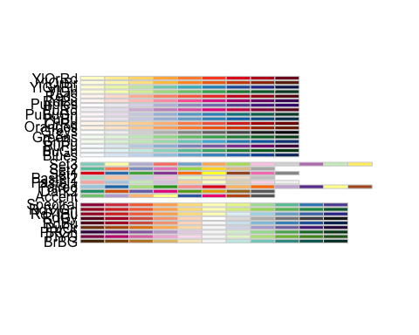

Now let's see it applied on some random data, displayed as boxplots, in this case with a qualitative palette implying a categorical grouping factor.

set.seed(5)  
rand.data <- matrix(rnorm(200, 30, 2), 10, 20)  
boxplot(rand.data, col = colorRampPalette(brewer.pal(8, "Set1"))(20))

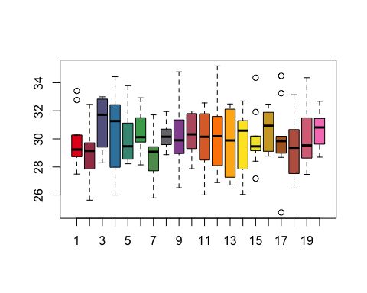

Depending on what is being communicated, the visualization could be improved by ordering the boxplots by median and using a diverging palette.

set.seed(5)  
rand.data <- matrix(rnorm(200, 30, 2), 10, 20)  
colMedians <- numeric()  
for(i in 1:20){  
 colMedians[i] <- median(rand.data[,i])  
}  
colOrder <- order(colMedians)  
rand.data <- rand.data[,colOrder]  
boxplot(rand.data, col = colorRampPalette(brewer.pal(8, "BrBG"))(20))

