Alice M. Carter

University of Montana

Flathead Lake Biological Station

32125 Bio Station Ln.

Polson, MT 59860

alice.carter@flbs.umt.edu

September 02, 2024

Kathryn L. Cottingham

Editor-in-Chief

Ecology

Dear Dr. Cottingham,

I am writing to submit our manuscript "Algal assemblage drives patterns in ecosystem structure but not metabolism in a productive river" for consideration as an original research article in Ecology. Our study, which links ecosystem structure and function across 200 km of a productive river, contributes to the understanding of how primary producer communities shape ecosystem dynamics and builds on fundamental theories developed in terrestrial ecosystems.

In this study, we use a novel approach that allows for temporal resolution of the structural and functional character of the autotrophic elements that drive metabolism in a river prone to nuisance algal blooms. We paired algal biomass measurements with daily primary production estimates collected over two growing seasons at six sites along the Upper Clark Fork River to characterize the growth rates of individual algal groups. Our findings reveal that, despite large differences in algal biomass, the presence of algal blooms and variation in the growth forms of primary producers contributed little to the variation in ecosystem primary productivity. A small but rapidly cycling group of epilithic algae were the main contributors to ecosystem carbon cycling, while the slow growing filamentous algae dominated the carbon stocks. This pattern represents a different association between ecosystem structure and function than is observed within terrestrial primary producer communities, though may be common in aquatic ecosystems.

Given the contribution our findings make to the understanding of aquatic ecology and ecological theory more broadly, we believe this manuscript will be of significant interest to the readers of Ecology.

We confirm that this manuscript is original, has not been published before, and is not currently under consideration for publication elsewhere. All authors have approved the manuscript and agree with its submission to Ecology.

Thank you for considering our work for publication. We look forward to your feedback.

Sincerely,

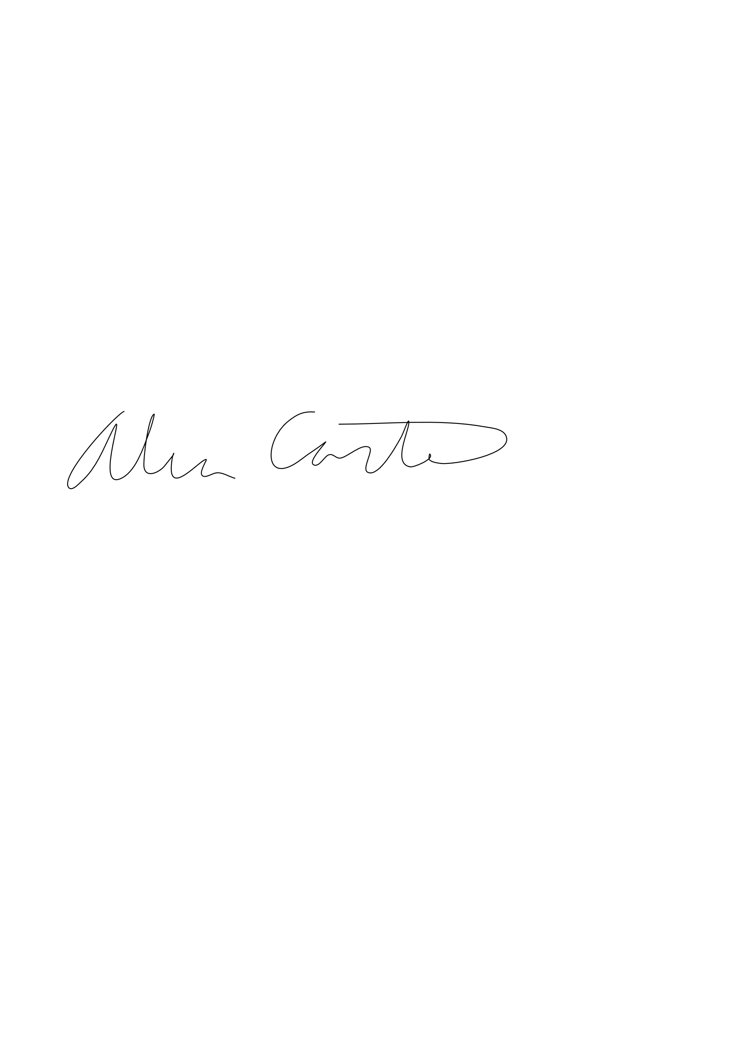

Alice M Carter