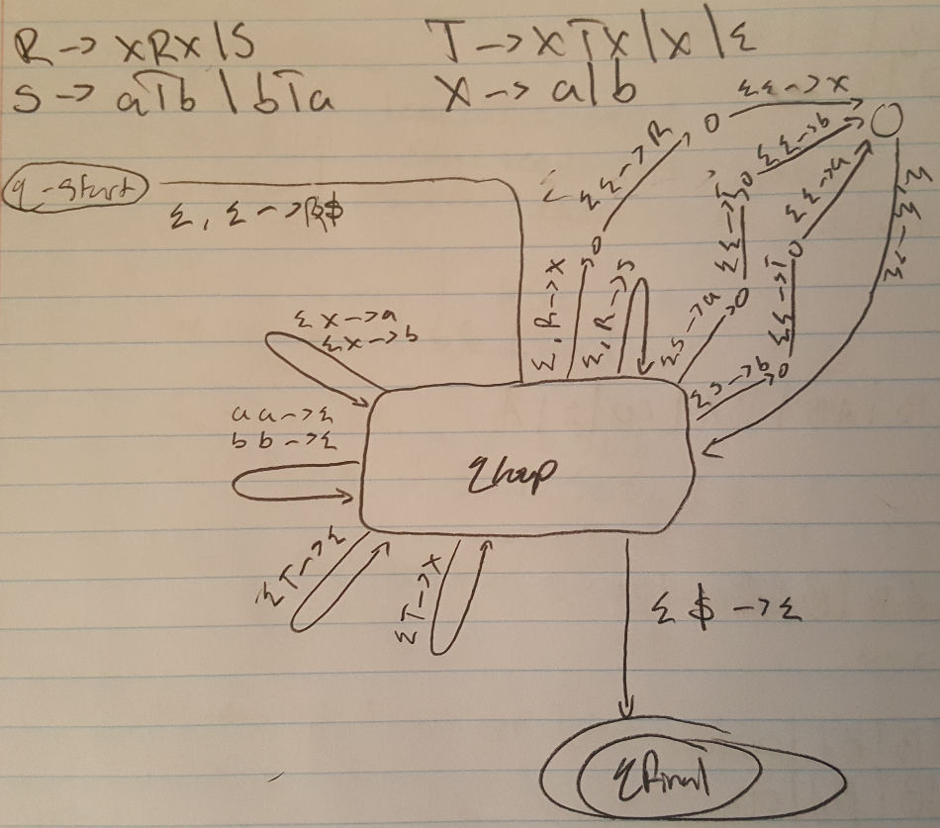Convert the following CFG into an equivalent CFG in Chomsky Normal Form

(all vars lead to 2 vars or one terminator)

A → BAB | B | ε

B → 00 | ε

CNF: -new start var

S => A

A → BAB | B | ε

B → 00 | ε

-delete ε rule for B, handle in A

S => A

A => BAB | B **| BA | AB | A** | ε

B => 00

-delete ε rule for A, handle in S

S => A **| ε**

A => BAB | B | BA | AB | A

B => 00

-delete unit rules, A => A, A => B

S => A | ε

A => BAB | BA | AB | 00

B => 00

-delete unit rules, S => A

S => **BAB | BA | AB | 00** | ε

A => BAB | BA | AB | 00

B => 00

-delete double terminals, 00

S => BAB | BA | AB | **CC** | ε

A => BAB | BA | AB **| CC**

B => **CC**

**C => 0**

-delete triple variables, BAB

S => B**B1** | BA | AB | CC | ε

A => B**B1** | BA | AB | CC

B => CC

**B1 => AB**

C => 0

Theorums:

Any context-free language is generated by a context-free grammar in Chomsky

normal form.

A language is context free if and only if some pushdown automaton recognizes it.

If a language is context free, then some pushdown automaton recognizes it.

If a pushdown automaton recognizes some language, then it is context free

Every regular language is context free

The class of DCFLs is closed under complementation. Any CFL whose complement isn’t a CFL isn’t a DCFL.

G passes the DK-test iff G is a DCFG

An endmarked language is generated by a deterministic context-free grammar if and only if it is deterministic context free.

Every DCFG has an equivalent DPDA

Every DPDA that recognizes an endmarked language has an equivalent DCFG.

**If A is a context-free language, then there is a number p (the pumping length) where, if s is any string in A of length at least p, then s may be divided into five pieces s = uvxyz satisfying the conditions 1. for each i ≥ 0, uvixyi z ∈ A, 2. |vy| > 0, and 3. |vxy| ≤ p.**

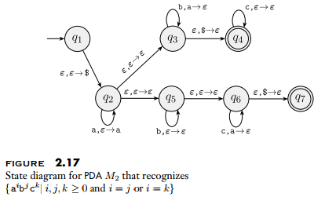

1.) Design context-free grammars for the following languages

1.1 A = {a^n b^m | n != 2m}.

G = (V, Σ, R, S) with set of variables V = {S, B, C}, where S is the start variable; set of terminals Σ = {a, b}; and rules

S => B

B => CBb | Bb | ε

C => aaC | a

1.2 B = {a^i b^j c^k |i, j, k ≥ 0 and i =

j or j = k}.

G = (V, Σ, R, S) with set of variables V = {S, A1, C1, A2, C2}, where S is the start variable; set of terminals Σ = {a, b, c}; and rules

S => A1C1 | A2C2 | ε

A1 => aA1b | ε

C1 => cC1 | ε

A2 => aA1 | ε

C2 => bC2c | ε

1.3 C = {a^n b^m|n = 3m}.

G = (V, Σ, R, S) with set of variables V = {S}, where S is the start variable; set of terminals Σ = {a, b}; and rules

S = aaaSb | ε

1.4 D = {a^n b^m|n ≤ m + 3}

G = (V, Σ, R, S) with set of variables V = {S}, where S is the start variable; set of terminals Σ = {a, b}; and rules

S => S1 | aS1 | aaS1 | aaaS1 | ε

S1 => aS1b | S1b | ε

