ABOUT:

Immigrant Sandwich features a diverse ensemble cast who vary from improv comedy fanatics to graduates of *The Second City Training Center* Improv Program. We are made up of American immigrants—both recent and *not-so-recent*! Our mission is to deliver exotic comedy freshly handpicked from the borders as a tasteful antidote to xenophobia. In other words, we’re more organic than Chipotle and better for you than any wellness shot you can buy at Whole Foods.

Our signature game is an original we created called “We Speak American.” In this game, ensemble players speak only their native languages—no English—and communicate by using universal expressions, exaggerated physical gestures, and sheer willpower. Our aim in this game is to be able to show that communication can and has always been achieved even without the need for the same language. If only our Illinois politicians came to our shows, we bet they’d learn a lot!

Perhaps this game sounds odd to you? If so, you might want to know that we indeed are all very odd. But I digress. You might also want to know that improv comedy was created by women to teach immigrant children how to speak English. So, as far as we’re concerned, we’re just keeping up the long-held tradition of utilizing the arts to embrace different cultures and people.

Like what you’ve read so far? Come join us at one of our upcoming events! Our greatest enthusiasts bring sustainable sandwich bags for us to sign. We also take cash.

­­­­­­­­­­­­­­______________________________________________________________________

BIOs:

Megan Hughes comes from the barren land of Lancaster, Ohio. She spends her free time channeling the inner powers of Tine Fey and Chris Farley to create comedy that makes life worth living. She received her Bachelor of Arts in Anthropology from Ohio University and somehow ended up in Chicago, IL where she frequents the Second City Training Center. She is an advocate for Human Rights and loves going to the movies.  
--Stock photo: mayonnaise

Alice Jasmine Crippa comes from the unfashionable ghetto suburbs of Milan. When it’s warm, you can find her outside doing yoga or hiking. When it’s cold she is inside, still doing yoga and hosting Italian dinners. She obtained her Master of Science in Communication Design from the Polytechnic University of Milan, where she teaches a workshop in collaborative practices for creative thinking. She came to Chicago by saying “YES” to a Creative Director position in the advertising industry, and then fell in love with all the yeses she can say as an improv student of the Second City Training Center. Baci e ciao belli.

--Stock photo: avocado

Apratim Vidyarthi and his unpronounceable name come from Delhi, though he considers his collection of hometowns to include the Bay Area and Chicago. His name means unique student, which is fitting because he's spent four years in college, one in grad school, and is aiming to go to law school. He currently works in consulting, which is glorified googling and requires humor for survival. Apratim began stand-up at Second City, inspired by his idol, Jon Stewart. He yes and-ed his way into improv, and enjoys making jokes about his name, his Indian-ness, and his immigrant experience. In his free time, you can find him playing tennis, eating steak, and getting into arguments.

--Stock photo: beef

Renata Camara is a bi-person, U.S. Army veteran, and differently-abled Latinx immigrant. She was born in the land of Samba and eventually settled in the Sunshine State for most of her primary years of miseducation. Much love to Lauryn Hill. She is currently a Conservatory student at the only place she’s truly felt at home: *The Second City*. She loves her family, Northwestern University, and her two dogs: Ralph and Evie. Her dream is to be the first military veteran cast member of *Saturday Night Live*. --Stock photo: lettuce

/*Still missing bios from: Julia and Gary*/

VALUES:

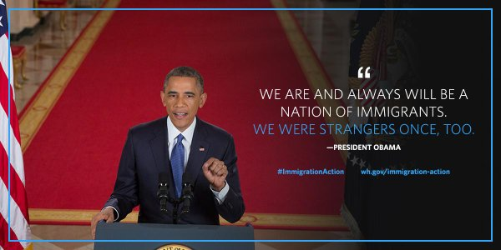

Source: <https://twitter.com/obamawhitehouse/status/535823195610578944>

Well, we couldn’t have said it better ourselves. We miss you Barack!

Our ensemble members embrace all sexualities, political parties, religions, and different forms of identifications. No i.d. is required to enjoy any of our shows! We are of course especially attuned to welcoming people from countries of origins that aren’t that of the already-great U.S. of A. We therefore strive to volunteer our time with local organizations that pay particular focus on immigration issues such as [The Young Center for Immigrant Children’s Rights](https://www.theyoungcenter.org/).

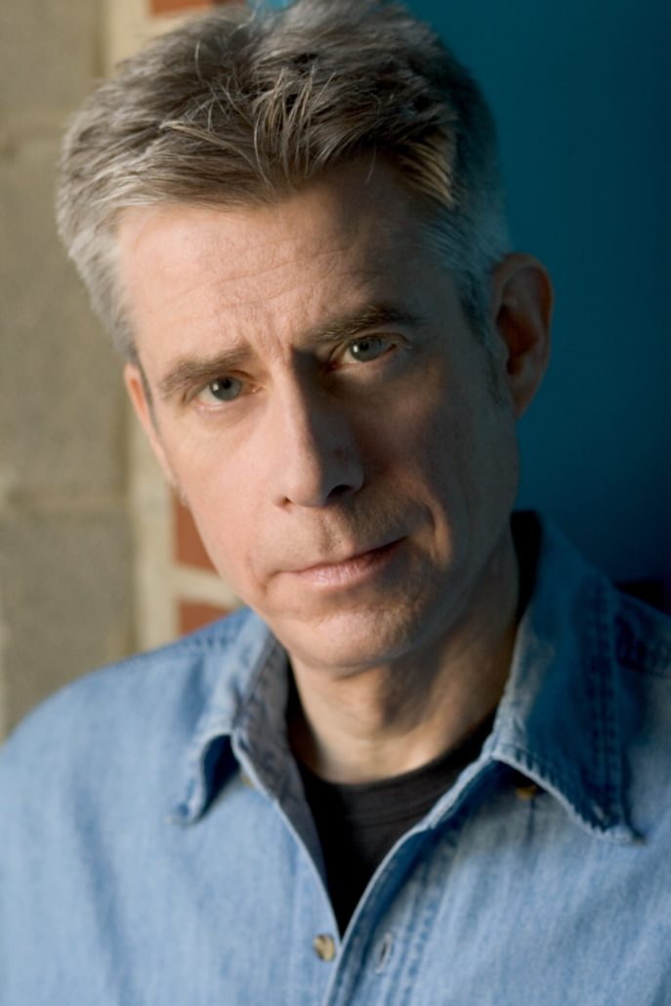COMMUNITY:

We HEART Chicago!!!

The Windy City blew all of us recent and not-so-recent immigrants together in 2018 and we sure are glad she did. Of course, we also heart Cloud Gate—did you know that’s the real name for the Bean?—but we would have never met without the genius and support of all the faculty at *The Second City Training Center*. We pay particular homage to Mark Czoske, our former faculty and current Director. I’m serious: we actually pay him in real dollars—so come see our shows and help us to keep paying him! In addition, we have also trained at the equally-wonderful iO Theater! It is there that we finetune our ensemble and music improv skills to the best of our abilities. Or maybe just to our average abilities? We’re hoping the former. You decide!