Pseudo Code:

class Person {

private:

string first_name;

string last_name;

string street_address;

string city;

string zip_code;

public:

Person(string first_name, string last_name, string street_address, string city, string zip_code) {

firstName = first_name;

lastName = last_name;

streetSddress = street_address;

city = city;

zipCode = zip_code;

}

string getFirstName() {

return firstName;

}

string getLastName() {

return lastName;

}

string getStreatAddress() {

return streetAddress;

}

string getCity() {

return city;

}

string getZipCode() {

return zipCode;

}

toString() {

string returnString = "FirstName: " + getFirstName() + "\nLastName: " + getLastName()

+ "\nAddress: " + getStreatAddress()+ "\nCity: " + getCity()

+ "\nZipCode: " + getZipCode();

return returnString;

}

};

main() {

Person person1("Dave", "Smith", "123 Fake St.", "Dever", "80123");

print person1.to_string() ;

exit;

}

C++ Code:

/* Simple Program with a few Errors for Correction

Please be sure to correct all outlined errors.

*/

#include <iostream>

// Standard namespace declaration.

using namespace std;

class Person {

private:

string first_name;

string last_name;

string street_address;

string city;

string zip_code;

public:

/**

* Constructor for the person object.

*/

Person(string first_name, string last_name, string street_address, string city, string zip_code) {

this->first_name = first_name;

this->last_name = last_name;

this->street_address = street_address;

this->city = city;

this->zip_code = zip_code;

}

/**

* Get the first name of this person.

*/

string getFirstName() {

return this->first_name;

}

/**

* Get the last name of this person.

*/

string getLastName() {

return this->last_name;

}

/**

* Get the street address of this person we are defining.

*/

string getStreatAddress() {

return this->street_address;

}

/**

* Get the city that this person resides in.

*/

string getCity() {

return this->city;

}

/**

* Get the zip code that this person resides in.

*/

string getZipCode() {

return this->zip_code;

}

/**

* Get the string representation of this Object.

*/

string to_string() {

string returnString = "FirstName: " + getFirstName() + "\nLastName: " + getLastName()

+ "\nAddress: " + getStreatAddress()+ "\nCity: " + getCity()

+ "\nZipCode: " + getZipCode();

return returnString;

}

};

int main() {

Person person1("Dave", "Smith", "123 Fake St.", "Dever", "80123");

cout << person1.to_string() << endl;

return 0;

}

Code Execution Screenshot:

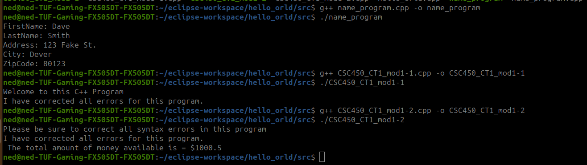

Github:

https://github.com/amcdaugale/Programming3/tree/main/Module_1



