**Pseudo Code:**

class two_strings

{

private:

string string1;

string string2;

public:

two_strings(){}

void set_string1(string string)

{

this.string1 = string;

}

void set_string2(string string)

{

this.string2 = string;

}

void print_strings()

{

string tmpstr = string1;

strcat(tmpstr, string2);

print "Concat str: " + tmpstr;

}

};

/**

* Main function.

*/

int main() {

two_strings stringArray[3];

string tmp;

for(3 itterations)

{

print "Please enter two strings to concatinate." << endl;

print"String1:";

in(tmp);

stringArray[x].set_string1(tmp);

print "String2:";

in(tmp);

stringArray[x].set_string2(tmp);

stringArray[x].print_strings();

}

return 0;

}

**Src Code:**

/**

* author: Alec McDaugale

*

* This program takes two strings from a user 3 times and prints it back to the user.

*/

// Max inputs.

#define INPUT_COUNT 3

#include <iostream>

#include <cstring>

using namespace std;

/**

* This class holds two strings and provides a function to concatinate and print the two strings.

*/

class two_strings

{

private:

string string1; // Variable to hold first string.

string string2; // Variable to hold first string.

public:

/**

* Default constructor.

*/

two_strings(){}

/**

* Set the first string.

*/

void set_string1(string string)

{

this->string1 = string;

}

/**

* Set the second string.

*/

void set_string2(string string)

{

this->string2 = string;

}

/**

* Converts the strings to charecter arrays, then concatinate and print

* the two strings togeather.

*/

void print_strings()

{

char strArray1[string1.length() + string2.length() + 1];

char strArray2[string2.length() + 1];

for(int i = 0; i < sizeof(string1.length()); i++)

{

strArray1[i] = string1[i];

}

for(int i = 0; i < sizeof(string2.length()); i++)

{

strArray2[i] = string2[i];

}

strcat(strArray1, strArray2);

cout << "Concat str: " << strArray1 << endl;

}

};

/**

* Main function.

*/

int main() {

two_strings stringArray[INPUT_COUNT]; // Array to hold custom type.

string tmp; // String to hold input.

// Loop to prompt user for two strings and print to terminal 3 times.

for(int x = 0; x < INPUT_COUNT; x++)

{

cout << "Please enter two strings to concatinate." << endl;

cout << "String1:" << endl;

cin >> tmp;

stringArray[x].set_string1(tmp);

cout << "String2:" << endl;

cin >> tmp;

stringArray[x].set_string2(tmp);

stringArray[x].print_strings();

cout << endl;

}

return 0;

}

**Code Execution:**

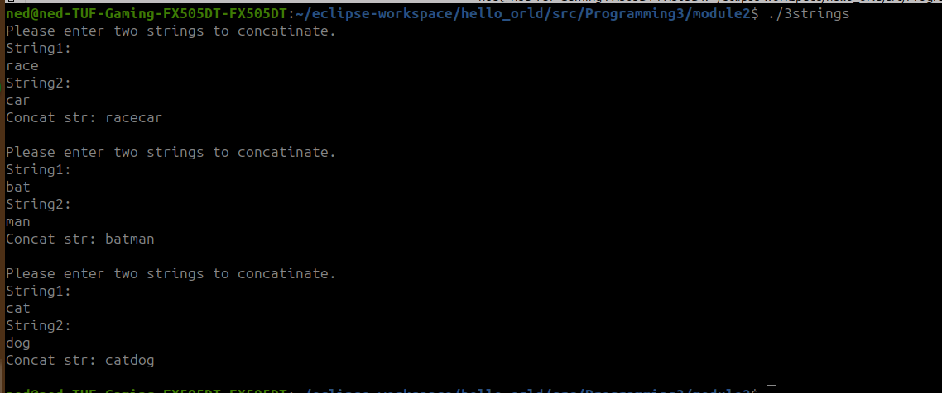

**Github**:

<https://github.com/amcdaugale/Programming3/tree/main/module2>

